**DoNotSleep Documentation:**

DoNotSleep is a tool, to prevent the computer change to a power-safe mode, for short period of time, without changing the global power-settings.

The tool resides in the system-tray. There are some predefined presets, which can be quickly selected to sleep for short period.

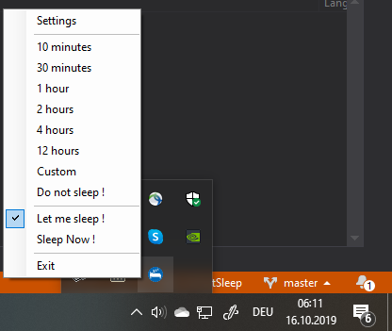

Via the Settings-Menu it is possible to set the ‘do-not-sleep’ period to an exact point in time.

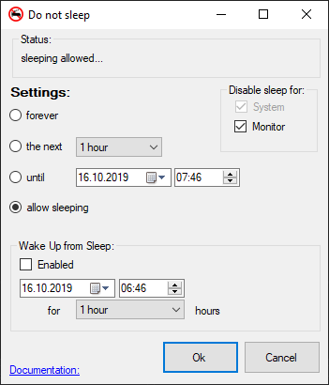

It is also possible to awake the computer from sleep at a certain moment.

**CommandLineParameters**:

**DoNotSleep.exe** *Parameter1* [*Parameter2*]

Parameter1:

|  |  |  |
| --- | --- | --- |
| Parameter1: | Parameter2: | Description: |
| 10MIN | - | -> sleep for 10 Minutes |
| 30MIN | - | -> sleep for 30 Minutes |
| 1HOUR | - | -> sleep for 1 Hours |
| 2HOUR | - | -> sleep for 2 Hours |
| 4HOUR | - | -> sleep for 4 Hours |
| 12HOUR | - | -> sleep for 12 Hours |
| INFINITE | - | -> until 2099 |
| CUSTOM | i.e “12.01.2020 00:00” | -> until 12.01.2020 00:00 ! It uses CurrentUICulture formats… |

DoNotSleep was developed by Michael Wittmann ([michaelwittmann@email.de](mailto:michaelwittmann@email.de)) , Dachau 2013-2019