Dwaar (دوّر)
Backend & Database System Design
Real-Time Delivery Tracking on AWS
Waste-recycling logistics platform — Jordan
Architecture comparison: AWS-native vs Supabase-centric
Target: growth-ready (tens of thousands of users, multi-city)
Version 1.0 — June 2026

Table of Contents

1. Executive Summary
This document is a complete system design for the backend and database powering Dwaar, an Arabic-first waste-recycling logistics app for the Jordanian market. The app today is a Flutter client with three roles — Driver, Supplier, and Recycling Company — backed by Supabase plus local JSON persistence. The goal now is a production backend that supports live delivery tracking in the style of Uber Eats, Careem, and Talabat: a supplier requests a pickup, the system matches a driver, and both sides watch the driver move on a map in real time until the waste is delivered to a recycler.
The hard part of any delivery app is not the CRUD — it is the real-time location pipeline: ingesting a GPS ping from every active driver every few seconds, indexing it geospatially, matching the nearest available driver to a new order, and fanning live positions out to the right customers with low latency. Everything else (orders, payments, ratings) is comparatively standard. This design therefore treats the tracking pipeline as the center of gravity and builds the rest around it.
Two deployment paths are compared in detail. The recommendation for Dwaar at this stage is a hybrid: keep Supabase (Postgres + Auth) as the system of record and add a thin AWS real-time tier (a WebSocket layer plus Redis for the live geo index) only for the tracking workload. This avoids a costly migration, lets the team ship quickly, and leaves a clean path to a fully AWS-native architecture once scale demands it. The full AWS-native blueprint is documented so the migration is a matter of swapping components, not redesigning.

2. Goals & Requirements

2.1 Functional requirements
- Pickup lifecycle: supplier creates a pickup request (waste type, form, weight category, location) → system matches a driver → driver accepts, drives to pickup, collects, drives to recycler, delivers.
- Live tracking: supplier and recycler see the assigned driver's live position and ETA on a map; driver sees turn-by-turn route to the next stop.
- Dispatch / matching: find the nearest online, available, capacity-appropriate driver to an incoming order and offer it; handle accept/reject/timeout.
- Status & history: every status transition is recorded and visible; proof-of-pickup / proof-of-delivery photos are captured.
- Notifications: push (and SMS fallback) for new offers, status changes, and arrival.
- Payments & payouts: order pricing, supplier payment, driver payout/wallet, ratings.
- Auth & roles: phone-based sign-up with OTP, role-based access (driver / supplier / recycler / admin).
- Bilingual: all server-facing labels/enums must support Arabic + English (handled today by enum label extensions on the client).

2.2 Non-functional requirements & scale targets
Attribute | Target | Why / how
Location ingest latency | < 1–2 s end-to-end | Driver ping → customer screen update; the headline UX metric
Concurrent online drivers | Design for ~5,000; burst 10k | Each pinging every 3–5 s ⇒ ~1–3k writes/s peak
Order throughput | Tens of thousands/day | Comfortable for a single Aurora/Postgres writer with read replicas
Availability | 99.9% (≈ 43 min/mo) | Multi-AZ; no hard multi-region requirement yet
Data durability | No lost orders/payments | Postgres is the system of record; pings are best-effort
Cost | Lean, scale-with-usage | Serverless / managed first; avoid idle fleets
Region | eu-central-1 (Frankfurt) or me-central-1 (UAE) | Lowest latency to Jordan; me-central-1 keeps data in-region
A useful sizing intuition: the database load is dominated by location pings, not orders. Five thousand drivers pinging every 4 seconds is ~1,250 writes/second of tiny rows — trivial for a purpose-built store (DynamoDB / Redis) but wasteful and risky if written synchronously into your relational system of record. The architecture keeps hot location data out of Postgres.

3. High-Level Architecture (AWS-Native Reference)
The diagram below is the full AWS-native target. Read it left to right: clients connect through an edge/API tier, which routes to stateless services, which read and write a polyglot data tier, with a platform tier handling maps, async events, push, and observability.
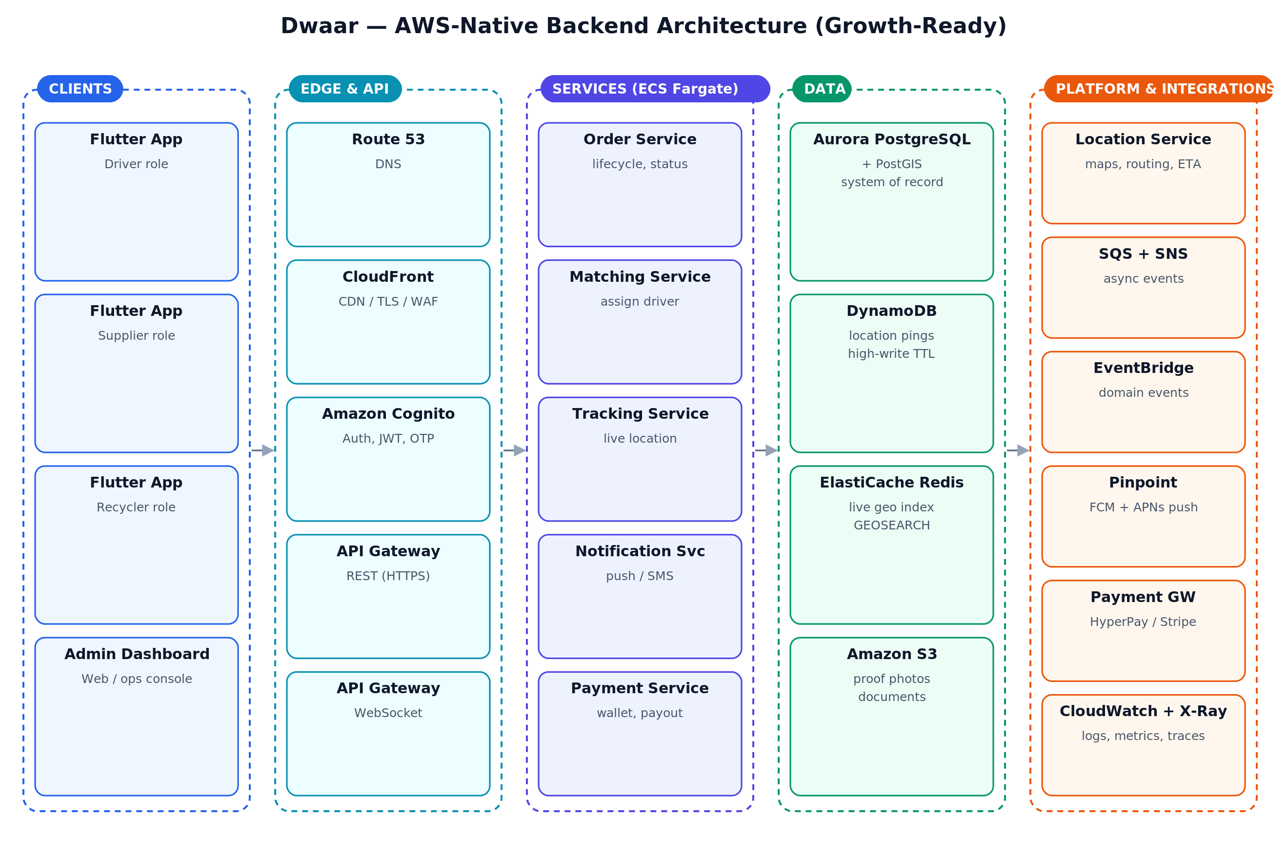
Figure 1 — AWS-native backend architecture, organized into five tiers.

3.1 Tier-by-tier walkthrough

Clients & edge
- Flutter apps + admin web reach the backend over HTTPS for request/response and over a secure WebSocket (WSS) for live tracking.
- CloudFront + AWS WAF terminate TLS, cache static assets, and provide a first line of defense (rate limiting, geo / IP rules). Route 53 handles DNS.
- Amazon Cognito issues JWTs after phone-OTP sign-in and is the single source of identity for both REST and WebSocket connections. (In the hybrid option, Supabase Auth plays this role.)

API tier
- API Gateway (REST/HTTP API) fronts the synchronous endpoints (orders, payments, profiles). It validates JWTs, throttles per-client, and routes to services.
- API Gateway (WebSocket API) holds the persistent connections used for live location. It maps connectionId ↔ user/order and invokes the Tracking Service on each message. This is the managed alternative to running your own socket fleet.

Services (ECS Fargate)
Stateless containers behind the API tier, scaled independently by CPU/queue depth. Splitting them keeps the high-churn tracking workload from competing with transactional order logic:
- Order Service — order lifecycle, status transitions, validation, pricing.
- Matching Service — nearest-driver search, offer/accept/timeout state machine.
- Tracking Service — ingests pings, updates the geo index, fans out positions, computes ETA.
- Notification Service — consumes events and sends push/SMS via Pinpoint.
- Payment Service — pricing, wallet, payout, payment-gateway integration.
Fargate is chosen over raw Lambda for the long-lived, steady-traffic services (especially Tracking, which benefits from warm connection pools to Redis). Lambda remains a fine choice for spiky, event-driven glue such as the Notification Service.

Data tier (polyglot persistence)
- Aurora PostgreSQL + PostGIS — the system of record: users, orders, payments, ratings. PostGIS gives geospatial columns and indexes for queries that must be durable and transactional.
- ElastiCache for Redis — the live geo index. GEOADD / GEOSEARCH answer “nearest drivers to this point” in sub-millisecond time, and Redis Pub/Sub backs the fan-out of positions to subscribers.
- DynamoDB — append-only location-ping history, keyed by driver/order with a TTL so old breadcrumbs auto-expire. Absorbs the high write rate cheaply and elastically.
- Amazon S3 — proof-of-pickup/delivery photos and documents, served via CloudFront with signed URLs.

Platform & integrations
- Amazon Location Service — maps, routing, and ETA. (Google Maps Platform is the common alternative and often has better coverage/quality in the MENA region — see §9.)
- SQS + SNS + EventBridge — asynchronous backbone. Order events are published once and consumed by notifications, analytics, and payouts independently, so services stay decoupled.
- Pinpoint — push (FCM/APNs) and SMS delivery.
- CloudWatch + X-Ray — centralized logs, metrics, alarms, and distributed tracing.

4. The Core: Real-Time Delivery Tracking
This is the part that makes the app feel like Careem/Talabat. The flow below shows a single driver position propagating from the driver's phone to the customer's map.
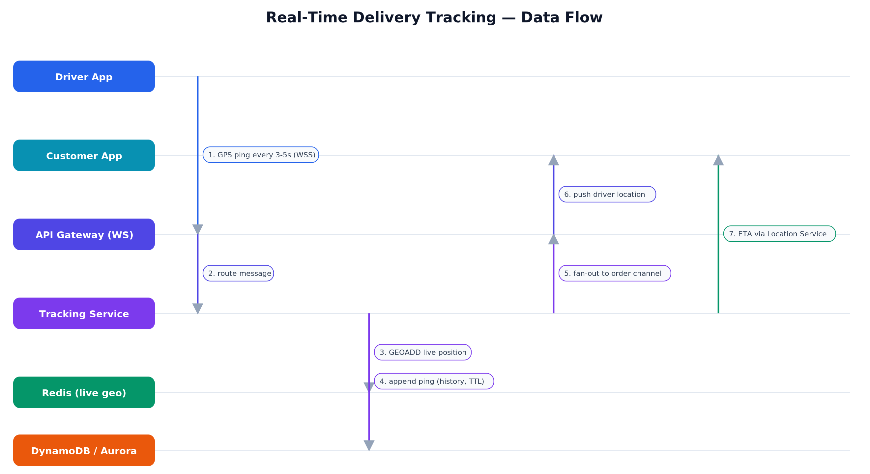
Figure 2 — Real-time tracking data flow (driver ping → geo index → customer fan-out → ETA).

4.1 Location ingestion
- Transport: the driver app opens one persistent WebSocket while on an active order and sends a compact position message every 3–5 seconds (adaptive: faster while moving, slower when idle, batched when the network drops).
- Why WebSocket over HTTP polling: a persistent socket avoids per-request TLS/handshake overhead, enables true server push to customers, and dramatically lowers battery and bandwidth use at this frequency.
- Write path: the Tracking Service writes the latest position to Redis (GEOADD drivers:online <lng> <lat> <driverId>) and appends the raw ping to DynamoDB for history (with TTL). Postgres is not touched on the hot path.

4.2 Live geo index & matching
Redis holds two things: a geo set of online drivers' current positions, and a per-driver hash of status/capacity. Dispatch becomes a fast two-step query:
// 1) candidate drivers within 5 km of the pickup, nearest first
GEOSEARCH drivers:online FROMLONLAT 35.91 31.95 BYRADIUS 5 km ASC COUNT 10

// 2) filter candidates by status + vehicle capacity (Redis hashes),
// offer to the best one, await accept, else fall through to the next.
PostGIS in Postgres can answer the same nearest-neighbour query durably (ORDER BY geom <-> point LIMIT 10 with a GiST index), and is the fallback / source of truth. Redis is used on the hot path purely for speed.

4.3 Fan-out to customers
- Channel model: each active order has a logical channel (e.g. order:{id}). The supplier and recycler watching that order subscribe to it over their own WebSocket.
- Delivery: when a new position arrives for a driver on order X, the Tracking Service publishes it to order:X; subscribers receive the update and animate the marker. With API Gateway WebSockets this is a fan-out of PostToConnection calls; with a self-managed fleet it is Redis Pub/Sub across socket servers.
- ETA: recomputed every few seconds (or every N meters) by calling the routing provider with the driver's position and the next stop, then pushed on the same channel. ETAs are cached briefly to control routing-API cost.

4.4 Reliability details that matter
- Reconnection: clients resume by re-subscribing to their order channel and reading the last-known position from Redis, so a dropped socket never shows a frozen map.
- Offline buffering: the driver app queues pings while offline and flushes them on reconnect; the server keeps the most recent and de-duplicates.
- Backpressure: if a driver floods pings, the server samples; if a customer is slow, only the latest position is kept (lossy is correct for live location).
- Geofencing: “arrived at pickup/dropoff” is detected server-side when the driver enters a radius around the stop, triggering status changes and notifications automatically.

5. Database Design
Postgres (Aurora or Supabase) is the relational system of record. The schema below mirrors the app's existing domain — note how the Flutter Order freezed model and its enums (OrderType, OrderStatus, WasteType, WasteForm, WeightCategory, VehicleType …) map directly onto columns, so the client needs minimal change.
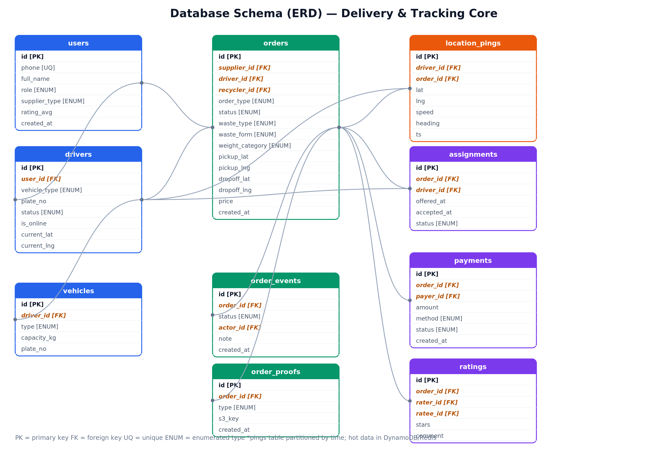
Figure 3 — Core relational schema. Hot location data lives in Redis/DynamoDB, not these tables.

5.1 Table responsibilities
Table | Purpose
users | All people; role + supplier_type enums drive routing (mirrors the app's HomeRouter).
drivers / vehicles | Driver profile, online flag, last-known position (denormalized for convenience), vehicle capacity & type.
orders | The pickup request and its full lifecycle: parties, waste attributes, pickup/dropoff coordinates, status, price.
order_events | Immutable audit log of every status transition (who, when, note) — powers history and disputes.
order_proofs | Pointers (S3 keys) to proof-of-pickup / proof-of-delivery photos.
assignments | The dispatch offer state machine: which driver was offered, accepted/rejected/timed-out, when.
location_pings | Durable breadcrumb history (cold copy). Hot, high-rate writes go to DynamoDB/Redis first.
payments / ratings | Order pricing & settlement, and two-way star ratings.

5.2 Key DDL (PostgreSQL + PostGIS)
CREATE EXTENSION IF NOT EXISTS postgis;

CREATE TYPE order_status AS ENUM ('requested','matched','accepted',
'en_route_pickup','at_pickup','collected','en_route_dropoff',
'delivered','cancelled');

CREATE TABLE orders (
id uuid PRIMARY KEY DEFAULT gen_random_uuid(),
supplier_id uuid NOT NULL REFERENCES users(id),
driver_id uuid REFERENCES drivers(id),
recycler_id uuid REFERENCES users(id),
order_type order_type NOT NULL,
status order_status NOT NULL DEFAULT 'requested',
waste_type waste_type NOT NULL,
waste_form waste_form NOT NULL,
weight_cat weight_category NOT NULL,
pickup_geom geography(Point,4326) NOT NULL,
dropoff_geom geography(Point,4326),
price_cents integer,
created_at timestamptz NOT NULL DEFAULT now(),
updated_at timestamptz NOT NULL DEFAULT now()
);
CREATE INDEX orders_status_idx ON orders(status);
CREATE INDEX orders_pickup_gix ON orders USING gist (pickup_geom);

-- durable driver position for PostGIS fallback matching
ALTER TABLE drivers ADD COLUMN geom geography(Point,4326);
CREATE INDEX drivers_geom_gix ON drivers USING gist (geom) WHERE is_online;

5.3 Design notes
- Keep pings out of the relational store. location_pings is a cold archive; the live position lives in Redis and the high-rate history in DynamoDB. Writing every ping to Postgres would bloat WAL and starve transactional load.
- Append-only events. order_events is never updated — it is the audit trail that makes disputes and analytics trivial and is friendly to event sourcing later.
- Enums match the client. Define Postgres enums to mirror the Dart enums so labels stay consistent; expose only .label/.shortLabel to users (bilingual) as the app already does.
- Row-Level Security. On Supabase especially, enforce RLS so a supplier can read only their own orders, a driver only assigned orders, etc. — security at the database, not just the API.

6. AWS-Native vs Supabase-Centric — Comparison & Recommendation
Both can run this product well. The question is cost-to-ship and operational burden now, versus ceiling and control later.
Concern | AWS-native | Supabase-centric
Database | Aurora PostgreSQL + PostGIS — huge ceiling, more ops/cost | Managed Postgres + PostGIS built in — same SQL, far less setup
Auth | Cognito (flexible, fiddly) | Supabase Auth — phone OTP, JWT, RLS out of the box
Realtime / tracking | API Gateway WebSocket or ECS socket fleet + ElastiCache Redis | Supabase Realtime is fine for moderate fan-out; heavy geo still wants Redis
Geo / nearest-driver | PostGIS + ElastiCache Redis GEOSEARCH | PostGIS in Supabase; add managed Redis (Upstash) for hot index
File storage | S3 + CloudFront | Supabase Storage (S3 under the hood)
Push / SMS | Pinpoint | Edge Function → FCM/APNs + an SMS provider
Background logic | ECS / Lambda + SQS/EventBridge | Edge Functions + pg_cron / queues (lighter, less powerful)
Time to launch | Slower — more pieces to wire | Fast — most of the stack is already there (and in use today)
Ops burden | Higher (you run more) | Low (managed platform)
Scaling ceiling | Very high, multi-region ready | High; very large scale eventually favors AWS-native
Monthly cost (growth stage) | Higher fixed floor (Aurora, NAT, ALB, Fargate) | Lower at this scale; predictable tiers

6.1 Recommendation
Given Dwaar already runs on Supabase and the priority is to ship a reliable tracking product for the Jordan market without a rewrite, the pragmatic path is a hybrid:
- Keep Supabase as Postgres (system of record, PostGIS, RLS) + Auth + Storage. Your existing AppOrderStore → Supabase mirroring stays.
- Add a thin AWS real-time tier only for tracking: a small ECS Fargate WebSocket/Tracking service plus managed Redis (ElastiCache, or Upstash for a serverless start) for the geo index and fan-out.
- Use DynamoDB (or a Postgres partitioned table) for ping history and S3-compatible storage for proofs.
- Keep a clean migration seam: bind every implementation behind the app's existing lib/domain/ interfaces so swapping Supabase → Aurora later is a config change in main.dart's MultiProvider, not a redesign.
This gives you Supabase's speed-to-market where it shines (auth, CRUD, RLS) and AWS's strength exactly where Supabase is weakest (high-rate geo + fan-out), while the documented AWS-native blueprint (Figure 1) remains the destination when scale or enterprise requirements demand it.

7. API Design

7.1 REST endpoints (representative)
Method | Path | Purpose
POST | /v1/orders | Supplier creates a pickup request
GET | /v1/orders/{id} | Order detail + current status
GET | /v1/orders?role=driver&status=active | Role-scoped order lists
POST | /v1/orders/{id}/accept | Driver accepts an offered order
POST | /v1/orders/{id}/status | Advance lifecycle (collected, delivered, …)
POST | /v1/orders/{id}/proofs | Upload proof photo (returns S3 signed URL)
GET | /v1/drivers/nearby?lat&lng | Admin/diagnostics nearest-driver query
POST | /v1/payments/{orderId} | Settle / record payment
POST | /v1/ratings | Submit a rating after delivery

7.2 WebSocket events
Event | Direction | Payload / meaning
driver.location | client → server | { orderId, lat, lng, speed, heading, ts }
order.subscribe | client → server | Customer subscribes to an order channel
location.update | server → client | Latest driver position for a subscribed order
eta.update | server → client | Recomputed ETA + remaining distance
order.status | server → client | Status change (arrived, collected, delivered)
offer.new | server → driver | New order offered to this driver (with timeout)
Authentication: the JWT (Cognito or Supabase) is passed on the WebSocket connect; the server resolves the user and authorizes every subscribe against the order's parties.

8. Deployment, Environments & CI/CD
- Infrastructure as Code: define everything in Terraform (or AWS CDK) — networks, Aurora/Redis, ECS services, API Gateway, IAM. No click-ops, so environments are reproducible.
- Environments: dev → staging → prod, each isolated. Mirror your current .env approach (SUPABASE_URL, keys, GEMINI_API_KEY) into AWS Secrets Manager / SSM Parameter Store — never in the repo.
- Containers: services build to Docker images in ECR; ECS Fargate runs them with rolling or blue/green deploys behind the ALB.
- Pipeline: GitHub Actions on push → run flutter analyze + flutter test (your AppOrderStore persistence tests are the safety net) → build images → terraform plan/apply to staging → manual gate → prod.
- Database migrations: versioned SQL migrations (Supabase CLI or Flyway/Sqitch) applied in the pipeline, never by hand.
- Mobile: flutter build appbundle/ipa in CI; ship via Play Console / App Store Connect or a service like Codemagic/Fastlane.

9. Maps, Routing & ETA Provider
Tracking quality depends heavily on the maps/routing provider, and coverage in Jordan matters more than brand:
- Google Maps Platform — strongest map data, routing, and traffic-aware ETAs in the MENA region; Routes/Distance Matrix and Geocoding APIs are the usual choice. Cost scales per request, so cache ETAs and snap-to-road sparingly.
- Amazon Location Service — cheaper, native to AWS/IAM, good if you are all-in on AWS; verify route quality on real Jordan addresses first.
- Mapbox — excellent SDKs and pricing, strong for the in-app map UI.
Decouple this behind a small routing interface so the provider can be swapped without touching the tracking pipeline. Control cost by recomputing ETA on movement thresholds (e.g. every 200 m or 15 s), not on every ping.

10. Security & Compliance
- Identity: short-lived JWTs, refresh tokens, phone-OTP sign-in; role claims checked on every request and socket subscribe.
- Authorization in depth: Postgres Row-Level Security so data access is enforced at the database, not only the API.
- Transport & secrets: TLS everywhere; secrets in Secrets Manager/SSM; least-privilege IAM roles per service.
- Network: databases and Redis in private subnets, reachable only from the service security group; WAF + rate limiting at the edge.
- Location privacy: expose a driver's live position only to the parties on the active order, and stop sharing once delivered. Set TTLs on ping history and define a retention policy.
- Data residency: for Jordanian user data, prefer me-central-1 (UAE) or eu-central-1 and document where personal and location data are stored and for how long.
- Backups & DR: automated Aurora/Postgres backups + point-in-time recovery; periodic restore drills.

11. Reliability & Scaling Roadmap
Stage | Scale | What you run
MVP | 1 city, < 1k users | Supabase (DB/Auth/Storage) + one small Fargate tracking service + Upstash Redis. Single AZ-ish, cheap.
Growth | Multi-city, 10k+ users | Multi-AZ Postgres + read replica; ElastiCache Redis; DynamoDB ping history; SQS/SNS for async; autoscaled Fargate. (This document's target.)
Scale | National, heavy load | Fully AWS-native (Figure 1): Aurora cluster, partitioned/sharded data, possible multi-region, dedicated socket fleet.
Each stage is a superset of the previous one — because the domain interfaces and the polyglot data boundaries are fixed up front, moving between stages swaps infrastructure without rewriting product logic.

12. Indicative Cost (Order-of-Magnitude)
These are rough planning estimates for the growth stage, not quotes — AWS and Supabase pricing change and depend on real usage. Verify with the AWS Pricing Calculator and current Supabase tiers before budgeting.
Component | Hybrid (recommended) | Full AWS-native
Database | Supabase Pro tier | Aurora PostgreSQL Multi-AZ
Realtime/compute | 1–2 small Fargate tasks | Several Fargate services + API GW WS
Cache (Redis) | Upstash / small ElastiCache | ElastiCache cluster
Ping history | DynamoDB on-demand | DynamoDB on-demand
Maps/routing | Usage-based (cache aggressively) | Usage-based
Rough monthly floor | Lower hundreds of USD | High hundreds → low thousands USD
The dominant variable cost is usually the maps/routing provider, followed by data egress — both controllable with caching and movement-threshold ETA updates.

13. Recommended Next Steps
- Lock the schema: create the Postgres migrations for orders/events/assignments/payments with PostGIS, matching your Dart enums.
- Stand up the tracking tier: one Fargate WebSocket/Tracking service + managed Redis; implement ping-ingest, GEOSEARCH matching, and order-channel fan-out.
- Wire the client: add a WebSocket tracking client behind a domain interface; reuse AppOrderStore for status, add a live-position stream for the map.
- Add dispatch: the offer/accept/timeout state machine in the Matching Service, backed by the assignments table.
- Choose the maps provider and build the routing/ETA abstraction; validate route quality on real Jordan addresses.
- Instrument & load-test: simulate thousands of pinging drivers; watch ingest latency, Redis CPU, and fan-out time before launch.
- Harden: RLS, secrets management, WAF, backups + a restore drill; then pilot in one city.
Prepared as a system-design reference for the Dwaar platform. Architecture diagrams are embedded above and provided as separate image files.

