Lab Automation
1

SRS Management System

Dashboard – Documentation

Table of Contents

Introduction ---------------------02

Modular & Sub-Modular Architecture------------ 02

Product Management---------------------- 03, 04

4. Testing Management & Auto ID Generation----- 05, 06

5. Detailed Remarks & Testing Criteria ---- 06, 07

6. Advanced Search & Tracking------- 08

7. Testing Workflow & Approval Process----- 08, 09, 10

8. Reports---- 12, 13, 14, 15

9. One Page Website – SRS Manufacture---------- 15, 16, 17, 18

2

1. Introduction
The SRS Management Dashboard is a web-based application developed to manage manufactured products, their testing lifecycle, and approval workflow. The system is designed in a modular and sub-modular architecture based on product type and testing type to ensure scalability and maintainability.
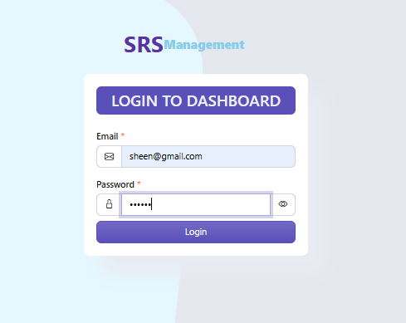
📸 Login to dashboard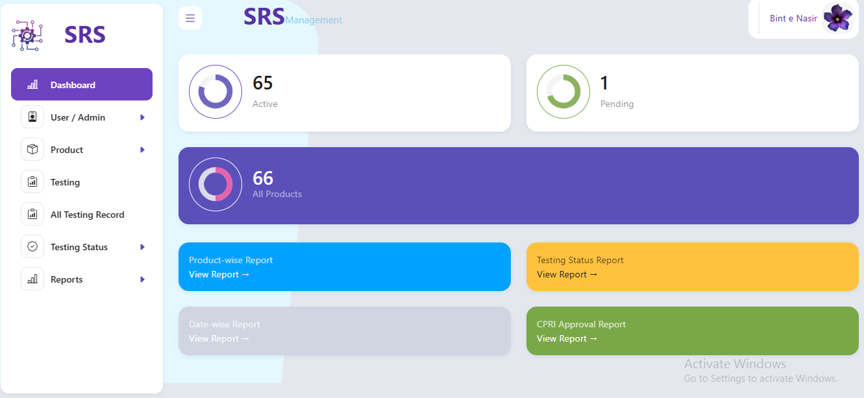
Dashboard view
3
2

2. Modular & Sub-Modular Architecture
The application follows a structured modular approach:
- Product Module: Handles product registration, product ID generation, and revision tracking.
- Testing Module: Manages different testing types, testing criteria, and result recording.
- Reports Module: Generates product-wise, testing-wise, and status-wise reports.
Each module is further divided into sub-modules based on product category and testing category.
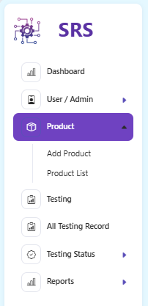
Module Navigation
4

3. Product Management
Each product is assigned a unique 10-digit Product ID as defined by the manufacturing unit. The system allows users to add, update, and view product details including product code, revision, and associated testing records.
Product Entry Screen
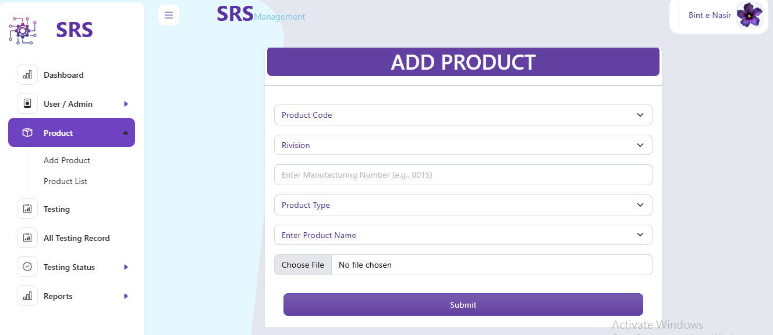
5
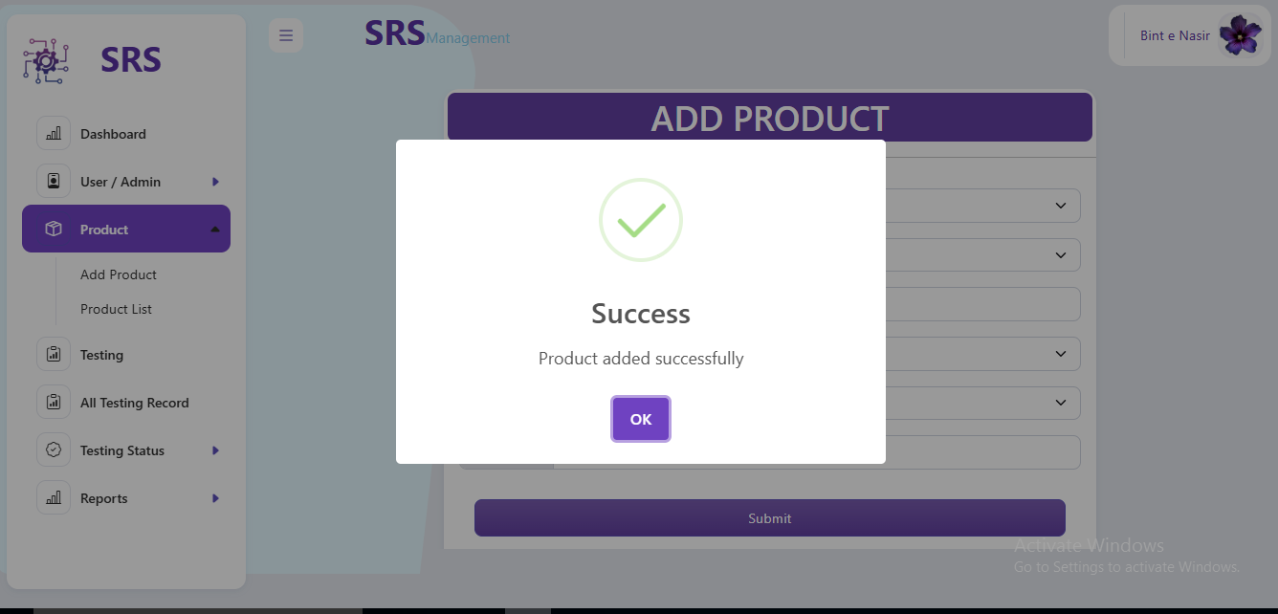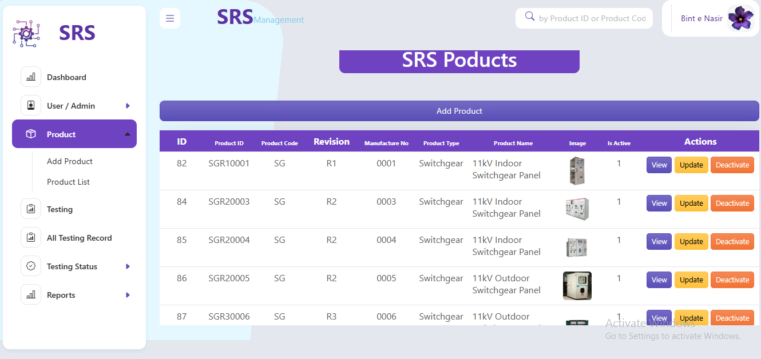

4. Testing Management & Auto ID Generation
6

When a testing record is entered, the system automatically generates a unique 12-digit Testing ID. This Testing ID is composed of the product code, product revision, testing code, and testing roll number.
The system ensures that no duplicate Testing ID can exist, thereby maintaining complete traceability.
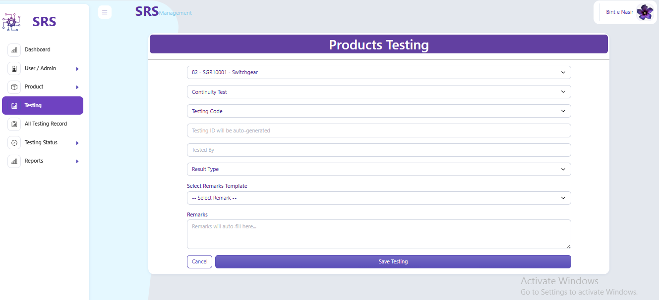
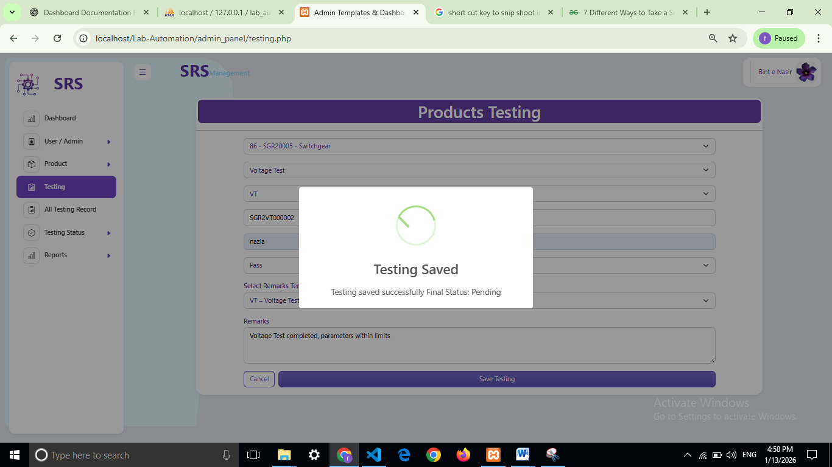
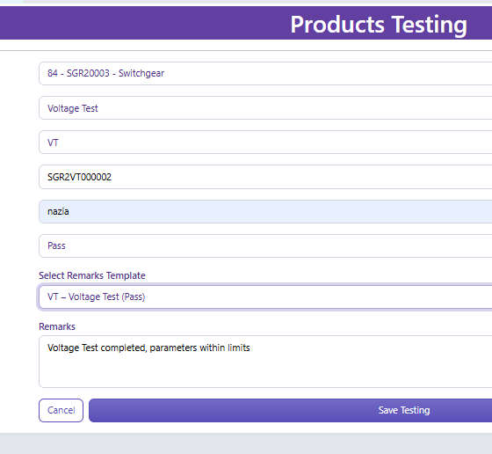
Testing Entry & Auto Generated ID
7

5. Detailed Remarks & Testing Criteria
The application allows detailed remarks to be captured for every test performed. Users can specify the testing criteria, expected output, actual output observed, final result (Pass/Fail/Pending), and any additional remarks.
8

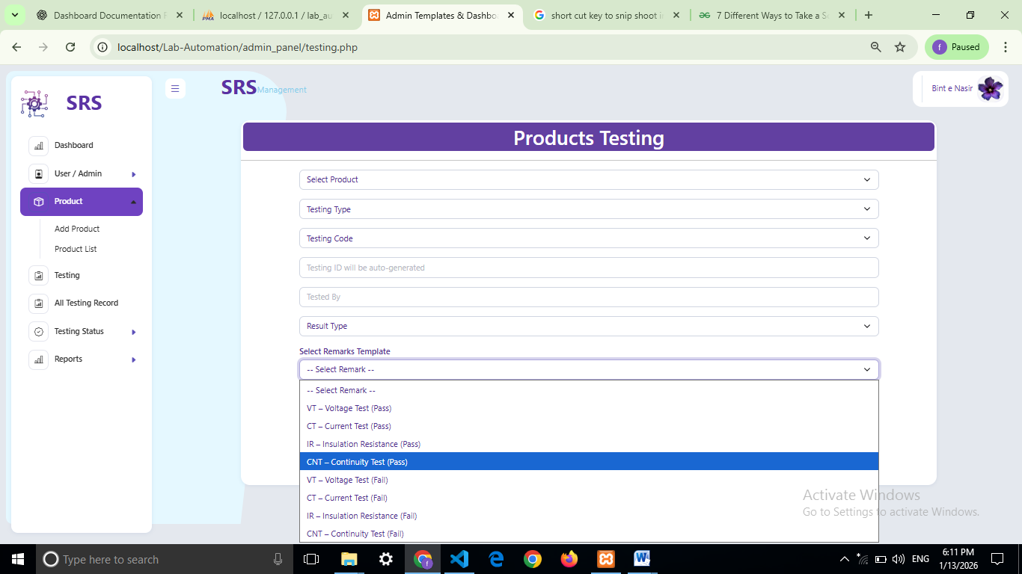
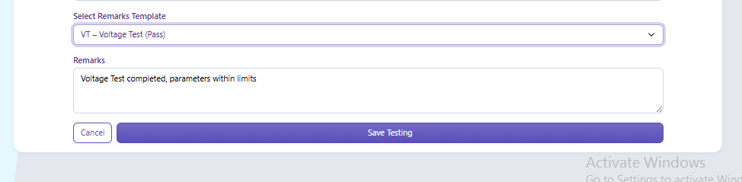
Detailed Remarks Section
9

6. Advanced Search & Tracking
An advanced search feature is provided to retrieve records using Product ID or Testing ID. Users can easily track the testing status and history of any product at any stage.
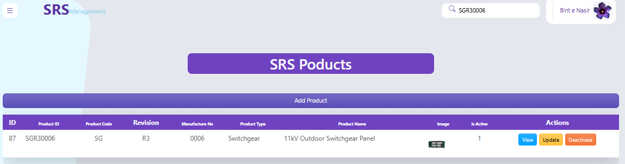
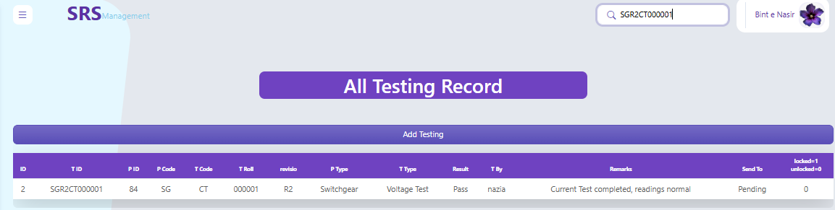
Advanced Search Screen

7. Testing Workflow & Approval Process
If a product fails during testing, it is marked for re-manufacturing. Products that pass internal testing are forwarded for CPRI testing and approval. Once approved by CPRI, the product is marked as eligible for market release.
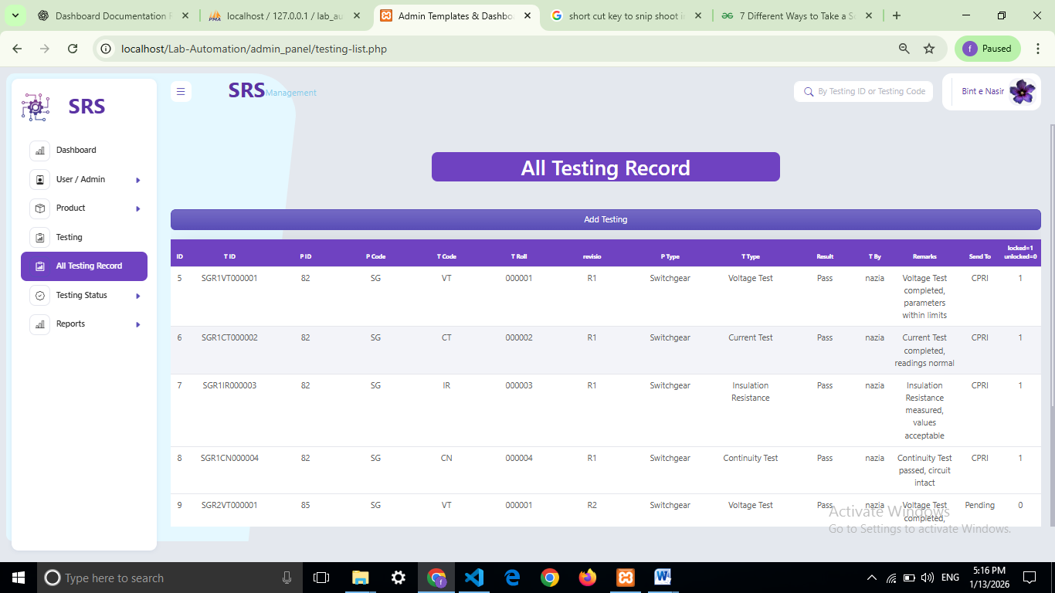
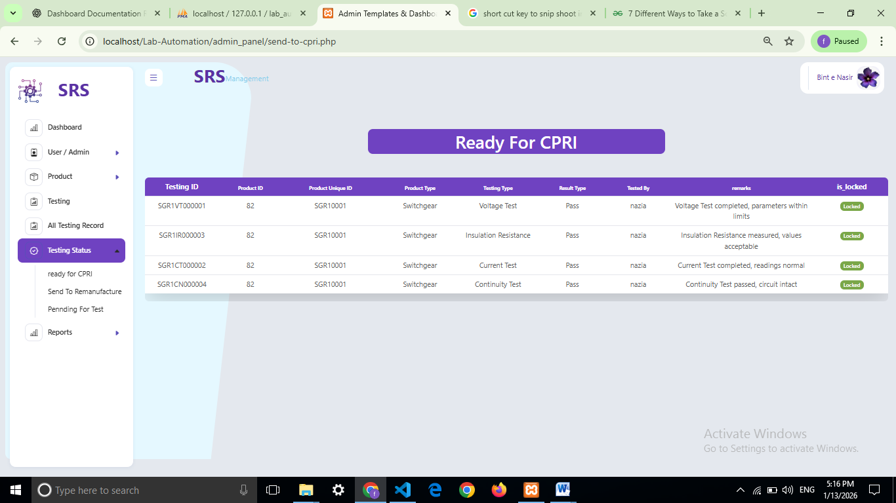
10
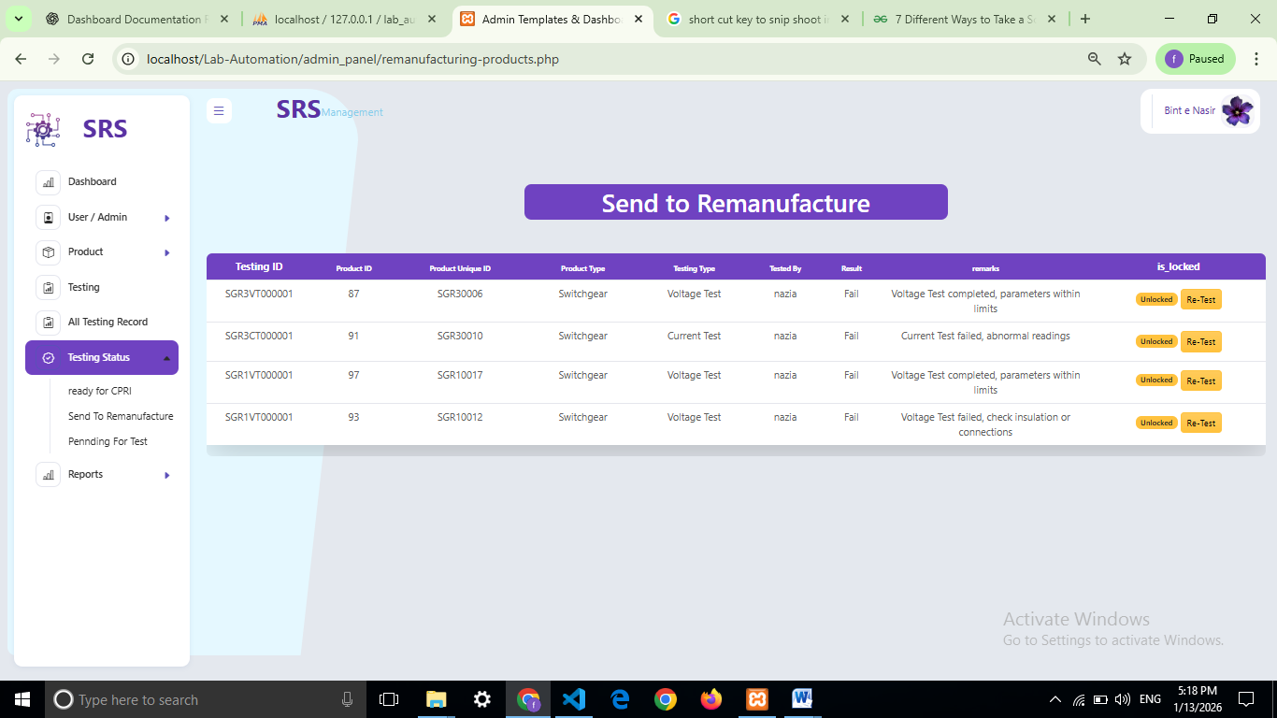
11
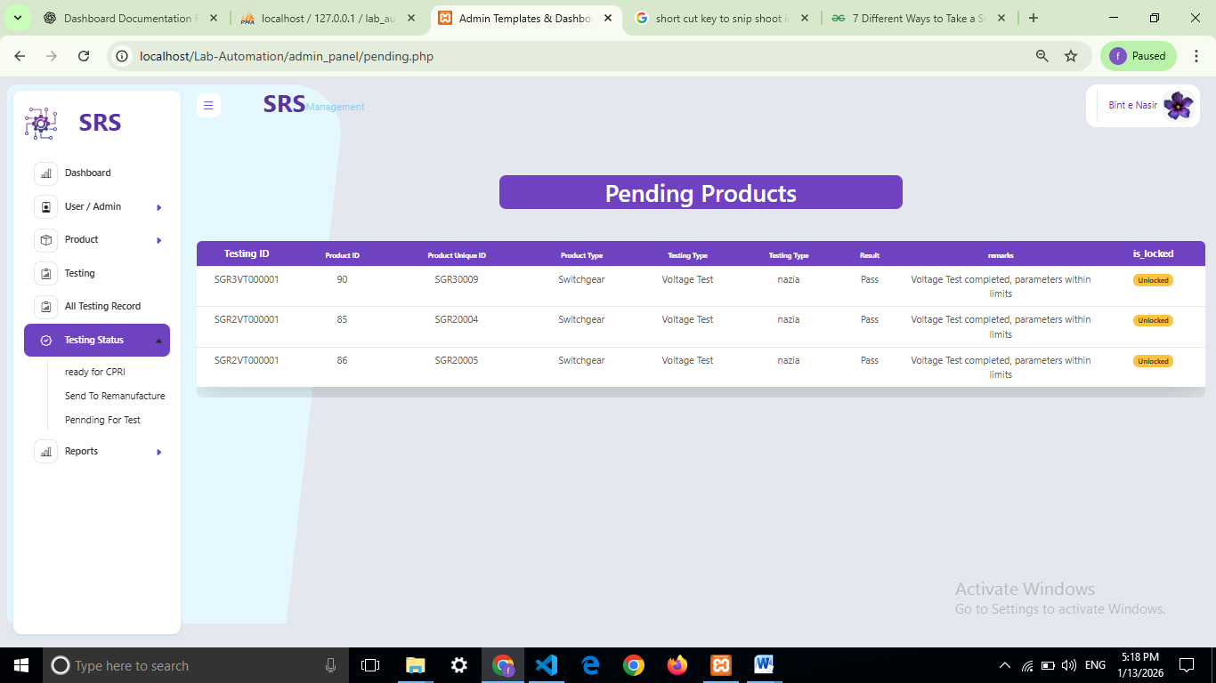
Testing Status Workflow

8. Reports
12

8. 1. Product-Wise Report

Description:
The Product-Wise Report displays testing details of products based on the selected Product ID or Product Type.

Information Displayed:
- Product ID (10-digit)
- Product Code and Revision
- Testing IDs associated with the product
- Testing types performed
- Testing results (Pass / Fail / Pending)
- Current status of the product
Purpose:
This report helps users analyze the complete testing history of a specific product.
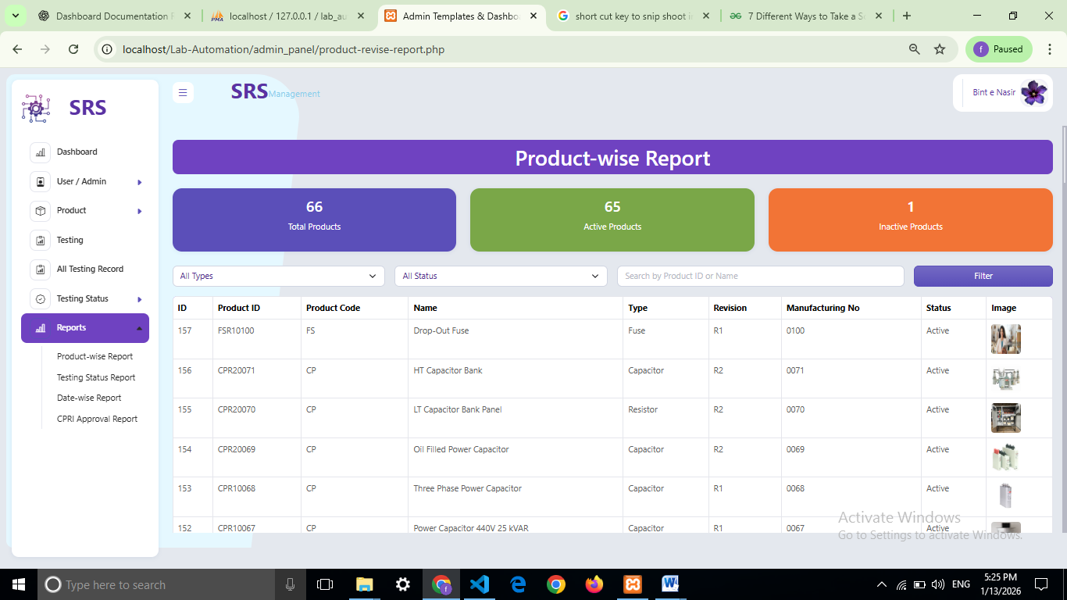
Product-Wise Report

8.2. Testing Status Report
Description:
The Testing Status Report provides a summary of all tests based on their current status.
Information Displayed:
- Testing ID (12-digit)
13
- Product ID
- Testing type
- Result status (Pass / Fail / Pending / Approved)
- Tested by (person name)
Purpose:
This report allows easy monitoring of pending tests, failed tests, and approved tests.
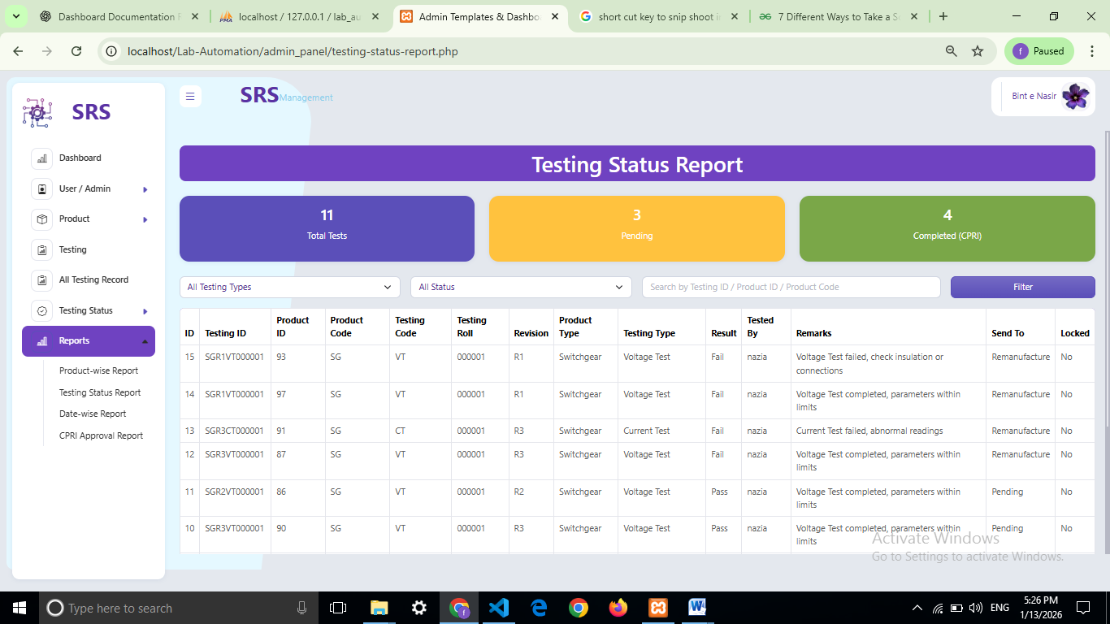Testing Status Report

8.3. Date-Wise Report
Description:
The Date-Wise Report displays product and testing records within a selected date range.
Information Displayed:
- Testing date
- Product ID
- Testing ID
- Testing type
- Result and status
Purpose:
This report helps in analyzing daily, weekly, or monthly testing activity.
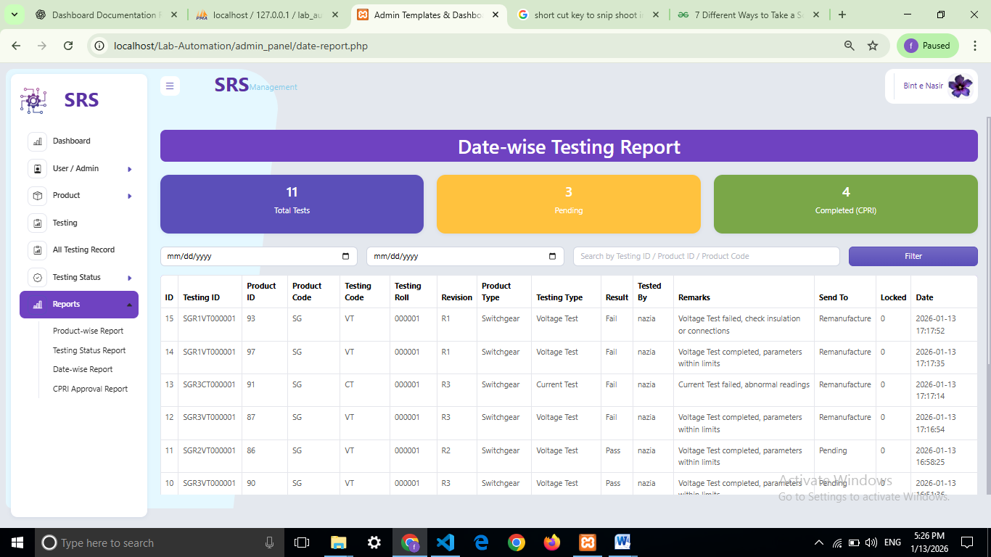Date-Wise Report
14

8.4. CPRI Approval Report
Description:
The CPRI Approval Report shows products that are eligible for or approved by CPRI.
Information Displayed:
- Product ID
- Testing ID
- Internal testing result
- CPRI status (Pending / Approved)
- Approval date (if applicable)
Purpose:
This report is used to identify products ready for market release.
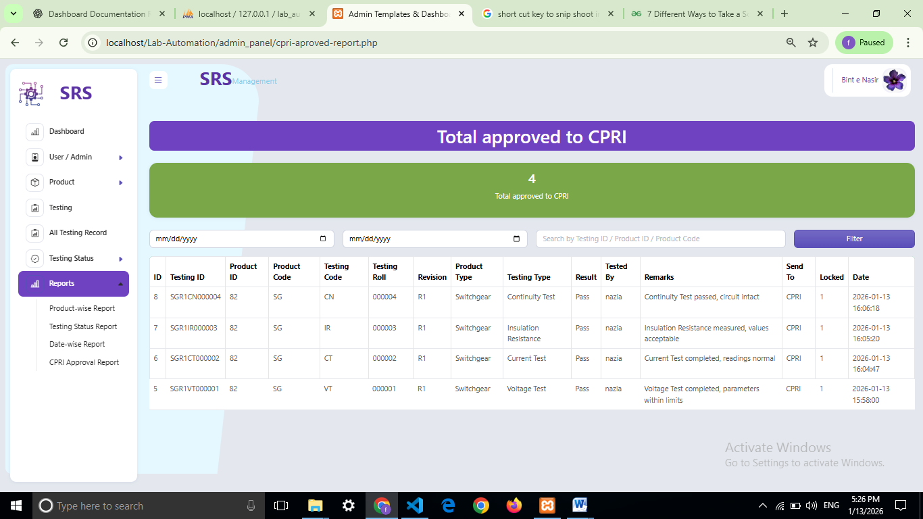
15
CPRI Approval Report

Contact
Admin Panel

8. One Page Website – SRS Manufacture
The system also includes a One Page Website named 'SRS Manufacture' for public information. It contains the following navigation links:
- Home
- About
- Testimonials
- Our Team
- Contact
- Admin Panel
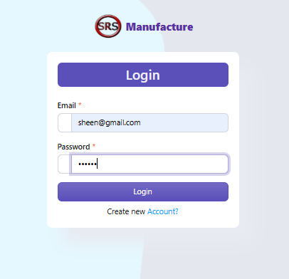
Login to SRS Manufacture
16
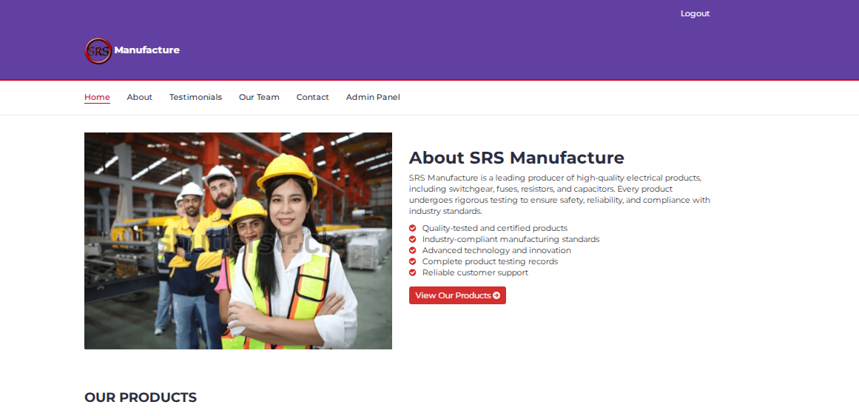
Website About
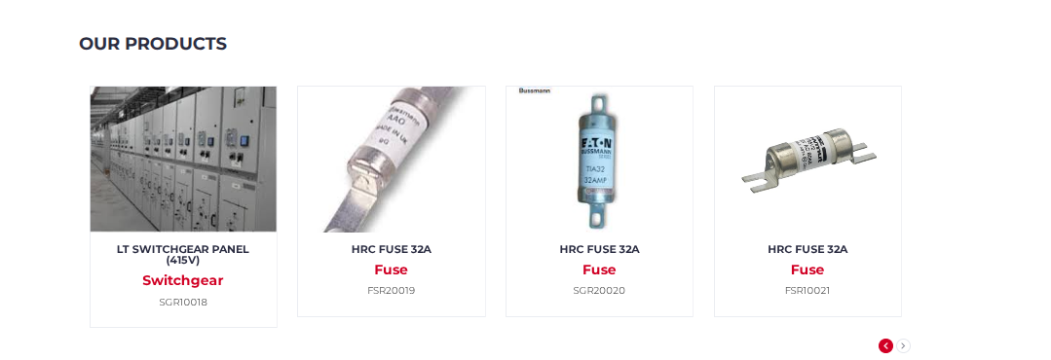– Product Section
17

Testing policy

📸 Screenshot Placeholder – Our Team Section

18
📸 Screenshot Placeholder – Testimonials Section
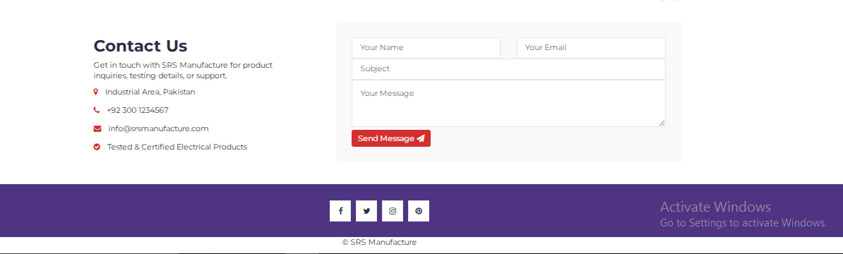
– Contact Section

Admin Panel Link in Navigation

9. Conclusion
The SRS Management Dashboard fully satisfies all functional, non-financial, and financial requirements. The system’s modular architecture, automated ID generation, advanced search capability, and structured testing workflow make it a reliable and scalable solution for manufacturing and testing management.

