**Get the fineness 0.01 pips spread of the all time!**

MBFX offers you variable spread as low as 0.01 pips for majority of pairs, with minimum probability of requotes. We offer you real-time direct feeds by prominent financial institutions.

Forex

Metals

Energies

Indices

Stocks Crypto

**Get access to razor-thin spreads with MBFX and ensure your profit probability**

Live prices are merely indicative. Test the most accurate pricing via live account

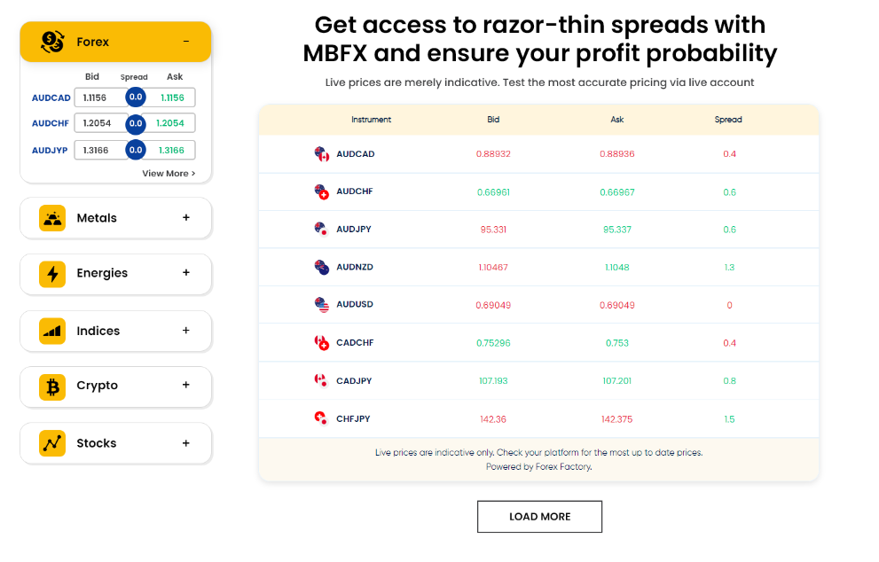

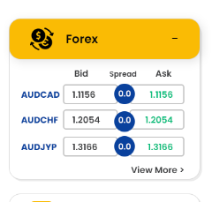

3 value will come though api in accordion and when hit view more. Full table menu will be appear in front. By default mix table will showing in big chart.

**What effect do spreads have on market?**

Spreads can be considered as the bid-ask price spread, which refers to the gap between the bid (from buyers) and the ask (from sellers) prices of a security or asset.However, sometimes it can also be indicated as difference in a trading position – the gap between a short position (that is, selling) in one futures contract or currency and a long position (that is, buying) in another.

**low liquidity or high volatility**

When the difference between the ask and bid prices are higher than usual, it indicates high spreads and create a condition of high volatility. Thus, non-major forex pairs tend to have a higher spread than major pairs.

**High liquidity or low volatility**

When the difference between the ask and bid prices is lower than usual, it could indicate low spread and create a condition of high liquidity. Thus, spreads tend to be lower during the major forex sessions.

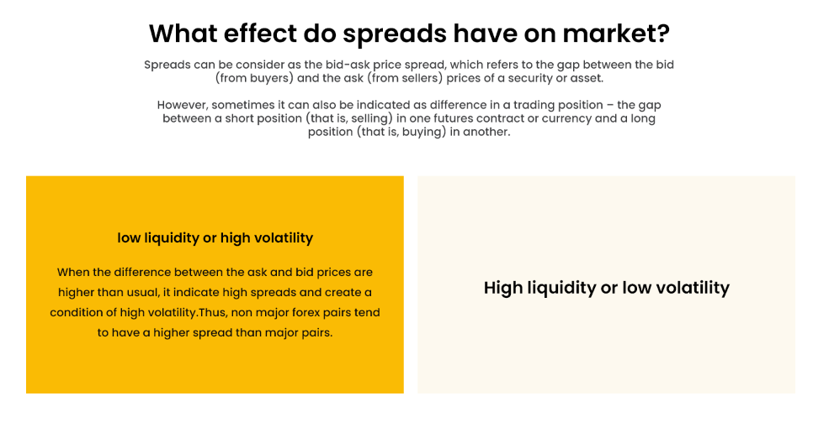

display exactly like mission and vision statement