**Trade with the best!**

300+ instruments, Maximum Leverage, Fastest Execution and much more...

Forex

Metals

Energies

Indices

Stocks Crypto

**Powerful trading with tight spreads and transparent trading conditions**

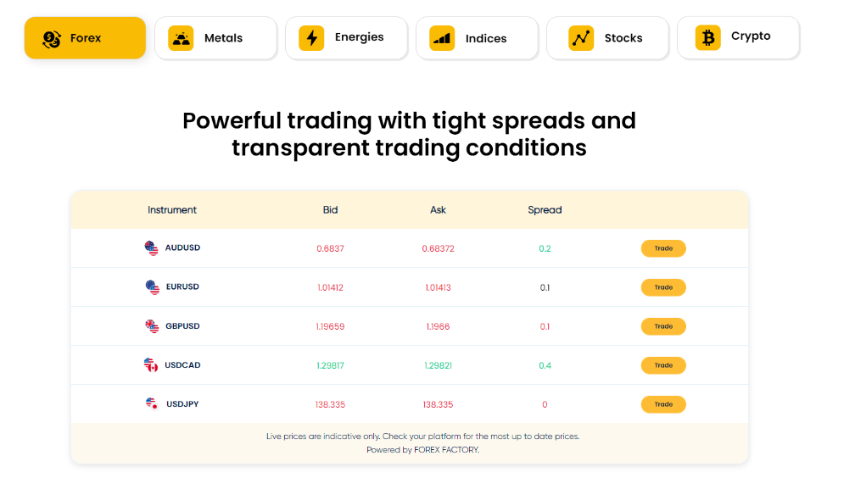

Table chart will be shown though API and chart will be change as per category click

**How does trading work?**

In order to begin trading you need to be developing your educational knowledge of financial markets and then read charts and watch price actions, building strategies based on your observations.Test these strategies with demo trading, while analyzing results and making continuous profits. Then you need to gain complete coincidence and take first leg of your journey with live trading account that helps you to address trade management and market psychology issues.........

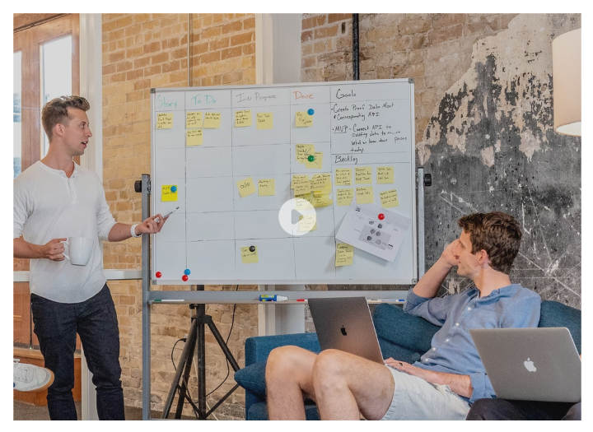

Video will be shown though API.

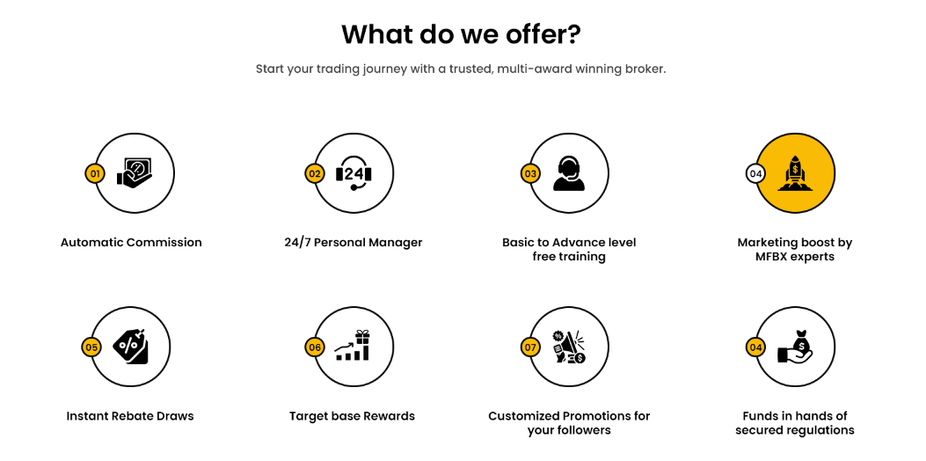

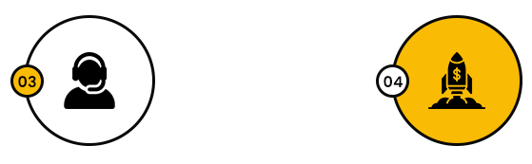

Normal >> Hover ( In hover state Big circle will fill with yellow and small circle became white.

What do we offer? Part will remain same in all 4 trading pages at same position

**What do we offer?**

Start your trading journey with a trusted, multi-award winning broker.

Automatic Commission

24/7 Personal Manager

Basic to Advance level free training

Marketing boost by MFBX experts

Instant Rebate Draws

Target base Rewards

Customized Promotions for your followers

Funds in hands of secured regulations