**Record low spreads, commissions and all optimal working conditions for a trader.**

The MBFX aimed to work with quality services only. We facilitate the need of every skill and non skill worker. You will experience optimal working conditions from light speed trade executions to award winning customer services.

Live Accounts Demo Accounts Premium Member (Coming soon)

**This section will be the same from the home page.**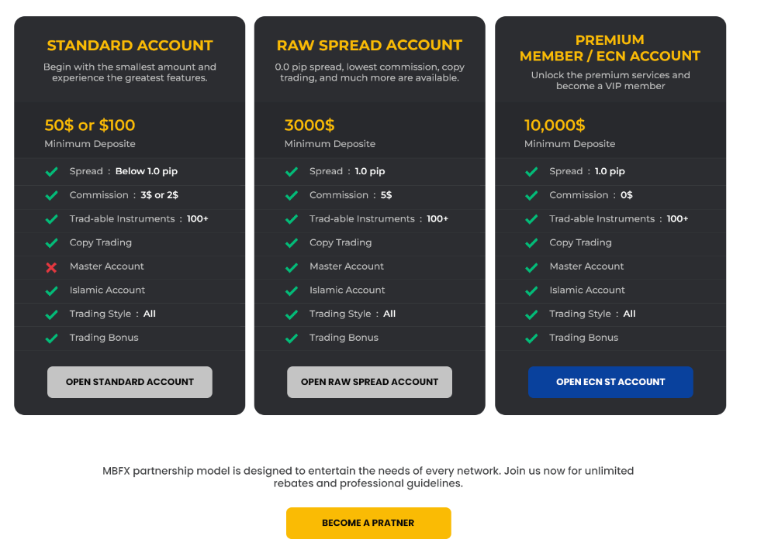

MBFX partnership model is designed to entertain the needs of every network. Join us now for unlimited rebates and professional guidelines.

**Brush up your trading skills with demo account**

Create a demo account with MBFX to explore trading functionality same as like account. Utilize a demo account to get your hands on advance trading features provided by MetaTrader 5 platform.

Get ready to explore the MBFX world

We Are Always Ready To Help You

Open a Demo account

Why choose MBFX over others

Compare and contrast trading condition and choose the best for yourself.

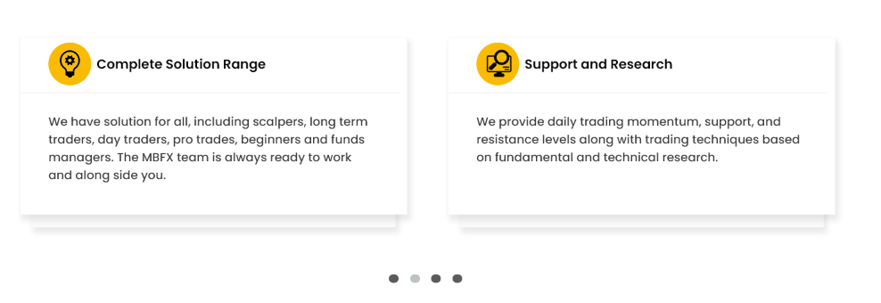

**Complete Solution Range**

We have solution for all, including scalpers, long term traders, day traders, pro trades, beginners and funds managers. The MBFX team is always ready to work and alongside you.

**Secure and Easy**

We maintain your privacy and have taken every step to establish easiest and most secured deposit withdraw methods.

**Friendly Coaching**

We will find the best match for your Copy trading, Signals services, and Expert Advisors without charging you anything extra.

**Support and Research**

We provide daily trading momentum, support, and resistance levels along with trading techniques based on fundamental and technical research.

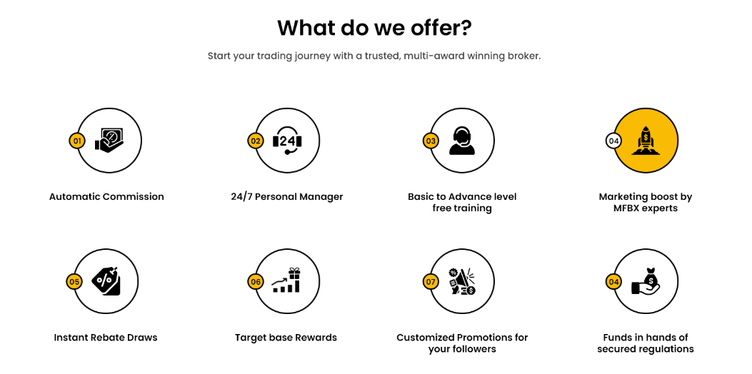



Normal >> Hover ( In hover state Big circle will fill with yellow and small circle became white.

What do we offer? Part will remain same in all 4 trading pages at same position

**What do we offer?**

Start your trading journey with a trusted, multi-award winning broker.

Automatic Commission

24/7 Personal Manager

Basic to Advance level free training

Marketing boost by MFBX experts

Instant Rebate Draws

Target base Rewards

Customized Promotions for your followers

Funds in hands of secured regulations