PIZZA SALES SQL QUERIES

1. KPI
2. Total Revenue

SELECT SUM(total_price) AS Total_Revenue from pizza_sales

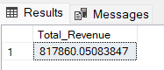

1. Average order value

SELECT SUM(total_price) / COUNT(DISTINCT order_id) AS Average_Order_Value from pizza_sales

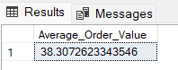

1. Total pizza sold

SELECT SUM(quantity) AS Total_pizza_sold from pizza_sales

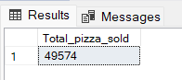

1. Total orders

SELECT COUNT(DISTINCT order_id) AS Total_orders from pizza_sales

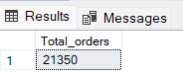

1. Average pizza orders

SELECT CAST(SUM(quantity) AS DECIMAL(10,2)) /

CAST(COUNT(DISTINCT order_id) AS DECIMAL(10,2)) AS Average_Order_quantity from pizza_sales

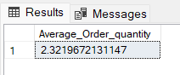

1. Top 5 selling pizza revenue

SELECT TOP 5 pizza_name, SUM(total_price) AS Total_Revenue from pizza_sales

GROUP BY pizza_name   
ORDER BY Total_Revenue DESC

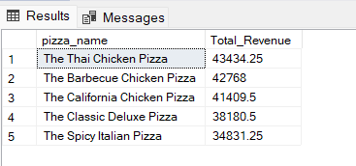

1. Bottom 5 selling pizza by revenue

SELECT TOP 5 pizza_name, SUM(total_price) AS Total_Revenue from pizza_sales

GROUP BY pizza_name

ORDER BY Total_Revenue ASC

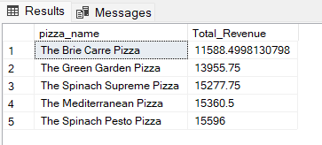

1. Bottom 5 selling pizza by quantity

SELECT TOP 5 pizza_name, SUM(quantity) AS Total_Quantity from pizza_sales

GROUP BY pizza_name

ORDER BY Total_Quantity ASC

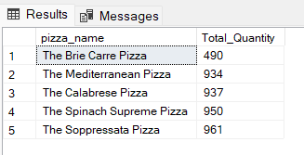

1. Top 5 selling pizza by quantity

SELECT TOP 5 pizza_name, SUM(quantity) AS Total_Quantity from pizza_sales

GROUP BY pizza_name  
ORDER BY Total_Quantity DESC

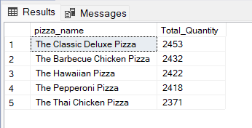

1. Top 5 selling pizza by Total orders

SELECT TOP 5 pizza_name, COUNT(DISTINCT order_id) AS Total_Orders from pizza_sales

GROUP BY pizza_name

ORDER BY Total_Orders DESC

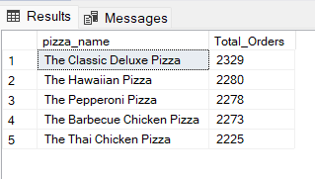

1. Bottom 5 pizza by Total orders

SELECT TOP 5 pizza_name, COUNT(DISTINCT order_id) AS Total_Orders from pizza_sales

GROUP BY pizza_name

ORDER BY Total_Orders ASC

