|  |  |
| --- | --- |
| Vehicle Dynamics and testing: LONGITUDINAL  **SUBMITTED BY: 142900**  **142923**  **142924**  **142925** |  |
| KPIT Technologies Ltd. |  |



Contents

PLANT MODELLING 3

ANALYSIS 4

ENVIRONMENTAL SCENARIOS 6

DISTURBANCES 6

CONTROLLER DESIGN AND VALIDATION 7

BEFORE STEP PID TUNE 7

AFTER STEP PID TUNE 7

PID CONTROLLER AFTER TUNE 9

PARAMETER AFTER TUNE 10

FREQUENCY RESPONSE BEFORE TUNE (BODE) 10

FREQUENCY RESPONSE AFTER TUNE (BODE) 11

SPEED, ACCURACY AND STABILITY (SAS) 11

VERFICATION AND VALIDATION 13

TEST HARNESS USING SIGNAL BUILDER ON THE PLANT MODEL 13

LONGITUDINAL VEHICLE DYNAMICS: REVERSE ASSIST

# PLANT MODELLING

* 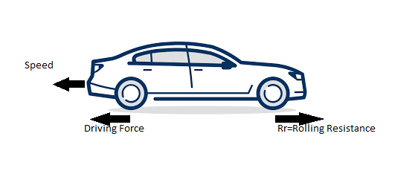The vehicle is moving in the reverse direction after the reverse assist feature has been activated
* Vehicle will be assisted by the driving force from the motor
* The motor used here is the DC motor for an electric vehicle
* Throttle and the braking will be mapped according to the reverse speed for the feature
* However the rolling resistance(Rr) will provide some opposite forces to the driving force
* Mass of the vehicle will change according to the segment
* The torque disturbance will vary depending on the vehicle with different powertrains

However, for each segment, equation and the transfer function will be same. Following are the considered parameters and disturbances in the model:

* Mass of the vehicle (m)
* Rolling resistance coefficient (Rr)
* Torque Disturbance (Td)
* Equation: Fd – Fr = ma

where, Fd: Driving Force

Fr: Rolling resistance force

a: Acceleration of the vehicle

SIMULINK MODEL

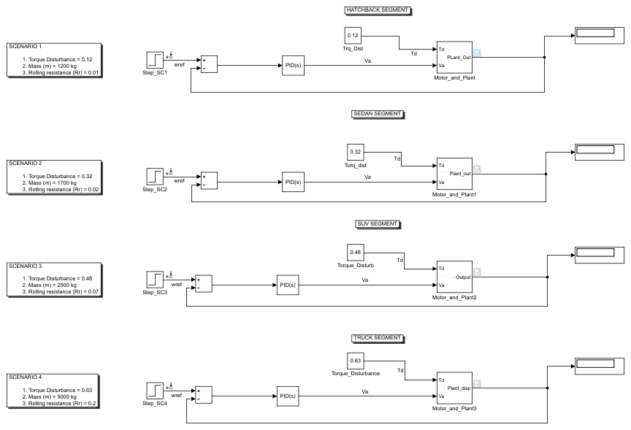

PLANT MODEL

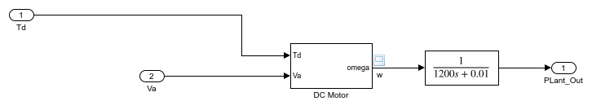

# ANALYSIS

Vehicle moving in reverse direction will have a limit of up to 20 km/h. The air drag will not be affected as the speed is very low. However, the rolling resistance will be in effect for all time.

**FOR A VEHICLE IN HATCHBACK SEGMENT**

* Mass(m) = 1200 kg
* Rolling resistance Coefficient(Rr) = 0.01
* Torque Disturbance(Td) = 0.12

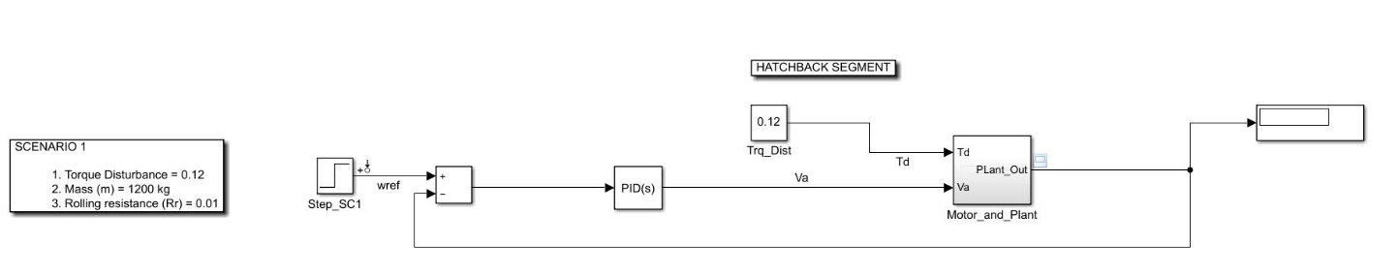

**FOR A VEHICLE IN SEDAN SEGMENT**

* Mass(m) = 1700 kg
* Rolling resistance Coefficient(Rr) = 0.02
* Torque Disturbance(Td) = 0.32

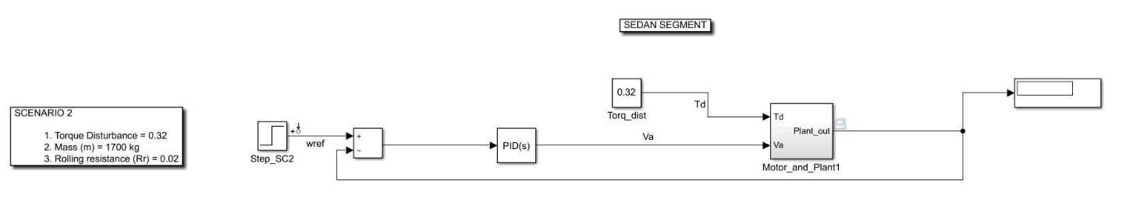

**FOR A VEHICLE IN SUV SEGMENT**

* Mass(m) = 2500 kg
* Rolling resistance Coefficient(Rr) = 0.07
* Torque Disturbance(Td) = 0.48

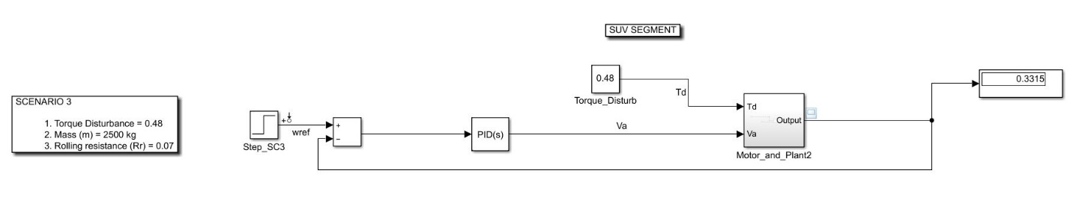

**FOR A VEHICLE IN TRUCK SEGMENT**

* Mass(m) = 1700 kg
* Rolling resistance Coefficient(Rr) = 0.2
* Torque Disturbance(Td) = 0.63

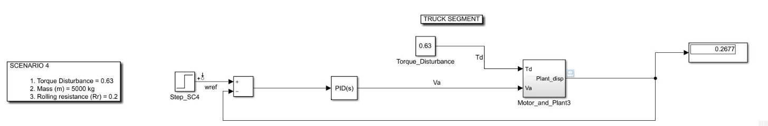

# ENVIRONMENTAL SCENARIOS

* The rolling resistance can change due to the size of the wheels of the vehicles
* Lighter the vehicles, lower will be the rolling resistance
* For hatchback weighing around 1200-1300 kg, the rolling resistance will be considered as 0.01 as their wheel radius is slightly smaller
* For sedan weighing around 1700-1800 kg, the rolling resistance will be considered as 0.02 as their wheel radius is slightly larger than hatchback
* For SUV weighing around 2500-2700 kg, the rolling resistance will be considered as 0.07 as their wheel radius is large
* For truck weighing around 5000-5500 kg, the rolling resistance will be considered as 0.2 as their wheel radius is very large

# DISTURBANCES

TORQUE DISTURBANCE (Td)

* When the torque varies due to the throttle input by system of powertrain
* The torque change can vary depending on the heating of the system
* Output from the load can vary depending on the disturbances factor
* The rolling resistance changes with the weight of the vehicle

# CONTROLLER DESIGN AND VALIDATION

## BEFORE STEP PID TUNE

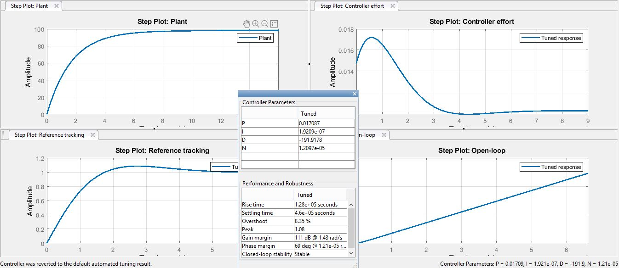

## AFTER STEP PID TUNE

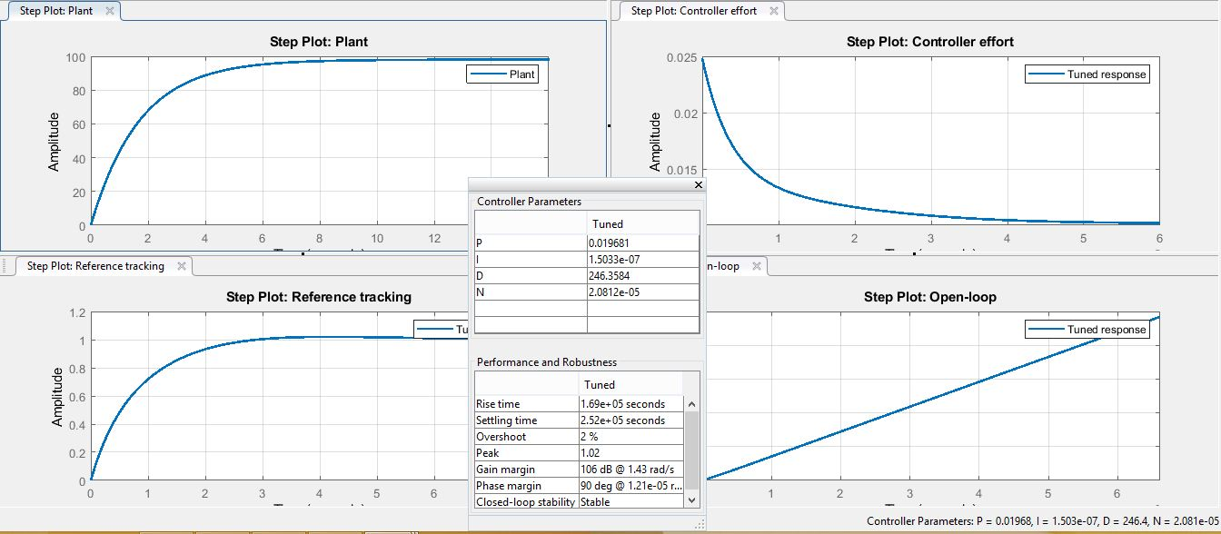

PARAMETER BEFORE TUNE

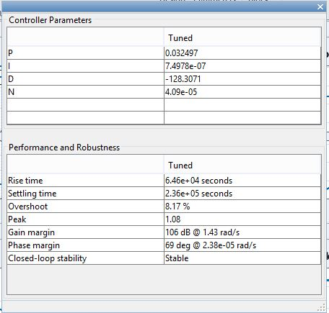

## PID CONTROLLER AFTER TUNE

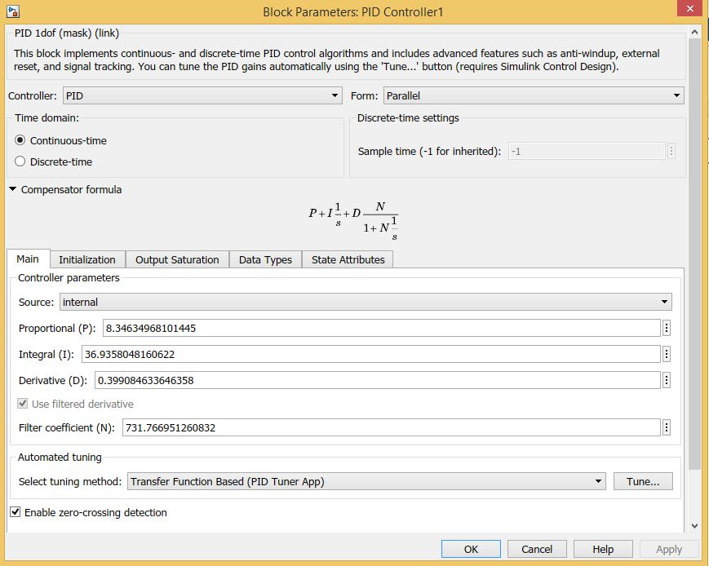

## PARAMETER AFTER TUNE

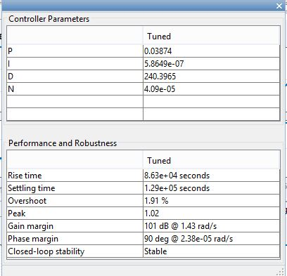

## FREQUENCY RESPONSE BEFORE TUNE (BODE)

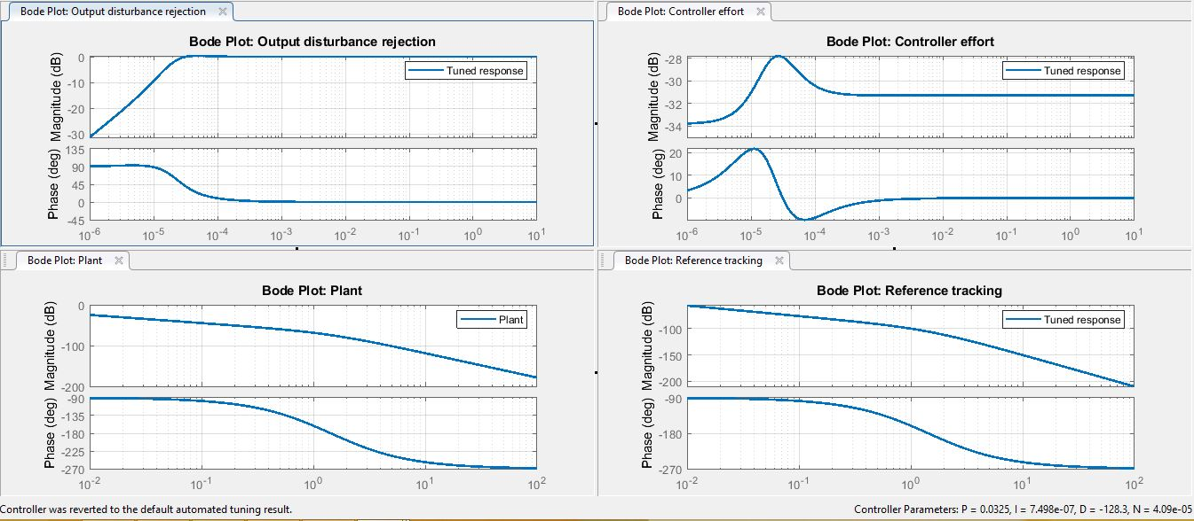

## FREQUENCY RESPONSE AFTER TUNE (BODE)

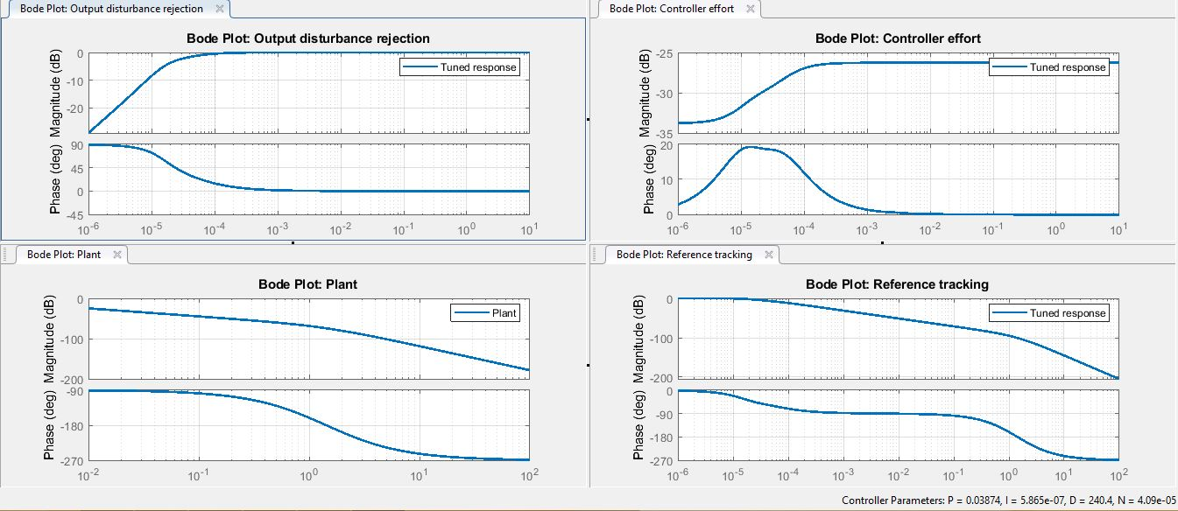

## SPEED, ACCURACY AND STABILITY (SAS)

**Before tune**

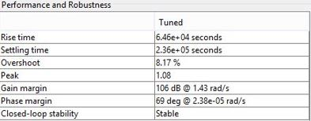

**SPEED:**

* The rise time before tune is provided as 0.646ms which is very fast.

**ACCURACY:**

* The overshoot is 8.17% which is more than 4%.
* This is showing that the accuracy is not very on point.

**STABILITY:**

* The controller is stable for the closed loop stability.
* However to adjust the stability with a balance of speed and accuracy, the phase margin has to be adjusted to lower the overshoot

**After tune**

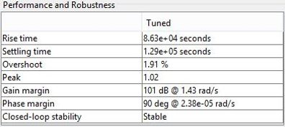

**SPEED:**

* The rise time before tune was provided as 0.646ms.
* However the tuned rise time is optimized at 0.863ms.
* This shows a decrease in the rise time.
* The settling time has decreased by almost 50%.

**ACCURACY:**

* The overshoot is 1.91% which is less than 4%.
* This is showing that the accuracy is optimized for a better speed and accuracy balance.

**STABILITY:**

* The controller is stable for the closed loop stability.
* However to adjust the stability with a balance of speed and accuracy, the phase margin has to be adjusted to lower the overshoot.

# VERFICATION AND VALIDATION

## TEST HARNESS USING SIGNAL BUILDER ON THE PLANT MODEL

**USING TEST SIGNALS**

1. Altering the Torque Disturbance (Td) in step format for a much higher value

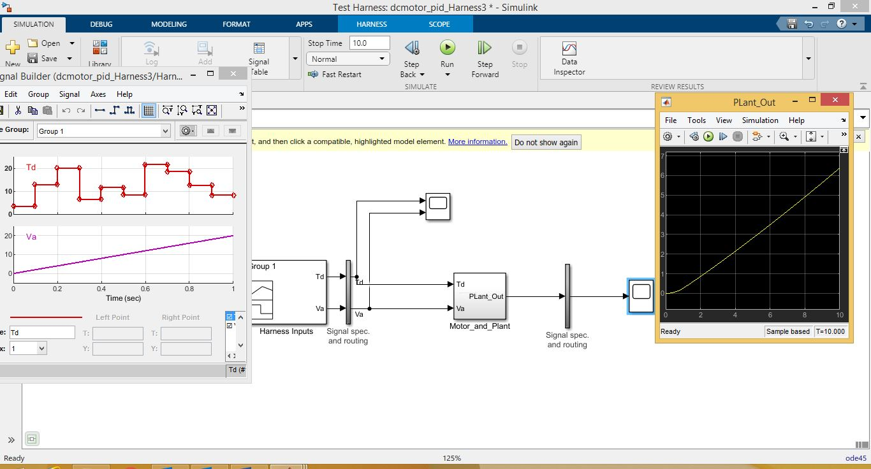

* Td is varying in a step format for a higher input from the signal builder
* This disturbance value is used to compare for the second run of the plant model
* The original value of Td is very small for the comparing of the signals
* The curve here using the test harness shows that the curve occurs at a much earlier stage

1. Altering again the Torque disturbance (Td) value to make a step signal which is increasing for the first half and again decreasing for the second half

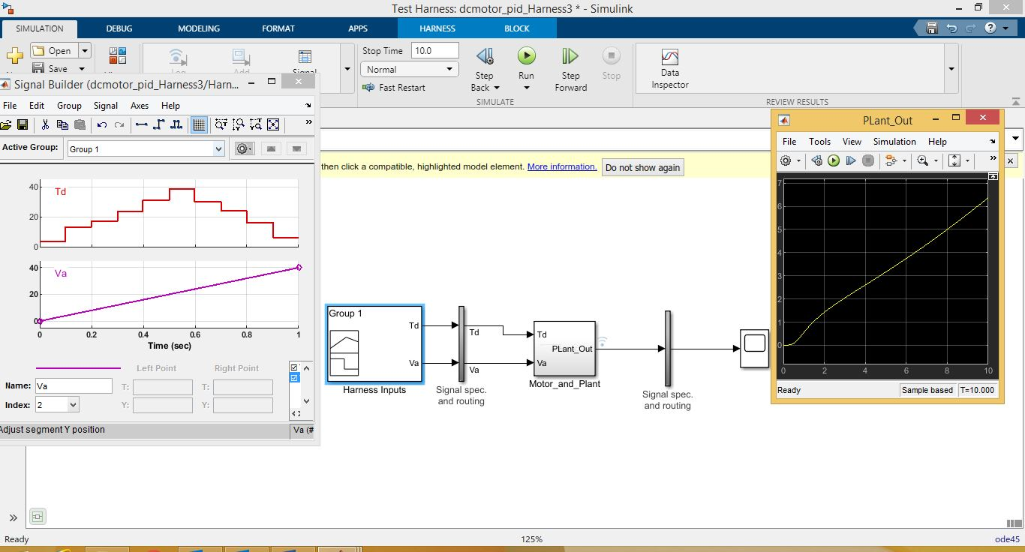

**COMPARING THE TEST HARNESS RUNS**

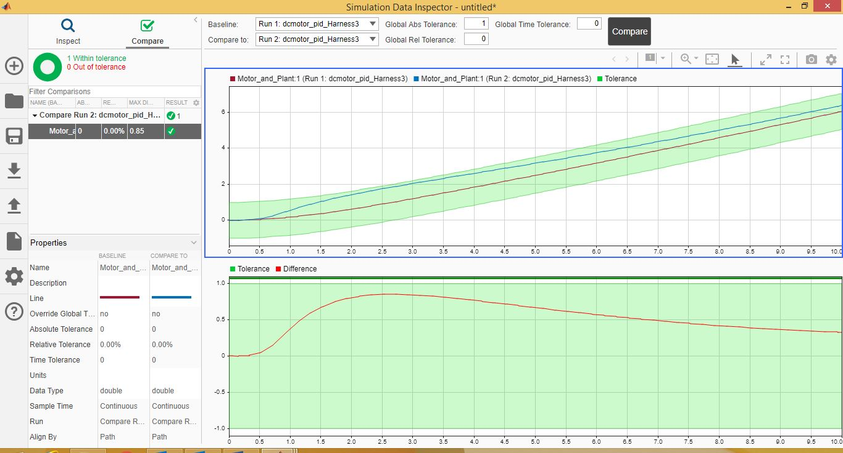

* The Plant model is within the tolerance level set for the both runs