|  |  |
| --- | --- |
| SAFETY AND BODY CONTROL MODULE  MILESTONE IV  SUBMITTED BY: DAYA MODEKAR (EMP ID: 142900)  POOJA KHANE (EMP ID: 142923)  PRATIK MALODE (EMP ID: 142924)  PRACHURJYA SHARMA (EMP ID: 142925) |  |
|  |  |



KPIT Technologies Ltd.

CONTENTS

1 ABSTRACT 4

2 INTRODUCTION 4

2.1 SEAT BELT ALERT SYSTEM 4

2.2 PASSIVE KEYLESS ENTRY 5

3 REQUIREMENTS 8

3.1 ADVANCED AIRBAG SYSTEM 8

HIGH LEVEL AND LOW LEVEL REQUIREMENTS (DOORS) 8

MARKET ANALYSIS 9

4W&1H 11

S.W.O.T. ANALYSIS 12

3.2 SEAT BELT ALERT SYSTEM 12

HIGH LEVEL AND LOW LEVEL REQUIREMENTS (DOORS) 12

SWOT ANALYSIS 13

4W1H 14

3.3 PASSIVE KEYLESS ENTRY 15

HIGH LEVEL AND LOW LEVEL REQUIREMENTS (DOORS) 15

MARKET ANALYSIS 15

S.W.O.T. ANALYSIS 16

4W&1H 16

4 LITERATURE REVIEW 17

4.1 AIRBAG SYSTEM 17

4.2 SEAT BELT ALERT SYSTEM 18

4.3 PASSIVE KEYLESS ENTRY 18

5 UML DIAGRAM 20

5.1 STRUCTURAL DIAGRAM 20

PIN DIAGRAM 20

BLOCK DIAGRAM 21

5.2 BEHAVIOURAL DIAGRAM 25

STATEFLOW DIAGRAM 25

FLOWCHART 26

6 BILL OF MATERIALS 29

7 EXECUTION PLAN 30

8 TEAM DESCRIPTION 30

9 INTEGRATED MODELLING AND TESTING 30

10 INTEGRATED TEST PLAN 32

11 INTEGRATED COMPLIANCE 33

11.1 MAAB CHECK 33

11.2 CODE COVERAGE 35

11.3 METRIC ANALYSIS 37

12 LEARNINGS AND DIFFICULTIES OVERCOMED 37

13 APPENDIX 37

**LIST OF FIGURES**

Figure 1: Arduino PIN Diagram 11

Figure 2: Passive Entry Block Diagram 12

Figure 3: Passive Entry State flow Diagram 13

Figure 4: Passive Entry Flowchart 14

LIST OF TABLES

Table 1: Segment Analysis 8

Table 2: Ageing Analysis 8

Table 3: SWOT Analysis 9

Table 4: 4W&1H 9

Table 5: Arduino Pin Definitions 11

Table 6: Bill of Materials 14

Table 7: Execution Plan 15

Table 8: Unit Testing 16

SAFETY AND BCM INTEGRAted system

# ABSTRACT

# INTRODUCTION

## ADVANCED AIRBAG SYSTEM

An airbag is an automotive safety restraint system for an occupant as well as passengers. The system consists of a flexible fabric envelope or cushion, designed to inflate rapidly during an automobile collision. Its purpose is to cushion occupants during a crash and provide protection to their bodies when they strike interior objects such as the steering wheel or a window etc. thus it lowers the number of injuries by reducing the force exerted by steering wheel, windows and the dashboard at any point on the body. continuing research and developments are going on in its module design, combustible material, air bag fabric design and material, coating etc. in making this life saving safety device further efficient. However, success of any safety restraint device depends on its correct implementation and certain safety rules to be followed.

The air bag system consists of three basic parts- an air bag module, crash sensor and a diagnosis unit. Some systems have on/off switch to deactivate air bag system. The air bag module contains both an inflator unit and the lightweight fabric air bag. The driver air bag module is located in the steering wheel hub, and the passenger air bag module is located in the instrument panel. When fully inflated, the driver air bag is approximately the diameter of a large beach ball. The passenger air bag can be two or three times larger since the distance between the right-front passenger and the instrumental panel is much larger than the distance between the driver and steering wheel. The crash sensors are located either in the front of the vehicle and/or in the passenger compartment. Vehicle can have one or more crash sensors. The sensors are activated by forces generated in significant frontal or near-frontal crashes only and not during sudden braking or while driving on rough or uneven pavement. The diagnostic unit monitors the readiness of the air bag system. the unit is activated when the vehicles ignition is turned on. if the unit identifies a problem, a warning light alerts the driver to service the air bag system before use. most diagnostic units contain a device, which stores enough electrical energy to deploy the air bag if the vehicle battery is destroyed very early in a crash sequence. vehicles like pickup trucks do not have rear seats; have manually operated on/off switches for the passenger air bags.

## SEAT BELT ALERT SYSTEM

Most of the accidents are occurred because of violation of rules. Result of this major accidents happened. In our day-to-day life we are careless in our safety while driving in vehicles for this we have to introduce some techniques to do these precautions compulsory.

There are several causes of road accidents and one among the major reasons is people forget to wear seat belt. Initially if we want to solve this problem, we have to realize that to drive is not a play. We manage a machine which is very dangerous, that it could kill anybody and there are laws which we need to carry out so in order to make aware of seat belts, mandatory system has been introduced. This system basically aims at bringing the rule into act such that seat belt must be worn by every individual who drives the car.

Carelessness which has always been a part of driving system in our system and surrounding, such that people tend to defy wearing helmets in two wheelers and so in the case of car they tend not to wear seat belt. Seat belts have been designed on the basis to serve as a purpose of safety to safeguard people from accidents such as at the time of collision or during sudden braking thus wearing will always avoid people from getting injured at an adverse rate compared to not wearing them thus this topic will be a lifesaving and effective too.

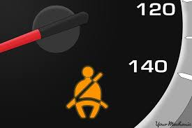

## PASSIVE KEYLESS ENTRY

Security! A key component every customer and industry focuses on. The automobile industry deals with a lot of unauthorized access and hassle when it comes to security of an automobile. The ease of how an automobile security is dealt in this age of technology is a vast pool of technology and devices for just unlocking and doing other basic actions for ease of use.

Late 1900 has seen the use of electronics and highly new iterations of automobile show that the shift from analog and the self-control of electronics to a more sensor based and wireless ways of controlling the security and automobile lock feature. The system has its own perks and loopholes. Security is a major concern for customers and the industry has been working for more better and sophisticated systems.

The next generation saw the use of proximity sensors for the security feature of a vehicle using a button on the door called the request sensor system. This mandated the key fob be on the user whenever locking or unlocking the vehicle. The key would have to be in the vicinity for the request buttons to work for the feature it is assigned to.

The new system uses a more advanced sensor system to detect movement of the hand placement of the user on the door handle. This helps in unlocking the vehicle without any button press on the key fob or the request button system. This has a sophisticated system for security and also the ease of access to the vehicle. Also around this technology, the use of wrist band having the sensor system to lock and unlock the vehicle have been used by manufactures to attract customer showcasing the ease of access. The boot release system using the foot waving underneath the trunk also has been used by many manufacturers.

EARLY SYSTEMS

Early implementation used a remote function having the lock, unlock buttons. This technology was featured in early automobiles as a luxury feature for ease of access to the vehicle. Only high end vehicles of automobile industry at those times provided this wireless remote entry system. The system had a transmitter circuit, which was inside the vehicle, and a receiver end in the key fob. A button press would allow the radio signal from the transmitter to do the locking or unlocking feature.

The two most common remote keyless-entry devices are:

The fob that goes on user key ring to [lock and unlock](https://auto.howstuffworks.com/power-door-lock.htm) user car doors (Many of these fobs also arm and disarm a [car alarm system](https://auto.howstuffworks.com/car-alarm.htm)). The small controller that hangs off user [car's](https://auto.howstuffworks.com/car.htm) sun visor to open and close the garage door. Some [home security systems](https://auto.howstuffworks.com/burglar-alarm.htm) also have [remote controls](https://electronics.howstuffworks.com/remote-control.htm), but these are not so common. The fob that user carry on user keychain or use to open the garage door is actually a small radio transmitter. When user push a button on the fob, user turn on the transmitter and it sends a code to the receiver (either in the car or in the garage). Inside the car or garage is a radio receiver tuned to the frequency that the transmitter is using (300 or 400 MHz is typical for modern systems). The transmitter is similar to the one in a [radio-controlled toy](https://science.howstuffworks.com/rc-toy.htm).

In the very early days of garage door openers, around the 1950s, the transmitters were extremely simple. They sent out a single signal, and the garage door opener responded by opening or closing. As garage door openers became common, the simplicity of this system created a big problem -- anyone could drive down the street with a transmitter and open any garage door! They all used the same frequency and there was no security.

By the 1970s, garage door openers had gotten slightly more sophisticated and had a controller chip and a DIP switch. A DIP switch has eight tiny switches arranged in a small package and [soldered](https://science.howstuffworks.com/cold-heat.htm) to the circuit board. By setting the DIP switches inside the transmitter, user controlled the code that the transmitter sent. The garage door would only open if the receiver's DIP switch were set to the same pattern. This provided some level of security, but not much. Eight DIP switches provide only 256 possible combinations. The transmitters in these circa-1970 garage door openers were also very simple where the transmitter consisted of two transistors and a couple of resistors, and not much else. A two-transistor transmitter like this, powered by a 9-volt [battery](https://auto.howstuffworks.com/battery.htm), is as simple as a radio transmitter gets. It's the same transmitter that user find in a pair of low-power walkie-talkies. Remote-entry transmitters have gotten a lot more sophisticated since then.

PRESENT SYSTEM

With the remote keyless-entry systems that user finds on [cars](https://auto.howstuffworks.com/car.htm) today, [security](https://auto.howstuffworks.com/car-alarm.htm) is a big issue. If people could easily open other people's cars in a crowded parking lot at the mall, it would be a real problem. And with the proliferation of [radio scanners](https://electronics.howstuffworks.com/radio-scanner.htm), user also need to prevent people from "capturing" the code that user transmitter sends. Once they have user code, they can simply re-transmit it to open user car.

The controller chip in any modern controller uses something called a hopping code or a rolling code to provide security. Some systems uses a [40-bit](https://computer.howstuffworks.com/bytes.htm) rolling code. Forty bits provide 240 (about 1 trillion) possible codes.

Working:

* The transmitter's controller chip has a [memory](https://computer.howstuffworks.com/computer-memory.htm) location that holds the current 40-bit code. When user push a button on user key fob, it sends that 40-bit code along with a function code that tells the car what user want to do (lock the doors, unlock the doors, open the trunk, etc.).
* The receiver's controller chip also has a memory location that holds the current 40-bit code. If the receiver gets the 40-bit code it expects, then it performs the requested function. If not, it does nothing.
* Both the transmitter and the receiver use the same [pseudo-random number generator](https://computer.howstuffworks.com/question697.htm). When the transmitter sends a 40-bit code, it uses the pseudo-random number generator to pick a new code, which it stores in memory. On the other end, when the receiver receives a valid code, it uses the same pseudo-random number generator to pick a new one. In this way, the transmitter and the receiver are synchronized. The receiver only opens the door if it receives the code it expects.
* If user are a mile away from user car and accidentally push the button on the transmitter, the transmitter and receiver are no longer synchronized. The receiver solves this problem by accepting any of the next 256 possible valid codes in the pseudo-random number sequence. This way, user (or user three-year-old child) could "accidentally" push a button on the transmitter up to 256 times and it would be okay -- the receiver would still accept the transmission and perform the requested function. However, if user accidentally push the button 257 times, the receiver will totally ignore user transmitter. It won't work anymore.
* So, what do user do if user three-year-old child DOES desynchronize user transmitter by pushing the button on it 300 times, so that the receiver no longer recognizes it? Most cars give user a way to resynchronize. Here is a typical procedure:
* Turn the [ignition](https://auto.howstuffworks.com/ignition-system.htm) key on and off eight times in less than 10 seconds. This tells the security system in the car to switch over to programming mode.
* Press a button on all of the transmitter user wants the car to recognize. Most cars allow at least four transmitters.
* Switch the ignition off.
* Given a 40-bit code, four transmitters and up to 256 levels of look-ahead in the pseudo-random number generator to avoid de-synchronization, there is a one-in-a-billion chance of user transmitter opening another car's doors. When user take into account the fact that all car manufacturers use different systems and that the newest systems use many more bits, user can see that it is nearly impossible for any given key fob to open any other car door.
* User can also see that code capturing will not work with a rolling code transmitter like this. Older garage door transmitters sent the same 8-bit code based on the pattern set on the DIP switches. Someone could capture the code with a radio scanner and easily re-transmit it to open the door. With a rolling code, capturing the transmission is useless. There is no way to predict which [random number](https://computer.howstuffworks.com/question697.htm) the transmitter and receiver have chosen to use as the next code, so re-transmitting the captured code has no effect. With trillions of possibilities, there is also no way to scan through all the codes because it would take years to do that.

# REQUIREMENTS

## ADVANCED AIRBAG SYSTEM

### HIGH LEVEL AND LOW LEVEL REQUIREMENTS (DOORS)

|  |  |  |  |
| --- | --- | --- | --- |
| S.no | Stakeholder Requirements | System Requirements | Software Requirements |
| 1 | Alarm after 5sec when Seatbelt system integrated at seat back rest is not applied after ignition. | Buzzer,Atmega 328p,LED,weight sensor. | Arduino API,Matlab(simulink) |
| 2 | When front airbag is triggered during the manual driving mode,the steering is retracted automatically near dash board. | Servo motor,crash detection sensor,accelerometer,airbag(led) | Arduino API,Matlab(simulink) |
| 3 | Laterally positioned wing shaped airbags to also be triggered depending on impact level. | crash detection sensor,accelerometer,airbag(led) | Arduino API,Matlab(simulink) |
| 4 | Facilitate seat belt tensioning during any crash. | crash detection sensor,accelerometer,seatbelt tensioner(led) | Arduino API,Matlab(simulink) |

### MARKET ANALYSIS

The automotive airbags & seatbelts market is estimated to be USD 55.77 billion in 2017 and is projected to reach 135.43 billion by 2025, at a CAGR of 11.97% during the forecast period. Increasing demand for safe, more efficient driving experiences, and growing stringency of safety regulations across the globe are playing a key role for driving airbags & seatbelts market. The base year considered for the study is 2017, and the forecast has been provided for the period between 2018 and 2025. The report analyses and forecasts the market size, in terms of volume (000’/million units) and value (USD million/ billion), of the automotive airbags & seatbelts market.

The automotive industry is witnessing a rapid evolution in safety features. The main objective behind the implementation of these features in vehicles is to provide a safer and more efficient and convenient driving experience. The increase in road accidents is a major concern for automobile manufacturers and governments. According to NHTSA, the total number of fatalities due to road accidents in the US in 2016 was 37,461, which grew by 5.6% from 2015. These statistics plainly illustrate the often-underestimated dangers inherent in driving a car. While these numbers are staggeringly high, they are fortunately in decline. Much of this decline in the frequency of vehicular crashes can be attributed to the widespread adoption of automotive safety systems, such as seatbelts and airbags.

Passenger car segment is estimated to be the fastest growing segment of the automotive airbags & seatbelts market, by vehicle. The number of passenger cars is growing at a significant rate in the emerging economies of the Asia pacific region. This can be attributed to the rise in GDP and the population of these countries, resulting in improved lifestyle, increased purchasing power of consumers, and development of infrastructure. Airbags and seatbelts are provided as a standard feature in passenger cars in most of the countries for preventing fatalities due to accidents.

**“side & curtain airbags: the fastest growing segment of the automotive airbags & seatbelts market, by airbags type “**

Side & curtain airbags are the fastest growing segment of the automotive airbags & seatbelts market, by airbags type. Side airbags are designed to help protect an adult's chest in a serious side-impact crash. These are mounted on the side of the seat or on the door, usually on the roof rail above the side windows. In the event of a side-impact crash, curtain airbags are used to protect an adult's head. According to insurance institute for highway safety, head-protecting side airbags reduce driver fatality risk by 45%. This effectiveness will help to grow the side & curtain airbags market in near future.

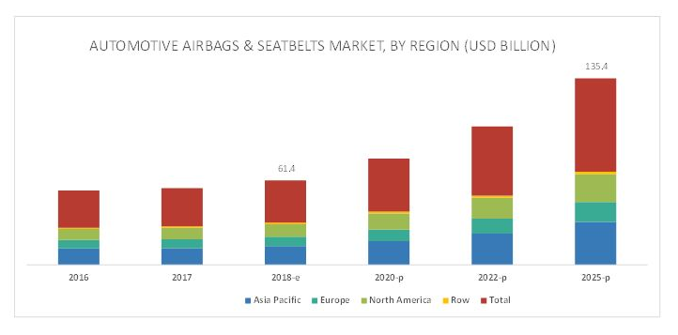

the Asia pacific region is estimated to dominate the automotive airbags & seatbelts market, in terms of value, in 2018.the rising consumer income levels, increased vehicle production in developing countries such as India and china, and increase in the number of luxury vehicles in countries such as japan fuel the growth of the automotive airbags & seatbelts market in the Asia pacific region.

The Asia pacific region is estimated to hold the largest share, by value, of the automotive airbags & seatbelts market in 2018. The demand for automotive airbags & seatbelts in this region is triggered by increasing vehicle production in developing nations such as china and India and the increasing number of luxury vehicles in countries such as china and japan. This region is also the leading producer of automobiles in the world.

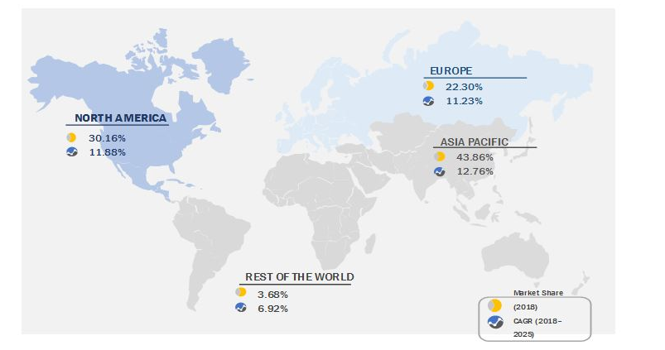

### 

### 4W&1H

|  |  |  |
| --- | --- | --- |
| S.no | Question | Description |
| 1 | What | Advanced Airbag System |
| 2 | Where | The system is situated in front of driver and as well other passengers |
| 3 | Why | To provide Safety to driver and other passenger in crash situations. |
| 4 | When | External accidents leading to severe crash. |
| 5 | How | Using various sensors to detect various occupants in vehicle along with crash detection sensors to make an decision on impact level and accordingly trigger the airbags and retract the steering. |

### S.W.O.T. ANALYSIS

## SEAT BELT ALERT SYSTEM

### HIGH LEVEL AND LOW LEVEL REQUIREMENTS (DOORS)

|  |  |  |  |
| --- | --- | --- | --- |
| Stakeholder’s  Requirements | Description | Hardware Requirements | Software Requirements |
| Seatbelt warning and ignition control | System will turn off the ignition whenever the seat belts are not buckled and alert message will be displayed. | 1. ATMEGA 328p  2. Seat belt sensor (Reed sensor)  3. LCD display | 1.Embeeded C  2.Code blocks  3.SimilIDE |

Growing awareness regarding the importance of implementing passive safety systems, such as airbags and seatbelts, among consumers is also likely to augment market expansion. Governments, especially in emerging nations including India, and China, are increasingly making amendments and introducing new regulations to ensure enhanced road safety in 2017, the Union Road Transport Ministry of India announced that cars manufactured from 1st July 2019 onwards must install essential safety features to curb the issues pertaining to over speeding and its consequences. These safety features include front airbags, seat belt reminders, and speed alert, and parking systems. On the other hand, factors such as production of counterfeit goods may hinder market growth as these pose a great threat to the sales, revenue, and brand image of key companies. According to the U.S. Federal Trade Commission, the global automotive parts industry claims to have lost billions of dollars due to the growing availability of counterfeit products.

### SWOT ANALYSIS

SWOT basically signifies the Strengths, weaknesses, opportunities and threat of the project.

Seatbelt warning and ignition system

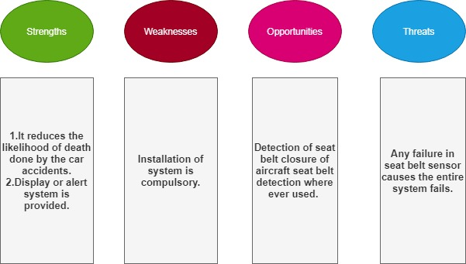

### 4W1H

4W1H basically signifies as to What, Where, When, Why and How the feature is to be used and implemented in a car.

**WhY**

While driving car wearing seat belt is important that can safe our life during accident periods but most of us are careless to wear seatbelt. Driver will be unable to start vehicle without wearing seat belt. The technology connects the drivers and the co passenger seat belts with the Ignition system such that without fastening the seat belts, the engine will not start. If the driver unfastens their seat belt is removed after starting off vehicle, the control unit will disengage the power input to the ignition switch after 30 seconds resulting in halt position.

**WHAT**

What we have made is mandatory seat belts in order to prevent accidents. The innovation is to provide seat belts using sensor circuits which are called as Ignition Inducing Seat belts using relay and micro controlling programming structure for automobiles.

**Where**

Installation can be done in all the vehicles in which we require seat belt safety.

When

When driver wants to start the engine.

**How**

In this system we use seat belt reed sensor to start the car when you buckle the seatbelt. By buckling the seatbelt reed sensor detects presence of seatbelt. Now seat belt reed sensor transmits the signal to the Microcontroller. Initially the Microcontroller at low state but after the signal has been received ATmega328P goes to the ON state. When ATmega328P goes to the ON state, the relay connected in between the ignition system and battery. In real time methodology we connect the reed sensor in between the ignition switch and the car battery. Heartbeat sensor is placed under the bottom of the seatbelt. So the car doesn't ignite until the sensor reads the seat belt buckling.

## PASSIVE KEYLESS ENTRY

### HIGH LEVEL AND LOW LEVEL REQUIREMENTS (DOORS)

|  |  |  |  |
| --- | --- | --- | --- |
| S.no | Stakeholder Requirements | System Requirements | Software Requirements |
| 1 | The vehicle signal range should not set the lock unless the receiver goes out of range | Servo motor,Atmega 328p,Status change,Radio Transceiver | Arduino API,Matlab(simulink) |
| 2 | The door signal goes on after the vehicle status changes | Servo motor,Signal sensor(led) | Arduino API,Matlab(simulink) |
| 3 | When receiver comes from vehicle to door, the status changes after it reaches door signal | Door servo,led,buzzer | Arduino API,Matlab(simulink) |

### MARKET ANALYSIS

**SEGMENT ANALYSIS**

|  |  |  |
| --- | --- | --- |
| LOW SEGMENT | MID SEGMENT | HIGHER SEGMENT |
| * Central Locking from driver’s side using physical key * Remote control for door lock/unlock | * Request sensor buttons on door handles * Proximity detection for the system to get connected to the beacon | * Use of keycard for lock/unlock * Passive entry when user’s hand is detected near the door handle |

Table 1: Segment Analysis

AGEING

|  |  |  |
| --- | --- | --- |
| BEFORE 10 YEARS | AFTER 5 YEARS | CURRENT TECHNOLOGY |
| * Central locking using the physical locking from the driver side * Key fab having only lock and unlock button * Hands-free entry using code in the window panel | * Tags inserted in human body using nanotechnology * AI recognizing user’s action for automatic lock/unlock | * Request sensor buttons * Contact based cards for lock/unlock mechanisms * Using mobile devices over connected services |

Table 2: Ageing Analysis

### S.W.O.T. ANALYSIS

|  |  |
| --- | --- |
| STRENGTH | WEAKNESS |
| * More secure system as the beacon sensitivity is required | * Proximity sensor may not be able to comprehend sometimes and |
| OPPORTUNITY | **THREAT** |
| * Motion sensor can be used to detect even the slightest movement | * If remote is within the proximity vicinity, security issues of hacking and robbing can happen |

Table 3: SWOT Analysis

### 4W&1H

|  |  |
| --- | --- |
| WHAT *is the feature?* | WHERE *is the system used?* |
| This feature is the Passive entry system for entry into a locked system | This feature is primarily used in vehicles to lock/unlock doors without physical key |
| WHY *is it used?* | **WHEN** *was this technology introduced?* |
| To increase the ease of access and security of a vehicle using wireless communication | This was introduced in early 1900 when automobile industry competed for excellence to increase the luxury feature of their vehicles |
| HOW *does the feature work?* | |
| * The feature uses proximity sensors to transmit and receive radio signals from the beacon (i.e. the key) * Transfer of data over a controlled code is used for enhanced security * Approaching the sensor unlocks while moving away from the range locks the vehicle | |

Table 4: 4W&1H

# LITERATURE REVIEW

## AIRBAG SYSTEM

[1] Air Bag: A Safety Restraint System of an Automobile (Tasnim N. Shaikh, Satyajeet Chaudhari and Hiren Rasania):

An Airbag is an automotive safety restraint system for an occupant as well as passengers. The system consists of a flexible fabric envelope or cushion, designed to inflate rapidly during an automobile collision. Its purpose is to cushion occupants during a crash and provide protection to their bodies when they strike interior objects such as the steering wheel or a window etc. Thus it lowers the number of injuries by reducing the force exerted by steering wheel, windows and the dashboard at any point on the body. This is accomplished in two ways, viz;

By increasing the interval over the force being applied or

By spreading the force over a large area of the body.

Air bag fabric has to keep a balance between two extreme conditions.It has to be sufficiently flexible to fold into relatively small volumes. At the same time it should be sufficiently strong to withstand the deployment at high speed, e.g. under the influence of an explosive charge, and the impact of passengers or other influences when inflated. Air bags must inflate very rapidly to be effective, and therefore come out of the steering wheel hub or instrumental panel with considerable force, generally at a speed over 100 mph.

Decision Algorithm for Smart Airbag Deployment Safety Issues (Aini Hussain, Member, IEEE, M A Hannan, Azah Mohamed, Senior Member, IEEE, Hilmi Sanusi and Burhanuddin Yeop Majlis, Member, IEEE):

Airbag deployment has been known to be responsible for huge death, incidental injuries and broken bones due to low crash severity and wrong deployment decisions. Therefore, the authorities and industries have been looking for more innovative and intelligent products to be realized for future enhancements in the vehicle safety systems (vsss). Although the vsss technologies have advanced considerably, they still face challenges such as how to avoid unnecessary and untimely airbag deployments that can be hazardous and fatal. Currently, most of the existing airbag systems deploy without regard to occupant size and position. It intends to provide a thorough discussion relating to the occupancy detection, occupant size classification, occupant off-position detection to determine safe distance zone for airbag deployment, crash-severity analysis and airbag decision algorithms via a computer modeling. The proposed system model consists of three main modules namely, occupant sensing, crash severity analysis and decision fusion.

## SEAT BELT ALERT SYSTEM

|  |  |  |  |
| --- | --- | --- | --- |
| Sr No. | Features | Title | Author |
| 1. | Seat belt | Seat belt alert system with ignition control in car | 1 Akshay Vetal, 2 Gaurav Sakurde,  3 Pradip Salunke,  4 Krinshna Barskar,  5 Prof. M. B. Bankar |
| 2. | Seat belt | Seat belt safety features using sensors to protect occupants | S.D Rahul,  Bhardwaj,  ShraddhaR,  Jogdhankar |

## PASSIVE KEYLESS ENTRY

[1] Hands-free Remote Entry System

This paper shows the hands-free system used in automobiles for increased security and ease of access to the vehicle without any physical entry on system to identify the signal and unlock which button is pressed. Using a control unit to provide a code for every request and to use it for authentication purpose to follow the action.

[2]Passive remote

The purpose is to help understand the basic technology involved in the system to create an area of sensors where in the main receiver when inside, could be used only for accessing the various functioned it is programmed to.

[3] Keyless remote system

The use of a mobile device having Bluetooth connectivity is used to connect to the vehicle and perform the security actions from anywhere in the world. The use of only the mobile device to connect to the vehicle having a ranged frequency.

[4]Study on vehicle and garage Remote entry

This information helped to understand the old system of using a radio signal of specific frequency to perform actions and the required lock/unlock functions. The direct connection when in direct sight provided a convenience feature which was at times only implemented in luxury cars. Having a key fob to do such actions without physical effort helped a lot and changed the present iterations on a whole new level.

# UML DIAGRAM

## STRUCTURAL DIAGRAM

### PIN DIAGRAM

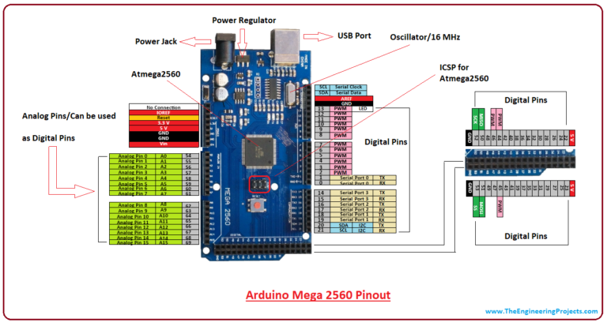

Figure 1: Arduino PIN Diagram

### BLOCK DIAGRAM

#### **INTEGRATED SYSTEM**

****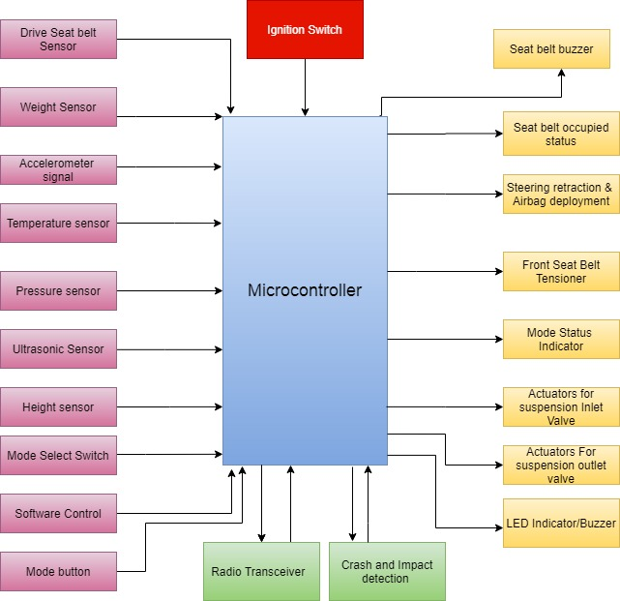****

#### AIRBAG SYSTEM

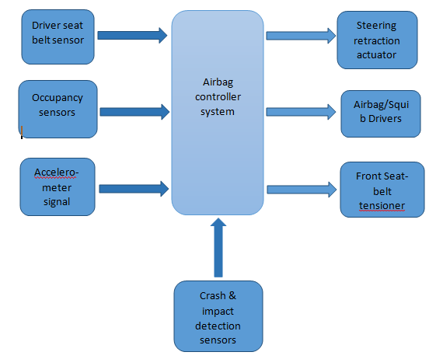

#### SEAT BELT ALERT SYSTEM

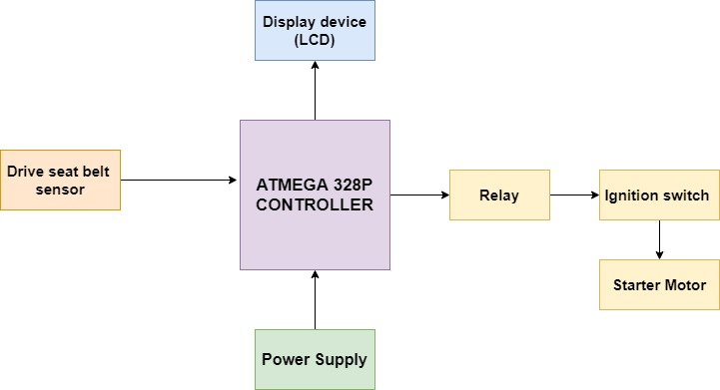

#### PASSIVE KEYLESS SYSTEM

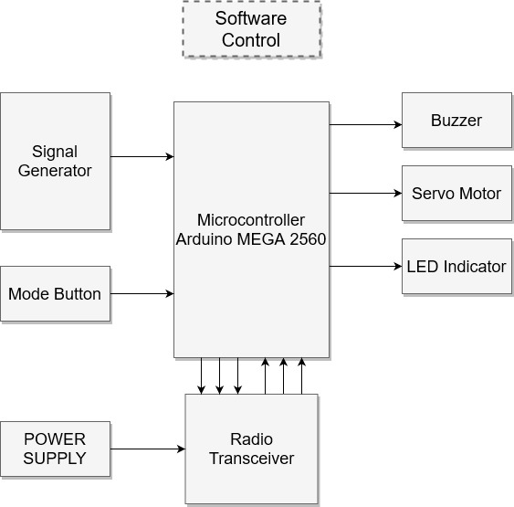

Figure 2: Passive Entry Block Diagram

## BEHAVIOURAL DIAGRAM

### STATEFLOW DIAGRAM

#### INTEGRATED SYSTEM

#### AIRBAG SYSTEM

#### PASSIVE KEYLESS ENTRY

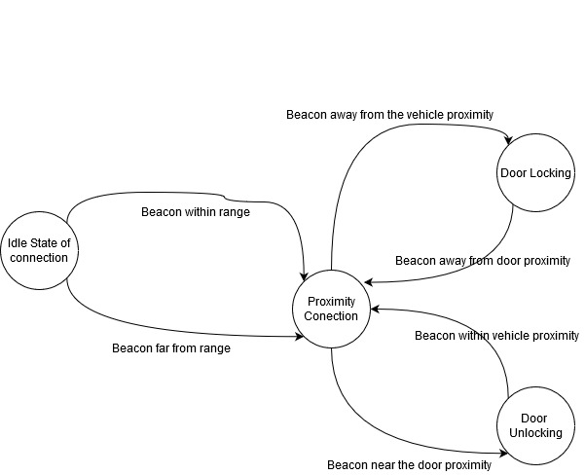

Figure 3: Passive Entry State flow Diagram

### FLOWCHART

#### INTEGRATED FLOWCHART

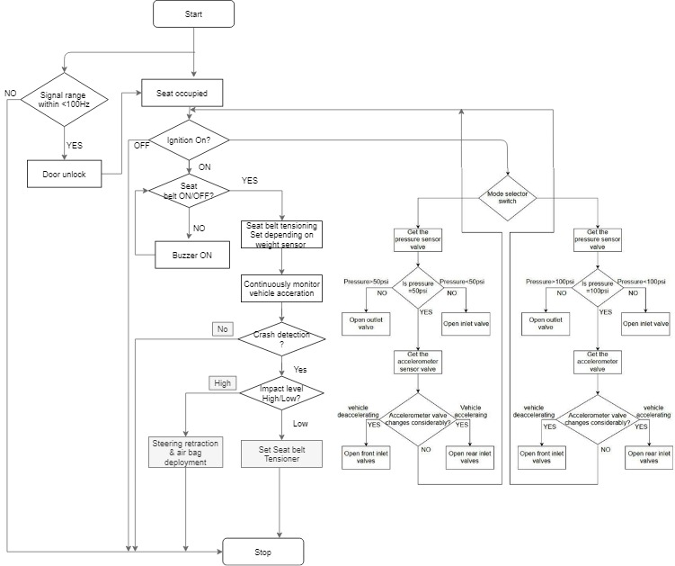

#### AIRBAG SYSTEM

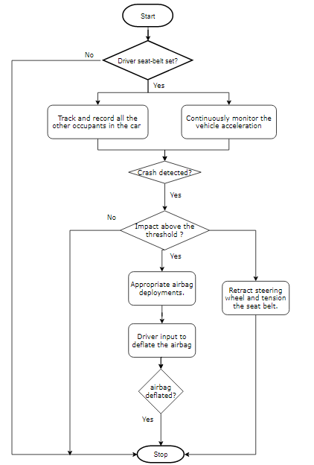

#### SEAT BELT ALERT SYSTEM

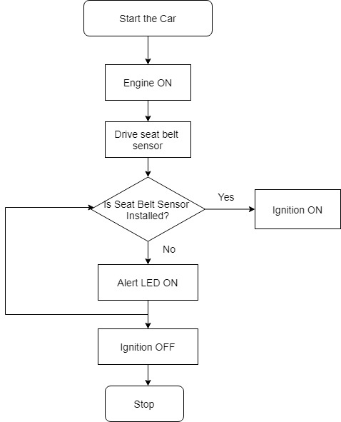

#### PASSIVE KEYLESS ENTRY

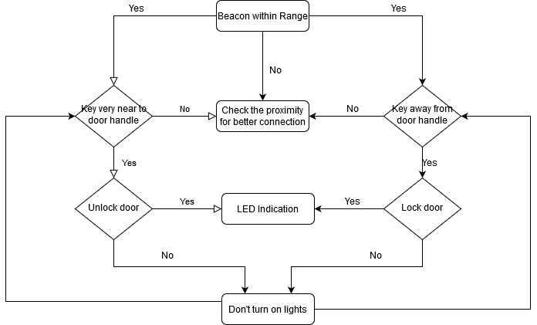

Figure 4: Passive Entry Flowchart

# BILL OF MATERIALS

|  |  |  |
| --- | --- | --- |
| COMPONENTS | QUANTITY | PRICE |
| Arduino MEGA | 1 | 1500 |
| Proximity sensor | 4 | 200 |
| Buzzer | 1 | 100 |
| LED | 1 | 80 |
| Servo motor | 1 | 400 |

Table 6: Bill of Materials

# EXECUTION PLAN

|  |  |  |  |  |
| --- | --- | --- | --- | --- |
| SL. NO. | TASK | STARTING DATE | COMPLETION DATE | HOURS ALLOTED |
| 1 | Problem Statement and Requirement Gathering | 07-02-2020 | 10-02-2020 | 18 hours |
| 2 | Hardware Design | 07-02-2020 | 10-02-2020 | 10 hours |
| 3 | Software Coding | 14—02-2020 | 17-02-2020 | 24 hours |
| 4 | Implementations and Simulations | 14-02-2020 | 17-02-2020 | 15 hours |
| 5 | Integrations |  |  | 20 hours |
| 6 | Testing |  |  | 10 hours |
| 7 | Documentation |  |  | 9 hours |

Table 7: Execution Plan

# TEAM DESCRIPTION

# INTEGRATED MODELLING AND TESTING

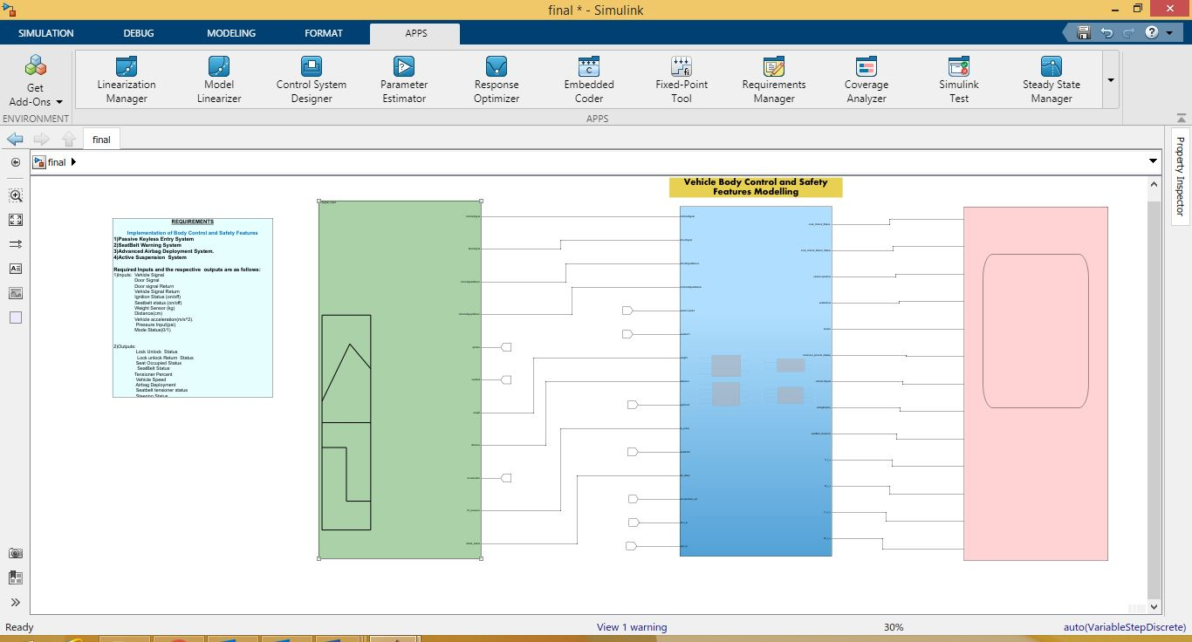

INTEGRATED SIGNAL BUILDER

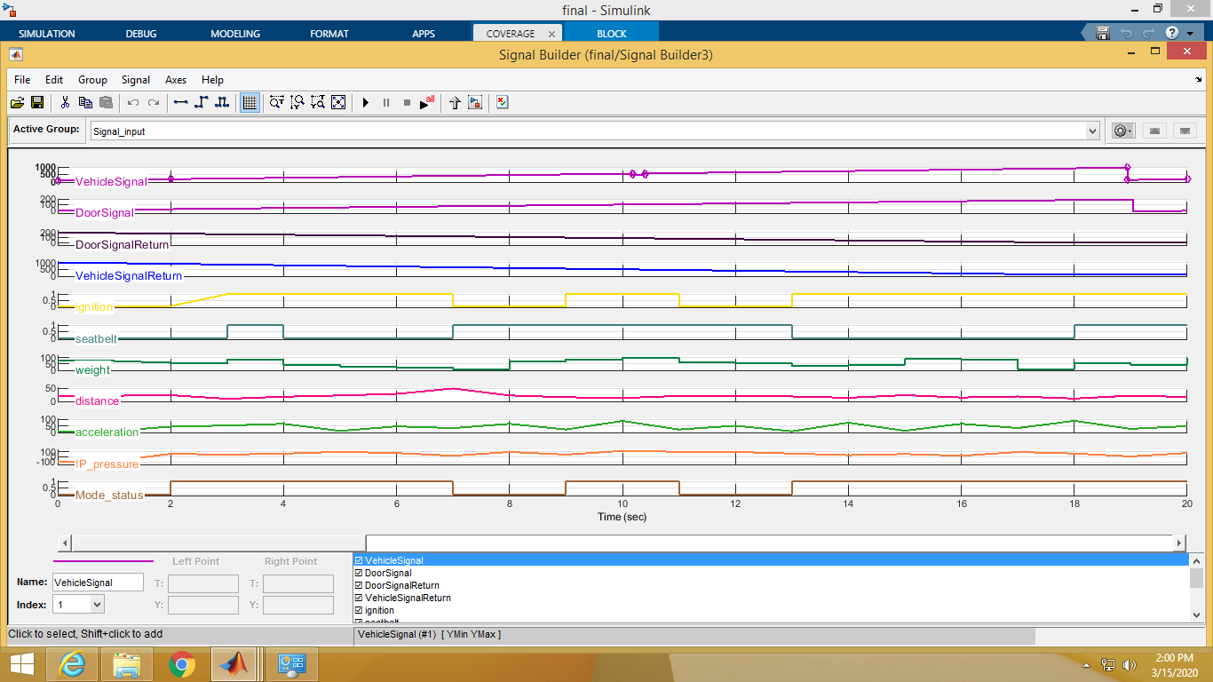

INTEGRATED OUTPUT IN SCOPE

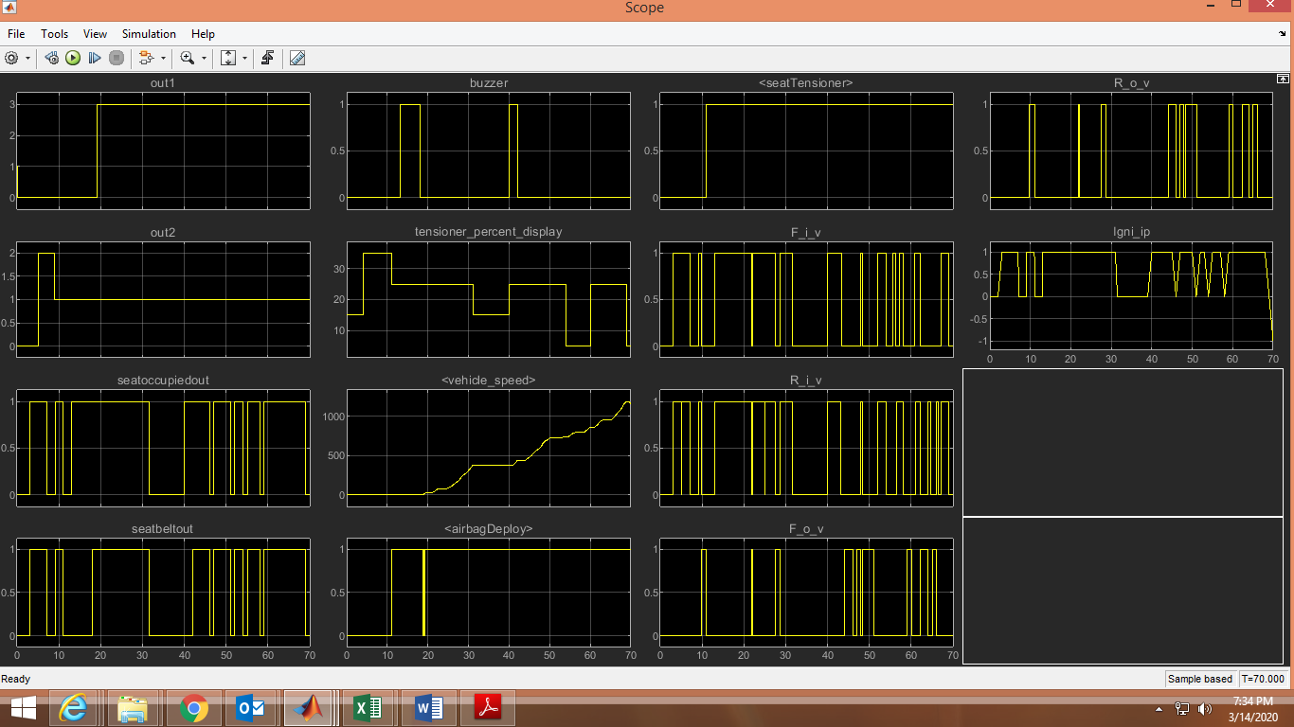

# INTEGRATED TEST PLAN

|  |  |  |  |  |  |
| --- | --- | --- | --- | --- | --- |
| TEST ID | PURPOSE OF TEST | INPUT | EXPECTED OUTPUT | OBSERVED OUTPUT | RESULT |
| TEST_01 |  |  |  |  |  |
| TEST_02 |  |  |  |  |  |
| TEST_03 |  |  |  |  |  |
| TEST_04 |  |  |  |  |  |
| TEST_05 |  |  |  |  |  |
| TEST_06 |  |  |  |  |  |
| TEST_07 |  |  |  |  |  |
|  |  |  |  |  |  |
|  |  |  |  |  |  |
|  |  |  |  |  |  |
|  |  |  |  |  |  |
|  |  |  |  |  |  |
|  |  |  |  |  |  |
|  |  |  |  |  |  |
|  |  |  |  |  |  |

# INTEGRATED COMPLIANCE

## MAAB CHECK

BEFORE CLEARING OF WARNINGS

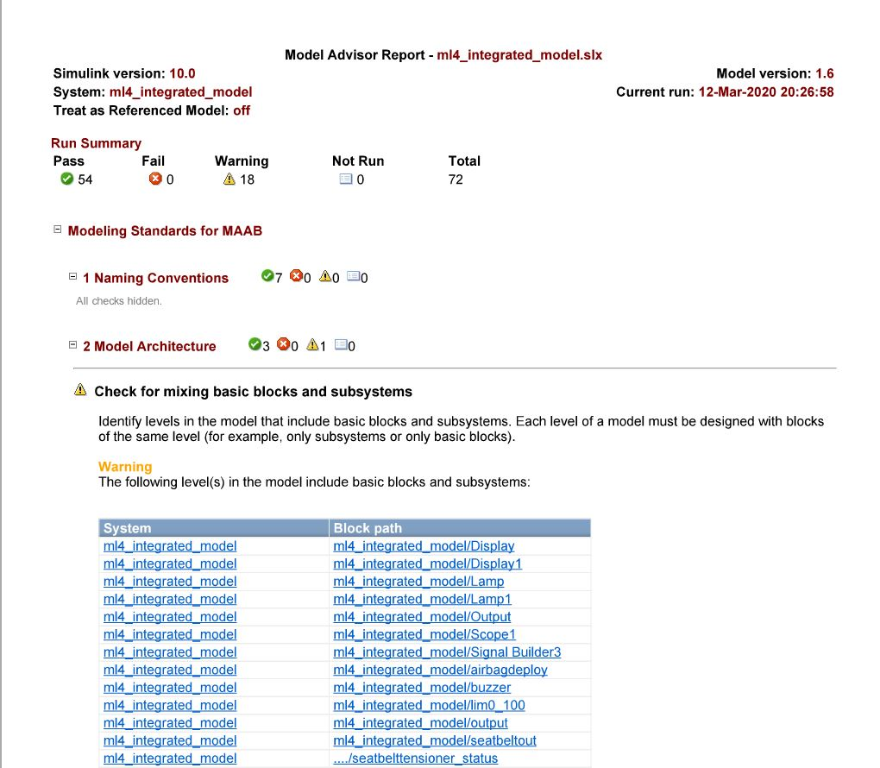

AFTER WARNING CLEARANCE AND CHECK

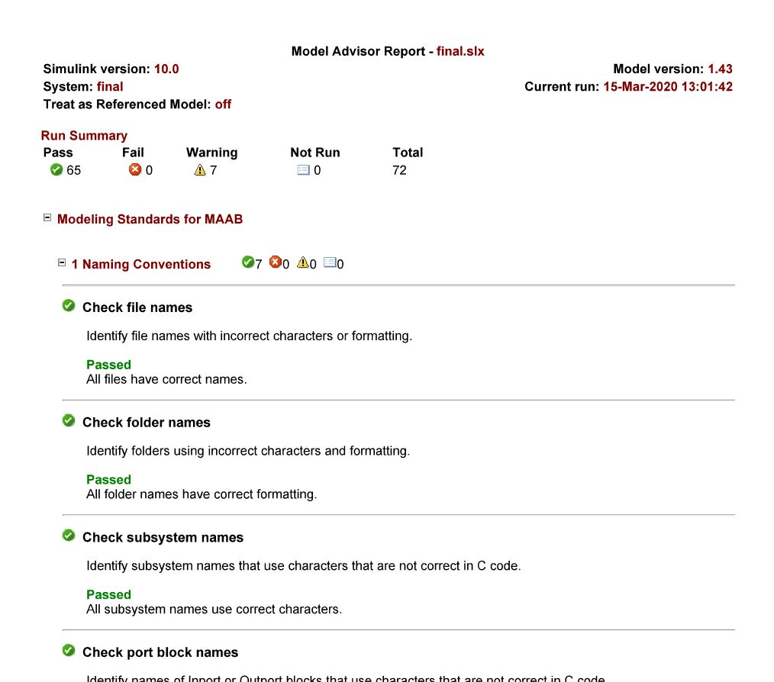

## CODE COVERAGE

CHECKING CODE COVERAGE USING MCDC OPTION

FIRST ITERATION OF CODE COVERAGE

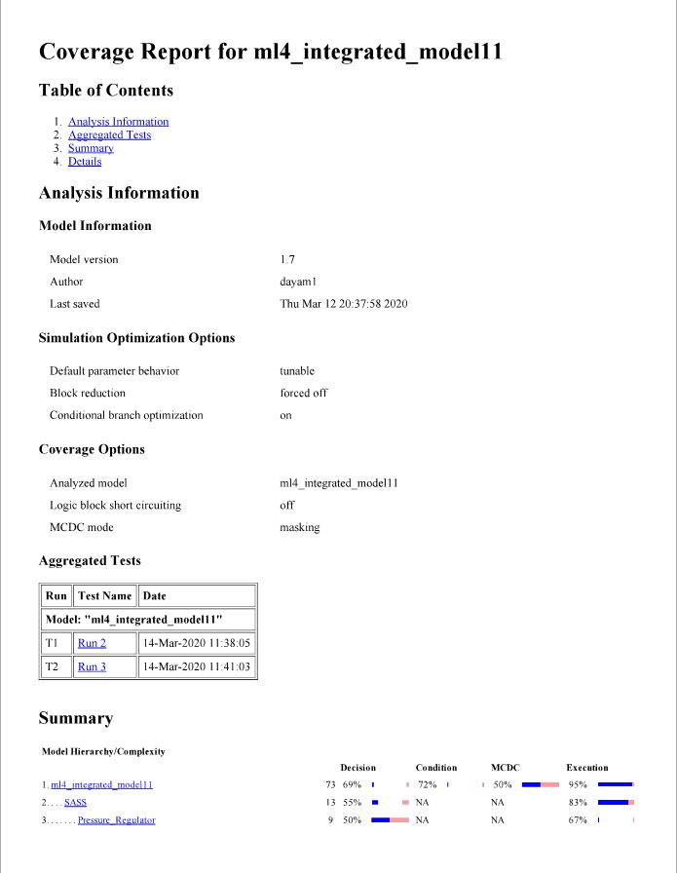

FINAL ITERATION OF CODE COVERAGE

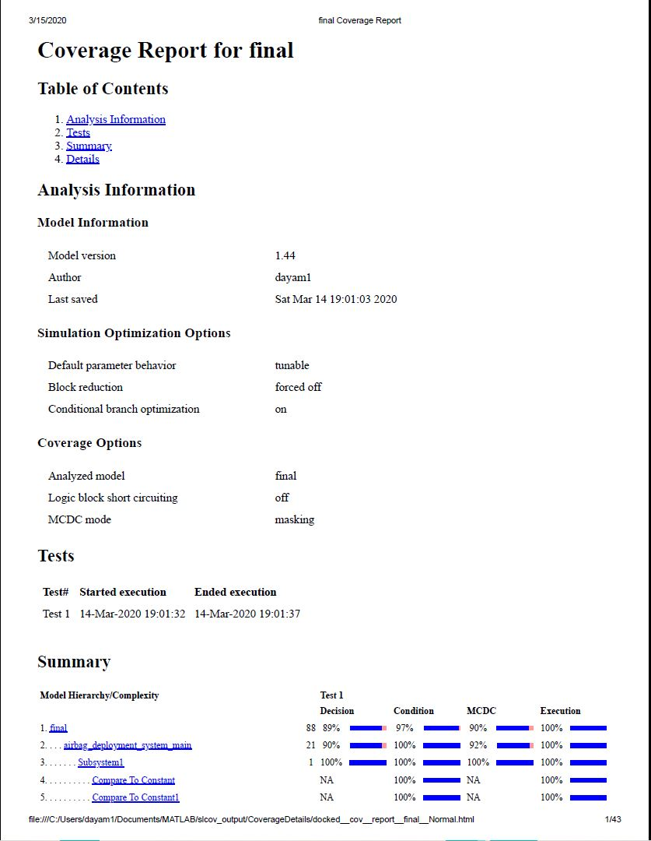

## METRIC ANALYSIS

# LEARNINGS AND DIFFICULTIES OVERCOMED

# APPENDIX