CBA&TESTING ACTIVITY



Contents
1 CONTINUOUS BUILD AUTOMATION(CBA) 3
1.1 WORKING IN GITHUB 3
1.2 WORKING IN TRAVIS-CI 4
1.3 WORKING IN CODACY 5
1.4 CHECKING BADGES FROM TRAVIS-CI AND CODACY 7
1.5 SCOPE OF CBA 7
2 GROUP COMMIT 7
2.1 WORKING IN GITHUB 7
2.2 SCOPE OF GROUP COMMIT 8
3 TESTING USING ASSERT 8
3.1 USING CODEBLOCKS 8
3.2 SCOPE OF ASSERT SIGNAL 10

No table of figures entries found.

CONTINUOUS BUILD AUTOMATION(CBA)

WORKING IN GITHUB
- Creation of repository in GITHUB
- Create a .c File and commit
- Create a .travis.yml File to build it in Travis-ci
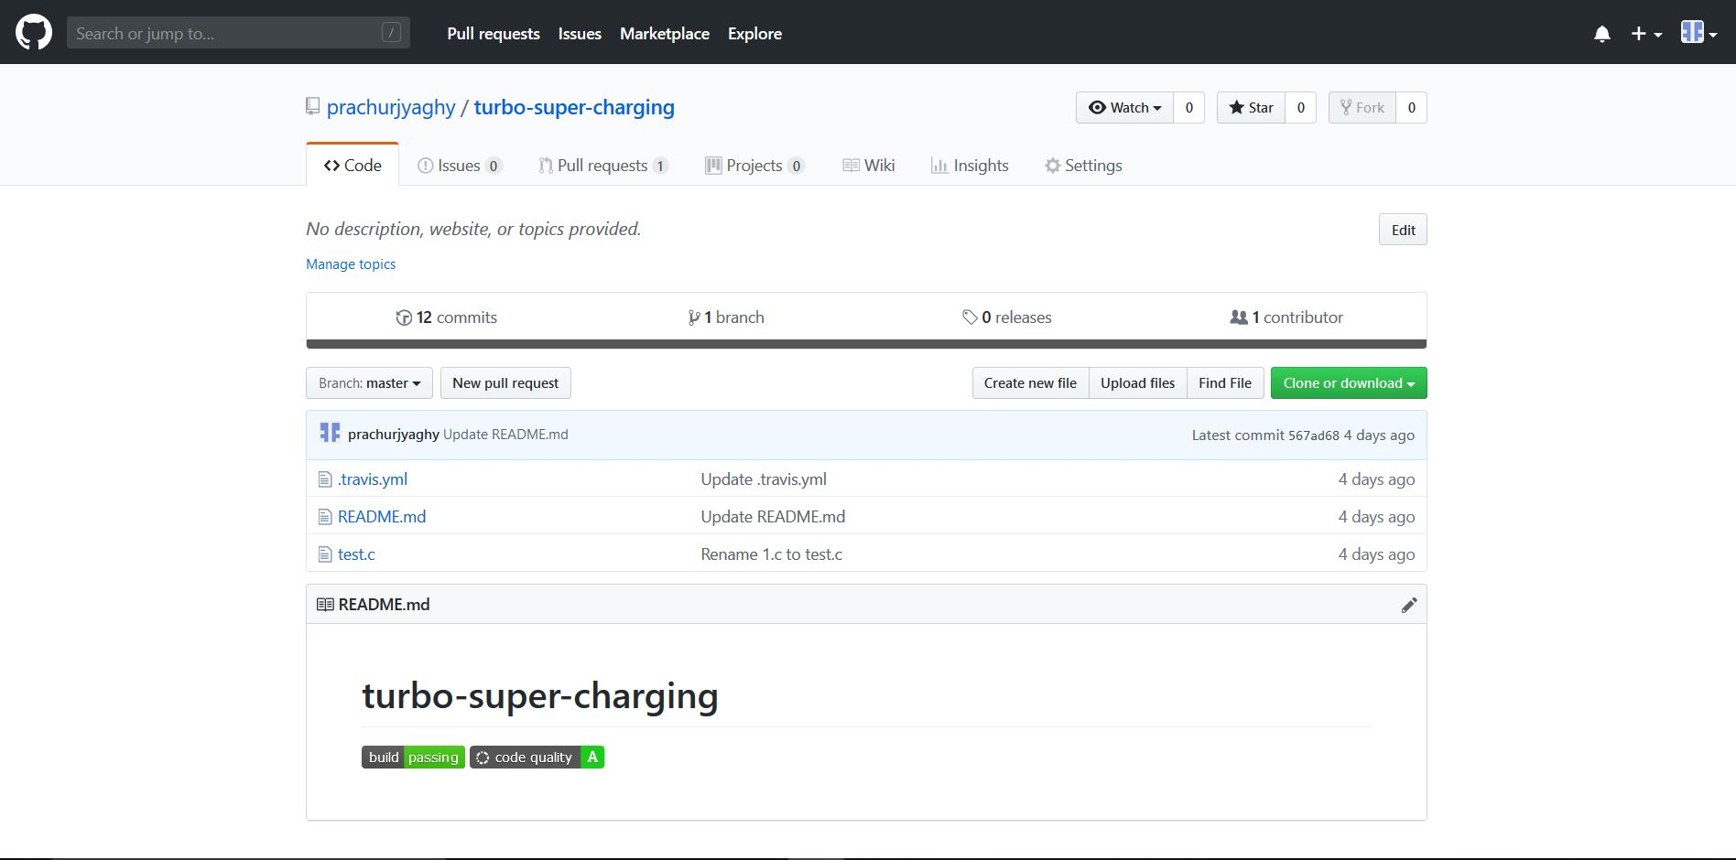

WORKING IN TRAVIS-CI
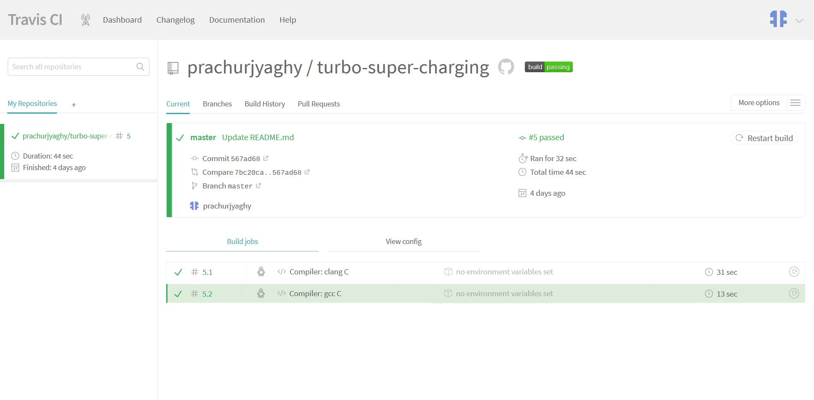
- Open the repository in Travis-ci
- Trigger a new build from More Options menu
- If there is no error, the build will set to green
- The following will be displayed to show every line and errors occured
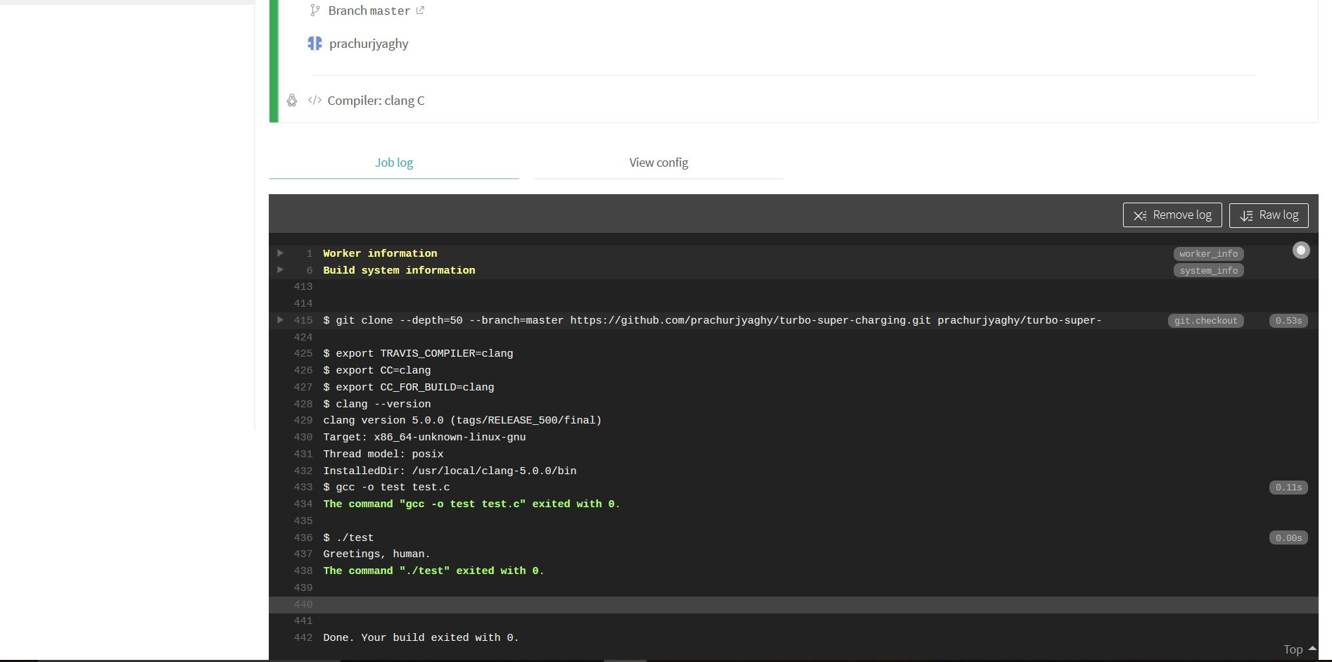
- Click on the Build Option
- Copy the URL and paste it in the GitHub Readme File
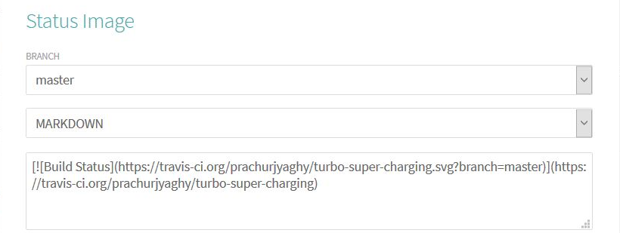

WORKING IN CODACY
- Review the project in Codacy to check further issues
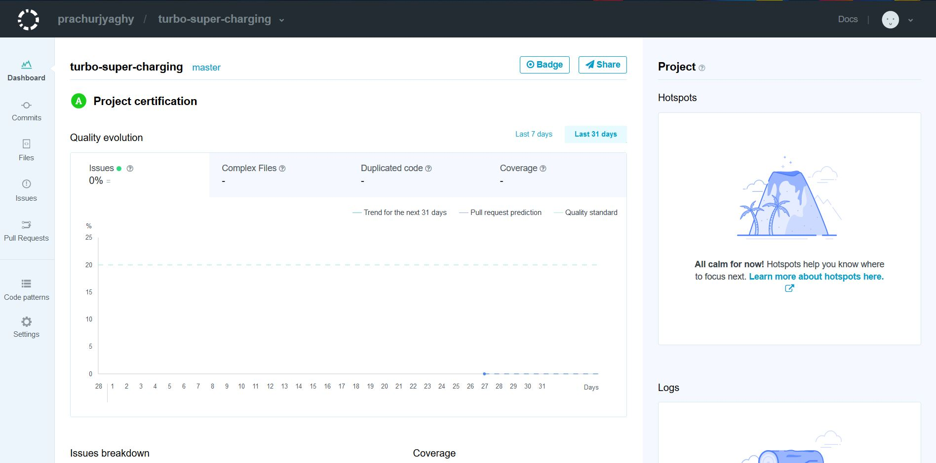
- Click on badge to get to advanced settings

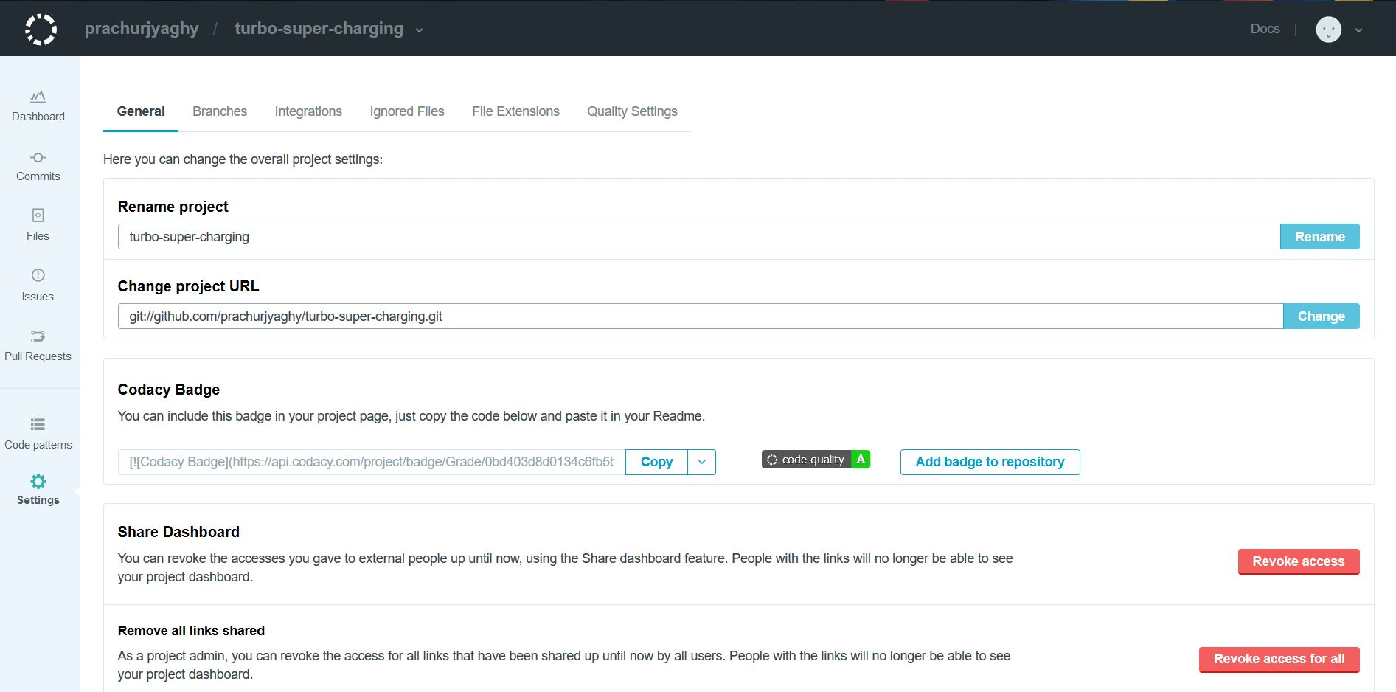
- Copy the Codecy Badge URL
- Paste the Codecy badge URL in GitHub Readme File

CHECKING BADGES FROM TRAVIS-CI AND CODACY

- These badges will determine the build and code quality

SCOPE OF CBA
- To control and access the files in the cloud server in GitHub and build the code in Travis
- Provides a platform to continuously to commit and modify the files saved in the cloud
- Provides a group to collaborate and each can contribute towards it

GROUP COMMIT

WORKING IN GITHUB
- To group commit, collaborators send invitation to another user
- Invitation is accepted
- In repository, a .c file is edited
- Print a comment and commit changes
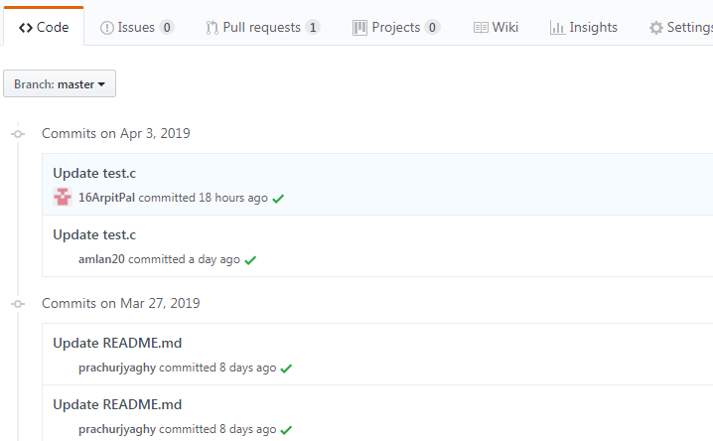

SCOPE OF GROUP COMMIT
- To control the accessibility of your repository
- To commit changes to files
- Group commit will make members to make changes to the committed repository

TESTING USING ASSERT

USING CODEBLOCKS
- Create a simple calculator C code
- Use assert signals to test the function
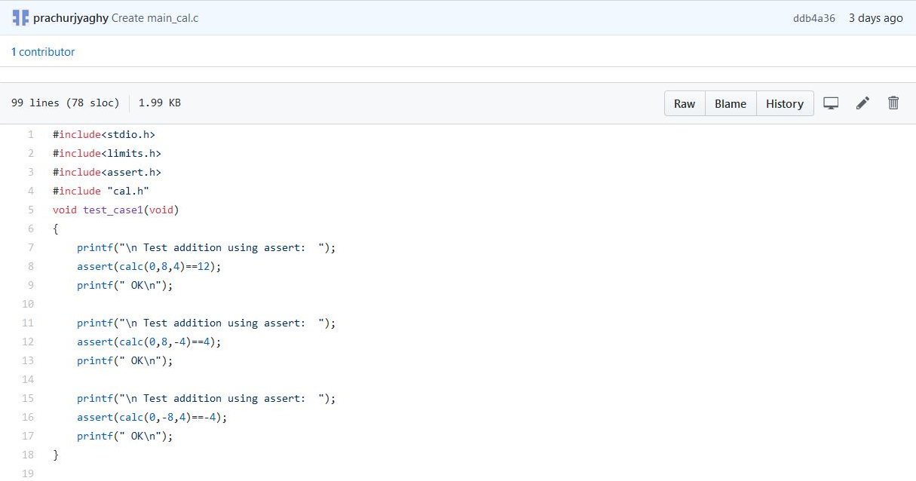
- Check the output in the command window
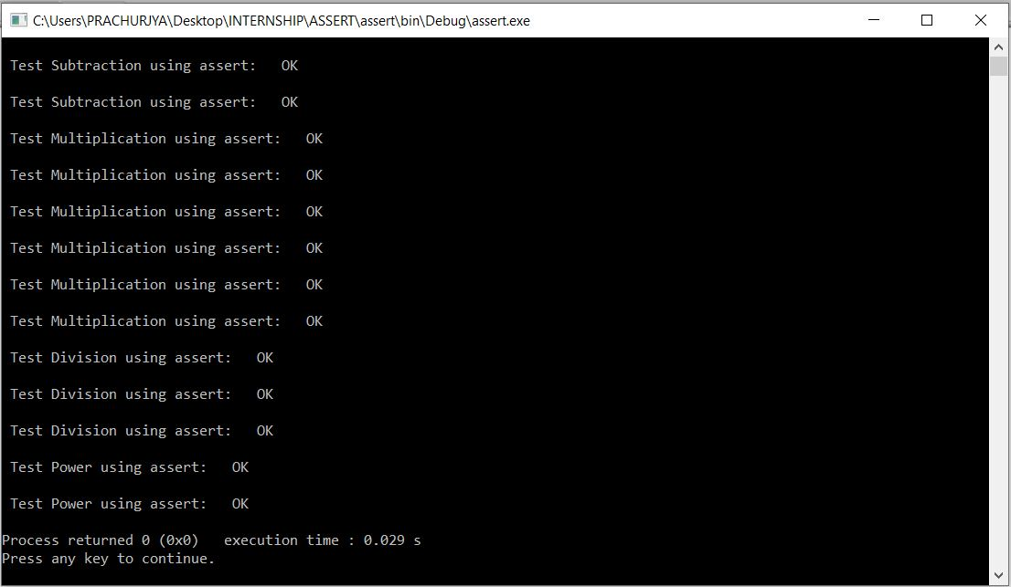
- Upload all the code files to GitHub
- Create a new Repository and Commit
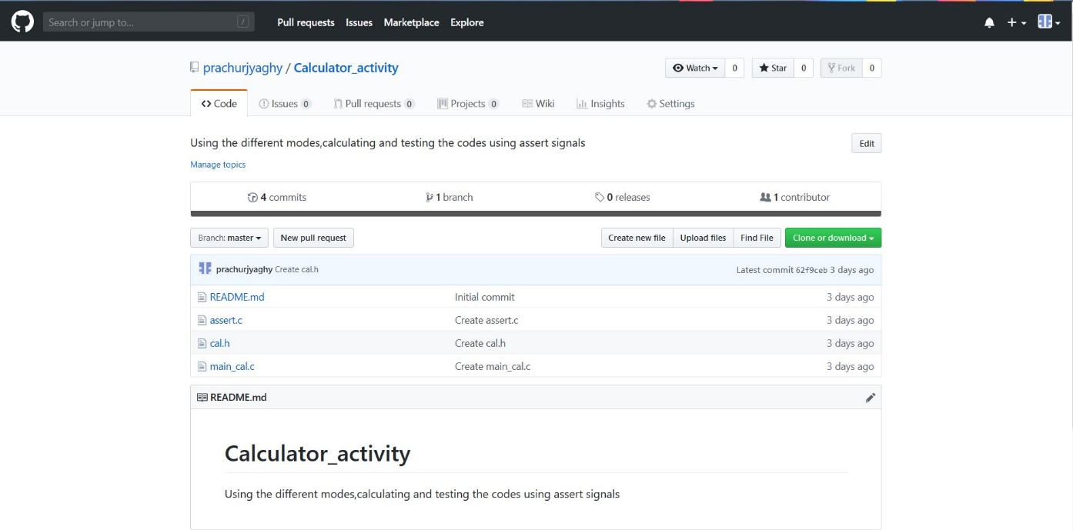

SCOPE OF ASSERT SIGNAL
- To check a code using assert function on a C code
- Using: assert(function(operation, Expressions)==Output)
- Signals are passed through function to compare the values by user defined ones

