Personal Contribution

1. Attend daily meetings and categorize all daily meeting records. (12 daily meetings in total)

2. Documenting for the Wiki Pages (4 Wiki pages in total including Home, Build & Test, Database designing, Requirement and Development).

3. Participating in making Power Point slide.

4. Carry on presentation in the first sprint.

5. Learning path in winter vacation: Junit -> Reflection -> Annotation -> Java Web -> JDBC -> c3p0 -> druid -> JDBC Template -> xml -> tomcat -> Servlet -> Request -> Response -> Servlet Context -> Cookie -> Session -> JSP.

6. Generating skeleton code frame for Java Spring MVC project (including some JSP files and some Servlet classes, configuration for Mybatis, tomcat).

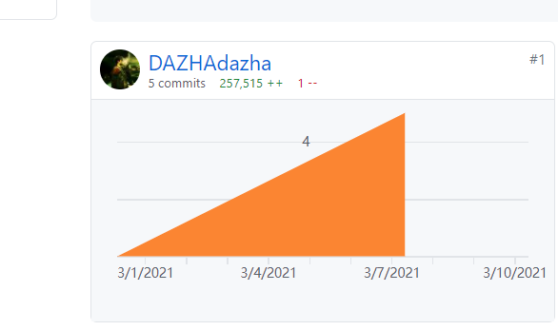

7. Participating in designing database tables (5 tables, films, halls, user, seats, sell) including all value constraints, ranges, and relationships.

8. Mapping database designing into tables, generating and storing database files and initialize data.

9. As the group leader, assign tasks (including drawing deployment diagram, structure diagram, function table for different deployment, front-end representation layer implementation, Java EE back-end business, android studio for mobile, documentation for all software structure) for all group members.

10. Determine the most prioritized requirements (Movie description, screenshots for movies，selling tickets (for children, adults, and the elders), emulating payment via credit card and cash, check tickets in the application, print ticket as pdf, validations via QR codes or bar codes, check weekly income, compare box office of different movies by generating graphs) to be implemented for the next sprint.

11. Determine the IDE (JetBrains IDEA) and other development tools (postman, Selenium, NaviCat), database software (MySQL), version control tools (Github Desktop), development method (agile), test frameworks (Junit), API standards and documentation of software development structure.