**Personal contribution：**

For preparation, I have studied some technical knowledge about Java Web such as Servlet, Spring, Tomcat and so on. In addition, I have got somewhere about Maven and reviewed MySQL during the winter holiday.

For teamwork, I attended twelve the daily meetings online. In these daily meetings, I mentioned some problems like what technique would be used, how to design the interface connecting the back-end and front-end and what the requirements of the cinema’s system.

For good measure, I finished the requirements design and made an iteration plan how to finish the project.

After the beginning of university, I submit some codes and documents to the github repository.

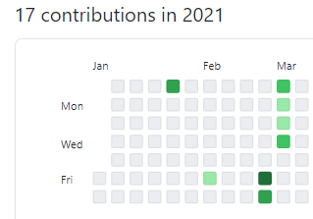

Form this picture, I have finished 17 contributions in 2021.

Work details:

For the codes, I built a project what is based on Spring, SpringMVC, Servlet and Tomcat. The fundamental framework has been designed and the prototype of UserService, UserDao and Controller layers was initiated. There were also some test codes to validate whether there is a good job.

For the documents, I submitted two documents that the first document talked about some common problems about Tomcat and how to solve them correctly. These problems are my problems when I config the deployment. For example, Artifact *:war exploded: Error during artifact deployment, solving this problem needs to reimport a new facet and compile it in Tomcat. I put the critical points into the document. Another document includes some information about Maven that there are how many libraries have been loaded and adding or removing some libraries. It just like a log about development.