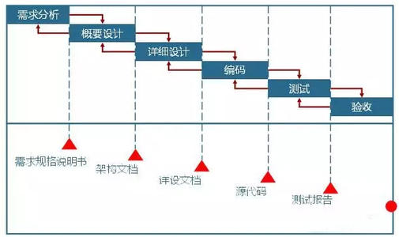

A complete software development life cycle

A complete software development life cycle includes a series of cycles from requirements analysis, outline design, detailed design, etc. in the first sprint cycle, I was mainly responsible for the design work of mobile terminal requirements design, outline design, etc. at the same time, I did some basic knowledge learning.

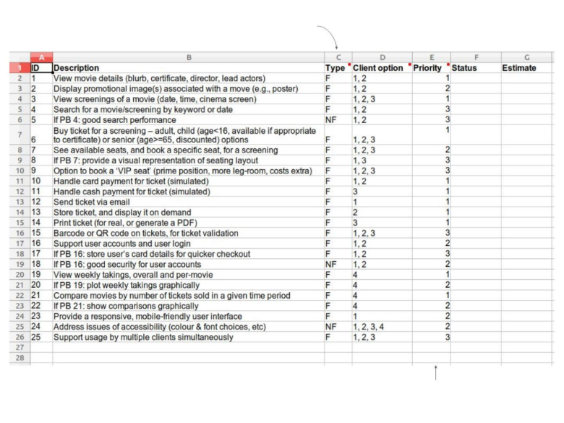

Detailed page design

|  |  |
| --- | --- |
| Main Page | Show ongoing/upcoming movie |
| Show Promotion Ads |
| Show surrounding theatre |
| Cinema/Upcoming Disk list | Show ongoing/upcoming movie |
| Owned Ticket | Show movie have seen/not see |
| Personal Information | Personal Information |
| My order |
| My service |
| Movie Detail | Show theatres |
| Movie Ticket Order | Show/Select Seats |
| Theatres Details | Show available movie and timetable |