TABLE OF CONTENTS

Sl. No. | Title | Page No.
1 | INTRODUCTION TO PROJECT | 4-5
2 | REQUIREMENT ANALYSIS (SRS) | 6-7
3 | DESIGN | 8-10
4 | INFORMATION ABOUT MODULE IMPLEMENTED BY STUDENT | 11-12
5 | DATABASE AND DATA DICTIONARY | 13-14
6 | INFORMATION ABOUT TESTING STRATEGY | 15-16
7 | CONCLUSION / FUTURE SCOPE | 17-18
8 | SNAPSHOTS OF GUI | 19-20
9 | REFERENCES | 21

CERTIFICATE OF COMPLETION

This is to certify that Abhinav Singh, a student of Bachelor of Technology in Computer Science and Engineering, has successfully completed the project entitled “ Object Detection for Visually Impaired People ” under the supervision of Ms Nikita, Assistant Professor of CSE department, in partial fulfillment of the requirements for the award of the degree of B.Tech in Computer Science and Engineering from Satyug Darshan Institute of Engineering and Technology, during the academic session 2025–2026.

The project demonstrates a comprehensive understanding of machine learning, computer vision, and database management through the implementation of a real-time face recognition system for attendance automation. The work done is original and has not been submitted elsewhere.

We appreciate the efforts and dedication shown by the student in successfully completing this project.

ACKNOWLEDGEMENT

We take this opportunity to express our sincere gratitude to all those who have supported and guided us throughout the course of our project titled:

“Object Detection For Visually Impaired People”

First and foremost, we would like to extend our heartfelt thanks to Ms Nikita, our esteemed project guide and Assistant Professor of CSE department, for her constant encouragement, expert guidance, and insightful feedback. Her dedication, patience, and invaluable mentorship played a pivotal role in shaping the direction and success of this project.

We also express our gratitude to the Department of Computer Science & Engineering,

Satyug Darshan Institute of Engineering & Technology, under the affiliation of J.C. Bose University of Science and Technology, YMCA, for providing the necessary academic infrastructure and support, without which the successful execution of this project would not have been possible. Our sincere thanks go to all the faculty members and technical staff who inspired us with their knowledge and expertise.

We would also like to acknowledge the unwavering support and motivation extended by our families and peers during the various phases of our project. Lastly, we would like to express our appreciation for each other’s dedication, teamwork, and mutual respect which enabled us to complete this project collaboratively and effectively This project has been a significant learning experience for us and has helped us grow both academically and personally.

With sincere appreciation

Abhinav Singh (23020004005)

CHAPTER 1

INTRODUCTION TO PROJECT

1.1 Background
Assistive technology has become increasingly important in recent years, playing a vital role in bridging the gap between disability and independence. For individuals with visual impairments, the challenge of navigating unfamiliar environments and recognizing everyday objects continues to pose significant difficulties. The absence of real-time contextual information greatly affects their confidence, mobility, and quality of life.
Recent advancements in artificial intelligence, computer vision, and deep learning have made it possible to develop intelligent systems that can interpret the environment visually and provide feedback in a way that humans can understand. This project explores how these technologies can be integrated to create a low-cost, efficient, and user-friendly object detection system for the visually impaired.

1.2 Problem Statement
Visually impaired individuals face numerous difficulties in identifying objects and navigating safely through their environment. Traditional tools like canes and guide dogs have limitations and are not always effective in detecting every type of obstacle or object. There is a lack of affordable and real-time assistive solutions that can verbally notify users of objects present around them.

1.3 Project Overview
This project aims to create a real-time object detection system for visually impaired users. The system captures video frames using a camera, detects objects using a deep learning model, and then announces the detected object names through a speech engine. The solution leverages technologies such as OpenCV for image processing, YOLO/MobileNet for object detection, and pyttsx3 for speech synthesis.
The primary focus is to build a robust and lightweight system that delivers low-latency, high-accuracy feedback suitable for real-world use.

1.4 Motivation
The primary motivation behind this project is to empower visually impaired individuals by giving them an affordable and reliable assistive tool that improves their independence. The fusion of AI and computer vision provides a unique opportunity to solve real-world problems in meaningful ways. By integrating speech feedback with object detection, we can enhance the daily experiences of those with visual impairments.

1.5 Objectives
- To enable real-time object detection using AI-based models.
- To convert object labels into audio outputs for speech-based guidance.
- To develop an accessible and cost-effective system that can be used in various real-world scenarios.
- To ensure low-latency performance for instant and continuous feedback.
- To improve user safety and awareness in dynamic environments.

1.6 Scope of the Project
The system is designed to identify and announce commonly encountered objects such as furniture, vehicles, food items, and electronic appliances. The implementation focuses on desktop use initially but is scalable for integration into wearable or mobile devices in the future. While current object detection relies on pre-trained models, future improvements can incorporate scene understanding, context detection, and multilingual audio output.

CHAPTER 2

REQUIREMENT ANALYSIS (SRS)

2.1 Introduction
This chapter outlines the Software Requirements Specification (SRS) for the project titled "Object Detection for the Visually Impaired." It defines the functional and non-functional requirements, the system environment, and design constraints necessary for successful development and deployment of the application.

2.2 Functional Requirements
The functional requirements define the core functionality of the system:
- Real-Time Object Detection:
The system must detect objects in real-time using a connected camera.
- Speech Feedback:
The detected object names must be announced using a text-to-speech engine.
- Object Label Extraction:
The system should extract object names from detection results accurately.
- Continuous Frame Processing:
The system must operate continuously, analyzing each frame from the camera feed.
- User Interface (optional):
A minimal console-based or GUI interface to start/stop the detection process.

2.3 Non-Functional Requirements
These requirements define the system’s quality attributes:
- Performance:
The system should provide low-latency responses and process frames efficiently.
- Scalability:
The system should support future upgrades, such as mobile app deployment or additional language support.
- Usability:
The system should be simple to operate for users with minimal training.
- Portability:
The application should be compatible with standard Windows/Linux machines.
- Maintainability:
Code and modules should be well-documented and modular for easy future updates.

2.4 Software Requirements
- Operating System: Windows 10 / Linux (Ubuntu recommended)
- Programming Language: Python 3.8+
- Libraries & Tools:
  - OpenCV (Video capture and image processing)
  - YOLOv3 / Coco names (Object detection)
  - pyttsx3 (Text-to-speech)
  - NumPy, Pandas (Data handling)
  - Tkinter or Streamlit (optional GUI)

2.5 Hardware Requirements
- Processor: Intel i5 or higher
- RAM: Minimum 4 GB (8 GB recommended)
- Camera: Inbuilt or USB webcam
- Storage: Minimum 500 MB free space

2.6 System Architecture
The architecture consists of the following core modules:
- Video Input Module
- Object Detection Engine
- Label Extraction Logic
- Text-to-Speech Converter
- Audio Output Module

2.7 Use Case Diagram
Use case includes:
- Start detection
- Process frame
- Detect objects
- Extract labels
- Announce via speech

CHAPTER 3

DESIGN

3.1 Introduction
This chapter focuses on the architectural and functional design of the project. The aim is to establish a clear structure for how the system components interact and how data flows from input to output. The design phase includes the System Architecture, Data Flow Diagrams (DFDs), and a summary of the Software Design Document (SDD).

3.2 High-Level System Architecture
The system is designed in a modular manner to ensure efficiency and scalability. The primary modules include:
- Camera Module: Captures live video frames using OpenCV.
- Object Detection Module: Uses a pre-trained deep learning model (YOLO/MobileNet) to detect objects in each frame.
- Object Label Extraction Module: Extracts the names of detected objects from the model’s output.
- Text-to-Speech (TTS) Module: Converts the object labels into audio using pyttsx3.
- Audio Output Module: Announces the detected objects to the user in real time.

3.3 System Design Diagram (Block Diagram)

┌────────────┐
│ Camera │
│ (OpenCV) │
└────---─────┘
│
▼
┌────────────┐
│ Frame │
│ Processing │
└────-───────┘
│
▼
┌───────────────┐
│ Object │
│ Detection │
│ (YOLO/Tensor) │
└────-──────────┘
│
▼
┌───────────────┐
│ Object Label │
│ Extraction │
└────-──────────┘
│
▼
┌───────────────┐
│ Text-to- │
│ Speech (TTS) │
│ Engine │
└────-──────────┘
│
▼
┌───────────────┐
│ Audio Output │
│ (Speakers) │
└───────────────┘

3.4 Data Flow Diagrams (DFD)

Level 0 DFD (Context Diagram)
+-----------------------+
| Visually Impaired |
| User |
+----------+------------+
|
v
+--------+--------+
| Object Detection |
| System |
+--------+--------+
|
v
[ Audio Feedback ]

Level 1 DFD
[User]
|
v
[Camera Capture] ---> [Object Detection Model]
|
v
[Label Extraction & Formatting]
|
v
[Text-to-Speech Conversion]
|
v
[Audio Output to User]

3.5 Software Design Document (SDD) Overview
- Module Name: Camera Frame Capture
Description: Captures real-time video frames using OpenCV.
- Module Name: Object Detection
Description: Detects objects using a pre-trained model such as YOLO or MobileNet.
- Module Name: Label Handler
Description: Extracts and prepares labels from the detection output.
- Module Name: TTS Engine
Description: Converts object names into audio format using pyttsx3.
- Module Name: User Output
Description: Plays audio output for the user via speakers/headphones.

CHAPTER 4

INFORMATION ABOUT MODULE IMPLEMENTED BY STUDENT

4.1 Introduction
This chapter provides an overview of the various modules implemented in the system. Each module contributes to a specific functionality in the pipeline, ensuring seamless object detection and real-time audio feedback.

4.2 Camera Capture Module
- Function:
Captures live video feed from the webcam.
- Technology Used:
OpenCV (cv2.VideoCapture)
- Operation:
This module initializes the camera, captures each frame continuously, and sends the frames to the object detection model.

4.3 Object Detection Module
- Function:
Detects objects in the video frames using a pre-trained deep learning model.
- Technology Used:
YOLOv5 / MobileNet / TensorFlow
- Operation:
The input frame is resized and preprocessed before being passed to the object detection model. The model returns bounding boxes and labels for each detected object.
- Model Characteristics:
  - Lightweight
  - Real-time inference speed
  - Supports multiple object detection in one frame

4.4 Label Extraction Module
- Function: Extracts the class labels (e.g., "person", "car", "chair") from the model’s detection output.
- Technology Used: Python dictionaries and string processing
- Operation: From the detection output, the system filters confidence scores and selects the top labels. These labels are stored in a list and passed on to the speech module.

  - Text-to-Speech (TTS) Module
- Function:Converts text labels into audible speech.
- Technology Used:Pyttsx3 (offline Python TTS library)
- Operation:The module receives object names and uses the pyttsx3 engine to vocalize the names in a clear and human-like voice.
- Key Features:
  - Offline processing
  - Adjustable voice rate and volume
  - Compatible with multiple platforms

4.6 Real-Time Audio Feedback Module
- Function: Provides real-time verbal feedback to the user.
- Technology Used: OS audio output (speakers or headphones)
- Operation: Once the TTS module generates speech, it is immediately played to the user, allowing them to know what objects are in the camera’s view.

4.7 Integration and Flow
Each of the above modules is integrated into a main program loop:
- Capture frame
- Detect objects
- Extract object names
- Convert names to speech
- Play audio to user
- Repeat for each new frame
This loop ensures a continuous and smooth user experience.

CHAPTER 5

DATABASE AND DATA DICTIONARY

5.1 Introduction
Although the project "Object Detection for the Visually Impaired" does not use a relational or NoSQL database system, it internally manages data structures such as lists and dictionaries to process detection results and maintain object metadata. This chapter provides insight into how data is organized and utilized during execution.

5.2 Data Handling Strategy
The system processes data dynamically in memory. Object labels and metadata (like detection confidence, bounding box coordinates) are temporarily stored for each frame.

5.4 Sample Object Data Format
object_data = [
{"label": "person", "confidence": 0.94},
{"label": "bottle", "confidence": 0.88}
]
This data is used to:
- Filter out low-confidence detections
- Prepare readable labels for audio output
- Provide context in future enhancements (e.g., color or quantity)

5.5 Label Dictionary (for TTS clarity)
Sometimes object labels returned by detection models may be technical or unclear. A label dictionary can be used to make them user-friendly.
label_dict = {
"tvmonitor": "television",
"bottle": "water bottle",
"sofa": "couch"
}
This dictionary enhances the clarity of speech output for the visually impaired.

5.6 Future Scope for Data Storage
In future versions, a persistent database (like SQLite or Firebase) could be used to:
- Log detections
- Track frequently detected objects
- Support object-specific behavior or feedback
- Enable personalized vocabulary

CHAPTER 6

INFORMATION ABOUT TESTING STRATEGY

6.1 Introduction
Testing ensures that the system performs accurately, efficiently, and meets the user requirements. In this project, both functional and performance testing were conducted to validate real-time object detection and speech output.

6.2 Testing Strategy
The following testing approaches were adopted:
- Unit Testing:
Individual modules (e.g., camera capture, object detection, TTS) were tested in isolation.
- Integration Testing:
Combined modules were tested to ensure they worked seamlessly when integrated.
- System Testing:
End-to-end testing was conducted with different real-world scenarios and lighting conditions.
- Performance Testing:
Latency and frame processing time were measured to ensure real-time responsiveness.
- Usability Testing:
Informal feedback was gathered to check ease of use and speech clarity.

6.4 Sample Output Logs
Detected: person (confidence: 0.92)
Speech Output: "Person"

Detected: bottle (confidence: 0.87)
Speech Output: "Water bottle"

6.5 Issues Observed
- In low lighting, object detection may fail or return false positives.
- Occasionally, overlapping speech occurs if many objects are detected rapidly.

6.6 Improvements Made After Testing
- Added confidence threshold to filter out low-accuracy detections.
- Adjusted speech rate and queue logic in TTS to avoid overlapping announcements.

CHAPTER 7

CONCLUSION / FUTURE SCOPE

7.1 Conclusion
The project "Object Detection for the Visually Impaired" successfully demonstrates the application of artificial intelligence and computer vision to solve a real-world accessibility challenge. By integrating OpenCV, deep learning models like YOLO or MobileNet, and a text-to-speech engine, the system delivers real-time audio feedback that helps visually impaired individuals recognize objects in their surroundings.
The system is capable of:
- Detecting multiple objects in real time
- Converting object labels into clear speech output
- Operating with minimal user interaction
Through careful design and testing, the application has been made robust, efficient, and user-friendly. Although simple in terms of interface, it offers substantial practical value by providing situational awareness to those who cannot rely on sight.

7.2 Limitations
Despite its achievements, the project has some limitations:
- Dependence on good lighting conditions
- Limited accuracy on rarely encountered objects
- English-only speech output
- Not optimized for mobile or wearable devices yet

7.3 Future Scope
This project lays the foundation for advanced assistive tools and can be expanded in several ways:
- Enhanced Detection Accuracy:
Training custom models on domain-specific datasets (e.g., kitchen items, urban objects) can improve performance.
- Mobile Integration:
Porting the system to mobile platforms (e.g., Android with TensorFlowLite) will increase portability and usability.
- Multilingual Support:
Supporting multiple languages will make the system accessible to a wider audience.
- Contextual Descriptions:
The system can be enhanced to describe object context, such as position or color (e.g., "A red apple on the table").
- Edge Device Optimization:
Using low-power AI processors like Raspberry Pi or Jetson Nano for wearable implementations.

With continued development, this system has the potential to evolve into a comprehensive AI-based assistive device, making a meaningful impact on the lives of visually impaired individuals.

CHAPTER 8

SNAPSHOTS OF GUI
This section contains sample snapshots of the working system interface and outputs. These images demonstrate the functional aspects of the application, including object detection and ––––speech output during runtime.

8.1 Live Video Feed with Detected Objects
Description:
This snapshot illustrates how objects are detected in real time and labeled with bounding boxes.

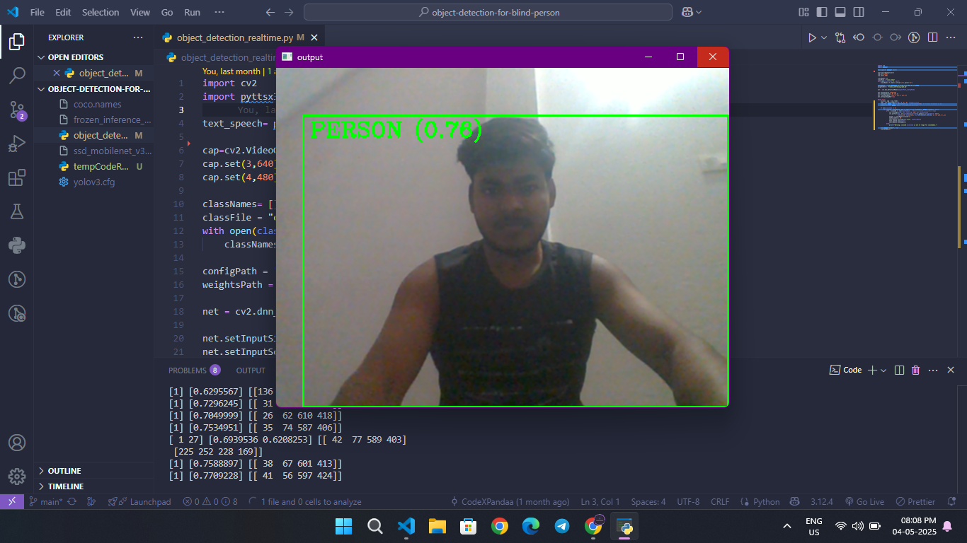
Fig. 8.1: Real-time object detection with bounding boxes.

8.2 Terminal Output for Detected Objects
Description:
Detected object names and confidence scores printed on the console.

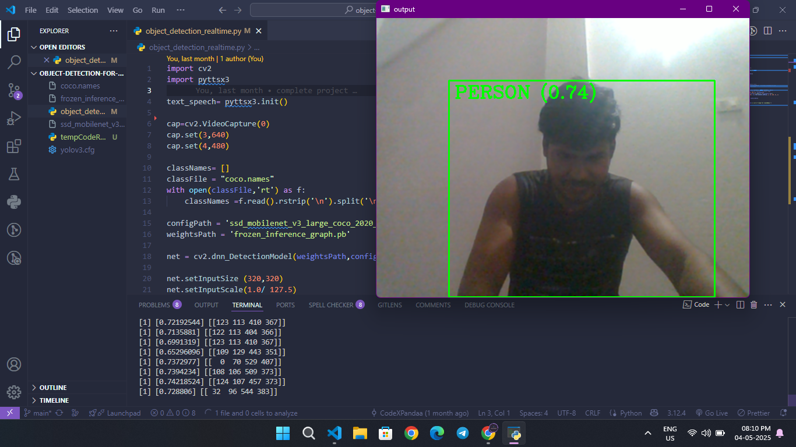
Fig. 8.2 : Detection logs in terminal.

CHAPTER 9

REFERENCES
- Redmon, J., Divvala, S., Girshick, R., &Farhadi, A. (2016). "You Only Look Once: Unified, Real-Time Object Detection," in Proceedings of the IEEE Conference on Computer Vision and Pattern Recognition (CVPR), pp. 779-788.
- Howard, A. G., Zhu, M., Chen, B., Kalenichenko, D., et al. (2017). "MobileNets: Efficient Convolutional Neural Networks for Mobile Vision Applications," arXiv preprint arXiv:1704.04861.
- Bradski, G. (2000). "The OpenCV Library," Dr. Dobb's Journal of Software Tools.
- Pyttsx3 documentation – https://pyttsx3.readthedocs.io
- TensorFlow Documentation – https://www.tensorflow.org
- OpenCV Documentation – https://docs.opencv.org
- Object Detection with YOLOv5 – https://github.com/ultralytics/yolov5

BRIEF PROFILE OF STUDENT
Name:Abhinav Singh
Enrollment Number : 23020004005
Course: B.Tech in Computer Science & Engineering
College: Satyug Darshan Institute of Engineering and Technology
Project Title: Object Detection for the Visually Impaired
Industry/Faculty Guide: Ms. Nikita
Email ID:abhinavsingh.cse23@satyug.edu.in
Contact Number:9971076701

