Exam is closed-book, closed-friends and closed-internet. All code has to be developed from scratch, no copy and paste. You may use your own memory-sheet (one sheet, front and back).

1] 1pt. Write a program to print powers of two (1, 2, 4, 8, 16, 32…) from 1 and lesser of 200, using a while loop.
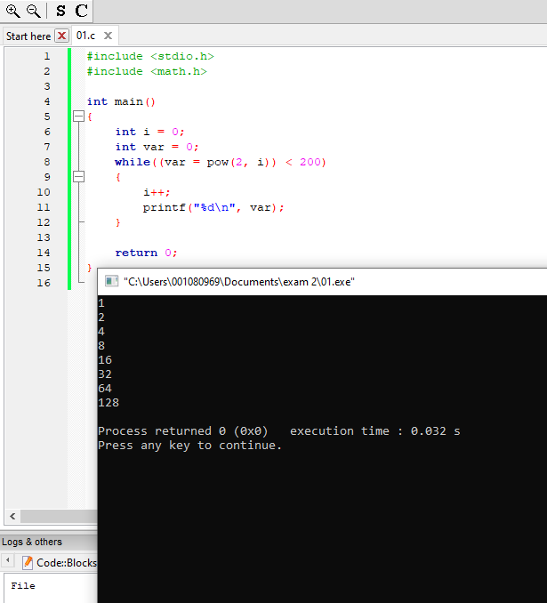

2] 1pt. Spot the mistake(s):
int a[50]={0}, i,c;
for( i=0; i<50; i++ ){
if( a[i]==0 )
a[i]=3*i+1;}
for( c=0; c<50; i++ )
printf( "%5d", a[i] );
printf( "\n\n" );

There is nothing wrong with the syntax of this code, it runs fine.
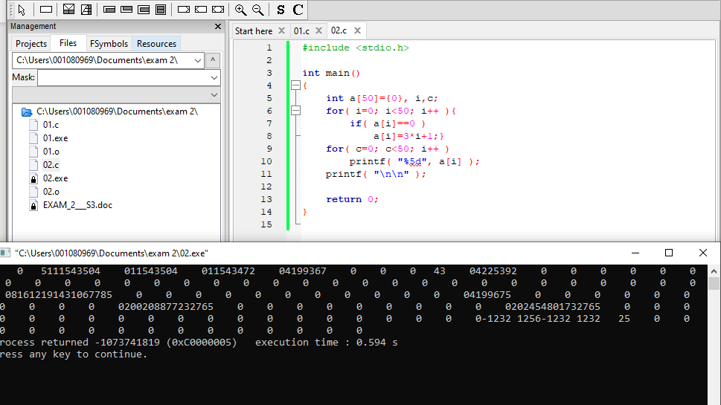
It needs the “#include <stdio.h>” to use the “printf()” functions.
It needs the “int main() {}” to run the code.
It does need a “return 0;”
The “}” on line 4 should be on its own line, or you could remove the pair (including the “{“ on line 2 as well), as it is unnecessary.

3] 1pt. What does this program print?
int s=1, c, arr[5] = {1, 2, 2, 1, 2};
for (c = 0; c < 5; c++ )
if( arr[c]-1 )
arr[c]=3;
for( c=0;c<=4;c+=1 )
s*=arr[c];
printf("%d\n", s);

The code will print 27, here is my rationalization for this:
int s=1, c, arr[5] = {1, 2, 2, 1, 2};
// for each element in arr that is > 1 set equal to 3.
for (c = 0; c < 5; c++ )
if( arr[c]-1 )
arr[c]=3;
// arr at this point is {1, 3, 3, 1, 3}
// s is then multiplied by each element in arr
// 1 -> 1 -> 3 -> 9 -> 9 -> 27
for( c=0;c<=4;c+=1 )
s*=arr[c];
// prints 27 followed by new line
printf("%d\n", s);

4] 1pt. Write C statements to do the following:

a. Declare an array mydata of type float, initialized with 1.1, 2.2, 3.3 but with space for one more number.

float mydata[4] = {1.1, 2.2, 3.3};

c. Set the value of the index 3 to be the sum of data in 1st position and 2nd position.
mydata[3] = mydata[0] + mydata[1];
f. Output mydata, only values greater than 2.5 having 6 spaces for each number, with two decimals.
for(int i = 0; i < 4; i++)
if(mydata[i] > 2.5)
printf(“%6.2f\t”, mydata[i]);
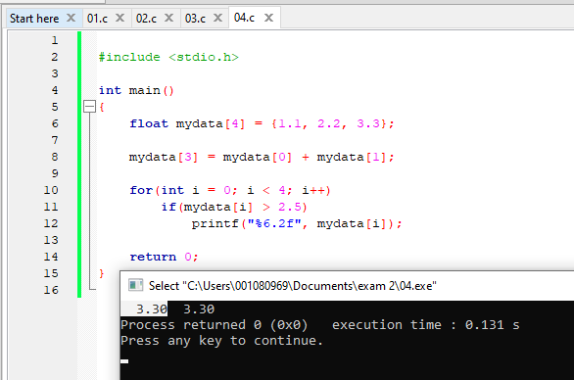
5] 2pt. Write a complete C program to declare and initialize an 8x8 matrix with this pattern of elements. Remember to keep inside the limits of the rows and columns. Do not initialize in the declaration. For printing, use a function, passing the matrix and the dimensions (8 and 8). There is a sequence: 3, 4, 3, 4, 3, 4….

2 | 2 | 2 | 3
2 | 2 | 4 | 2
2 | 3 | 2 | 2
4 | 2 | 2 | 2

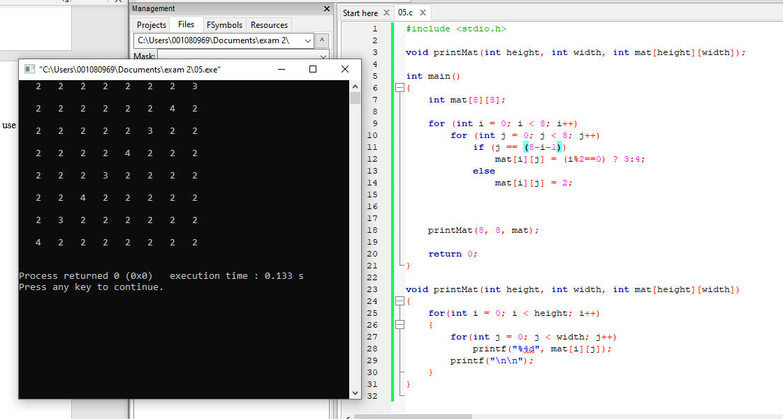
6] 1pt. What is the output of this program? (explain in your own words when the actual values are not known, like address_of_a[2]).

#include <stdio.h>
int *p, *q, b, c;
int a[5]={7,6,5,4};
int main() {
p = a;
b = *(p+4);
q = a+3;
c = q[0];
*(a+1) += a[b];
printf("%d %d %d %d %p\n", *q, b, p[b+1], c, q );
return 0;
}

#include <stdio.h>
// p and q are pointers to integers, b and c are integers.
int *p, *q, b, c;
// a is an array (or pointer to first element) of 5 integers.
int a[5]={7,6,5,4};
int main() {
// pointer p now points to the first element in a
p = a;
// b is now equal to the 5th element (4th index) of a, which is 0
// because the array was initialized, so all other elements are 0.
b = *(p+4);
// q now points to the 4th element (3rd index) of a, which is 4.
q = a+3;
// c is now equal to 4, which is what q was pointing towards.
c = q[0];
// take the value stored at the 2nd element (1st index) of a,
// which is 6, and add the 0th (which is what b was equal to)
// index (1st element), with a value of 7, of a to it.
*(a+1) += a[b];
// This will print "4, 0, 13, 4, address of the 4th element (3rd index)
printf("%d %d %d %d %p\n", *q, b, p[b+1], c, q );
return 0;
}
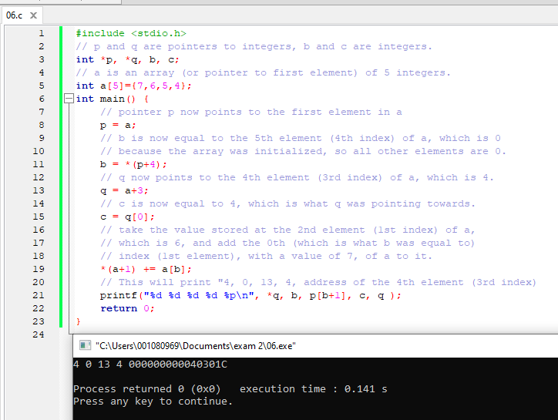
7] 1pt. Identify the errors in the following fragment of code:

char c, b[]={ 'h', 'e', 'l', 'l', 'o' }; // no null character in
// the array. This is a bad string.
int j=sizeof( b ); // No error, j is now 5

c = b[j-2]; // No error, c is now ‘l’
*(b+j-1) = 5; // No error, b[4] is now ASCII code 5
*(b+j) = 'W'; // This is out of bounds, unknown address.
*b + j = 45.1; // Nothing to assign 45.1 to, this errors
b+=1; // b will always point to the first address
// in the array, therefore this is invalid

8] 2pt. Write a function "words" that takes a string as the only argument and will return the number of words at the string (number of spaces plus one):
int main() {
char name[] = "He said howdy to all";
printf( "%d\n", words( name ) );
}
Demonstrate it by printing the number of words in the main function.
