1)

Req = 940k

Req,min = 900k

Req,max = 980k

Matlab:

Req,min = 901.9k

Req,max = 977.8k

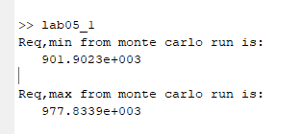

Multimeter:

929.65k

2)

Req = 235k

Req,min = 225k

Req,max = 245k

Matlab:

Req,min = 225.2k

Req,max = 244.7k

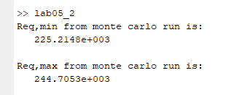

Multimeter:

232.28k

3)

Req = 313.332k

Req,min = 300k

Req,max = 326.667k

Matlab:

Req,min = 300.9k

Req,max = 325.0k

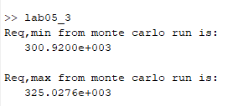

Multimeter:

312.32k