**Books/Authors with Templates**

Objectives:

* Practice incorporating a many-to-many relationship in a full-stack application

Using the same project from the previous assignment, create an application that does the following:

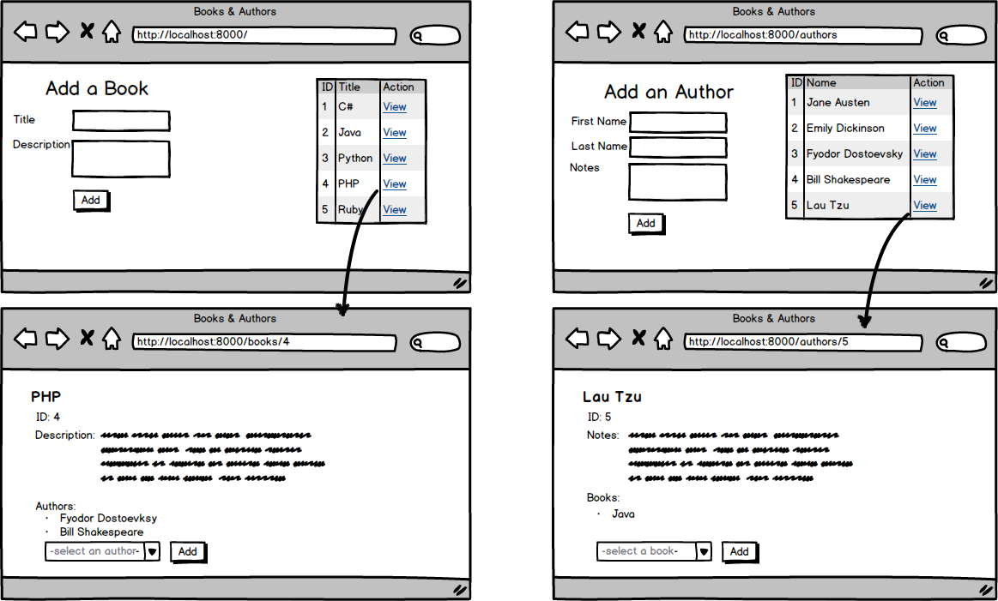

* Top of Form
* Add a template for creating books that also displays a table of all books in the database
* Complete the route for adding a book to the database
* Add a template that displays a specific book and its details, including all the authors associated with the given book
* Create a form on the specific book template that has a dropdown of all the authors in the database. The "Add" button should add the selected author to the given book.
* Add a template for creating authors that also displays a table of all authors in the database
* Complete the route for adding an author to the database
* Add a template that displays a specific author and its details, including all the books associated with the given author
* Create a form on the specific author template that has a dropdown of all the books in the database. The "Add" button should add the selected book to the given author.
* SENSEI BONUS: Have the dropdown menus only include authors or books not yet associated with the given book or author, respectivelyBottom of Form