**Internet**

For this assignment, we want you to watch how many times you're using <div> tags. Whenever you have one element within a division, it means you don't need that division! For example, imagine you had a code like this

*<div id="banner">*

*<h1>Word Stream</h1>*

*</div>*

*<div id="left_nav">*

*<div class="title">*

*<h3>WordStream for PPC</h3>*

*</div>*

*<div class="heading">*

*<div class="emphasis">Drive more Profits Through PPC!</div>*

*</div>*

*</div>*

By looking at the code above, can you identify unnecessary divisions? We hope so! Again, whenever you have one element inside a division, it means that's redundant! Think about how you can refactor the code above to make it simpler. One possible way to refactor the code is to do something like below

*<h1 id="banner">Word Stream</h1>*

*<div id="left_nav">*

*<h3>WordStream for PPC</h3>*

*<h4>Drive more Profits Through PPC!</h4>*

*</div>*

**Great programmers always do things with less code**, and we want you to practice reviewing your code and always striving to do things in the most simple manner possible. Fewer lines of code -- less text -- this is always better. Please remember that.

Now, duplicate the page below while considering what you've learned above.

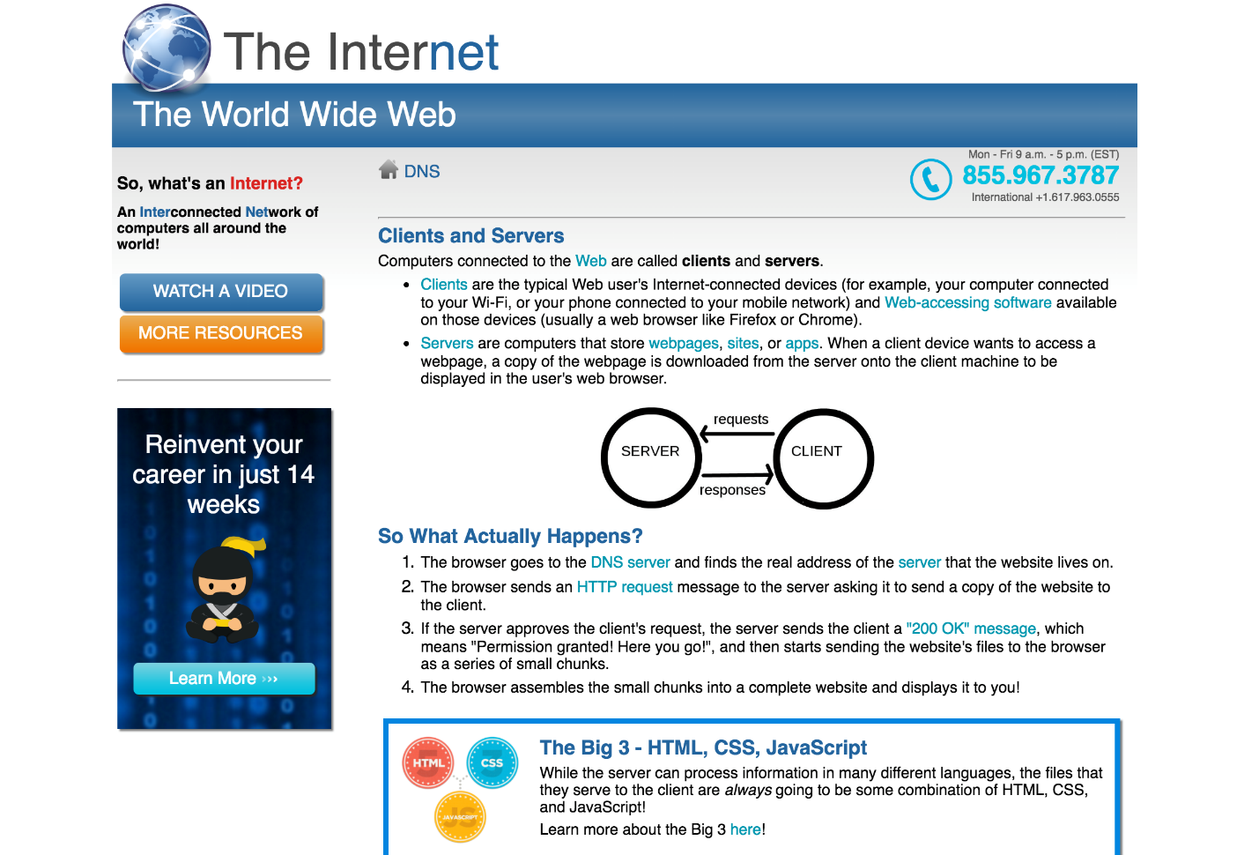

* It's recommended that you reset and normalize the CSS attributes before you add your own CSS attributes.
* Make sure you've validated your HTML and that you're not using any float: left or right.
* Make sure you double checked your code for any redundant use of ids or classes. Make sure you don't have any single element within a division.
* Refactor your HTML code, if necessary.
* Top of Form
  + Work on the exercise above and upload your code here. You may put your HTML, CSS and image files in one folder and have that folder be compressed/zipped before uploading.

Bottom of Form