**Languages**

For this assignment you need to create a CRUD application for a language dashboard.

* name: Min char 2, Max char 20
* creator: Min char 2, Max char 20
* currentVersion: Cannot be empty

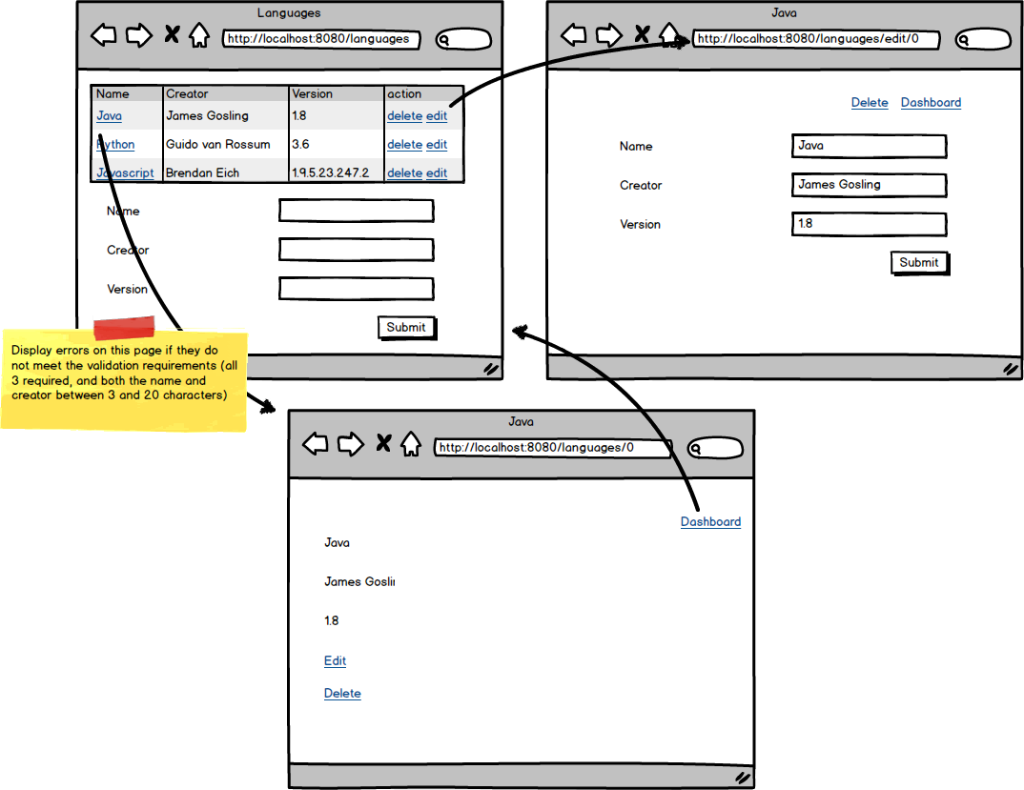

Topics:

* Data Persistence
* CRUD

Tasks:

* The GET /languages route should show a table of all the languages with links to edit and delete the languages; also include a form for creating new languages.
* The POST /languages routes should create a language.
* The GET /languages/{id} route should return the specific language and details.
* The GET /languages/{id}/edit route should show the edit page to of a specific language
* The PUT /languages/{id} route should should update a language
* The DELETE /languages/{id} route should delete the specific language at that id.
* All routes should be validated and show errors.
* Data must persist across reloads in a MySQL database.