**Playground**

Objectives:

* Get comfortable passing information from the route to the template
* Understand how to display information passed from the route in the template file
* Get comfortable using for loops in the template file
* Get comfortable using if statements in the template file

Internal Styling

*Just for this assignment*, use an internal stylesheet or inline CSS ([review here](https://www.w3schools.com/css/css_howto.asp)).

Level 1

When a user visits **http://localhost:5000/play**, have it render three beautiful looking blue boxes. Please use a template to render this.

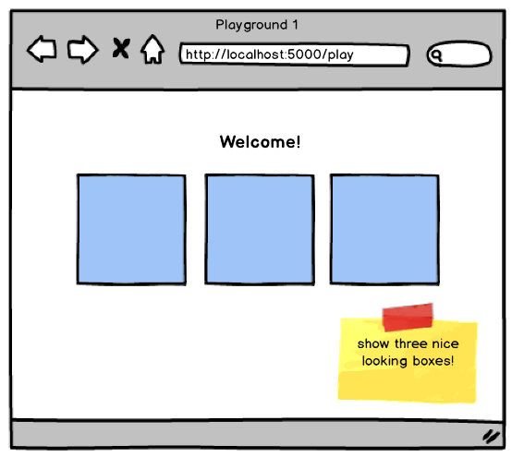

Level 2

When a user visits **localhost:5000/play/(x)**, have it display the beautiful looking blue boxes x times. For example, localhost:5000/play/7 should display these blue boxes 7 times. Calling localhost:5000/play/35 would display these blue boxes 35 times. Please remember that x originally is a string, and if you want to use it as an integer, you must first convert it to integer using int(). For example int("7") returns 7.

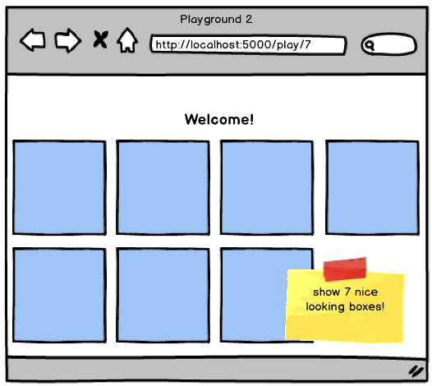

Level 3

When a user visits **localhost:5000/play/(x)/(color)**, have it display beautiful looking boxes x times, but this time where the boxes appear in (color). For example, localhost:5000/play/5/green would display 5 beautiful green boxes. Calling localhost:5000/play/35/red would display 35 beautiful red boxes.

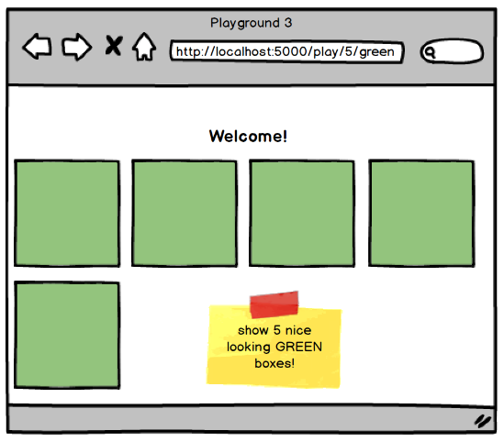

* Top of Form
* Create a new Flask project
* Have the /play route render a template with 3 blue boxes
* Have the /play/<x> route render a template with x number of blue boxes
* Have the /play/<x>/<color> route render a template with x number of boxes the color of the provided value
* NINJA BONUS: Use only one template for the whole project

Bottom of Form