**Tabs**

Develop a tabs component that will take in an array of items. Each item will have a label and a content property. When you click on each individual tab header, it should change the state of the tabs so that the correct content is displayed.

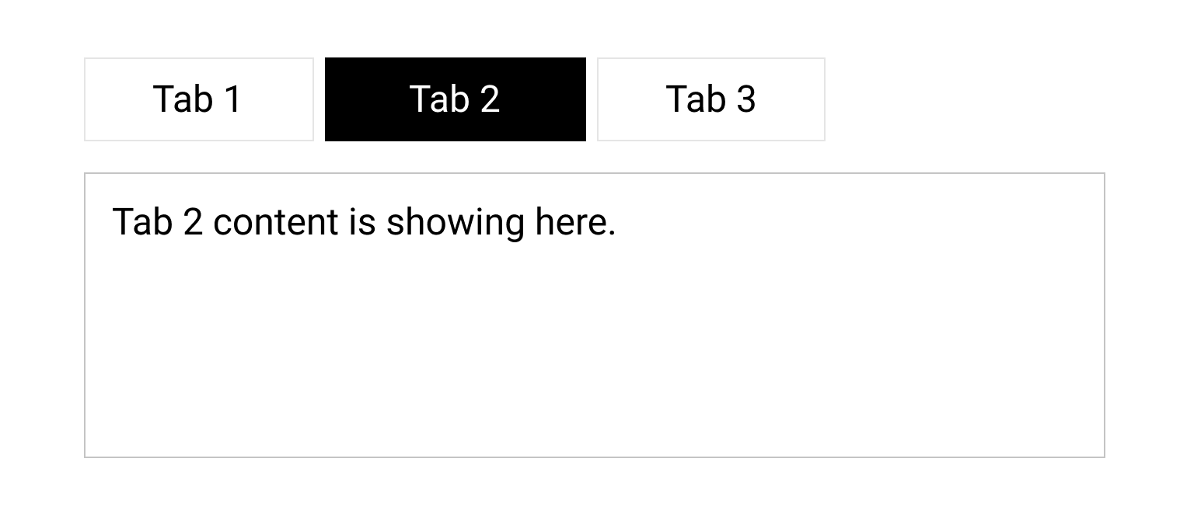

* Top of Form
  + Create a tabs component that accepts an array of varying length.
  + Have the tab headers, when clicked on correctly show the appropriate content below.
  + Ninja Bonus: Allow each tab to optionally have a callback which gets fired when the relevant tab header is clicked.
  + Ninja Bonus: Add some CSS animations to the tab switching to smooth out the user experience.
  + Sensei Bonus: Add a JavaScript animation to the tab switching action.

Bottom of Form