Forest Fire Program Flowchart
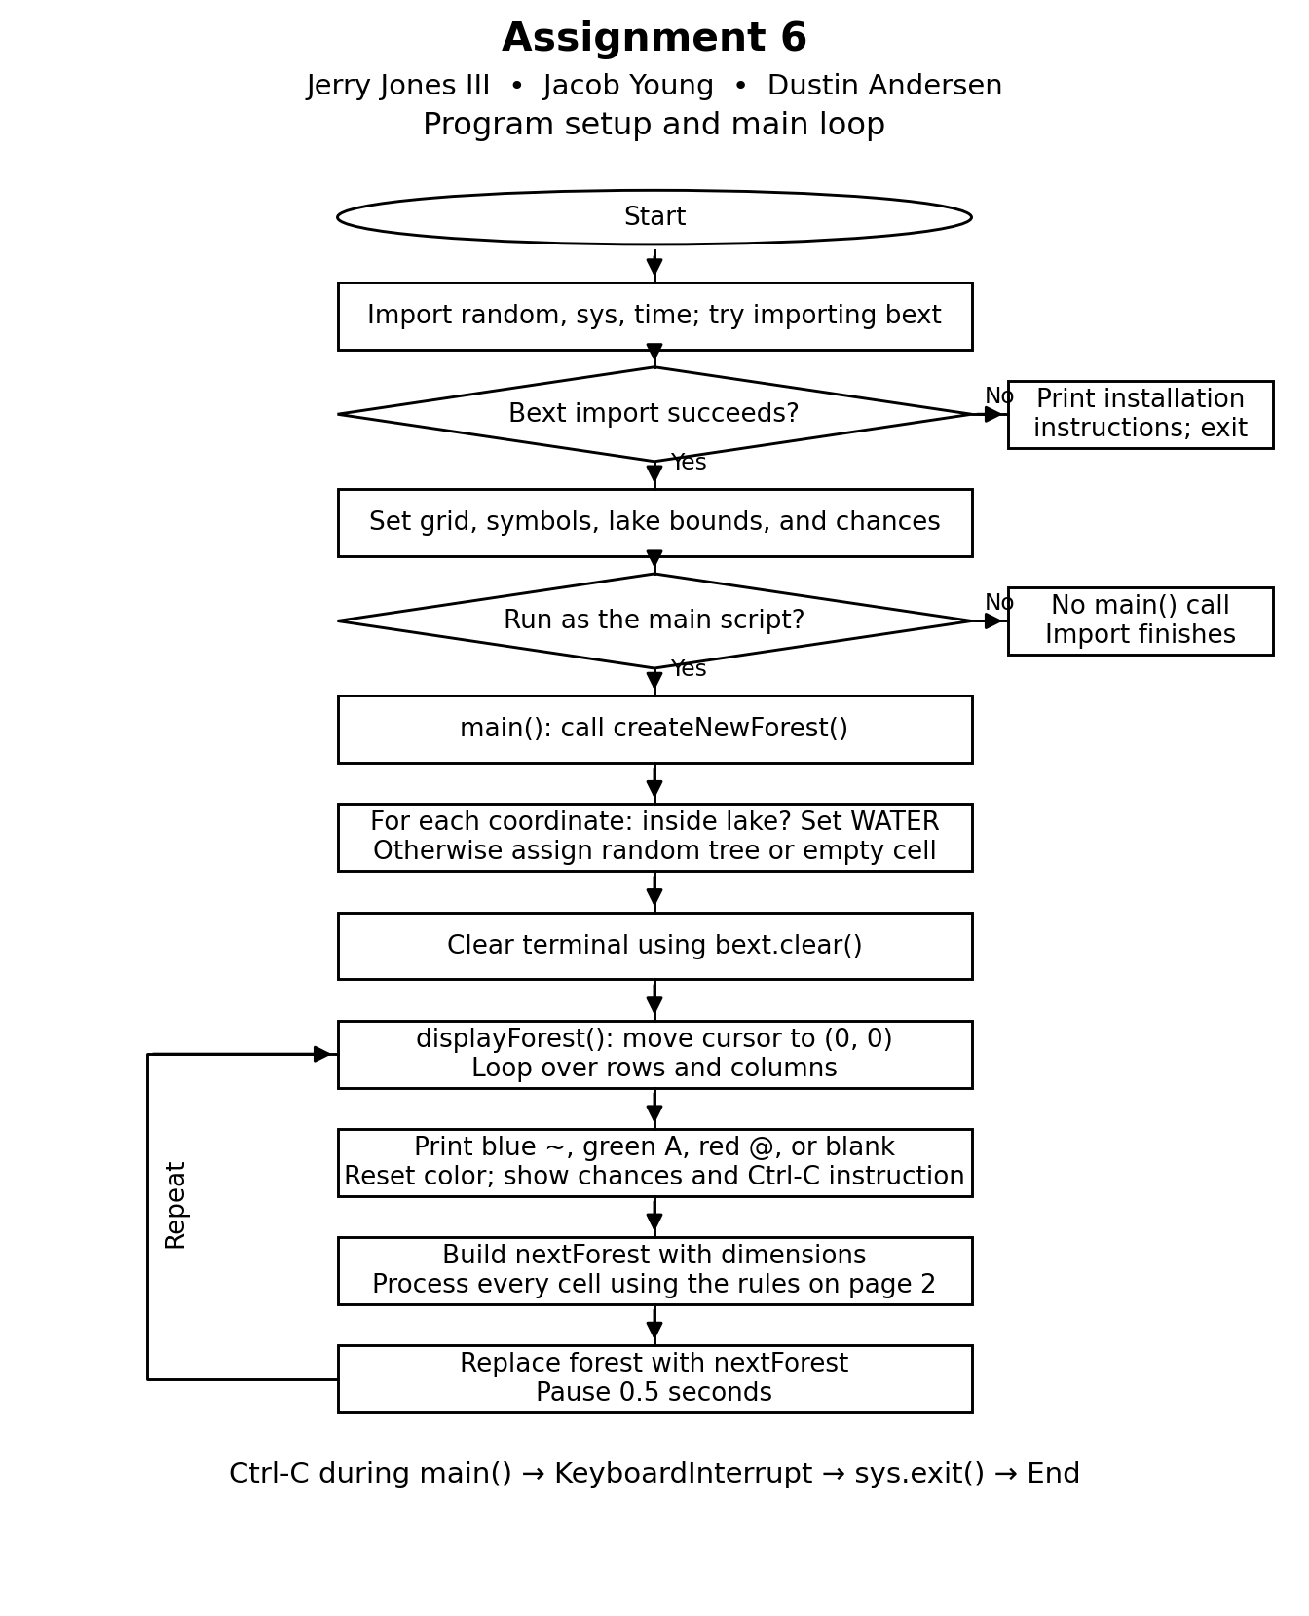

Forest Fire Cell Update Flowchart
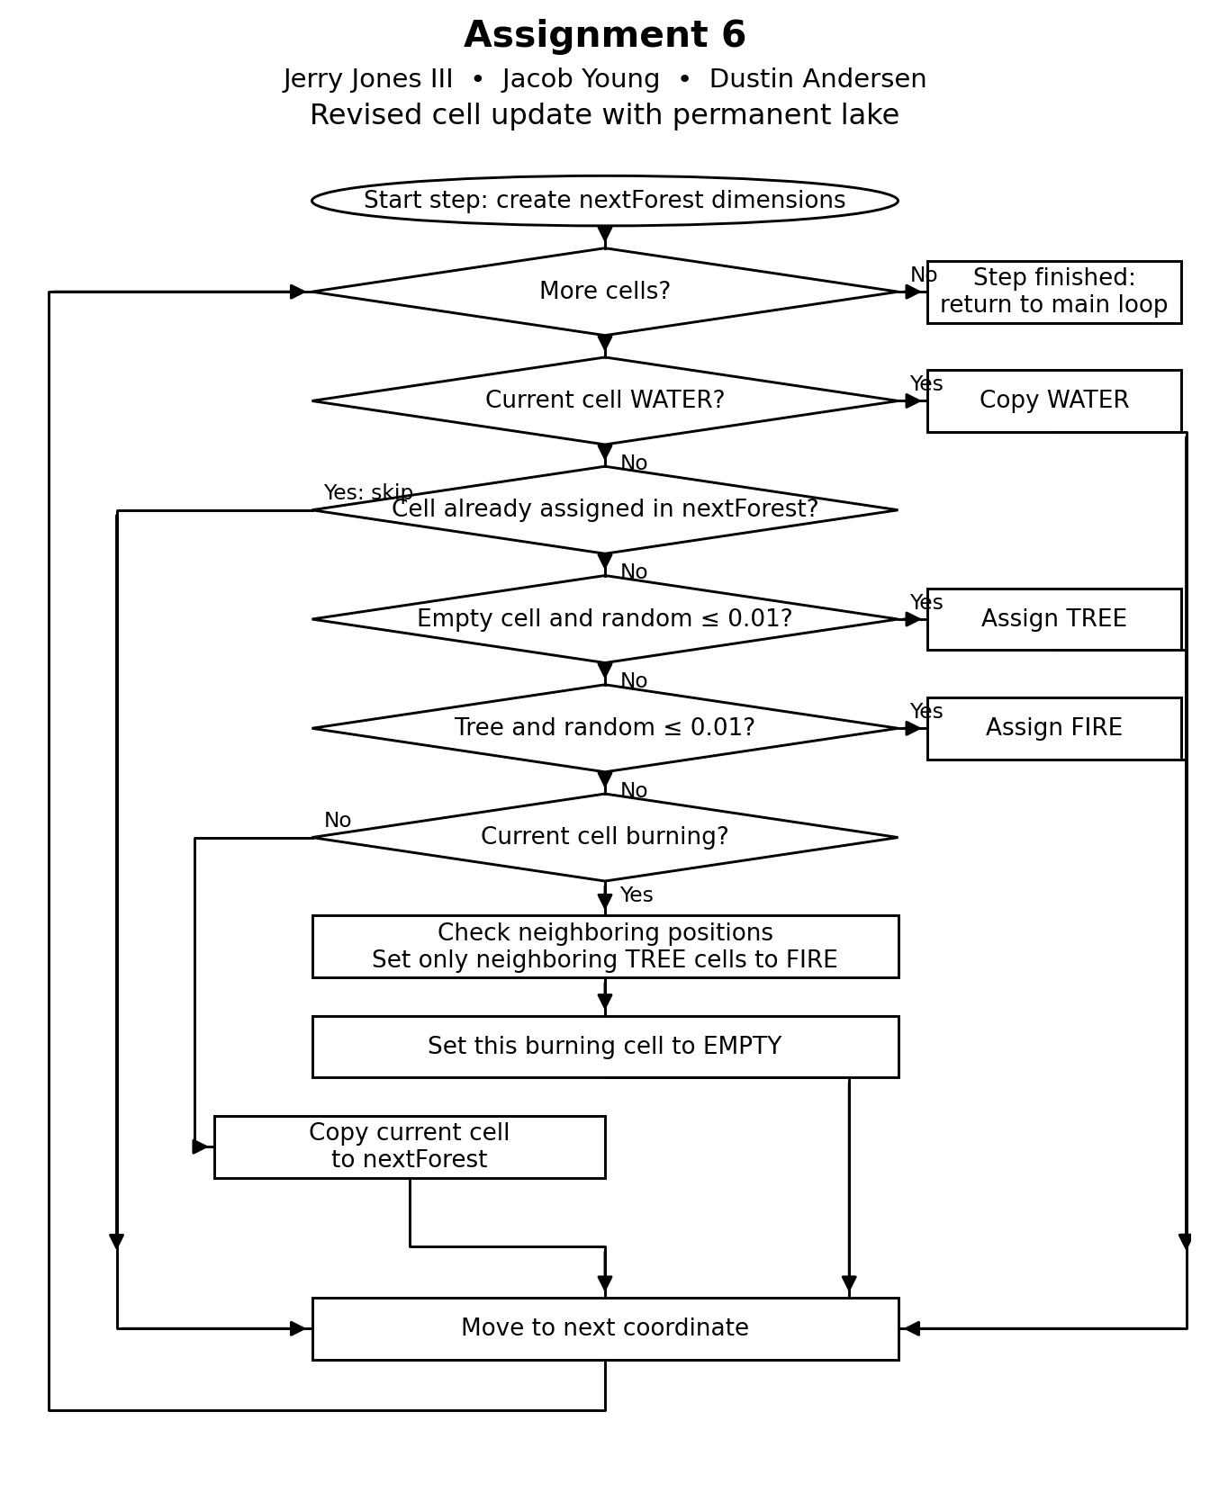

Permanent Lake Rules
Assignment 6
Jerry Jones III, Jacob Young, Dustin Andersen
The revised simulation adds a permanent blue lake to the center of the forest. Water cells use the ~ character. The simulation still shows trees as green A characters and fire as red @ characters.

Lake placement
The lake is 19 columns wide and 8 rows high. In the 79 by 22 display, it occupies x coordinates 30 through 48 and y coordinates 7 through 14. Each cell inside these bounds starts as WATER. Other cells use the original random tree and empty-space rules.

Water protection and fire spread
During every update, WATER cells are copied directly into nextForest and skipped before any growth, lightning, or burning rules run. Trees cannot grow in the lake, and lightning cannot ignite it. When a burning tree checks its neighbors, only TREE cells can become FIRE, so water cannot burn or be overwritten by spreading fire.
Fire spreads only to adjacent cells, including diagonal neighbors. It cannot jump over or travel through the lake. Fire can still move around the shoreline, and separate lightning strikes can start new fires on either side.

Remaining simulation rules
After the water check, already assigned coordinates are skipped. Empty cells have a 1 percent growth chance, trees have a 1 percent lightning chance, burning cells spread to neighboring trees and become empty, and other cells keep their state. The completed nextForest replaces the current forest, followed by a 0.5 second pause. Ctrl-C exits.

Verification
Checks cover lake placement, permanent water through repeated updates with growth and lightning set to 100 percent, fire isolation across a water strip with lightning disabled, and blue rendering of the ~ character.

Run in a terminal
Install Bext if needed with py -m pip install bext. Run py forestfiresim.py from the folder containing the program. Press Ctrl-C to stop.

