Dustin Andersen
Assignment 8

Student JSON Flowchart
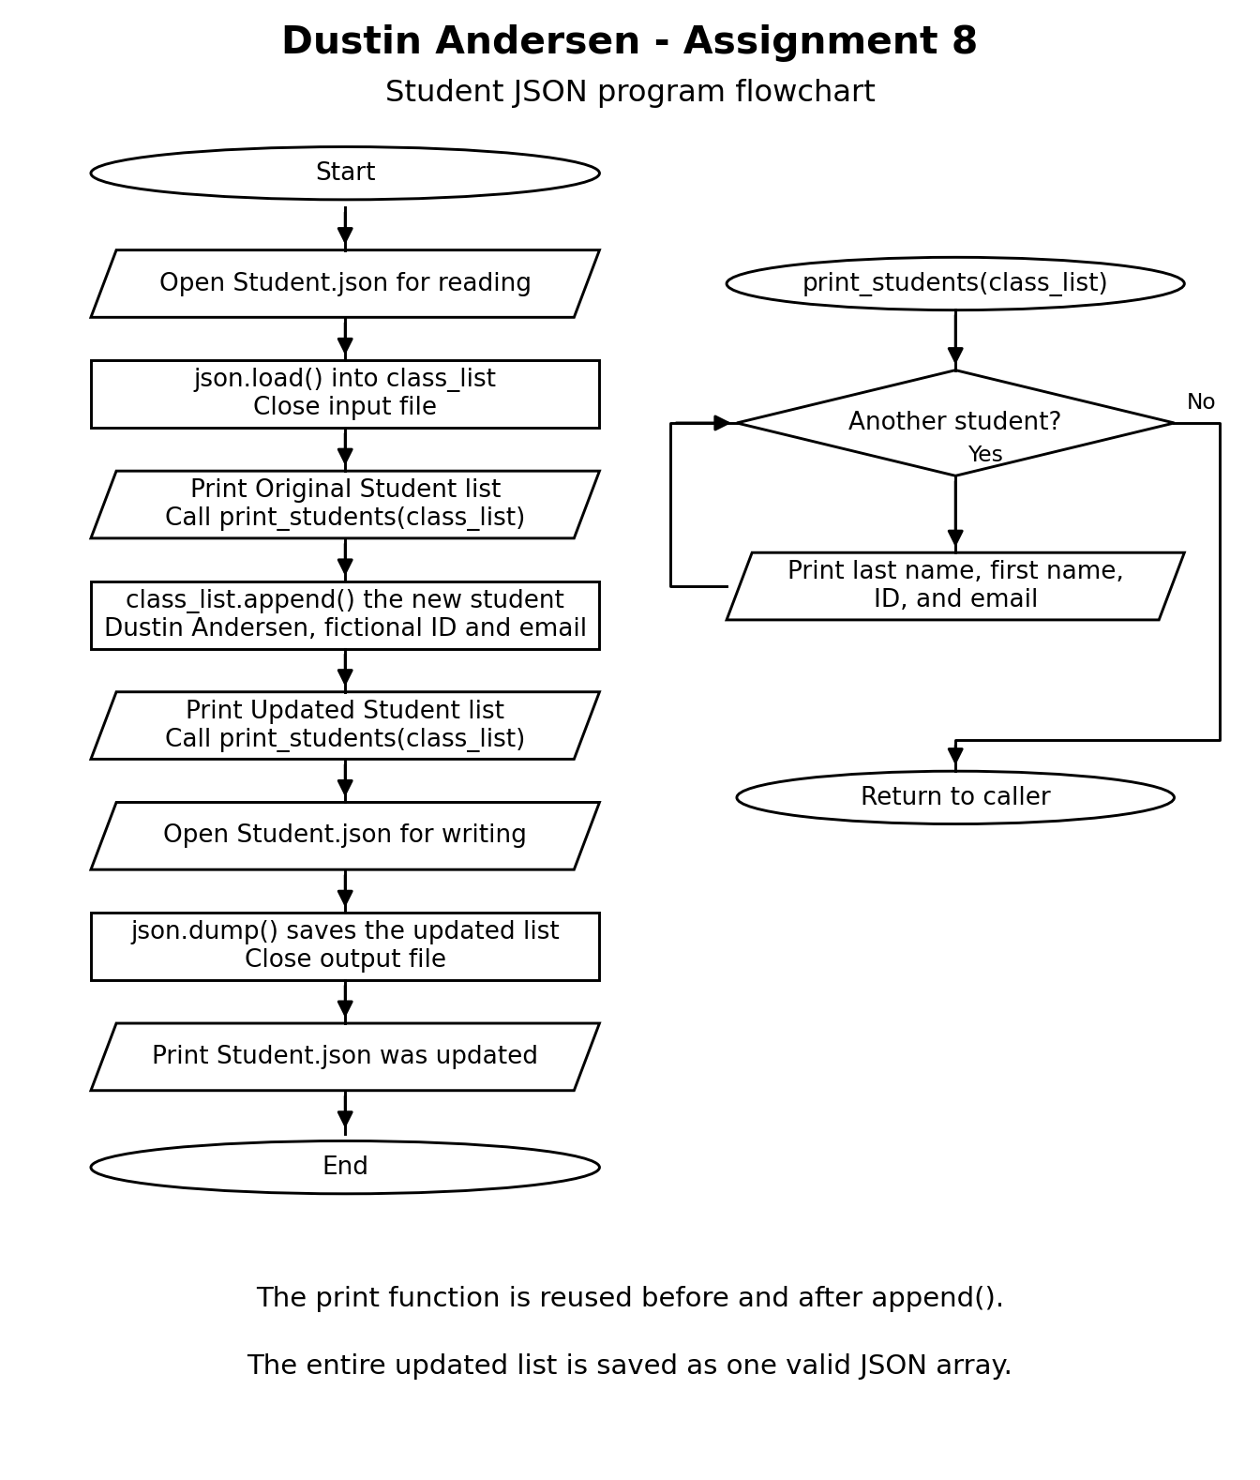

Program Results
The program loads the original four records using json.load(), prints them, appends a fictional student entry with list.append(), prints the updated five-record list, and saves it using json.dump().

Captured command output
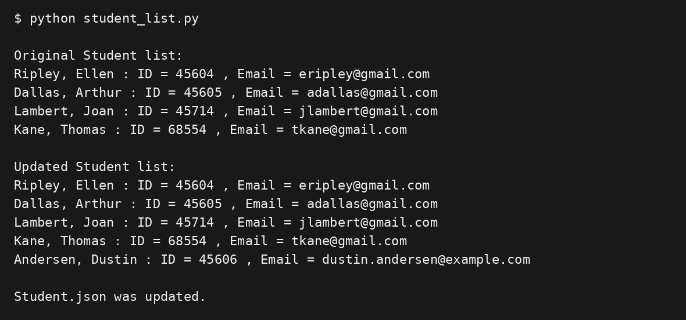
The added ID 45606 and email dustin.andersen@example.com are fictional. The updated file was reopened to verify that it contains valid JSON and preserves all four original records.

Editor file change notification
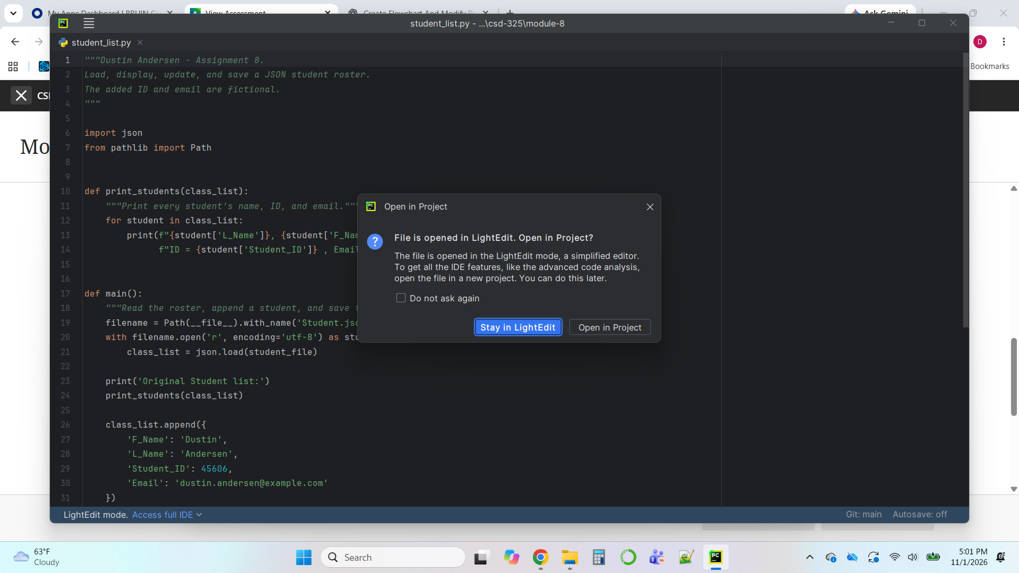
Open Student.json in your editor before running the program. Run the program from a terminal, then return to the editor. If it reports that the file changed outside the editor, capture the notification before choosing how to reload or save. Some editors reload automatically; the Python save confirmation is separate from this editor notification.
To reproduce the original four-record output, start with a fresh copy of the attached Student.json. Each program run appends one entry. Keep student_list.py and Student.json in the same folder.

Updated JSON Contents
Contents of Student.json after the first run
[
{
"F_Name": "Ellen",
"L_Name": "Ripley",
"Student_ID": 45604,
"Email": "eripley@gmail.com"
},
{
"F_Name": "Arthur",
"L_Name": "Dallas",
"Student_ID": 45605,
"Email": "adallas@gmail.com"
},
{
"F_Name": "Joan",
"L_Name": "Lambert",
"Student_ID": 45714,
"Email": "jlambert@gmail.com"
},
{
"F_Name": "Thomas",
"L_Name": "Kane",
"Student_ID": 68554,
"Email": "tkane@gmail.com"
},
{
"F_Name": "Dustin",
"L_Name": "Andersen",
"Student_ID": 45606,
"Email": "dustin.andersen@example.com"
}
]

