Forest Fire Program Flowchart
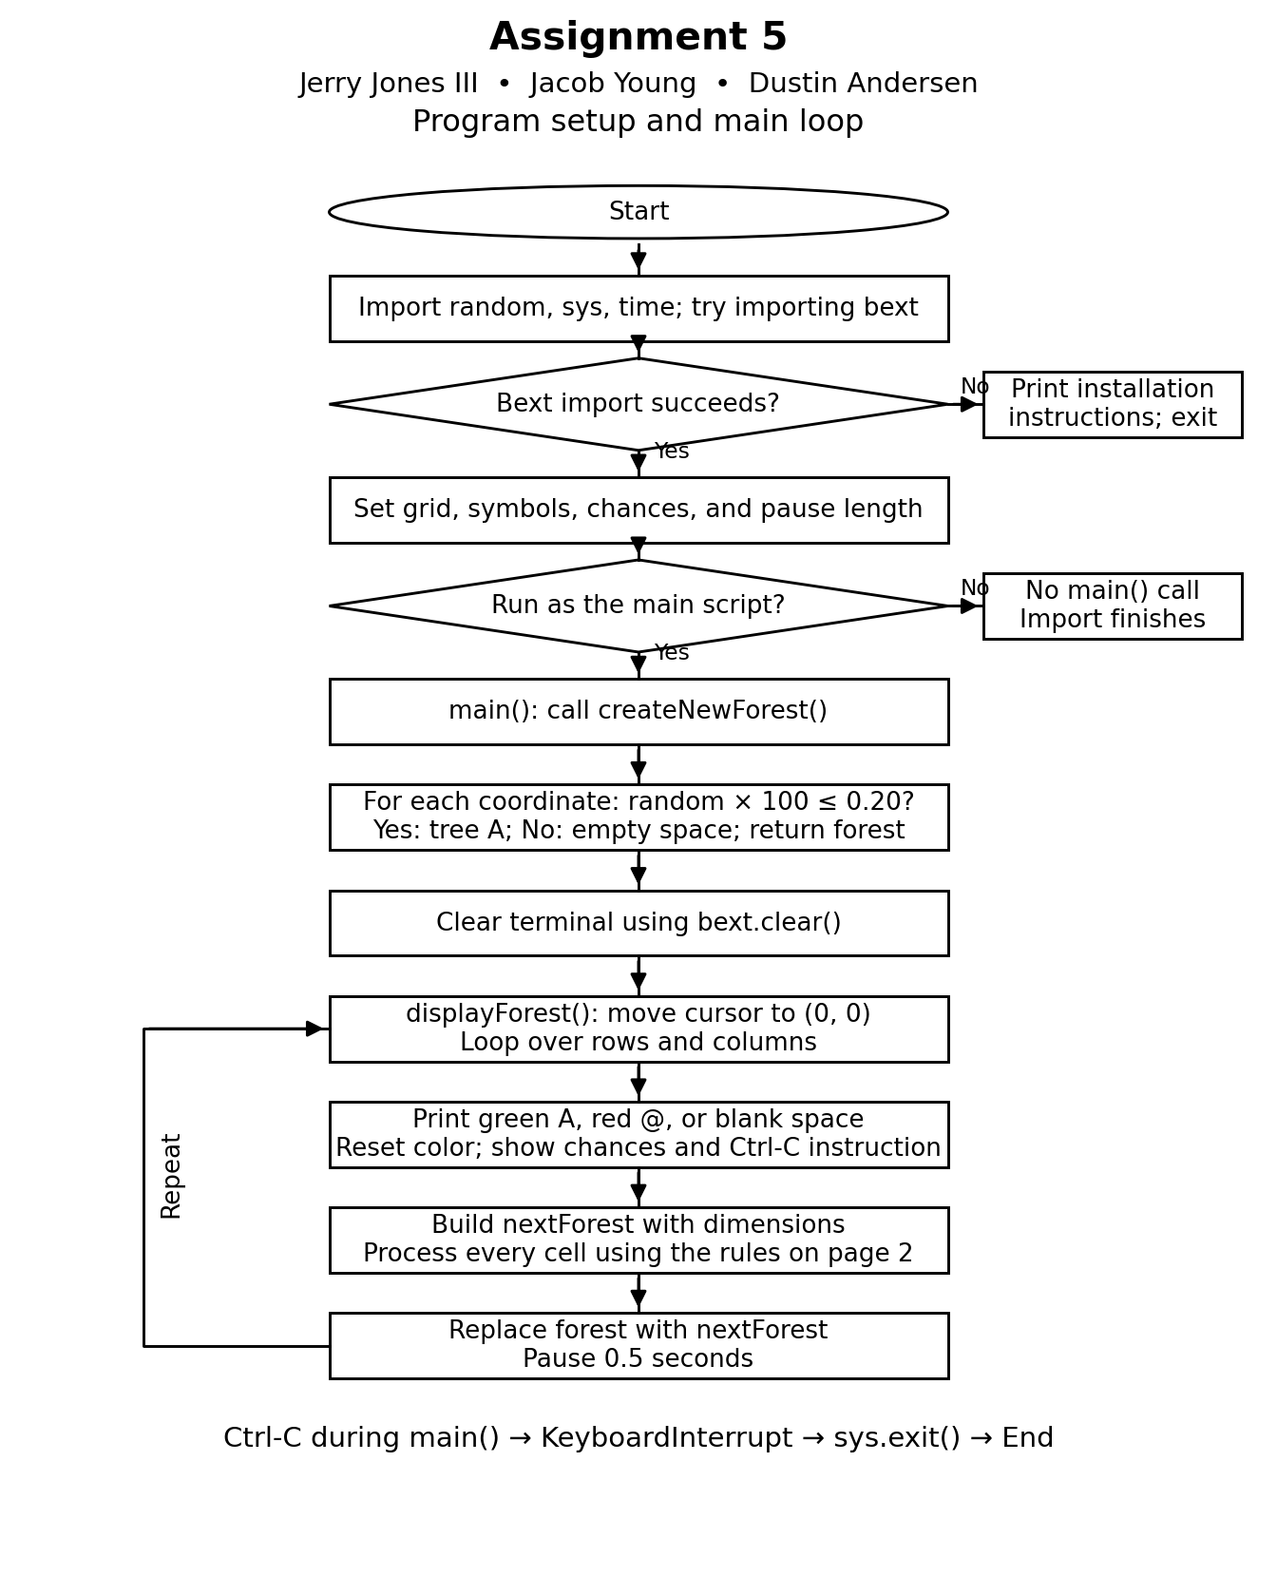

Forest Fire Cell Update Flowchart
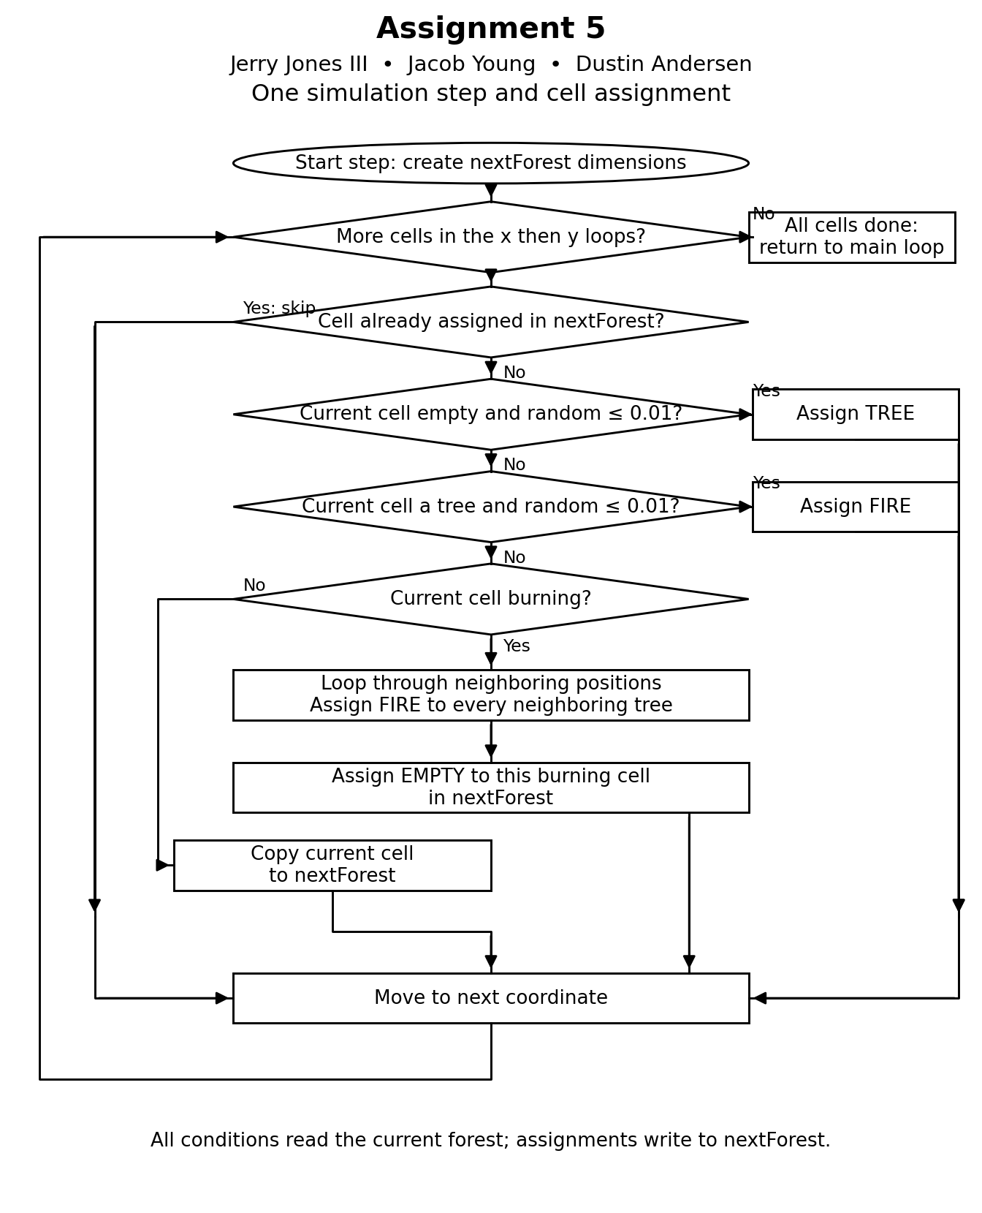

Forest Cell Assignment Rules
Assignment 5
Jerry Jones III, Jacob Young, Dustin Andersen
The program represents a 79 by 22 forest with terminal character cells. A green A represents a tree, a red @ represents fire, and a space represents an empty cell. It displays the current forest, computes the next forest, and pauses for half a second before repeating.

Initial forest
Each coordinate begins as a tree or an empty space. The supplied condition is (random.random() * 100) <= 0.20, which gives about a 0.2 percent chance of a tree. The comment describing a 20 percent starting density does not match that calculation. No cell starts as fire. The flowcharts follow the supplied code without changing it.

Rules for each update
- If a coordinate is already assigned in nextForest, skip it. This preserves assignments made earlier during fire spread.
- An empty cell has a 1 percent chance to grow into a tree.
- A tree has a 1 percent chance of being struck by lightning and becoming fire.
- A burning cell sets neighboring trees on fire in nextForest. The neighbor loop checks all eight surrounding positions, including diagonals. The center offset is also checked, but the burning center is not a tree. Positions outside the grid return no tree.
- After spreading, the burning cell becomes empty.
- If no earlier condition applies, copy the existing cell into nextForest.
- After all coordinates are processed, replace forest with nextForest and pause for 0.5 seconds.

Randomness and stopping
Random starting positions, tree growth, and lightning cause different patterns between runs. Updates read the current forest and write to nextForest. Ctrl-C raises KeyboardInterrupt, which the program catches before calling sys.exit().

