Dustin Andersen
Assignment Number: Module 2 Assignment
Python Grade Calculator Debugging
For this assignment, I used the Python grade calculator program. I placed a breakpoint before the program called the calculate_grade() function and used the debugger to move through the code.
Breakpoint
I placed a breakpoint on line 14 and ran the program with a score of 85. The program stopped before calling the function, which let me check the value stored in score.
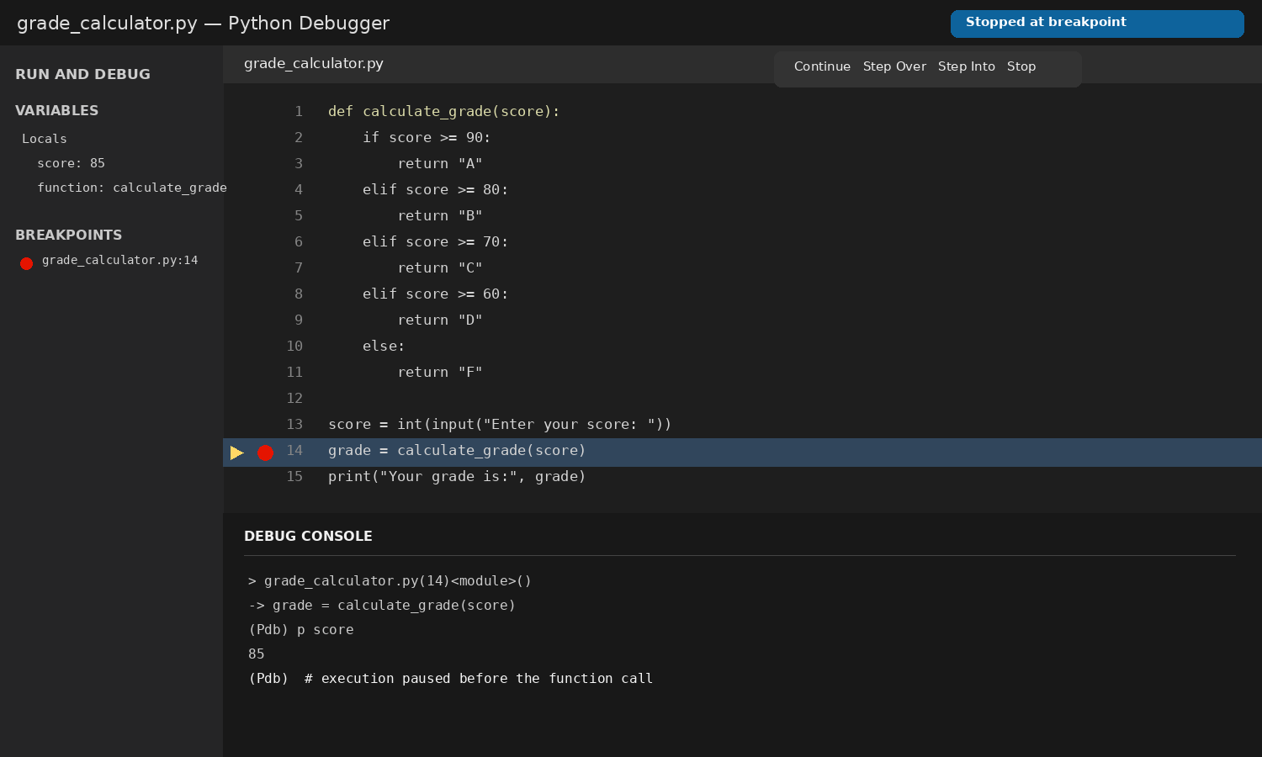
Screenshot 1: The program stopped at the breakpoint.

Step Into the Function
Next, I used Step Into. This moved the debugger inside calculate_grade() and stopped at the first if statement, where the program checked whether the score was at least 90.
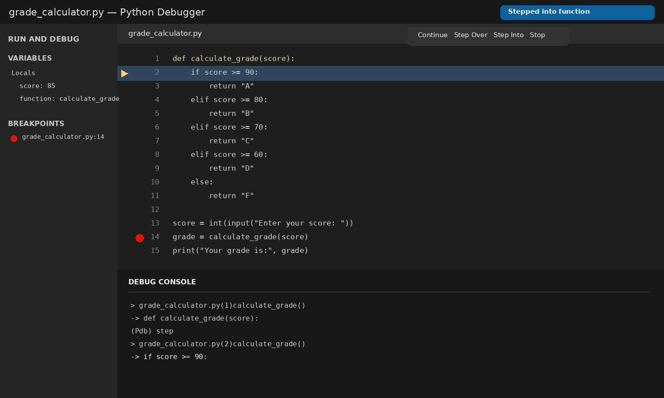
Screenshot 2: The debugger stepped into calculate_grade().

Moving Through the Program
I used the Next command to keep moving through the function. Since 85 is not at least 90, the program went to the next condition. Because 85 is at least 80, the debugger moved to return "B".
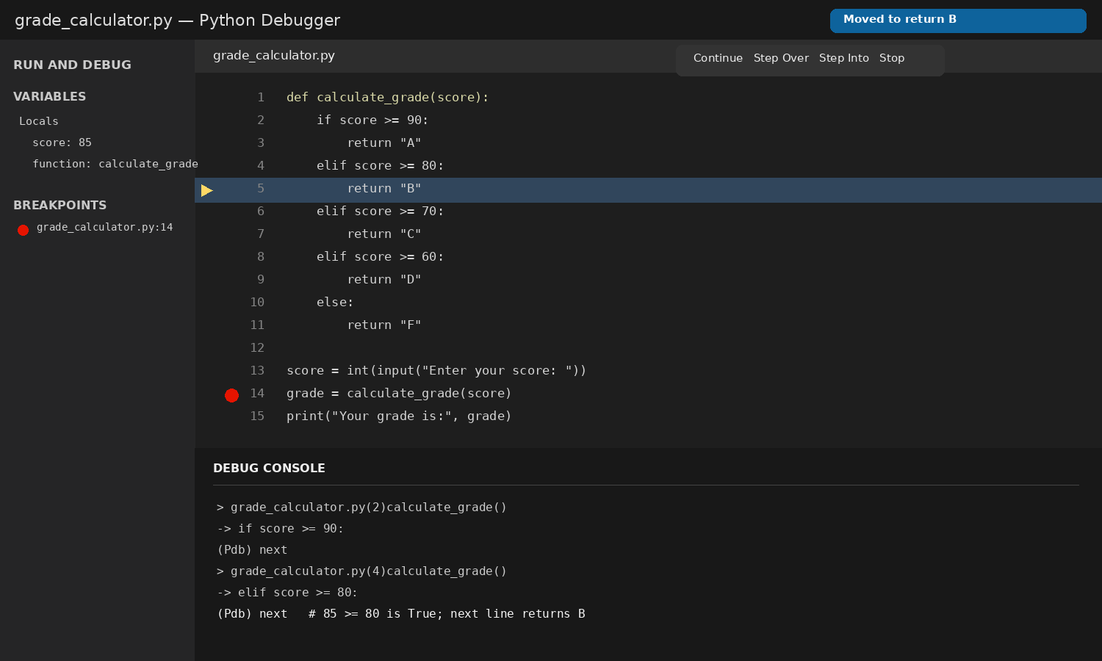
Screenshot 3: The debugger moved to the line that returns B.
This showed me how the debugger follows each condition in the function. The final grade for the score of 85 was B.

