Dustin Andersen
Assignment 7

City Function Testing
The following runs show the original city and country function, the errors caused by required parameters, and the passing tests after making those parameters optional.

Initial function output
Step 4: The function accepts a city and country. Three calls print three formatted strings.
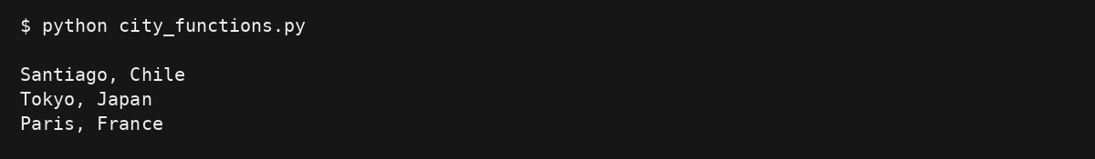

Original test passes
Step 5: test_city_country() checks that Santiago and Chile return Santiago, Chile.
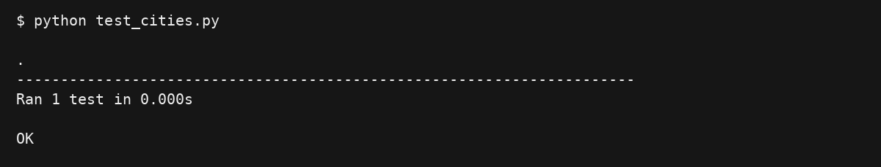

Population Parameter

Required population causes an error
Steps 6 and 7: city_country(city, country, population) requires population. The original two-argument test produces a TypeError because population is missing. unittest reports this as an error.
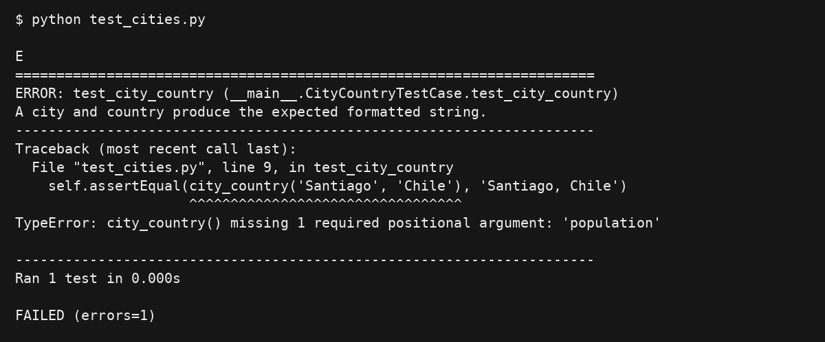

Optional population restores the passing test
Steps 8 and 9: Changing the signature to city_country(city, country, population=None) allows the original two-argument test to pass again.

Language Parameter

Required language causes an error
Steps 10 and 11: The intermediate signature is city_country(city, country, population=None, *, language). The keyword-only language parameter is required while population stays optional. The original test produces a TypeError because language is missing.
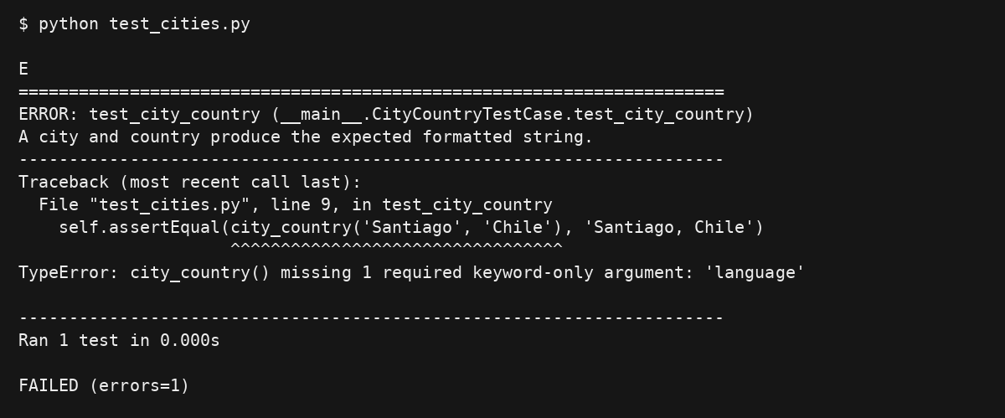

Optional language restores the passing test
Steps 12 and 13: The final signature is city_country(city, country, population=None, language=None). Both extra arguments are optional, so test_city_country() passes.

Final Program Output

Two three and four arguments
Step 14: The final program calls city_country() with city and country; then adds population; then adds population and language.
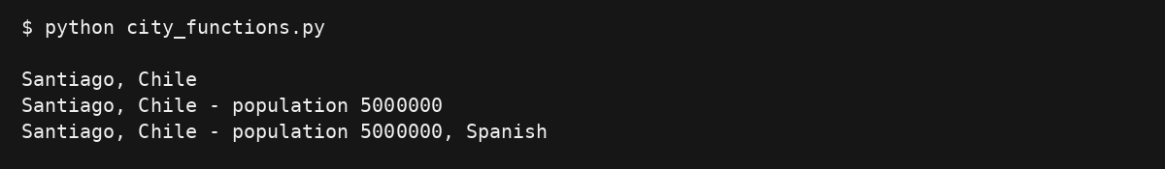

Final files
city_functions.py contains the final function and the three demonstration calls. The calls are inside an if __name__ == "__main__" block so they do not run when the test imports the function.
test_cities.py imports unittest and city_country, defines test_city_country(), and runs unittest.main() when executed directly. Keep both Python files in the same module-7 folder.

Run commands
python city_functions.py
python test_cities.py

