**Business Understanding**

Problem statement:

In this application, you will explore a dataset from Kaggle. The original dataset contained information on 3 million used cars. The provided dataset contains information on 426K cars to ensure speed of processing.  Your goal is to understand what factors make a car more or less expensive.  As a result of your analysis, you should provide clear recommendations to your client -- a used car dealership -- as to what consumers value in a used car.

**Data Understanding**

Reviewing the data we can find some issues with developing a model due to several factors I will summarize below:

* Some entries had a price of $0
* Data has units from 1905, but for most dealers that isn’t useful. I chose a cutoff of 1950
* Some units weren’t fully operational or were labeled missing
* The VIN number would not be helpful
* Region was removed and state was used to simplify the investigation
* Model was removed and used in favor of the manufacturer

As a first pass investigation I decided to keep the model to a simpler level but keep as many unique top-level categories as possible.

**Data Preparation**

I removed data that was problematic given the issues above then mapped the categorical data into Boolean (0, 1) so that a model could be created for it.

The categorical and continuous data was separated to see the impact they have on the data independently and this resulted in two end models.

**Modeling**

The two models were developed, and both give some intuitive insight on the price of used vehicles and what matters most.

Treating year as a numerical value I found that the optimum number of polynomials to use was 3 to keep the validation data set MSE lower.

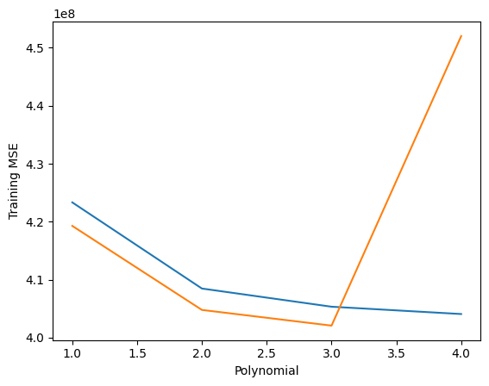

**Evaluation**

Below are some highlights for the plot

**Deployment**

Customers are most interested in the following types of cars:

* Excellent/Good/Like New Condition
* 4/6/8 cylinders
* Automatic/Manual Transmission
* SUV/Sedan/Truck Type
* Alternative/Electric Fuel type
* Rear Wheel Drive
* Luxury Car brands
* Newer models
* Lower milage

Next Steps

* Investigate region specific machine learning models
* Investigate car model specific machine learning models