Resume

Career Objective:

Self-motivated and hardworking person seeking for an opportunity to work in industrial sector to prove my skills and utilize my knowledge & intelligence in the growth of the organization.
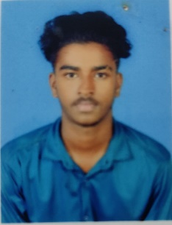

Shijo D.

Email: shijomass99@gmail.com Mob: +918667875609

Date of Birth:
17-04-2004

Gender:
male

Nationality / religion:
Indian/Christian

Languages:
Tamil, English, Malayalam

Co-Curricular Activities:
*Athletics
*Cricket
*Kabbadi
Academic Profile

Qualification | Institution | Year of Passing | Percentage of Marks
SSLC | St Fransis Xavier higher  secondary school ,  Manzhuly. | 2021 | 77%
HSC | VKB higher secondary school , Colachel | 2019 | 54%
Bachelor of Engineering (Mechanical Engineering) | Annai Vailankanni College of Engineering.  Pottalkulam. | 2025 | 6.5 cgpa

Extra-Curricular Act Software Proficiency

- Programming Languages : NXCAD, CAD, Python.
- Programming IDE: PRO E,CATIA
- Operating Systems: Fedora, Ubuntu, Windows.

STRENGT

- Consistenly Seeking and Learning New Technology.
- Thrive in Dynamic,Fast-Paced Environments.
- Familiar with UI Toolkits and Frameworks.
- Ability to grasp the new skills quickly.
- Excellent Communication skill.

Internship

CNC MACHINE OPERATOR.

Internship

Keltron Knowledge Centre, Trivandrum.

DECLARATION:

I here declare that the above details are true and complete to the best of my knowledge and belief.

Yours Faithfully,
Shijo

