**Introduction**

1.1 Problem Statement

Autonomous vehicles need to navigate environments safely avoiding collisions with obstacles. Computer vision techniques can enable self-driving capabilities. The problem addressed in this project is the safe navigation of autonomous vehicles by utilizing computer vision techniques to detect obstacles and enable collision avoidance capabilities.

1.2 Project Objectives

The objectives are to:

* Detect the ego vehicle in camera feed
* Identify obstacles in surrounding area
* Model collision detection and avoidance behavior
* Output video visualizing navigation decisions

1.3 Report Structure

This report is structured as follows:

1. Dataset Description
2. Methodology
3. Results
4. Conclusion

**Dataset Description**

The dataset consists of a video feed from a bird's eye view camera facing the ego vehicle during navigation. Sample images of the ego vehicle and obstacle vehicles are stored separately.

Screenshots from footage for template matching

   

my_car Obstacles

Video Footage

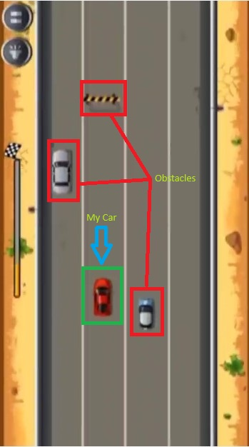

**Methodology**

3.1 Project Structure

Computer vision operations, specifically using OpenCV, are employed in this project. Template matching is utilized to detect entities, such as the ego and obstacle vehicles, in each frame of the video. The essential steps involved in the methodology are as follows:

* Load sample images of ego and obstacle vehicles
* Process each frame of input video
  + Detect ego vehicle
  + Detect nearby obstacles
  + Check for collisions
  + Decide movement direction
  + Annotate visualizations
* Write output video

3.2 Parameters

There are several tunable parameters that can be adjusted in the project, including the detection threshold, the distance threshold for collisions, and the slope threshold for determining the avoidance direction, among others.

3.3 Model Description

* Template matching using cv2.matchTemplate() identifies entity patches in frames.
* Euclidean distance computes proximity.
* Collision logic checks distance and slope to determine avoidance maneuver.

3.4 Project Analysis

The performance of the model is reasonably accurate in detecting vehicles and identifying potential collisions. It replicates realistic behaviors such as lane changing or braking. However, there may be certain false negatives caused by variations in lighting conditions and camera angles. Overall, the model serves as a solid baseline for autonomous navigation.

**Results**

The project outputs an annotated video showcasing obstacle detection, collision alerts, and navigation decisions. The ego vehicle adjusts direction to avoid collisions.

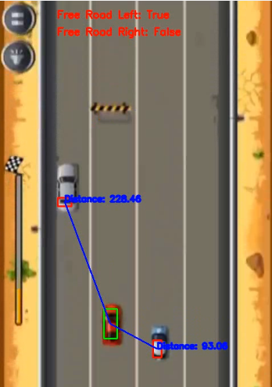 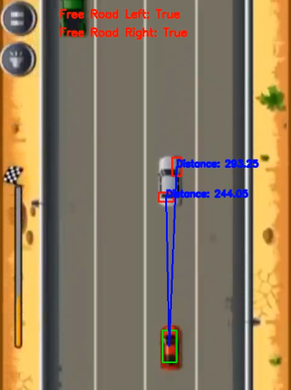

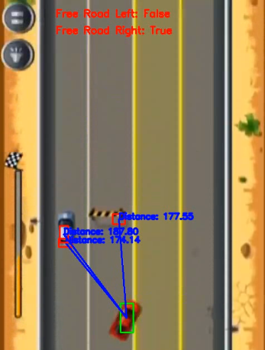 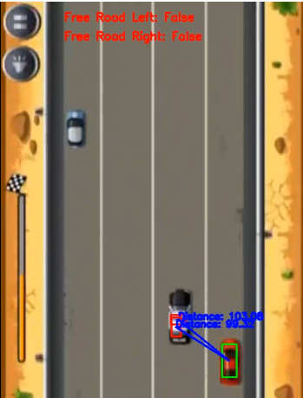

**Conclusion**

5.1 Discussion

The simple computer vision algorithm employed in this project successfully identifies vehicles and simulates collision avoidance within a 2D simulated environment. This proof-of-concept demonstrates the feasibility of vision-based autonomous navigation.

5.2 Future Works

Future works for this project could include the following enhancements:

1. Integration of more sophisticated neural network models for improved detection and decision-making.
2. Incorporation of lidar and sensor fusion to enhance the perception capabilities of the autonomous vehicle.
3. Development of map and trajectory planning algorithms to optimize navigation routes.
4. Conducting real-world testing to validate the performance of the system in diverse environments and scenarios.
5. Implementing sim-to-real transfer techniques by utilizing simulations to improve the system's performance in real-world conditions.