**How to setup**

* The source code is hosted in a public git repository at <https://github.com/DAthukorala/FireBaseDemo>
* Download the source code and copy to your local folder
* The source code have two applications
  + NonAngular
    - This is the html page that holds the data which needs to be saved in the cloud
    - This page will backup data as it change in a local indexedDB and will call the web api every 60 seconds to save that data in firebase storage
  + FireBaser
    - This is the restful web api which gets called by the html page to save data in firebase
* I have given a json file which contains authentication token for my fire base account separately to Kumara. Please copy that file to a local folder
* Since your PC is now acting as the server that hosts the web API, we need to setup authentication for firebase in that server, so all requests coming from that server to firebase endpoints will be authenticated without any prompts.
* To do that we are going to setup an environment variable and save the path to the json file that contains the authentication token
* Create a new environment variable

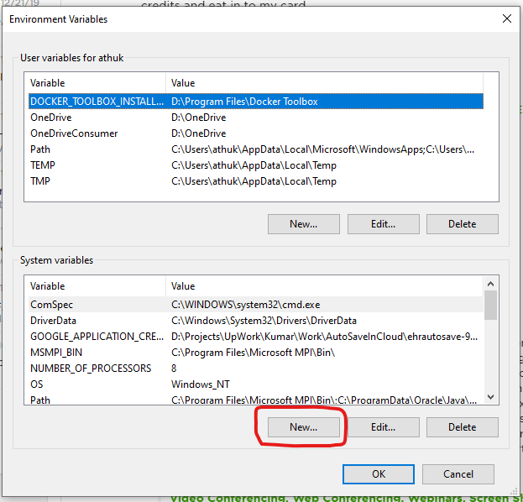

* Enter the GOOGLE_APPLICATION_CREDENTIALS as the variable name and the path to the json file in the value field

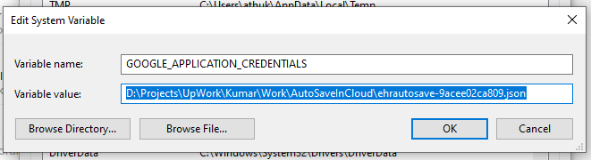

* Restart your machine
* Open the fire baser project using visual studio and run it. Now we have a web api endpoint running that can save data to firebase and that can be called by the html page
* Open form.html file in NonAngular folder and change data, you will be able to see the values getting backed up in local indexedDB and in firebase cloud by clicking the provided buttons

I have added the explanations on each file and their objective as comments in those files for your reference

P.S.

* In Firebaser project, only the following files will be of any interest
  + ValuesController
  + IAutoSaveRepository
  + AutoSaveRepository
  + AutoSaveInfo
* Please note that I have added excessive comments in the code. This is just for documentation purpose. Avoid bloating code with such documentation if possible.