Development of a Smart Luxmeter with IoT Monitoring System

Alfie Joy Alagenio  
*Electrical Engineering Program, College of Engineering Education  
University of Mindanao, Matina*Davao City, Philippines  
a.alagenio.443256@umindanao.edu.ph Neil William P. Floreta  
*Electrical Engineering Program, College of Engineering Education  
University of Mindanao, Matina*Davao City, Philippines  
n.floreta.454918@umindanao.edu.ph Riza T. Papillero  
*Electrical Engineering Program, College of Engineering Education  
University of Mindanao, Matina*Davao City, Philippines  
r.papillero.464122@umindanao.edu.ph

1. Introduction

Every living creature on earth needs light, which is a crucial type of energy. The entirety of the color spectrum is included in white light, sometimes referred to as visible light or apparent light [1]. Additionally, electromagnetic waves that can be seen with the eye are referred to as light. Energy is emitted by a light source, and some of this energy is transformed into visible light. The production of light is the result of electromagnetic waves, often known as radiation [2]. Luminous flux, or the quantity of light emitted, is measured in lumens. The luminous flux emitted from a point source of light is best described as a line expanding uniformly radially. As a result, the number of flux lines hitting the surface will be utilized to gauge the amount of light flux there is [3]. The essential duties of an electrical engineer include creating, testing, and developing systems and machinery, as well as devices and equipment. One of an electrical engineer's job responsibilities is designing brightness [4].

A Luxmeter, which measures light intensity in Lux, is the instrument used to determine the quantity of light intensity from a light source at a location. Standard lux meters are fairly expensive; therefore, we can create a tool that does the same job but is considerably less expensive. By utilizing electronic components, specifically sensors, we may create a lux meter. A sensor is a device that can be utilized to transform a specific quantity into an analog or digital unit so that an electrical circuit can read it [1, 5]. The sensor readings collected from connected devices can be displayed, saved for later use, and sent to a remote site for control or other purposes. By 2020, it is predicted that about 50 billion objects will be connected to the internet, with an average of nearly six devices per individual [6].

The systems that are constructed now are far more complex than their predecessors, thanks to the development of sophisticated sensors and wireless networking. In significant public and private areas, organizations continue to utilize wasteful technologies. Modern LEDs have not yet been able to replace them [7]. The importance of lighting is evident in various contexts. It is crucial in security and patrol areas where crimes frequently occur, as well as in studies that examine illumination and lux values within different environments [5].

Monitoring is the practice of watching how a system behaves while also ensuring that its unique qualities are maintained. Depending on whether the observations and forecasts match, these qualities, if the observed behavior can be quantified, could be either quantitative or qualitative. Effective monitoring offers insightful information that can be used to better understand and regulate the system of interest [7, 8]. It is projected that, in the future, cameras will be a more practical and popular option than sensor-based safety systems because of how quickly the technology is evolving [9].

For instance, the research looked at channel attributes, system design, various VLC characteristics, and medium access methods. Additionally, several VLC applications were identified, including indoor positioning [10, 11]. IEEE 802.15.7, which was released in 2011, was a standard that described the physical layers for short-range visible light communications. It focused on flicker mitigation and dimming support [11]. For every new type of defect and product, the feature extraction procedure needs to be devised, which is a challenge with the traditional surface inspection techniques that rely on hand-designed features [12]. If the heat source is not properly handled, the light-emitting diode's (LED) lifespan will decrease [13].

Improving illumination in a modern workplace is vital for enhancing user comfort. By enhancing light, thermal conditions, air quality, and sound quality, costs can be effectively controlled, especially considering that the majority of expenses in offices are related to wages [14]. For this reason, a large number of engineers and researchers test LEDs, LED luminaires, and lighting installations that use LED luminaires extensively [15].

This research proposal aims to design and develop an innovative lux meter with IoT capabilities for real-time monitoring of light standards. The study includes reviewing existing technologies, designing a portable lux meter prototype, creating an IoT monitoring system, evaluating performance in different lighting environments, and validating accuracy through calibration tests. The proposed system seeks to advance light measurement technology, enhance functionality, and provide seamless connectivity for efficient light management and optimization.

This research aims to develop innovative solutions that enhance the accuracy, functionality, and efficiency of lux meters, improving light measurement and management. The integration of IoT monitoring capabilities in a smart lux meter reduces energy waste and improves energy efficiency. This study contributes to the creation of sustainable lighting solutions that minimize environmental impact while offering convenience, energy savings, and improved user experiences.

The significant aspect of developing a smart lux meter with an IoT monitoring system lies in its ability to provide accurate and real-time monitoring of light standards. By integrating IoT capabilities, the lux meter can seamlessly connect to a network and transmit light-intensity data for analysis and management. This enables efficient light control and optimization, ensuring that lighting conditions align with established standards, and making it a comprehensive solution for effective light management in various environments. This development addresses the need for improved light measurement technology and offers practical benefits such as energy savings, enhanced productivity, and increased well-being.

The scope and delimitation of this study are environmental conditions, such as extreme temperatures, humidity, or exposure to direct sunlight, which may affect the performance and durability of the lux meter and IoT components. The system's reliability and accuracy may be compromised in such challenging environments, as may connectivity and network dependencies. The functionality of the smart lux meter heavily relies on a stable and reliable network connection. Any network disruptions or connectivity issues may hinder real-time monitoring and data transmission, impacting the overall effectiveness of the system.

1. Materials and Methods

In the recommended configuration, the luxmeter acts as a means of monitoring illumination. The IoT makes it possible to analyze data on light intensity levels and monitor light standards in real time in a room-setting environment. Additionally, utilizing a PC or smartphone via an application. The data can be transferred directly by email. The Luxmeter is sent via IoT to the application to automatically record luxmeter readings. If the user inserts an SD card, the data will also be saved on the card. Consequently, using a computer or smartphone, it is possible to check the consistency of the value.

* 1. **Conceptual Framework**

As Figure 1 shows, the main concept of the study is the analysis of the data by reading the light and its temperature in a room setting and transferring the data from the reading from the luxmeter. Reading the lights is an effective way to avoid a complicated eye problem that causes damage to human eyesight. In this way, it is also possible to see the lights that need to be replaced, that are broken, or that no longer exist according to the space in the said study. And the data obtained here will be automatically transferred to a computer or smartphone via IoT, aiming to be recorded in real-time.

Another name for this modern environment is external information, which is sensitive and adaptable to the needs of man and society today. By assessing the illumination in the aforementioned study, modern technology is frequently targeted at enhancing the comfort of everyone. Users of residences or possibly establishments might enhance their capacity to preserve their wonderful vision and prevent its loss.

A portable instrument used to measure brightness is called a luxmeter. It precisely assesses how intense the brightness appears to the human eye. This is distinct from measurements of the actual light energy generated by or reflected from an object or light source. The lux is a unit of brightness, or more precisely, illuminance.

**INPUT**

Luxmeter with IoT

**PROCESS**

Measuring illuminance

**OUTPUT**

Send data in email or SD card



Fig. 1 Development of smart luxmeter with IoT Monitoring System

* 1. **Methods and Procedures**

The system block diagram shown in Figure 1 depicts a luxmeter connected to Wi-Fi that can connect to a computer or smartphone with an application that stores the read illuminance values obtained from the luxmeter. Because the Internet of Things is the project's principal objective, the hardware and software components can be divided into two major areas. The application is the software, and the prototype is the hardware.

The prototype will turn on when a 5V to 6V source is applied. The LCD will initially display the title "Luxmeter with IoT" before delaying for a short while before displaying "Connecting to Wi-Fi". "Wi-Fi connected" will be shown if the connection is successful; otherwise, it will reset. The prototype will measure the lux and display the lux amount after successfully connecting to the internet. If the user adds an SD card, the data will then be saved on it.

Since the prototype is connected to the application and the internet, the usage time starts once it is connected. The LCD widget will then display the value of the lux. Every modification to the LCD prototype will alter the value. The widget for the application LCD. The LCD widget is located below. Live data will be seen on the chart. That can lead to a conclusion, be based on the line graph to determine the sensor performance shown. The measured value is then recorded and can be transmitted by email to the user. Consequently, the user need not no longer needs to memorize the lux value.

Functionality testing included accuracy checks on the project's luxmeter systems as well as overall project functionality. The data gathering must be finished and compared to the project. If the luxmeter acquires data that is no longer consistent with its standard lumens, it will alarm and provide information on where the bulb needs to be replaced because it is no longer inside the luxmeter's exclusive standard lumen range. The luxmeter can also see how warm the light is perceived by the meter at the same time.

For the success of the study, we will conduct various tests to ensure that our device works. And can be used for security purposes and to ensure the safety of human life.

The researchers will create a luxmeter to prevent the wrong light from being installed or not suitable for the space to be used and ensure the safety of those who live or use it. After the layout is complete, we start canvassing and finding project materials.

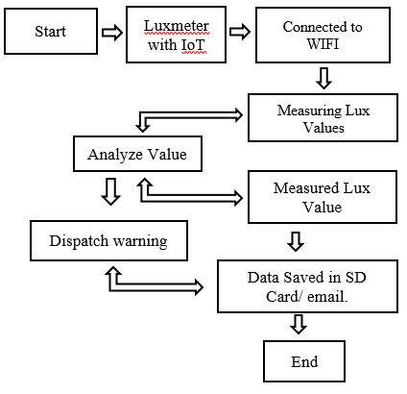

Figure 2. Block Diagram

* 1. **Materials and Resources**

A suitable microcontroller or development board (e.g., Arduino, Raspberry Pi) is the core of the system. Furthermore, it covers the light sensor options, including photodiodes, phototransistors, and ambient light sensors, highlighting their specifications, sensitivity, and range.

A power supply consideration will be a 5V rechargeable battery. As well as the display modules, optional components such as an OLED display or an LCD, enclosures, and other supporting materials will be needed for the device.

A communication module will also be used, such as a Wi-Fi module (ESP8266 or ESP32) or a GSM module (SIM800 or SIM900).

The software and programming cover the necessary tools, languages, and libraries required for programming the smart luxmeter. It explores the use of integrated development environments (IDEs), such as the Arduino IDE, as well as programming languages such as C/C++ or Python. Additionally, it discusses relevant libraries and APIs for sensor interfacing and IoT communication, enabling seamless integration with the chosen IoT platform.

Temperature and humidity sensors, like the DHT11 or DHT22, can be included in the luxmeter as sensors and actuators. This makes it possible to measure and keep an eye on the light intensity and environmental factors. The presence or movement of people close to the luxmeter can be detected using motion sensors, such as passive infrared (PIR) sensors. Applications, where the luxmeter needs to change illumination based on occupancy, may find use for this functionality and relay modules can be used to use the lux values to control external devices. For instance, the relay module may cause the activation of artificial lighting systems if the lux level drops below a predetermined threshold.

* 1. **Proposed Design**

The proponents got started by doing research and broadening their understanding of smart luxmeters and IoT monitoring systems. The proposed smart luxmeter with an IoT monitoring system is designed to enable real-time monitoring, data analysis, and remote access to lux data for efficient lighting management. It integrates a high-precision light sensor, connectivity modules, and IoT protocols to transmit and store data on a cloud-based platform. The proposed design aims to provide accurate lux measurements while minimizing power consumption, maximizing battery life, and making it convenient to use. Also, its additional features that will detect the deflected luminance will make readings more accurate and quick.

The design was picked based on several constraints on the importance of the study's aims. The proponents created designs and assessed the benefits and drawbacks of each technique. When it comes to economics, the environment, sustainability, and manufacturability, both strategies involve trade-off analyses.

The smart luxmeter with an IoT monitoring system design is influenced by factors such as measurement accuracy, sensor selection, power efficiency, connectivity options, and integration with IoT platforms. The device must provide accurate measurements across different lighting conditions, and the sensor should be selected based on sensitivity, measurement range, and spectral response. Power consumption should be minimized, and the device should be designed to be easily installed and integrated with existing lighting infrastructure.

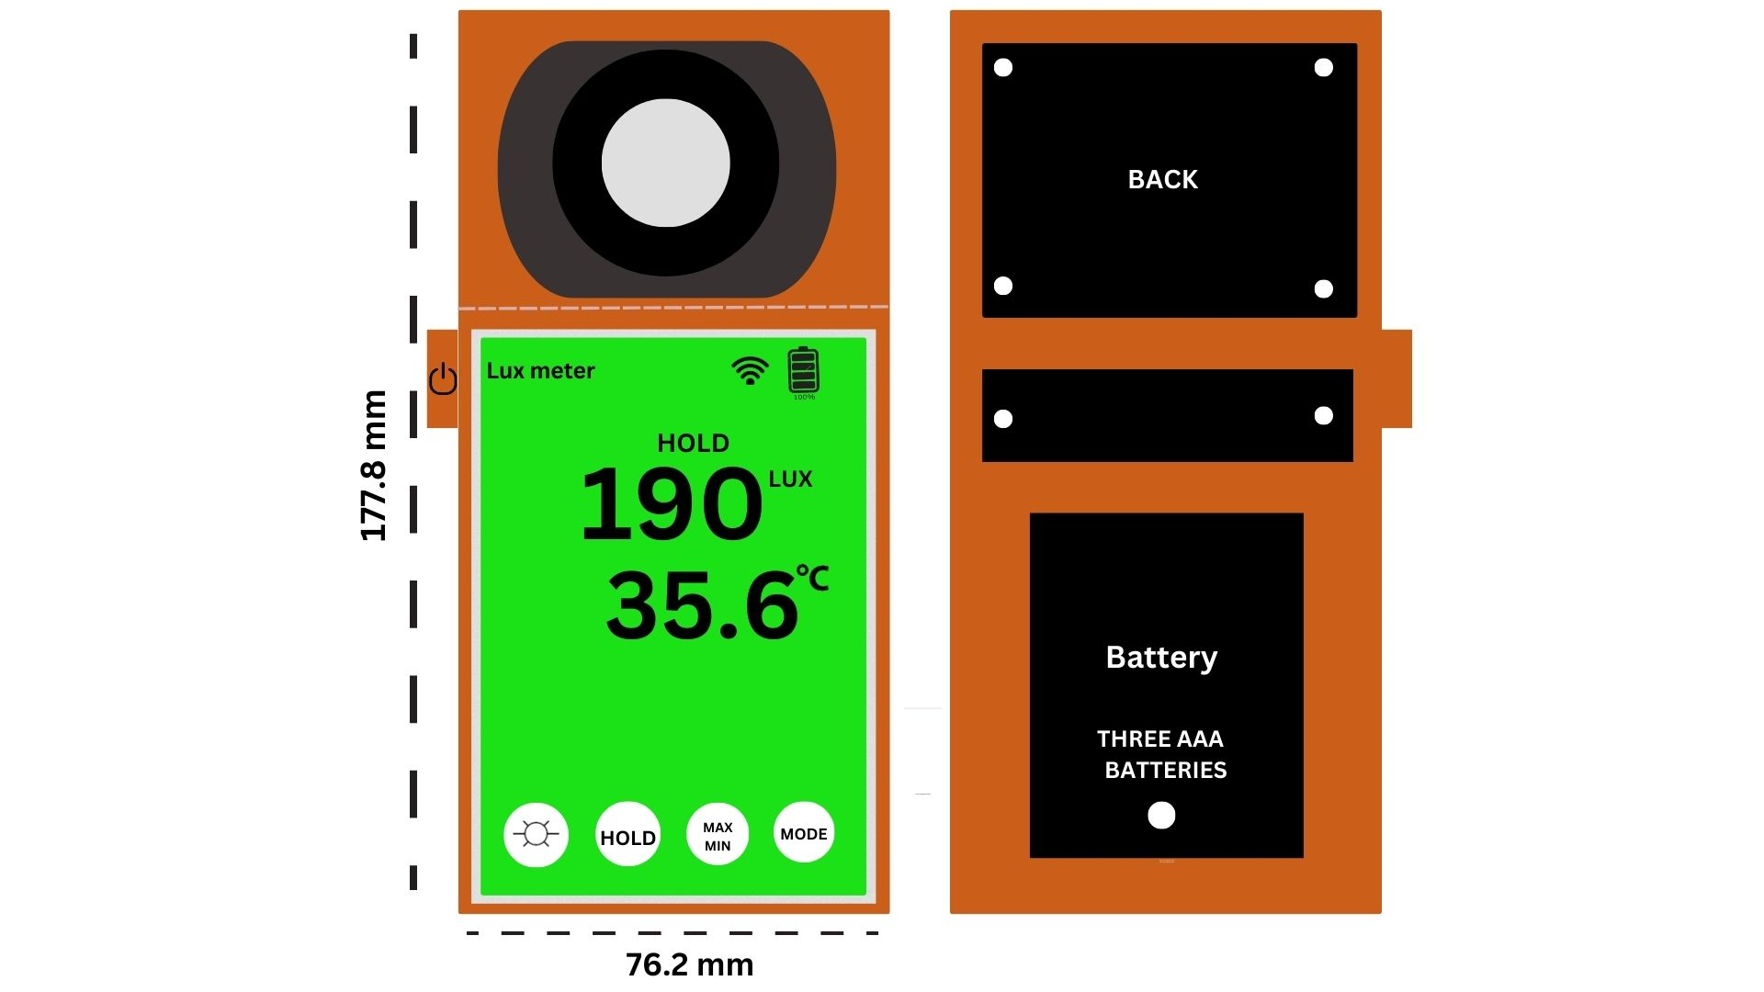

Figure 3. Proposed Design

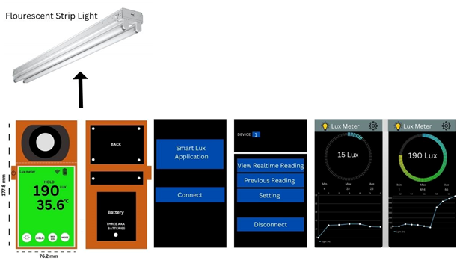

Figure 4. Smart Lux Application

The device will offers a range of powerful measurement functions, including the ability to measure current values, maximums, minimums, illuminance difference, integrating illuminance, and average integrating illuminance. It supports both automatic and manual storage of illuminance data, allowing for up to 60 groups, respectively. With a wide measuring range of 0 to 10,000 lux and automatic range shift, it ensures accurate readings in various lighting conditions. The meter comes with computer-based software, making it user-friendly. It boasts quick response, high portability, and can be operated with a single hand. Additionally, the sensor can be rotated for convenience, and a backlight feature enhances visibility.

References

1. Manik, S., Muslimin, A. M., & Subgan, A. A. (2020). Perancangan Alat Ukur Intensitas Cahaya Berbasis Arduino Leonardo Menggunakan Sensor LDR (Light dependent Resistor). Jurnal Natural, 16(1), 1-13.
2. Doyan, A. (2022). Arduino-Based Light Intensity Measurement. AMPLITUDO: Journal of Science and Technology Inovation, 1(1), 26-28.
3. Mukhlis, M. A., Lesmono, A. D., & Nuraini, L. (2021). Analisis Hubungan Indeks Bias dan Intensitas Cahaya Pada Berbagai Fluida. Jurnal Pembelajaran Fisika, 10(4), 150-155.
4. Ahmad, M. D., Noor, S. M., Rahman, N. A., & Haris, F. A. (2021, March). Lux meter integrated with internet of things (IoT) and data storage (LMX20). In 2021 IEEE International Conference in Power Engineering Application (ICPEA) (pp. 138-142). IEEE.
5. Yusuf, M. A., Azmi, M. M., Ismail, A. H., Ibrahim, I. I., Hashim, M. S. M., & Kamarrudin, N. S. (2018, August). Webcam Based Lux Meter Using Grid-Based Image Processing. In 2018 International Conference on Computational Approach in Smart Systems Design and Applications (ICASSDA) (pp. 1-6). IEEE.
6. Ghosh, A., Kundu, P. K., & Sarkar, G. (2018, December). Automated lux measurement for lighting design in indoor space using mobile sensor. In 2018 IEEE Applied Signal Processing Conference (ASPCON) (pp. 106-109). IEEE.
7. Ghosh, A., Kundu, P. K., & Sarkar, G. (2020). Design and real-time implementation of cloud based indoor illumination monitoring system. Journal of The Institution of Engineers (India): Series B, 101, 223-227.
8. M.T. Jilani, M.Z.U. Rehman, A.M. Khan, O. Chughtai, M.A. Abbas, M.T. Khan, An implementation of IoT-based microwave sensing system for the evaluation of tissues moisture. Microelectron. J. (2018). <https://doi.org/10.1016/j.mejo.2018.03.006>
9. Ozkahraman, M., Yilmaz, C., & Livatyali, H. (2021). Design and Validation of a Camera-Based Safety System for Fenceless Robotic Work Cells. Applied Sciences, 11(24), 11679.
10. Pathak, P. H., Feng, X., Hu, P., & Mohapatra, P. Visible Light Communication, Networking and Sensing: A Survey, Potential and Challenges.
11. Zhuang, Y., Hua, L., Qi, L., Yang, J., Cao, P., Cao, Y., ... & Haas, H. (2018). A survey of positioning systems using visible LED lights. IEEE Communications Surveys & Tutorials, 20(3), 1963-1988.
12. Mujeeb, A., Dai, W., Erdt, M., & Sourin, A. (2018, October). Unsupervised surface defect detection using deep autoencoders and data augmentation. In 2018 International Conference on Cyberworlds (CW) (pp. 391-398). IEEE.
13. Muhamad, W. N. W., Anuar, A. S. M., Sarnin, S. S., Azreen, M. M., Idris, A., & Kassim, M. (2018, October). Intelligence Lighting Control System with Precise Dimming and Correlated Color Temperature. In TENCON 2018-2018 IEEE Region 10 Conference (pp. 1235-1240). IEEE.
14. Kruisselbrink, T., Dangol, R., & Rosemann, A. (2018). Photometric measurements of lighting quality: An overview. Building and Environment, 138, 42-52.
15. Czyżewski, D. (2023). The Photometric Test Distance in Luminance Measurement of Light-Emitting Diodes in Road Lighting. Energies, 16(3), 1199.
16. M. A. Yusuf, M. S. M. Azmi, A. H. Ismail, I. I. Ibrahim, M. S. M.

Hashim, and N. S. Kamarrudin, “Webcam Based Lux Meter Using

Grid-Based Image Processing,” in Proc. 2018 International Conference

on Computational Approach in Smart Systems Design and

Applications

[17] M. Sheth and P. Rupani, “Smart Gardening Automation using IoT with BLYNK App,” in Proc. Int. Conf. Trends Electron. Informatics, ICOEI 2019, vol. 2019, pp. 266–270.

[18] P. Serikul, N. Nakpong, and N. Nakjuatong, “Smart Farm Monitoring via the Blynk IoT Platform : Case Study: Humidity Monitoring and Data Recording,” Int. Conf. ICT Knowl. Eng., vol. 2018-Novem, pp. 70–75, 2019.