MAGIC-dMAP: Multiple Atlases and Granularities—Integrating Connectivity Dynamics for Multisite Autism Prediction

Introduction
Autism spectrum disorder (ASD) is a neurodevelopmental disorder affecting social communication and behavior. Its estimated global age-standardized prevalence was 0.67% in 2023¹. ASD diagnosis relies on developmental history and behavioral assessment, which can be time-consuming and influenced by the assessment setting and co-occurring conditions. Currently, no ASD-specific neuroimaging biomarker has been established for routine clinical use². Resting-state functional magnetic resonance imaging (rs-fMRI) noninvasively characterizes brain functional connectivity³. However, heterogeneity in ASD-related connectivity patterns⁴ and intersite variability challenge the cross-site generalization of rs-fMRI-based ASD classifiers⁵. Here, we propose a multi-atlas, multi-granularity framework that combines coarse-grained window-wise statistics with fine-grained edge-wise dynamics. Its performance was evaluated across 17 Autism Brain Imaging Data Exchange I (ABIDE-I) sites⁶ using a leave-one-site-out (LOSO) protocol.

Methods

Data and Preprocessing
We analyzed 1,020 subjects from 17 ABIDE-I sites, including 500 with ASD and 520 neurotypical controls (NC). Demographics and acquisition parameters are summarized in Figure 1. As shown in Figure 2A, T1-weighted (T1w) images were brain-extracted using brain masks⁷ and nonlinearly registered to Montreal Neurological Institute (MNI) space using Advanced Normalization Tools (ANTs)⁸. rs-fMRI underwent head-motion correction using FSL MCFLIRT⁹ and was coregistered to T1w using FSL FLIRT boundary-based registration (BBR),¹⁰ guided by white matter segmentations¹¹. The functional images in T1w space were then resampled to MNI space using the T1w-to-MNI transformation, preserving original voxel spacing. Region-of-interest (ROI) time series were extracted using the Automated Anatomical Labeling (AAL),¹² Craddock 400 (CC400),¹³ Dosenbach160,¹⁴ Eickhoff–Zilles (EZ),¹⁵ and Harvard–Oxford (HO)¹⁶ atlases.
Figure 1. Demographic and fMRI acquisition characteristics of the 17 ABIDE-I sites (1,020 subjects: 500 ASD, 520 NC). Columns show scanner manufacturer, group counts, matrix and voxel sizes, time points (T), repetition time (TR), age (mean ± SD), and male proportion. ABIDE-I, Autism Brain Imaging Data Exchange I; fMRI, functional magnetic resonance imaging; ASD, autism spectrum disorder; NC, neurotypical control; SD, standard deviation.
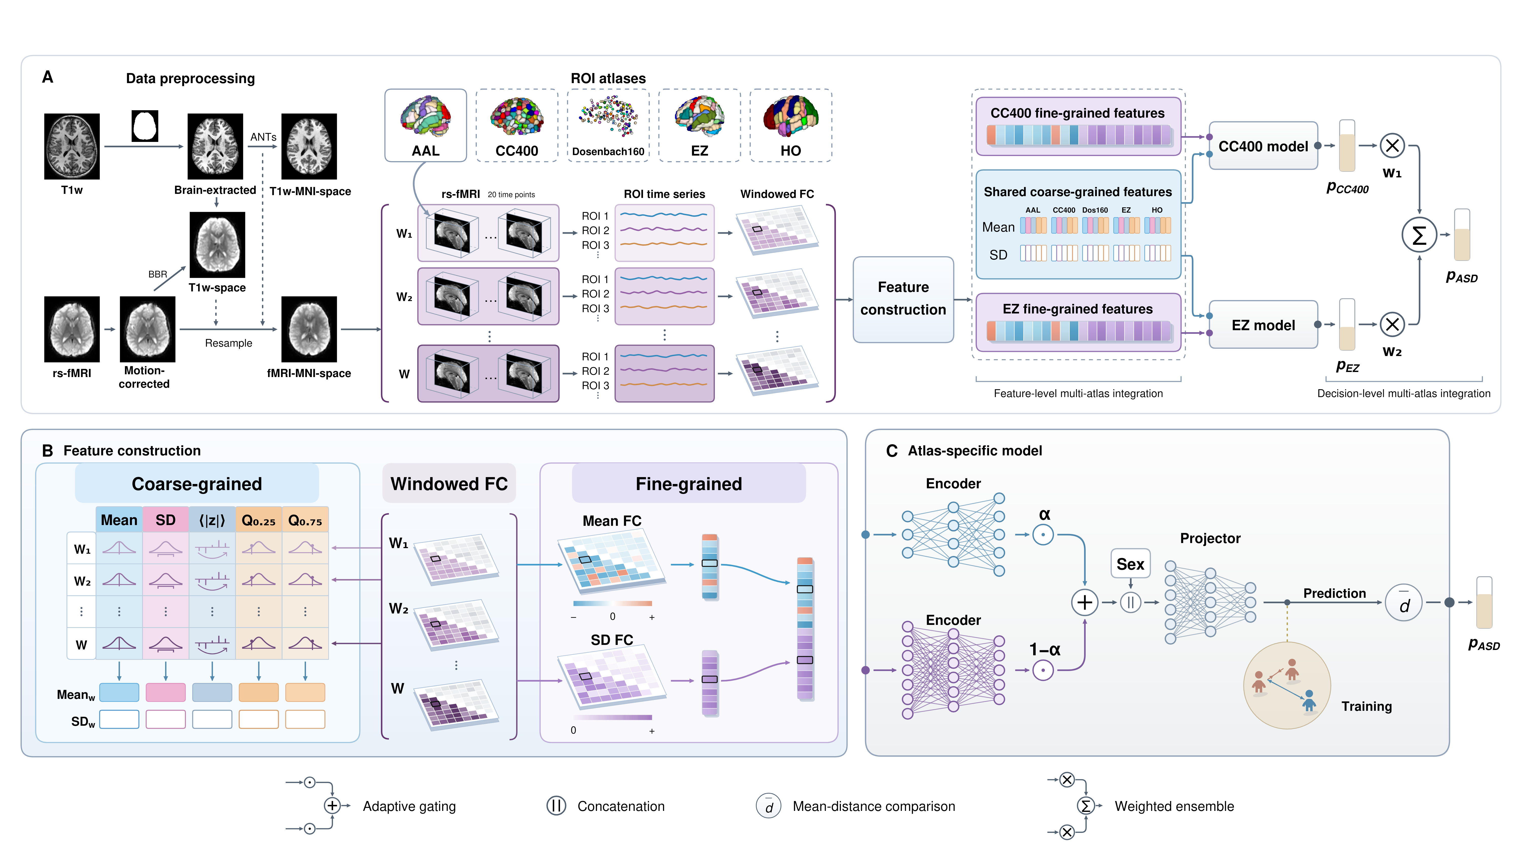
Figure 2. MAGIC-dMAP framework. (A) Workflow from data preprocessing to ASD prediction. (B) Feature construction in (A): coarse-grained and fine-grained features from windowed FC. (C) Common CC400/EZ model architecture and triplet training. ⟨|z|⟩, mean absolute connectivity; W, total number of windows; α and 1−α, adaptive feature-wise fusion weights; w₁ and w₂, validation-derived ensemble weights; FC, functional connectivity; SD, standard deviation; ASD, autism spectrum disorder.

Multi-Granularity Dynamic Feature Construction
Dynamic functional connectivity (dFC) features were constructed at coarse and fine granularities from windowed FC matrices (Figure 2B). These matrices were computed from ROI time series using Pearson correlations with a window length and stride of 20 frames. For coarse-grained features, the mean, standard deviation (SD), mean absolute value, and 25th and 75th percentiles were calculated across connections within each window. The across-window means and SDs of these five measures were then concatenated, providing compact summaries of overall connectivity distributions and their temporal variation. Fine-grained features comprised the across-window mean and SD of individual ROI-to-ROI connections, yielding a higher-dimensional representation that preserves connection-specific strength and temporal variability.

Multi-Atlas Integration and Metric Learning
We integrated multi-atlas information at the feature and decision levels (Figure 2A). Coarse-grained features from all five atlases were concatenated into a shared vector, paired with CC400 fine-grained features in the CC400-specific model and EZ fine-grained features in the EZ-specific model. Both models used the same architecture (Figure 2C). Parallel multilayer perceptron (MLP) encoders learned representations from the shared coarse-grained and atlas-specific fine-grained inputs. Feature-wise gated fusion combined these representations. Sex was then added as a covariate before a projection MLP generated subject-level embeddings. Triplet metric learning compared three subjects, bringing those with matching diagnoses closer and separating those with different diagnoses. Each model compared mean Euclidean distances from a subject embedding to ASD and NC training embeddings, assigning higher ASD probabilities when closer to ASD. At the decision level, the CC400 and EZ probabilities were ensembled using validation-derived weights w₁ and w₂ (Figure 2A) to obtain the final ASD probability.

Results
LOSO evaluation included 1,020 subjects (500 ASD/520 NC), with one site held out for testing, a second site used for validation, and the remaining sites used for training in each fold. As shown in Table 1, mean test area under the receiver operating characteristic curve (AUC) and accuracy (ACC) were 0.6855/0.6467 across all 17 sites and 0.7033/0.6651 across eight sites with >50 subjects (n = 697). CMU achieved the highest AUC (0.7857), and KKI the highest ACC (0.7500).
Table 1. Site-level LOSO performance on ABIDE-I. n denotes subjects. Train (Val) gives training counts, with validation site and count in parentheses. Summary rows report total test counts and unweighted means across the corresponding sites. ASD, autism spectrum disorder; NC, neurotypical control; AUC, area under the receiver operating characteristic curve; ACC, accuracy.
Test site | Test n (ASD/NC) | Train (Val) | AUC | ACC
NYU | 175 (75/100) | 789 (PITT, 56) | 0.6975 | 0.6514
UM | 139 (65/74) | 825 (YALE, 56) | 0.6996 | 0.6331
UCLA | 98 (54/44) | 866 (PITT, 56) | 0.7235 | 0.6633
LEUVEN | 63 (29/34) | 898 (USM, 59) | 0.6775 | 0.7143
USM | 59 (43/16) | 910 (MAX_MUN, 51) | 0.7340 | 0.7119
YALE | 56 (28/28) | 789 (NYU, 175) | 0.7717 | 0.6786
PITT | 56 (29/27) | 789 (NYU, 175) | 0.7050 | 0.6607
MAX_MUN | 51 (23/28) | 910 (USM, 59) | 0.6180 | 0.6078
Sites with n > 50 | 697 (346/351) | — | 0.7033 | 0.6651
KKI | 48 (20/28) | 874 (UCLA, 98) | 0.7661 | 0.7500
TRINITY | 47 (22/25) | 914 (USM, 59) | 0.6800 | 0.5532
STANFORD | 39 (19/20) | 918 (LEUVEN, 63) | 0.7053 | 0.6667
CALTECH | 37 (19/18) | 808 (NYU, 175) | 0.6550 | 0.5946
SDSU | 36 (14/22) | 886 (UCLA, 98) | 0.6234 | 0.6389
OLIN | 34 (19/15) | 935 (MAX_MUN, 51) | 0.7123 | 0.6765
SBL | 30 (15/15) | 851 (UM, 139) | 0.6178 | 0.6000
CMU | 26 (14/12) | 855 (UM, 139) | 0.7857 | 0.6538
OHSU | 26 (12/14) | 938 (YALE, 56) | 0.4821 | 0.5385
All sites | 1020 (500/520) | — | 0.6855 | 0.6467
Age-stratified LOSO results are presented in Table 2. The adolescent group had the highest mean AUC (0.7830) and ACC (0.7010), followed by school-age children and adults.
Table 2. Age-stratified LOSO performance on ABIDE-I. n denotes test subjects in each age group. AUC and ACC are unweighted means across evaluable sites. ASD, autism spectrum disorder; NC, neurotypical control; AUC, area under the receiver operating characteristic curve; ACC, accuracy.
Age group | Age (years) | n | ASD / NC | AUC | ACC
School-age children | 6–12 | 379 | 191 / 188 | 0.6772 | 0.6500
Adolescents | 13–17 | 334 | 158 / 176 | 0.7830 | 0.7010
Adults | ≥18 | 307 | 151 / 156 | 0.6615 | 0.6128
Figure 3 shows the validation-weighted ensemble saliency map, highlighting the top 5% of brain regions based on the absolute gradient of the ASD prediction score.
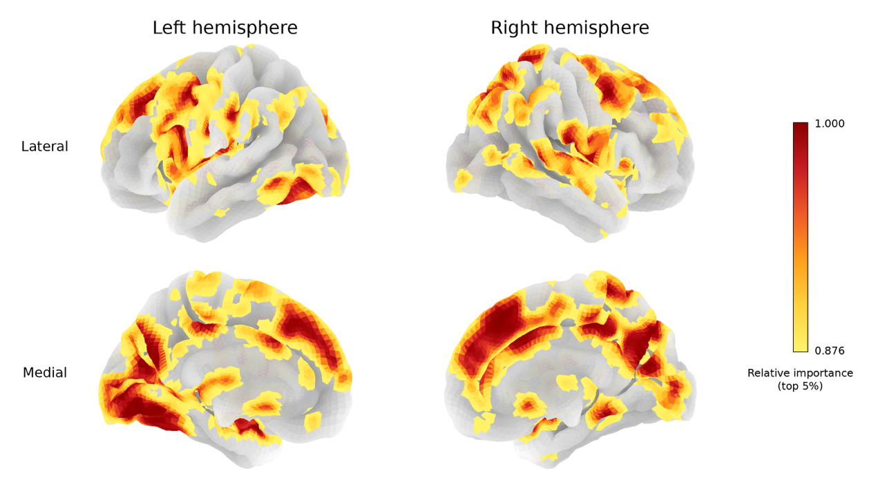
Figure 3. Cortical distribution of ensemble saliency for ASD classification. Absolute-gradient saliency maps from the CC400 and EZ models were combined using validation-derived weights. The top 5% of relative importance values are shown on lateral and medial surfaces of both hemispheres. Darker red indicates higher relative importance.

Discussion
The framework demonstrated generalization to unseen sites, with a mean AUC of 0.7033 across the eight larger sites. The lowest performance at OHSU may partly reflect its shorter time series. Age-stratified performance suggested age-related differences in discriminability and motivated further research in younger populations. Saliency maps highlighted posterior medial, medial frontal, temporoparietal, and temporo-occipital cortices, providing preliminary insight into connectivity features contributing to model predictions.

Conclusion
Multi-atlas, multi-granularity dFC features and triplet metric learning support cross-site ASD classification and provide preliminary insight into regional contributions to model predictions. Future work will aim to improve cross-site classification and investigate connectivity patterns that consistently contribute to predictions across sites, relating them to functional brain networks.

References
1. GBD 2023 Mental Disorder Collaborators. Updated trends in the global prevalence and burden of mental disorders, 1990–2023: a systematic analysis for the Global Burden of Disease Study 2023. Lancet. 2026;407(10543):2040–2064. doi:10.1016/S0140-6736(26)00519-2.
2. Hirota T, King BH. Autism spectrum disorder: a review. JAMA. 2023;329(2):157–168. doi:10.1001/jama.2022.23661.
3. Amemiya S, Takao H, Abe O. Resting-state fMRI: emerging concepts for future clinical application. J Magn Reson Imaging. 2024;59(4):1135–1148. doi:10.1002/jmri.28894.
4. Ilioska I, Oldehinkel M, Llera A, et al. Multiscale heterogeneity of atypical functional connectivity in autism. Nat Ment Health. 2026;4(6):1010–1020. doi:10.1038/s44220-026-00656-y.
5. Itahashi T, Yamashita A, Takahara Y, et al. Generalizable and transportable resting-state neural signatures characterized by functional networks, neurotransmitters, and clinical symptoms in autism. Mol Psychiatry. 2025;30(4):1466–1478. doi:10.1038/s41380-024-02759-3.
6. Di Martino A, Yan CG, Li Q, et al. The autism brain imaging data exchange: towards a large-scale evaluation of the intrinsic brain architecture in autism. Mol Psychiatry. 2014;19(6):659–667. doi:10.1038/mp.2013.78.
7. Wang L, Sun Y, Seidlitz J, et al. A lifespan-generalizable skull-stripping model for magnetic resonance images that leverages prior knowledge from brain atlases. Nat Biomed Eng. 2025;9(5):700–715. doi:10.1038/s41551-024-01337-w.
8. Avants BB, Tustison NJ, Song G, et al. A reproducible evaluation of ANTs similarity metric performance in brain image registration. NeuroImage. 2011;54(3):2033–2044. doi:10.1016/j.neuroimage.2010.09.025.
9. Jenkinson M, Bannister P, Brady M, Smith S. Improved optimization for the robust and accurate linear registration and motion correction of brain images. NeuroImage. 2002;17(2):825–841. doi:10.1006/nimg.2002.1132.
10. Greve DN, Fischl B. Accurate and robust brain image alignment using boundary-based registration. NeuroImage. 2009;48(1):63–72. doi:10.1016/j.neuroimage.2009.06.060.
11. Sun Y, Wang L, Li G, Lin W, Wang L. A foundation model for enhancing magnetic resonance images and downstream segmentation, registration and diagnostic tasks. Nat Biomed Eng. 2025;9(4):521–538. doi:10.1038/s41551-024-01283-7.
12. Tzourio-Mazoyer N, Landeau B, Papathanassiou D, et al. Automated anatomical labeling of activations in SPM using a macroscopic anatomical parcellation of the MNI MRI single-subject brain. NeuroImage. 2002;15(1):273–289. doi:10.1006/nimg.2001.0978.
13. Craddock RC, James GA, Holtzheimer PE 3rd, Hu XP, Mayberg HS. A whole brain fMRI atlas generated via spatially constrained spectral clustering. Hum Brain Mapp. 2012;33(8):1914–1928. doi:10.1002/hbm.21333.
14. Dosenbach NUF, Nardos B, Cohen AL, et al. Prediction of individual brain maturity using fMRI. Science. 2010;329(5997):1358–1361. doi:10.1126/science.1194144.
15. Eickhoff SB, Stephan KE, Mohlberg H, Grefkes C, Fink GR, Amunts K, Zilles K. A new SPM toolbox for combining probabilistic cytoarchitectonic maps and functional imaging data. NeuroImage. 2005;25(4):1325–1335. doi:10.1016/j.neuroimage.2004.12.034.
16. Desikan RS, Ségonne F, Fischl B, et al. An automated labeling system for subdividing the human cerebral cortex on MRI scans into gyral based regions of interest. NeuroImage. 2006;31(3):968–980. doi:10.1016/j.neuroimage.2006.01.021.

