# Microscopy Image Processing Workflow

This workflow provides a complete pipeline for processing microscopy images, including raw data handling, metadata extraction, and image preprocessing. It is designed for high-resolution microscopy research and collaboration.

## Raw Data & Metadata

Stored in CZI format generated by Zeiss software by researchers/users

* Embedded Metadata: Includes acquisition parameters, sample information, and instrument settings

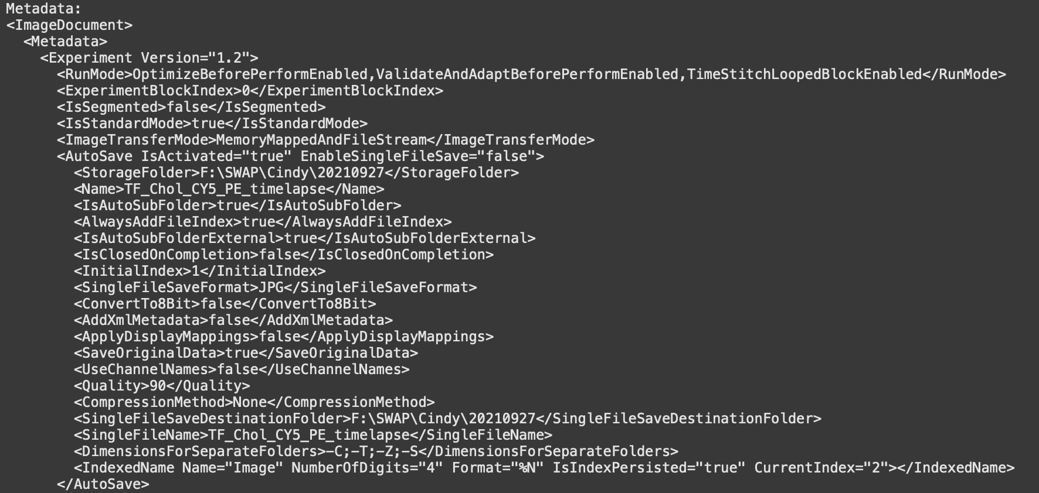

* **External Metadata:** Linked CSV files with clinical or experimental sample information. This is generated synthetically by WEHI’s Intern Clinical Dashboard Team

Example how external metadata look like. There are 23 columns information containing patients’ information. This could be extended to other extension such as JSON.

## Image Processing Workflow

1. Deskewing: Corrects image distortions from acquisition.  
2. Deconvolution: Enhances clarity and sharpness.  
3. Downsampling: Reduces resolution for storage efficiency.  
4. Data Summarization: Generates key metrics and compressed outputs.

## Repository Contents

- main.py: Script for processing CZI files into Zarr format.  
- External Metadata File: Links images to sample and patient data.  
- Processed Data: Saved in Zarr/TIFF format for visualization and analysis.  
- Documentation: README file detailing the workflow.

## Data Access

Usage: Download raw or downsampled datasets as needed for analysis.

1. Primary Dataset: Available on Zenodo: <https://zenodo.org/records/7117784>
2. WEHI Internships Dataset: Available on Zenodo: <https://zenodo.org/records/14807924>
3. Data Portal Github: <https://github.com/DBK333/Omero-DataPortal/tree/main/OmeroImageSamples>

## Using the Workflow

- Clone the repository and navigate to the project directory.  
- Run `python main.py` to process CZI files to Zarr format.  
- View processed data with Napari or other visualization tools.  
- Extract metadata using Zeiss software or included scripts.