DBMS – Lab ASSIGNMENT 2
1. Create a table EMP1 with following structure.

ID | Name | Basic | Designation | Age

Column Description:-
ID Number (2)
Name Varchar2 (10)
Basic Number (6, 2)
Designation Varchar2 (10)
Age Number (2)

Query:
CREATE TABLE EMP1 (
ID NUMBER(2),
Name VARCHAR2(10),
Basic NUMBER(6, 2),
Designation VARCHAR2(10),
Age NUMBER(2)
);

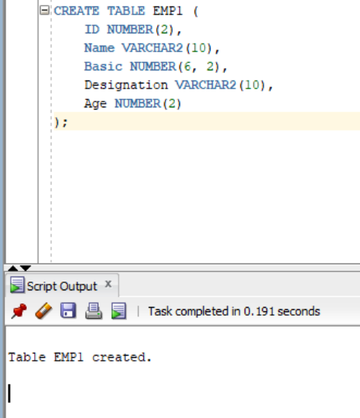

2. Change the data type of the field Basic from float to integer with required size of the EMP1 table.
Query:
ALTER TABLE EMP1
MODIFY Basic NUMBER(6);

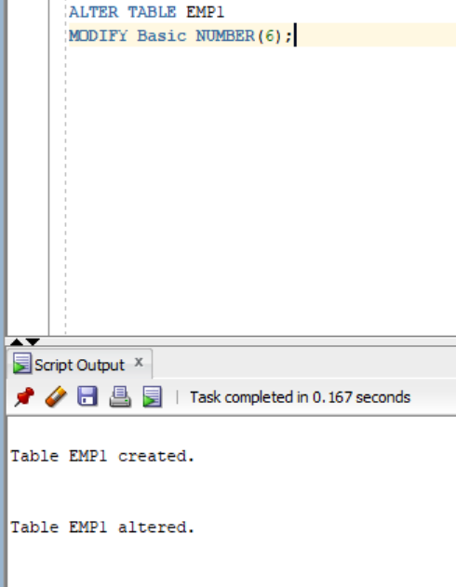

3. Change the field size of Name column of the EMP1 table from 10 to 15.
Query:
ALTER TABLE EMP1
MODIFY Name VARCHAR2(15);
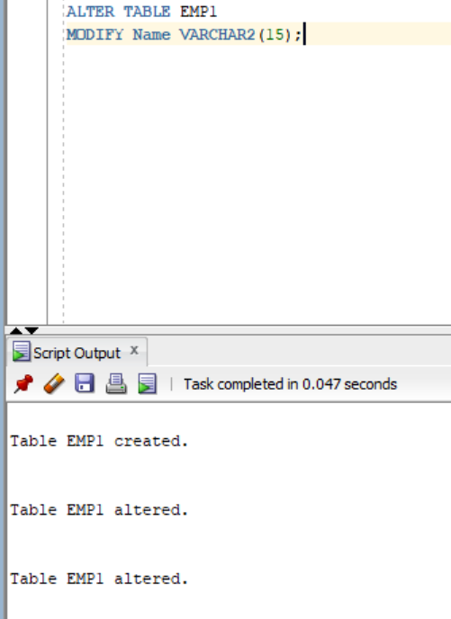

4. Create another table EMP_trainee with the same (changed) structure. The column ID to be renamed as Emp_id in the EMP_trainee table.
Query:
CREATE TABLE EMP_trainee (
Emp_id NUMBER(2),
Name VARCHAR2(15),
Basic NUMBER(6),
Designation VARCHAR2(10),
Age NUMBER(2)
);
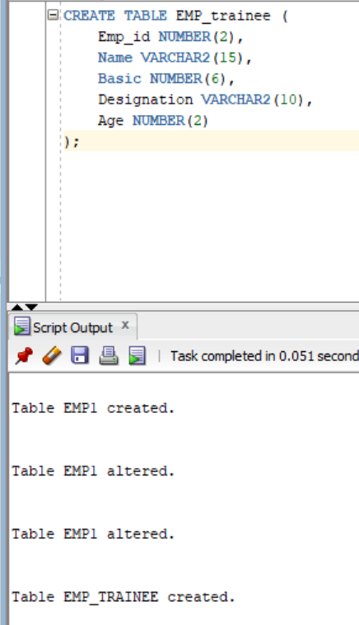
5. Insert following data in EMP1 table:-
(1, Rohit, 6700, Manager, 24)
(2, Sunil, 6200, Engineer, 27)
(3, Payal, 6300, Engineer, 25)
(4, Kunal, 6700, Trainee, 28)
(5, Sunita, 6230, Trainee, 26)
(6, Bimal, 7000, Trainee, 25)
Query:
INSERT INTO EMP1 (ID, Name, Basic, Designation, Age) VALUES (1, 'Rohit', 6700, 'Manager', 24);
INSERT INTO EMP1 (ID, Name, Basic, Designation, Age) VALUES (2, 'Sunil', 6200, 'Engineer', 27);
INSERT INTO EMP1 (ID, Name, Basic, Designation, Age) VALUES (3, 'Payal', 6300, 'Engineer', 25);
INSERT INTO EMP1 (ID, Name, Basic, Designation, Age) VALUES (4, 'Kunal', 6700, 'Trainee', 28);
INSERT INTO EMP1 (ID, Name, Basic, Designation, Age) VALUES (5, 'Sunita', 6230, 'Trainee', 26);
INSERT INTO EMP1 (ID, Name, Basic, Designation, Age) VALUES (6, 'Bimal', 7000, 'Trainee', 25);

-- Save the changes permanently
COMMIT;
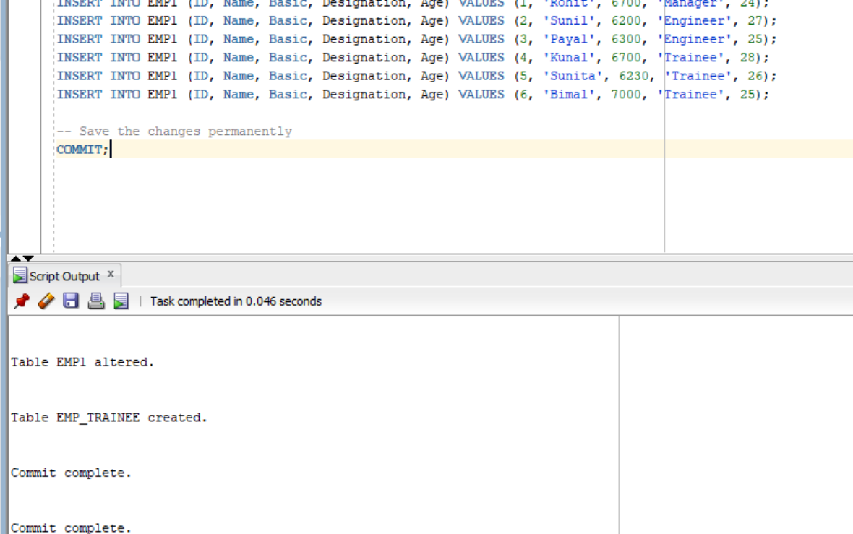
6. Insert all rows with the designation ‘trainee’ from the EMP1 table to EMP_trainee table
Query:
INSERT INTO EMP_trainee (Emp_id, Name, Basic, Designation, Age)
SELECT ID, Name, Basic, Designation, Age
FROM EMP1
WHERE LOWER(Designation) = 'trainee';

-- Save changes permanently
COMMIT;
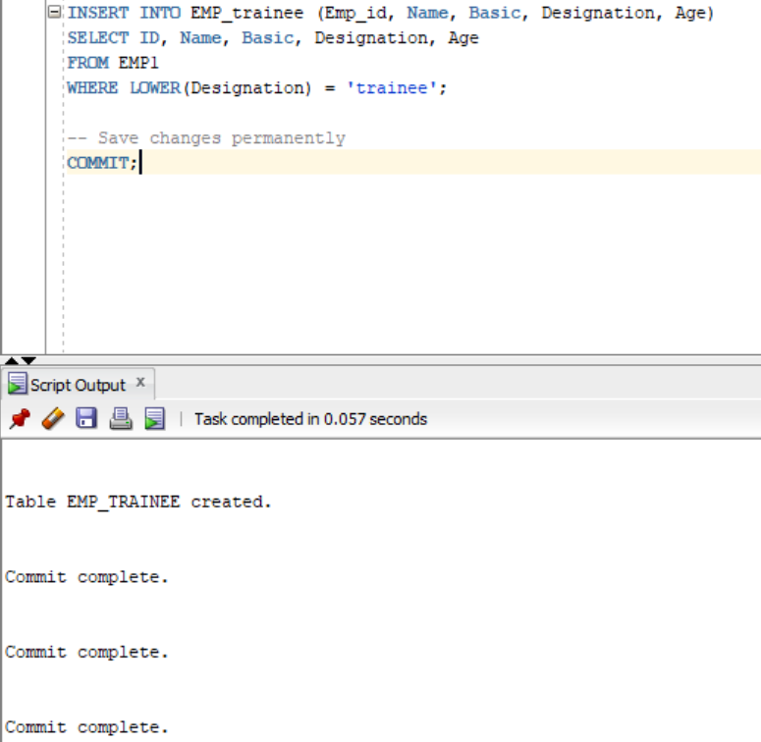
7. Add columns Skills (data type-varchar2 and size-10) and DOJ(data type-date) to the EMP1 table and add data for the Skills and DOJ columns according to your own wish.
Query:
ALTER TABLE EMP1
ADD (
Skills VARCHAR2(10),
DOJ DATE
);
UPDATE EMP1 SET Skills = 'Java', DOJ = TO_DATE('15-JAN-2022', 'DD-MON-YYYY') WHERE ID = 1;
UPDATE EMP1 SET Skills = 'Python', DOJ = TO_DATE('20-MAR-2022', 'DD-MON-YYYY') WHERE ID = 2;
UPDATE EMP1 SET Skills = 'SQL', DOJ = TO_DATE('10-JUN-2022', 'DD-MON-YYYY') WHERE ID = 3;
UPDATE EMP1 SET Skills = 'C++', DOJ = TO_DATE('01-AUG-2023', 'DD-MON-YYYY') WHERE ID = 4;
UPDATE EMP1 SET Skills = 'Testing', DOJ = TO_DATE('15-SEP-2023', 'DD-MON-YYYY') WHERE ID = 5;
UPDATE EMP1 SET Skills = 'Web Dev', DOJ = TO_DATE('01-DEC-2023', 'DD-MON-YYYY') WHERE ID = 6;

-- Save the changes permanently
COMMIT;
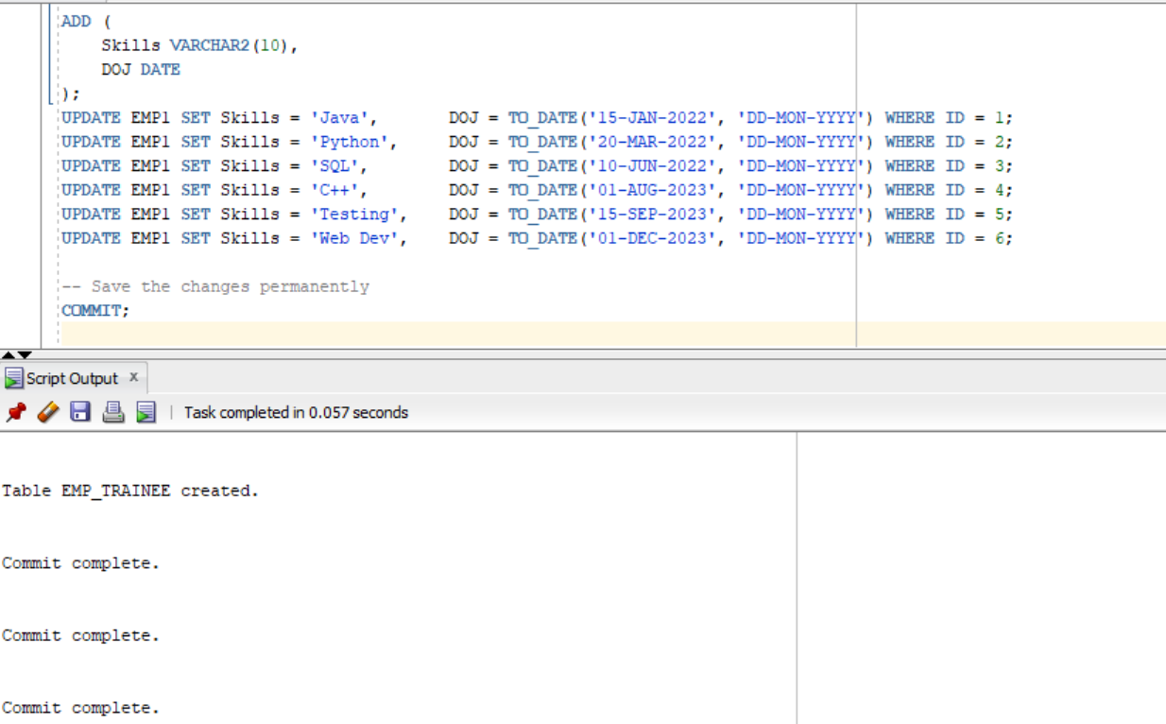

8.Update more than one row in one query in EMP1 table.
Query:
UPDATE EMP1
SET Basic = CASE
WHEN ID = 1 THEN 7500
WHEN ID = 2 THEN 6800
WHEN ID = 3 THEN 6900
ELSE Basic
END
WHERE ID IN (1, 2, 3);

COMMIT;
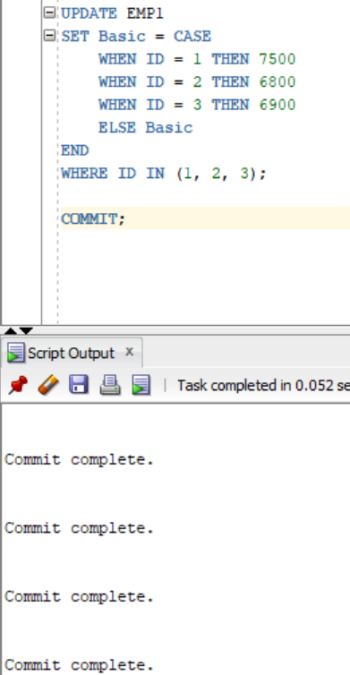
9. Rename the column Age of EMP1 table to Age_in_Years.
Query :
ALTER TABLE EMP1
RENAME COLUMN Age TO Age_in_Years;
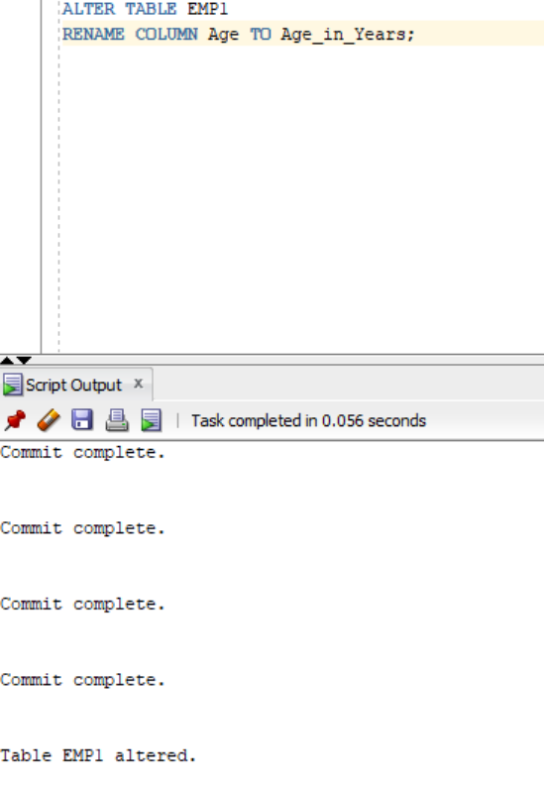
10. Drop the Age column from the EMP_trainee table.
Query:
ALTER TABLE EMP_trainee
DROP COLUMN Age;
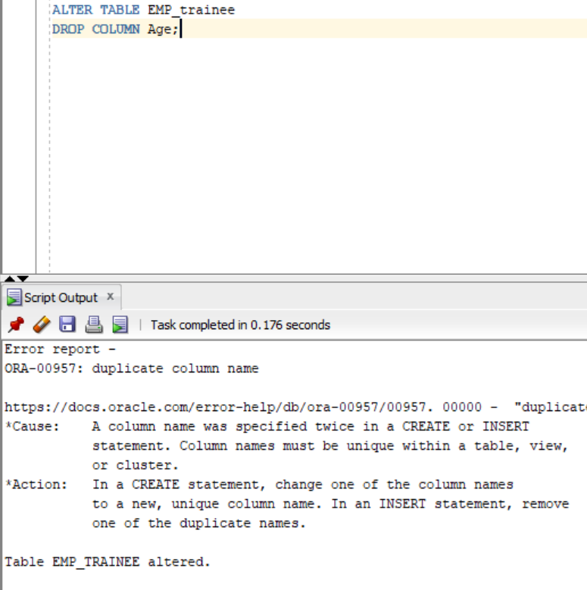
11. Rename the table EMP to EMP_Mgr_Engr.
Query:
RENAME EMP TO EMP_Mgr_Engr;
12. Truncate EMP_Mgr_Engr table.
Query:
TRUNCATE TABLE EMP_Mgr_Engr;

