LAB Assignment-7
Create the following table Employee_Details.
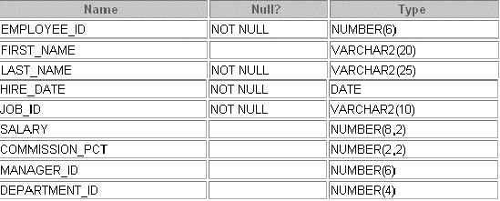
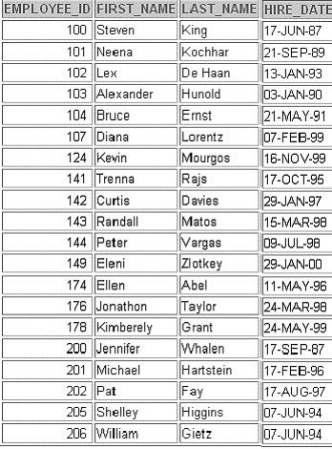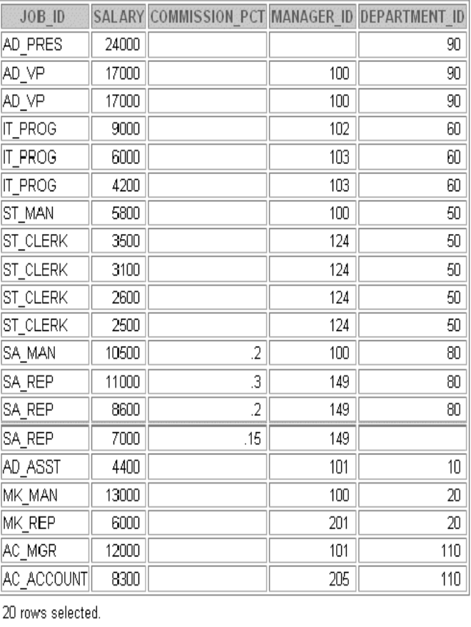
- Execute all the problems using functions.
- Employee_id is the primary key of the table.

- Display the First Name of all employees in LOWER CASE , those who work in department no 20 or 50 or 80.
- Display the Last Name of all employees in UPPER CASE , those who work in department no 10 or 110 or 60.
- Display all job_id in the format ‘ Sa_Rep’.
- Display the Name( Both First name and Last Name concatenated together) of all employees using function.
- Find the length of the last names of the employees getting commission.
- Find out the numeric position of the letter ‘a ‘ in the First Name of all employees.
- Displays employee first names and last names joined together, the length of the employee last name, and the numeric position of the letter a in the employee last name for all employees who have the string CLERK contained in the job ID .
- Display the salary of all employees in 10 digits. Pad the extra digits with ‘$’ either on the left or on the right hand side.
- Trim ‘e’ from all employees first name who has an ‘e’ in their first name and display with the column renamed as ‘Trimmed’.
- Display the department_id, Salary and hire_date of those employees whose first name contains exactly 6 characters. Use function to display the result.
- Display the job_id of those employees whose first name contains ‘e’. Display the position of ‘e’ in their first name.
- Display the employee last name for all employees who have the string REP contained in the job ID starting at the fourth position of the job ID.
- Calculate the remainder of the salaries after it is divided by 3000 for all employees whose job title is sales representative.
- Display the salary of all employees in the format ‘ $7,000.00’.
- Display the salary of all employees in the format ‘ $7000’ who works in depatment 60 or 90 or 110.
- Create a query that displays the employees’ last names and commission amounts. If an
employee does not earn commission put “No Commission.” Label the column COMM.
- Find the no. of days elapsed between today’s date and the hire date. Round off the no. of days.
- Find the no. of weeks elapsed between today’s date and the hire date of all employees.
- Find the no. of years elapsed between today’s date and the hire date. Round off the no. of years.
- Display the employee name and the number of months between today’s date and employee’s hire date. Label the column MONTHS_WORKED.
- Display the employee name and the last day of the months in which the employees were hired.
- Display each employee’s name and the year in which the employees were hired in words.
- Display the date 5 months later to today’s date. Rename the column as FUTURE DATE.
- Display name (format: first_name (space) last_name), the day and date of joining of all employees.
- Display the annual salary of all employees where annual Salary :=( salary *12)+comm_pct. In another column display the rounded off annual salary up to 2 places after decimal point.

