DBMS – Lab ASSIGNMENT 1
1. Display the data in existing default employees or emp or employee table.Query:
Query:
SELECT * FROM catalog WHERE ROW NUM<=5;

2. Display the structure of the above table.

Query:
DESC catalog;

3. Create a table “Student” with following structure:

Roll Name Age Course Math Physics Computer
Birthday

Details of Attributes:-
Roll Number (5)
Name Varchar2 (30)
Age Number (5)
Course Varchar2 (5)
Math Number (6, 2)
Physics Number (6, 2)
Computer Number (6, 2)
Birthday Date

Query:
CREATE TABLE Student
(
Roll NUMBER(5),
Name VARCHAR2(30),
Age NUMBER(5),
Course VARCHAR2(5),
Math NUMBER(6,2),
Physics NUMBER(6,2),
Computer NUMBER(6,2),
Birthday DATE
);

DESC Student;

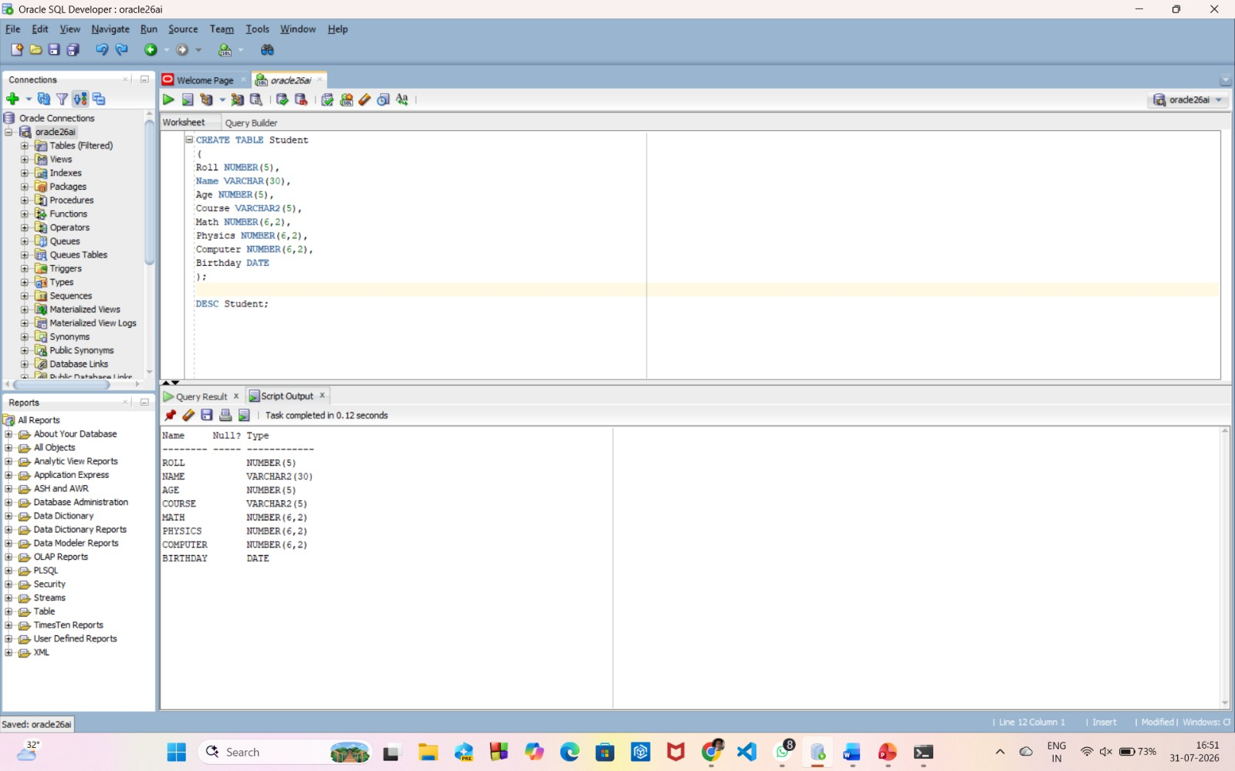

4. Create table MSc from the Student table with the same fields and same structure but without any data.

Query:
CREATE TABLE MSc AS
SELECT * FROM Student
WHERE 1=2;
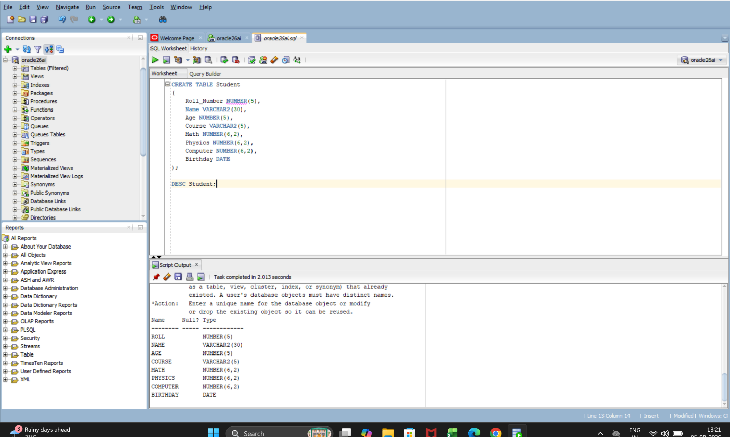
5. Display the structure of MSc table.

Query:
CREATE TABLE MSc AS
SELECT * FROM Student
WHERE 1=2;

DESC MSc;
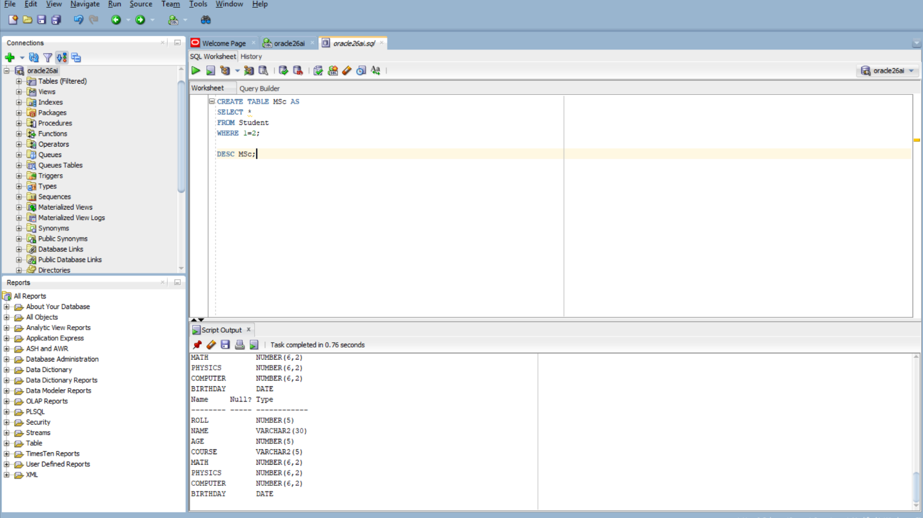
6. Create table ‘MCA’ from the Student table with the same fields and same structure but without any data. Rename Course with Department and Name with First Name.

Query:
CREATE TABLE MCA AS
SELECT
Roll,
Name AS First_Name,
Age,
Course AS Department,
Math,
Physics,
Computer,
Birthday
FROM Student
WHERE 1=2;
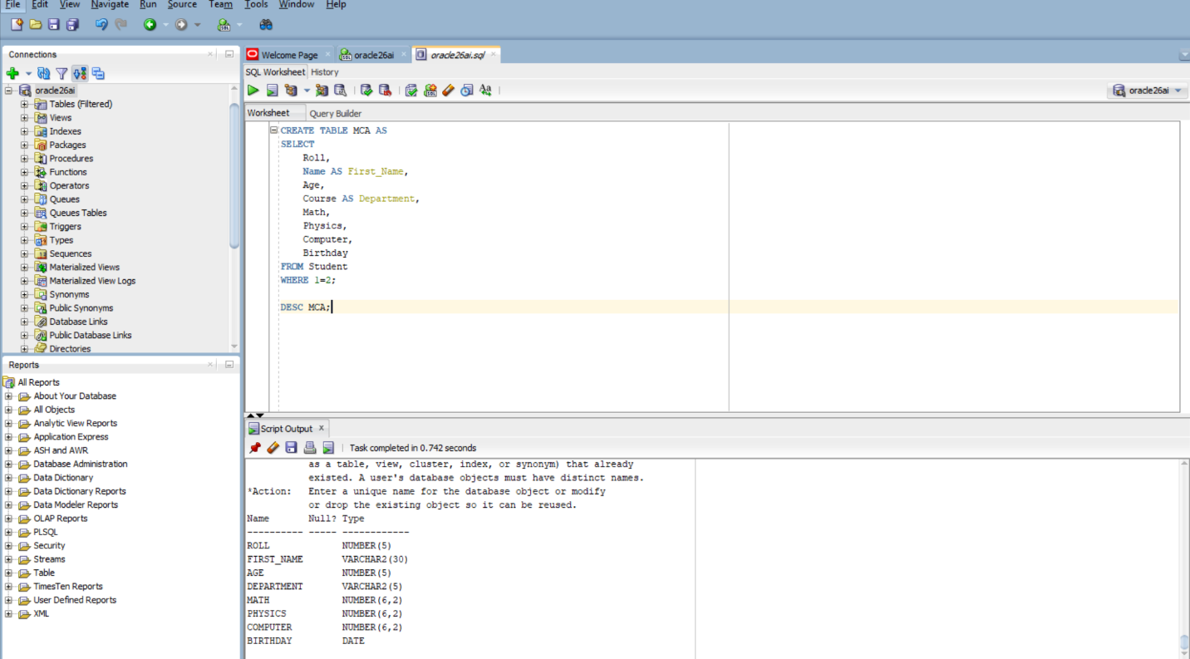

7. Display the structure of MCA table.

Query:
CREATE TABLE MCA AS
SELECT
Roll,
Name AS First_Name,
Age,
Course AS Department,
Math,
Physics,
Computer,
Birthday
FROM Student
WHERE 1=2;

DESC MCA;
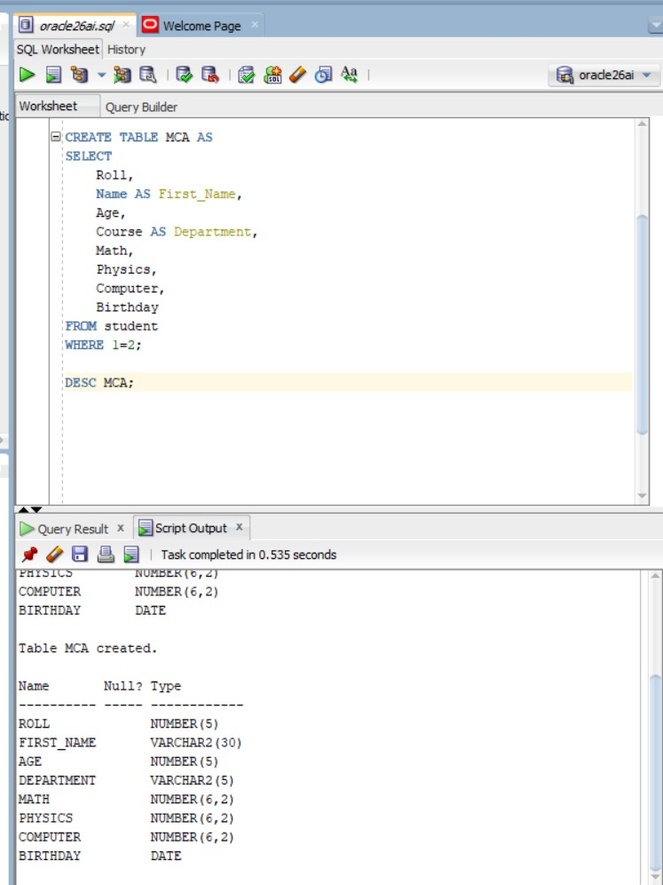

8. Insert following records into the Student table:-

• 1, Rahul,19,BCA,79.5,67,89,15-jun-93
• 2,Kunal,21,BCA,68,76,59.5,16-aug-91
• 3,Aditi,20,MSc,90,73,56,20-sep-92
• 4,Sumit,20,MCA,57.5,78,81,07-dec-91
• 5,Anirban,22,MCA,80,68,63,15-sep-94
• 6,Kumkum,21,BCA,72,54.5,60,08-feb-95
• 7,Suman,21,BCA,91.5,32,61,10-mar-94
• 8,Rohit,22,MSc,85,76,92,19-apr-92

Query:
INSERT INTO Student
VALUES (1, 'Rahul', 19 , 'BCA', 79.5, 67, 89, '15-JUN-93');

INSERT INTO Student
VALUES (2, 'Kunal', 21 , 'BCA', 68, 76, 59.5, '16-AUG-91');

INSERT INTO Student
VALUES (3, 'Aditi', 20 , 'MSc', 90, 73, 56, '20-SEP-92');

INSERT INTO Student
VALUES (4, 'Summit', 20 , 'MCA', 57.5, 78, 81, '07-DEC-91');

INSERT INTO Student
VALUES (5, 'Anirban', 22 , 'MCA', 80, 68, 83, '15-SEP-94');

INSERT INTO Student
VALUES (6, 'Kumkum', 21 , 'BCA', 72, 54.5, 60, '08-FEB-95');

INSERT INTO Student
VALUES (7, 'Suman', 21 , 'BCA', 91.5, 32, 61, '10-MAR-94');

INSERT INTO Student
VALUES (8, 'Rohit', 22 , 'MSc', 85, 76, 92, '19-APR-92');

COMMIT;

9. Display all the students’ details from Student table.

Query:
INSERT INTO Student
VALUES (1, 'Rahul', 19 , 'BCA', 79.5, 67, 89, '15-JUN-93');

INSERT INTO Student
VALUES (2, 'Kunal', 21 , 'BCA', 68, 76, 59.5, '16-AUG-91');

INSERT INTO Student
VALUES (3, 'Aditi', 20 , 'MSc', 90, 73, 56, '20-SEP-92');

INSERT INTO Student
VALUES (4, 'Sumit', 20 , 'MCA', 57.5, 78, 81, '07-DEC-91');

INSERT INTO Student
VALUES (5, 'Anirban', 22 , 'MCA', 80, 68, 83, '15-SEP-94');

INSERT INTO Student
VALUES (6, 'kumkum', 21 , 'BCA', 72, 54.5, 60, '08-FEB-95');

INSERT INTO Student
VALUES (7, 'Suman', 21 , 'BCA', 91.5, 32, 61, '10-MAR-94');

INSERT INTO Student
VALUES (8, 'Rohit', 22 , 'MSc', 85, 76, 92, '19-APR-92');

COMMIT;

SELECT * FROM Student;

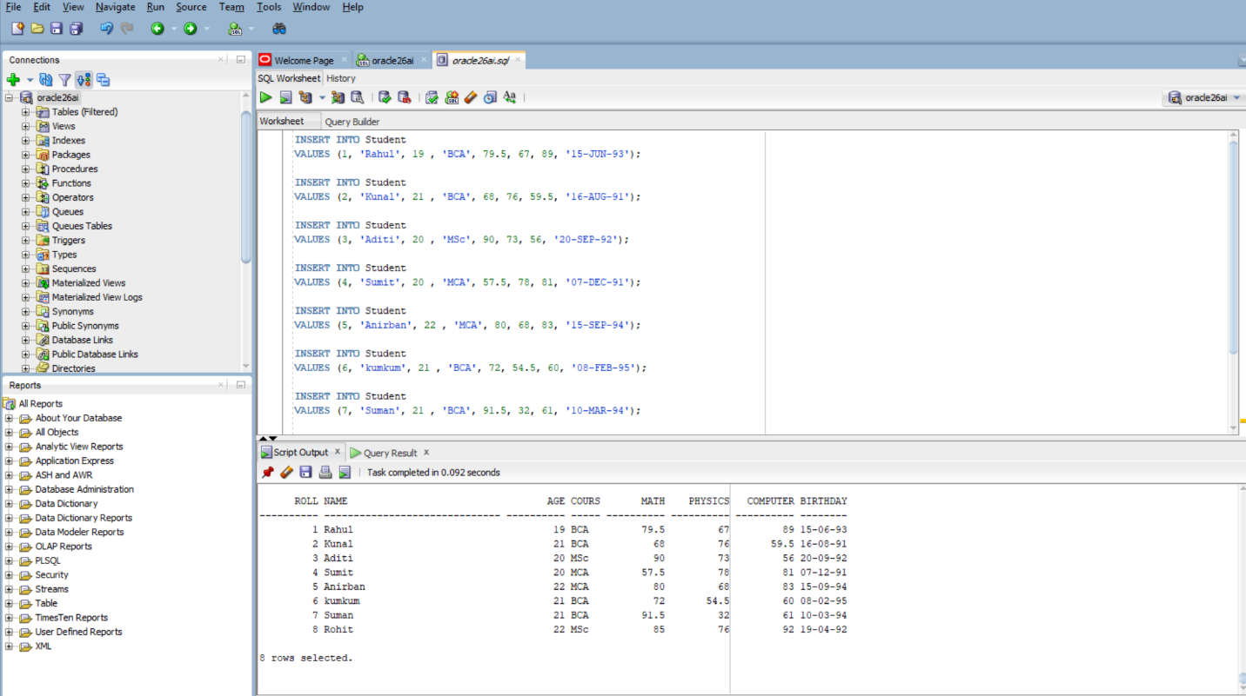

10. Find out the details of the students with roll no 5 from Student table.

Query:
SELECT * FROM Student
WHERE Roll= 5;
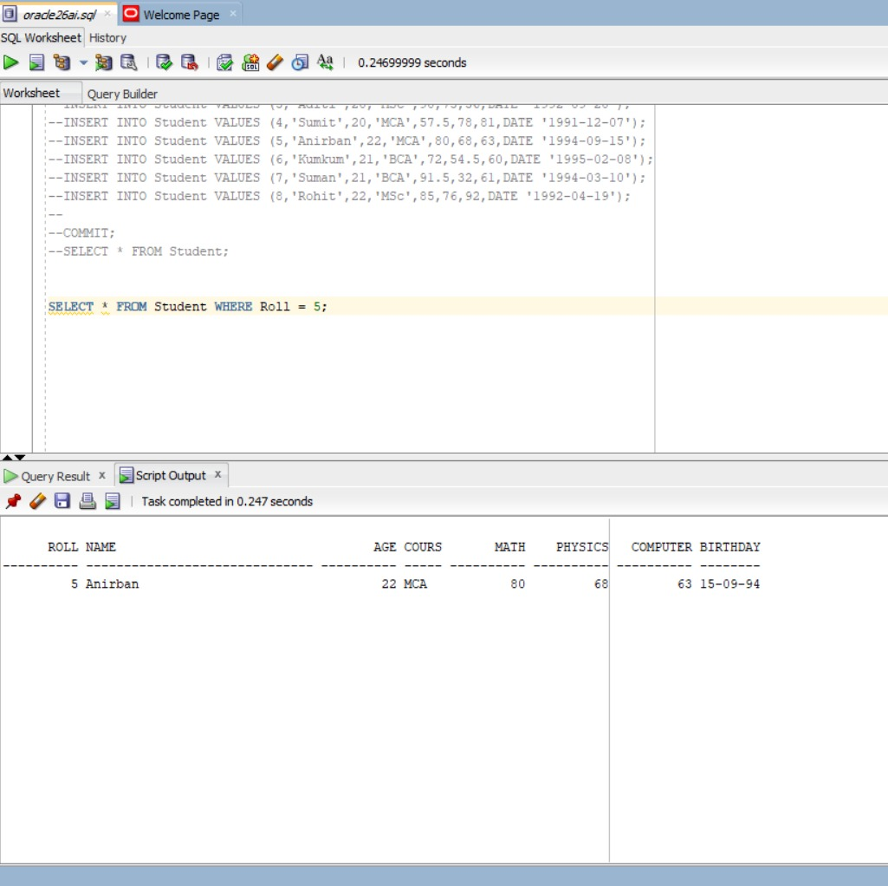
11. Show the roll, name, marks of all subjects for all students from Student table.

Query:
SELECT Roll,
Name,
Math,
Physics,
Computer
FROM Student;
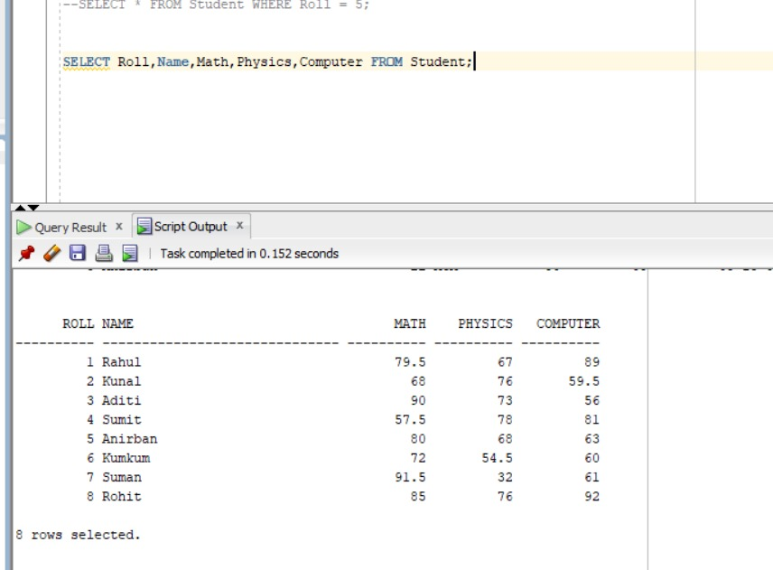
12. Show the roll, name, marks of all subjects for all students from Student table.

Query:
SELECT * FROM Student
WHERE Course= 'BCA';
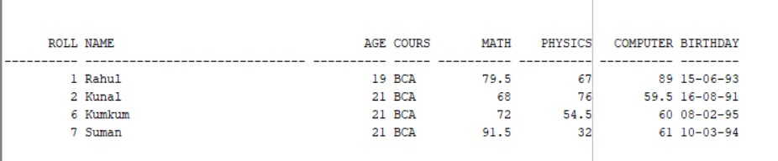
13. Insert data in the ‘MCA’ table from ‘Student’ table where course is MCA.

Query:
INSERT INTO MCA
SELECT * FROM Student
WHERE Course = 'MCA';
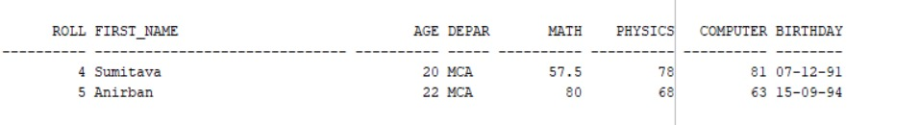
14. Insert data in the ‘MSc’ table from ‘Student’ table where course is MSc.

Query:
INSERT INTO MSc
SELECT * FROM Student
WHERE Course = 'MSc';

COMMIT;

15. Display the structure of ‘Student’ and ‘MCA’ table.

Query:
DESC Student;
DESC MCA;

16. Display all the details of each student in ‘Student’ table with Course appearing first in the display column list.

Query:
SELECT Course,
Roll,
Name,
Math,
Physics,
Computer,
Birthday
FROM Student;
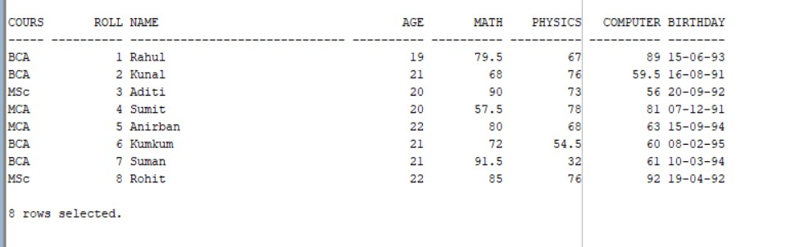
17. Update the Math marks of the student with Roll no 7 from 91 to 95 in the ‘Student’ table.

Query:
UPDATE Student
SET Math = 95
WHERE Roll = 7;
COMMIT;

18. Update the Name of the student with Roll no 4 from Sumit to Sumitava in ‘MCA’ table.

Query:
UPDATE MCA
SET First_Name = 'Sumitava'
WHERE Roll = 4;
COMMIT;

19. Delete the details of the student with Roll no 2 from the ‘Student’ table.

Query:
DELETE FROM Student
WHERE Roll=2;
COMMIT;
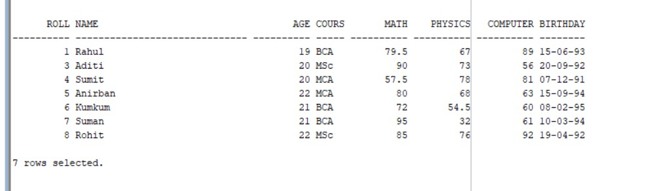
20. Delete the details of all students from the ‘Student’ table.

Query:
DELETE FROM Student
COMMIT;

