TAXI MANAGEMENT SYSTEM

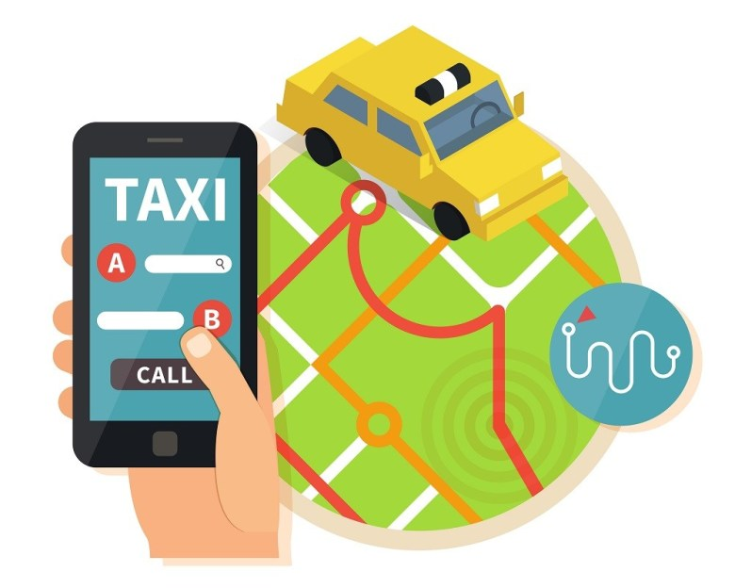

BY :

-GIDDALURI NAGA LAKSHMAN (B518023)

-SASWAT KUMAR SWAIN (B518043)

-SOURAV KUNDA (B518051)

-RAJ KUMAR PANDA (B518037)

**Group no. – 5**

**Project no. - 8**

TABLE OF CONTENTS

* SYSTEM DESCRIPTION
* DATA DESCRIPTION
* ENTITY RELATION DIAGRAM

SYSTEM DISCRIPTION

This is a project based on taxi management. It consists of seven tables named “Consumer”, “Driver”, “Expense”, “Order”, “Owner”, “Taxi” and “Transaction”. Each table consists of attributes that describe it. The main aim of Taxi Management project is to rent taxi and get payments from respective clients. We aim to demonstrate the use of create, read, update and delete MySQL operations through this project. The project starts by adding a taxi and by adding details of driver using the taxi added. The owner provides taxi to the drivers and ads their expenses on daily basis. Booking scene is where a customer can book a taxi to get of the desired location.

DATA DESCRIPTION

CUSTOMER :

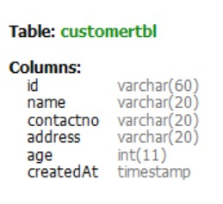

DRIVER:

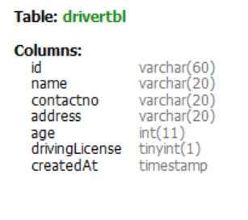

EXPENSE:

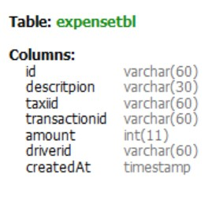

ORDER:

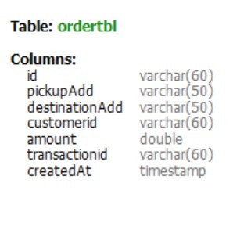

OWNER :

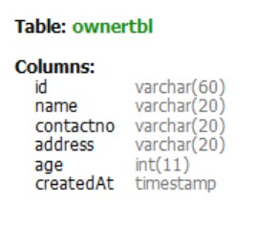

TAXI:

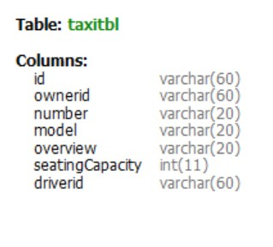

TRANSACTION:

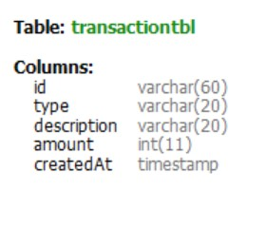

ENTITY RELATION DIAGRAM

TRANSACTION

OWNER

OWNS

DRIVER

EXPENSE

ORDER

TAXI

CUSTOMER