Document Name |  | Confidentiality Level
合同管理系统 |  | Only for Recipients Reference
Template Code | Version | Document Code

合同管理系统
项目总结报告

Revision Record
Date | Revision Version | CR ID /Defect ID | Sec No. | Change Description | Author
2017/6/12 | 1.0 |  |  | 初稿完成 | 彭昱森
2017/6/13 | 1.1 |  |  | 第一次修改 | 彭昱森

Content
目录
1. Project Basic Situation 4
2. Project Acceptance Coverage 4
2.1 Project progress 4
2.2 Development environment 5
2.3 Project Structure 5
2.4 Application 7
2.5 Deliverables 19
3. Project Work Summary 19
3.1 Code statistics 19
3.2 Document work summary 20
4. Lessons learned and Suggestions for Improvement 20

1. Project Basic Situation
Project Name: | 合同管理系统 | Project Category: | 1
Project ID: | 1 | Technology Used: | Java
Development Environment: | Eclipse | Running Platform: | Windows 10
Project Start & Finish Time: | 2017/05/24~2017/06/14 | Project Working Place:
Project Manager: | 游江平
Project Developer: | 王剑、牟子涵、彭昱森
Project Description | 随着社会主义市场经济体制的建立和发展，以及法律、法规的健全和规范，采 用计算机技术进行合同的管理是必然趋势。  合同管理系统能快捷、规范地起草合同，按照合同管理的流程进行起草、分配、 会签、定稿、签订、执行管理等，并提供有效的数据查询、统计分析等管理功能， 有利于合同的签约、履行和管理工作。  本项目将合同数据和合同管理流程有机结合起来，基于B/S网络架构，数据集中 管理，确保了合同管理的规范、严谨和高效，有利于提高工作效率和准确性。

2. Project Acceptance Coverage

2.1 Project progress
(S.N.) | Stages | Scheduled start/end time | Actual start/end time | List of deliverables | Remarks
1 | Project start | 5.24 | 5.24 | 项目启动
2 | Project planning | 5.25 | 5.25 | 项目计划
3 | Requirement analysis | 5.26 | 5.26 | 需求分析
4 | System design | 5.27-5.29 | 5.27-5.29 | 系统设计
5 | Coding and test | 5.28-6.12 | 5.28-6.12 | 代码若干行
6 | Acceptance | 6.13 | 6.13 | 完整程序一份

2.2 Development environment
System/Tool/Component | In English (version number) | Remarks
Operating system | Windows 10
Development tool | Eclipse 4.6.3

2.3 Project Structure
1. Project structure design idea
1、系统的三层架构，包的结构图如下
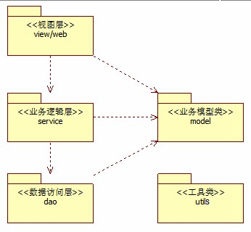

图
1-2

系统包结构

系统分为表示层，业务逻辑层，数据访问层，以及部分公用工具类将放置在utils中。

2、程序的开发模式和三层结构
系统使用Model 2开发模式：JSP+Servlet+JavaBean(MVC)，它与三层架构的结合中， Servlet(控制器)和JSP页面(视图)充当表示层，JavaBean即模型(包含业务逻辑，数据访问和业
务模型类等)充当业务逻辑层和数据访问层。

3、三层结构与Model 2结合的包层次结构
程序架构 | 文件与目录结构
表示层 | JSP文件
表示层 | com.ruanko.web
业务逻辑层 | com.ruanko.service
数据访问层 | com.ruanko.dao com.ruanko.dao.impl
模型类 | com.ruanko.model

文件夹目录
文件夹名 | 说明
css | 存放样式文件
images | 存放图片
js | 存放脚本文件
upload | 存放上传的文件

2. Project directory structure
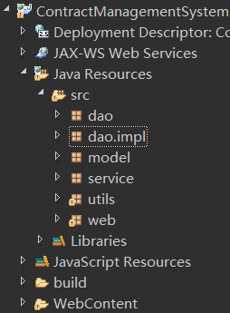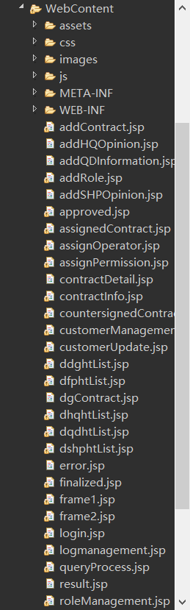

2.4 Application
1. 注册
(1) Functional description

输入用户名，邮箱，密码以注册账号，并到注册邮箱中打开激活链接，以成功激活账号

(2) Running screenshot
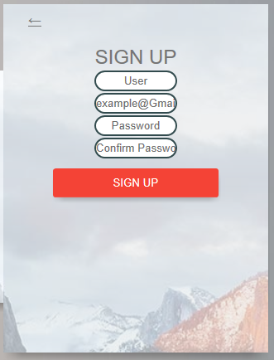
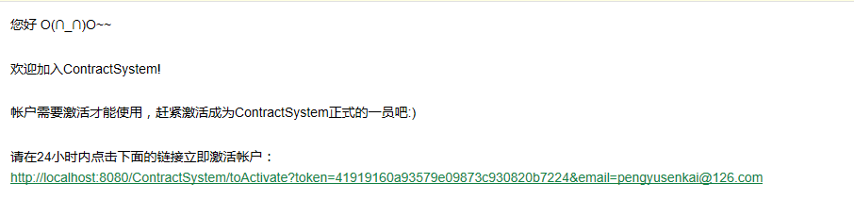

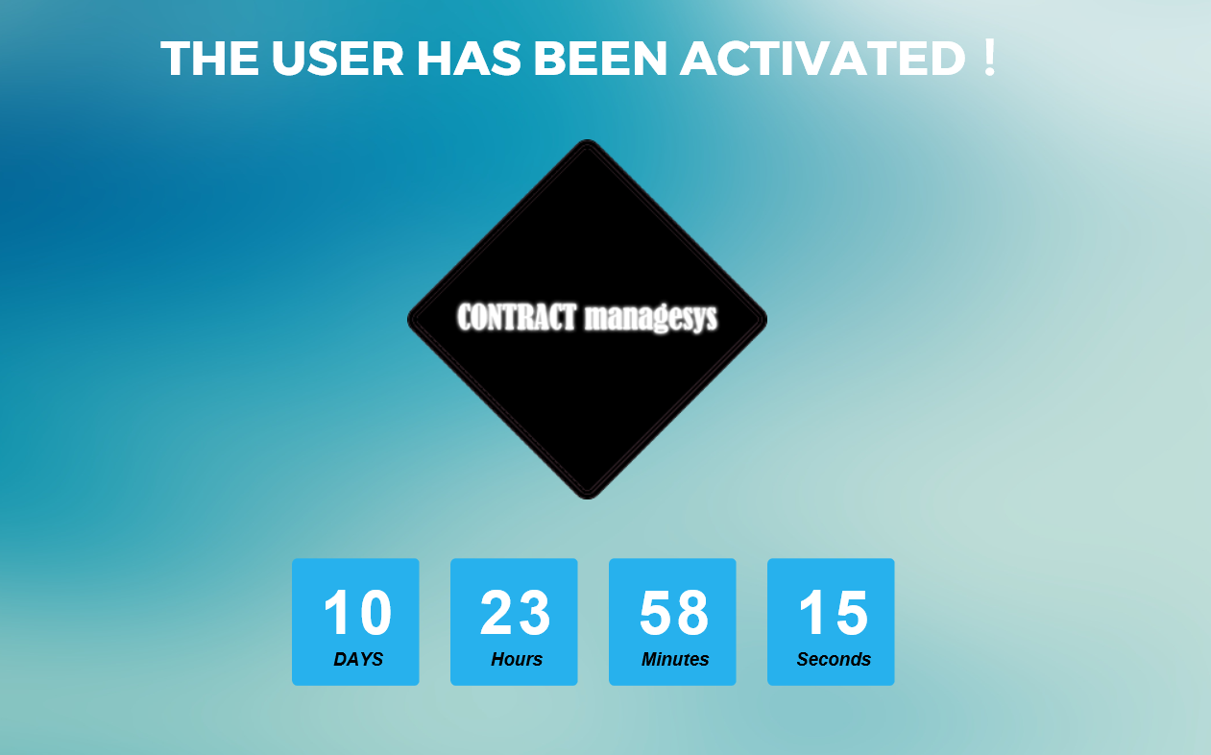
(3) Development idea and core code
/**
* Save user information
*
* @param User object
* @return Return true if saved successfully,otherwise return false
* @throws AppException
*/
@SuppressWarnings("resource")
public boolean add(User user) throws AppException {
Connection conn = null; // Define database connection object
PreparedStatement psmt = null;// Define PreparedStatement object

boolean flag = false;// Operation flag
try {
conn = DBUtil.getConnection();// Create database connection
// Declare operation statement,save user information into database, "?" is a placeholder
String sql = "insert into t_user (name,password,sec_password,email,token,activatetime,createdate,status)"
+ " values (?,?,?,?,?,?,?,?)";

psmt = conn.prepareStatement(sql);// Pre-compiled sql
// Set values for the placeholder
psmt.setString(1, user.getName());
psmt.setString(2, user.getPassword());
psmt.setString(3, user.getSecPassword());
psmt.setString(4, user.getEmail());
psmt.setString(5, user.getToken());
psmt.setLong(6, user.getActivateTime());
psmt.setString(7, user.getCreateDate());
psmt.setInt(8, user.getStatus());
flag = psmt.execute();// Execute the update operation,return the affected rows
if (flag == true) {
String content = "User" + user.getId() + "insert data into t_user";
String sql2 = "insert into t_log(user_id,time,content)values(?,?,?)";
psmt = conn.prepareStatement(sql2); // pre-compiled sql

SimpleDateFormat sDateFormat = new SimpleDateFormat("yyyy-MM-dd hh:mm:ss");
String date = sDateFormat.format(new java.util.Date());
// Set values for the placeholder
psmt.setInt(1, user.getId());
psmt.setString(2, date);
psmt.setString(3, content);
psmt.executeUpdate();
}
} catch (SQLException e) {
e.printStackTrace();
throw new AppException("dao.impl.UserDaoImpl.add");
} finally {
DBUtil.closeStatement(psmt);// Close database object pretreatment
DBUtil.closeConnection(conn);// Close database connection object
}
return flag;
}2. 登录
(1) Functional description

注册成功后，输入用户名和密码，进入管理系统页面。

(2) Running screenshot
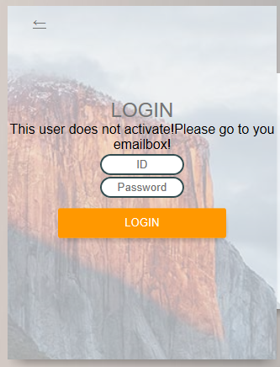
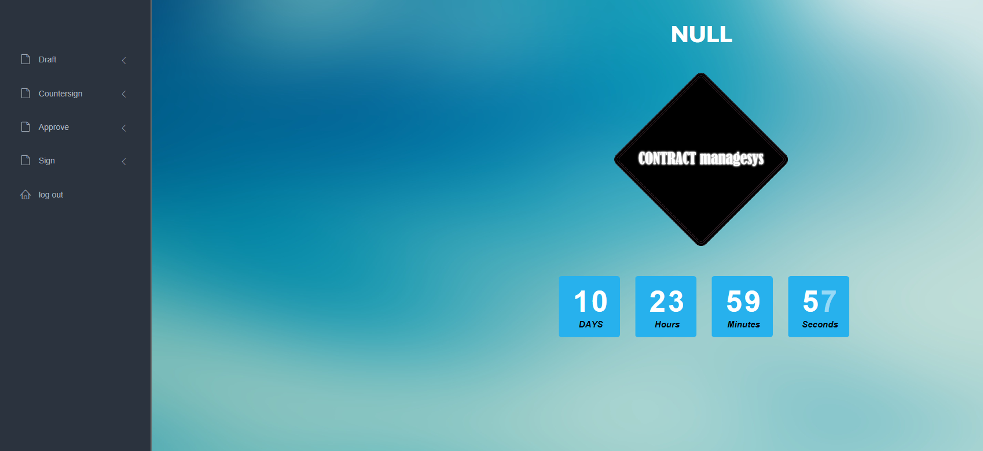

(3) Development idea and core code
}

/**
* Query user number according to the user name and password
*
* @param name
* @param password
* @return User number
* @throws AppException
*/
public int login(String name, String password) throws AppException {
int userId = -1; // Initialize userId
//Declare database connection object, pre-compiled object and result set object
Connection conn = null;
PreparedStatement psmt = null;
ResultSet rs = null;

try {
// Create database connection
conn = DBUtil.getConnection();
// Declare operation statement:query user id according to the user name and password , "?" is a placeholder
String sql = "select id from t_user where name = ? and password = ? and del = 0";
// pre-compiled sql
psmt = conn.prepareStatement(sql);
// Set values for the placeholder
psmt.setString(1, name);
psmt.setString(2, password);
// Execute the query operation
rs = psmt.executeQuery();
// Query record and get user id
if (rs.next()) {
userId = rs.getInt("id");
}

} catch (SQLException e) {
e.printStackTrace();
throw new AppException("dao.impl.UserDaoImpl.login");
} finally {
// Close database object operation, release resources
DBUtil.closeResultSet(rs);
DBUtil.closeStatement(psmt);
DBUtil.closeConnection(conn);
}
return userId;
3. 起草合同
(1) Functional description

“Draft Contract”起草合同，输入合同名称，客户，生效时间，失效时间，赔偿金，内容。
点击“submint”起草，点击“reset”重置。
在“Contract to be finalized”中查看即将到期的合同
在“Finalized Contract”中查看已到期的合同
在“Query Process”中查看合同进度

(2) Running screenshot


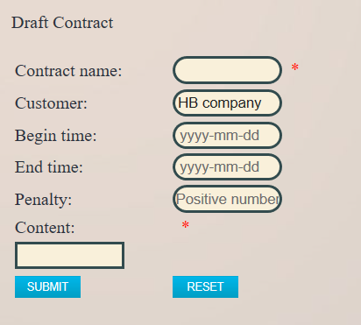


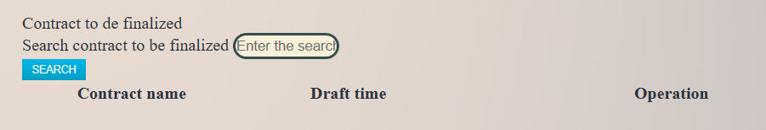

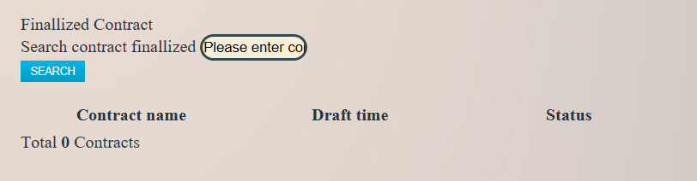

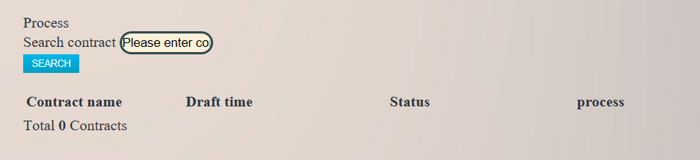
(3) Development idea and core code

@SuppressWarnings("resource")
public boolean add(Contract contract) throws AppException{
boolean flag = false;// Operation flag
// Declare database connection object, pre-compiled object and results set object
Connection conn = null;
PreparedStatement psmt = null;
ResultSet rs = null;

try {
// Create database connection
conn = DBUtil.getConnection();
//Declare operation statement,save contract information, "?" is a placeholder
String sql = "insert into t_contract"
+"(user_id,customer,num,name,beginTime,endTime,content) "
+"values(?,?,?,?,?,?,?)";

// Pre-compiled sql, and return primary key
psmt = conn.prepareStatement(sql, PreparedStatement.RETURN_GENERATED_KEYS);

// Set values for the placeholder
psmt.setInt(1, contract.getUserId());
psmt.setString(2, contract.getCustomer());
psmt.setString(3, contract.getNum());
psmt.setString(4, contract.getName());
// Turn java.util.Dat to java.sql.Date
java.sql.Date beginTime = new java.sql.Date(contract.getBeginTime().getTime());
java.sql.Date endTime = new java.sql.Date(contract.getEndTime().getTime());
psmt.setDate(5, beginTime);
psmt.setDate(6, endTime);
psmt.setString(7, contract.getContent());

psmt.executeUpdate();// Execute update
rs = psmt.getGeneratedKeys(); //Get primary key in insert row,only one record in result set

if (rs.next()) {
contract.setId(rs.getInt(1));// Get primary key's value,and set it into contract object
flag = true; // If affected lines greater than 0, so operation success
String content = "User" + contract.getUserId() + "insert data into t_contract";
String sql2 = "insert into t_log(user_id,time,content)values(?,?,?)";
psmt = conn.prepareStatement(sql2); // pre-compiled sql
// Set values for the placeholder
psmt.setInt(1, contract.getUserId());
SimpleDateFormat sDateFormat = new SimpleDateFormat("yyyy-MM-dd hh:mm:ss");
String date = sDateFormat.format(new java.util.Date());
psmt.setString(2, date);
psmt.setString(3, content);
psmt.executeUpdate();
}

} catch (SQLException e) {
e.printStackTrace();
throw new AppException(
"dao.impl.ContractDaoImpl.add");
} finally {
// Close database object operation, release resources
DBUtil.closeResultSet(rs);
DBUtil.closeStatement(psmt);
DBUtil.closeConnection(conn);
}
return flag;
}
4. 会签合同
(1) Functional description

点击“Contract to be countersigned”搜索将要被会签的合同
点击“Countersigned Contract”查看已会签的合同

(2) Running screenshot


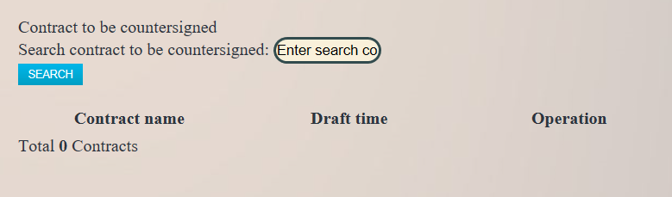

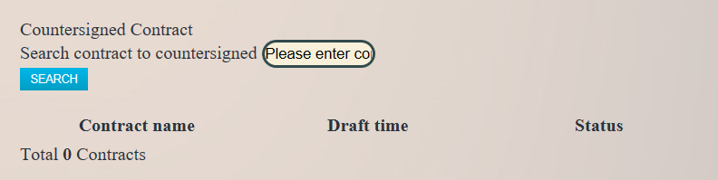
(3) Development idea and core code
/**
* 会签合同，将会签内容保存到数据库里
* 判断未会签人数是否为0，若为0则添加“会签完成”的state
*
* @param conProcess contract process object
* @return boolean Return true if operation successfully閿涘therwise return false
* @throws AppException
*/
public boolean counterSign(ConProcess conProcess) throws AppException {
boolean flag = false;// Define flag

// Set process's operation type to "PROCESS_CSIGN"
conProcess.setType(Constant.PROCESS_CSIGN);
// Set corresponding state of "PROCESS_CSIGN" type is "DONE"
conProcess.setState(Constant.DONE);

try {
if (conProcessDao.update(conProcess)) { //更新数据库记录
/*
* After countersign successful, statistics total number of persons to be countersigned, if the total number is 0, then all people have completed countersign
* and set contract process state to "STATE_CSIGNED"
*/
// Pass parameters through conProcess to statistics the number of persons to be countersigned,set state to "UNDONE"
conProcess.setState(Constant.UNDONE);

// 未会签人数
int totalCount = conProcessDao.getTotalCount(conProcess);

// if the number of persons to be countersigned is 0, then all people have completed countersign
if (totalCount == 0) {
ConState conState = new ConState();
conState.setConId(conProcess.getConId());
// Set contract state to "STATE_CSIGNED"
conState.setType(Constant.STATE_CSIGNED);
// Save contract state information
flag = conStateDao.add(conState);
}
}
} catch (AppException e) {
e.printStackTrace();
throw new AppException(
"service.ContractService.counterSign");
}
return flag;
}
5. 审批合同
(1) Functional description

点击“Contract to be approved”查看待审批的合同
点击“Approved Contract”查看已审批的合同

(2) Running screenshot

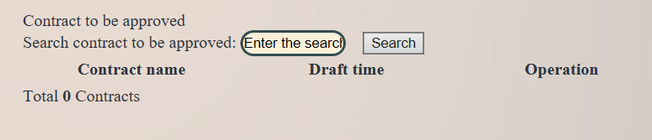

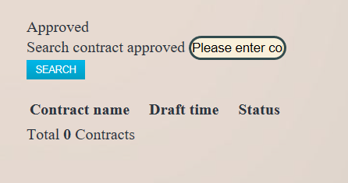
(3) Development idea and core code
/**
* 审批合同
*
* @param conProcess Contract process object
* @return boolean Return true if operation successfully閿涘therwise return false
* @throws AppException
*/
public boolean approve(ConProcess conProcess) throws AppException {
boolean flag = false;// Define flag

// Set process's operation type to "PROCESS_APPROVE"
conProcess.setType(Constant.PROCESS_APPROVE);

try {
/*
* First to do approve operation,then count all the number of persons to be approved and persons approved as "refuse",
* if the number of persons to be approved is 0,and the number of persons approved as "refuse" is 0,
* so all the approver have complete the approval and pass the approval,
* and now set contract process state to "STATE_APPROVED"
*/
if (conProcessDao.update(conProcess)) { // To approve contract,enter approval information
// Pass Parameter through conProcess to count number of approver,set state to "UNDONE"
conProcess.setState(Constant.UNDONE);
// Get total number of persons to be approved
int tbApprovedCount = conProcessDao.getTotalCount(conProcess);

// Pass Parameter through conProcess to count number of refused approver,set state to "VETOED"
conProcess.setState(Constant.VETOED);
// Get total number of persons approved as "refuse"
int refusedCount = conProcessDao.getTotalCount(conProcess);

/*
* If the number of persons to be approved is 0, then all the approver have been complete approval,
* and all passed approval, so save contract state as "STATE_APPROVED"
*/
if (tbApprovedCount == 0) {
if(refusedCount == 0)
{
ConState conState = new ConState();
conState.setConId(conProcess.getConId());
// Set contract state type to "STATE_APPROVED"
conState.setType(Constant.STATE_APPROVED);
// Save contract state information
flag = conStateDao.add(conState);
}else
{
contractDao.setDel(conProcess.getConId());
}
}
}
} catch (AppException e) {
e.printStackTrace();
throw new AppException(
"service.ContractService.approve");
}
return flag;
}

6. 签订合同
(1) Functional description

点击“Contract to be signed”查看待签订的合同
点击“Signed Contract”查看已签订的合同

(2) Running screenshot

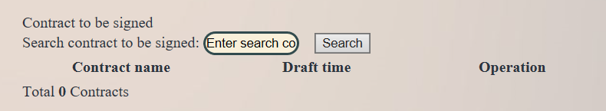

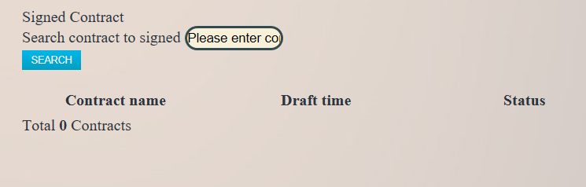
(3) Development idea and core code
/**
* 签订合同
*
* @param conProcess Contract process object
* @return boolean Return true if operation successfully閿涘therwise return false
* @throws AppException
*/
public boolean sign(ConProcess conProcess) throws AppException {
boolean flag = false;// Define flag

// Set process's operation type to "PROCESS_SIGN"
conProcess.setType(Constant.PROCESS_SIGN);
// Set "PROCESS_SIGN" type corresponding state to "DONE"
conProcess.setState(Constant.DONE);

try {
if (conProcessDao.update(conProcess)) {// Sign contract:update contract process information

// Instantiation conState object, for encapsulate contract state information
conProcess.setState(Constant.UNDONE);
int totalCount = conProcessDao.getTotalCount(conProcess);

if (totalCount == 0) {
ConState conState = new ConState();
conState.setConId(conProcess.getConId());
// Set contract state to "STATE_CSIGNED"
conState.setType(Constant.STATE_SIGNED);
// Save contract state information
flag = conStateDao.add(conState);
}
}
} catch (AppException e) {
e.printStackTrace();
throw new AppException(
"service.ContractService.sign");
}
return flag;
}

6. 注销
(1) Functional description

点击“Log out”注销用户

(2) Running screenshot

(3) Development idea and core code
/**
* Process POST logout request
*/
public void doPost(HttpServletRequest request, HttpServletResponse response)
throws ServletException, IOException {
// Declare session
HttpSession session = null;
// Get session by using request object
session = request.getSession();
// Delete use information from session
session.removeAttribute("userId");
session.removeAttribute("userName");
// Redirect to login page
response.sendRedirect("toLogin");
}

2.5 Deliverables

Processes(Stages) | Deliverables | Deliver or not（√） | Remarks
Project start | Project Start Report | √
Project planning | Project Planning Report | √
Requirement analysis | Requirement Specifications（SRS） | √
System design | System Design Specifications（SD） | √
Coding implementation and test | Project Source Code | √
Coding implementation and test | Project user’s manual | √
Acceptance and close | Project Closure Summary Report | √

3. Project Work Summary

3.1 Code statistics

Package | Lines of coding | Lines of comments | Comment rate
Dao | 2621 | 234 | 0.08
Model | 1400 | 165 | 0.12
Service | 2079 | 135 | 0.06
Utils | 266 | 13 | 0.05
Web | 3068 | 259 | 0.08
Total | 9434 | 806 | 0.085

3.2 Document work summary
Name | Process | Document | Pages
 | Initialization | Project Start Report | 7
 | Plan | Project Planning(optional) | 6
 | RA | Requirement Specification(optional) | 22
 | System Design | System Design(optional) | 10
 | Implement | User Manual | 12
 | Accepting | Project Acceptance report
 | Accepting | Project Closure Summary Report | 13
Total |  |  | 70

4. Lessons learned and Suggestions for Improvement
1、在项目初期没有进行风险的管理探讨，项目远景定义和功能集合的详细定义。
经验总结：
由于客户一般对计算机不是很了解，和他们交流是用软件行业的专业俗术语，他们根本就不懂，如果用文档也很难把需求写得那么明白。
如果让客户一看就可以看出这个就是他们想要的，我认为最好的方式就是做系统原形（界面的功能模拟）。
2、不注重用户参与。
没有一开始就让用户参与详细需求的制定的做法，大部分都是靠需求采集人员的猜想，猜想往往和实际有差距，造成系统功能不切合实际，与项目实际需求差距大，运行效果差。
经验总结：
项目的开始和结束用户是需要一直参与进来的，我们每做个可以运行的功能等就需要和用户交流，这样可以避免很多风险也可以尽早发现需求的误解的等等。

