Document Name |  | Confidentiality Level
数据库管理系统 |  | Only for Recipients Reference
Template Code | Version | Document Code

数据库管理系统
项目总结报告

Revision Record
Date | Revision Version | CR ID /Defect ID | Sec No. | Change Description | Author
2017/5/23 | 1.0 |  |  | 初稿完成 | 彭昱森

Content
1. Project Basic Situation 3
2. Project Acceptance Coverage 3
2.1 Project progress 3
2.2 Development environment 4
2.3 Project Structure 4
2.4 Application 4
2.5 Deliverables 5
3. Project Work Summary 5
3.1 Code statistics 5
3.2 Document work summary 5
4. Lessons learned and Suggestions for Improvement 6

1. Project Basic Situation
Project Name: | 数据库管理系统 | Project Category: | 1
Project ID: | 1 | Technology Used: | C++
Development Environment: | Qt | Running Platform: | Windows 10
Project Start & Finish Time: | 2017/04/26~2017/05/24 | Project Working Place:
Project Manager: | 游江平
Project Developer: | 王剑、牟子涵、彭昱森
Project Description | 数据库管理系统用于建立、使用和维护数据库。它对数据库进行统一的管理和控制，以保证数据库的安全性和完整性。用户通过DBMS访问数据库中的数据，数据库管理员也通过DBMS进行数据库的维护工作。它可使多个应用程序和用户用不同的方法在同时或不同时刻去建立，修改和询问数据库。DBMS提供数据定义语言DDL（Data Definition Language）与数据操作语言DML（Data Manipulation Language），供用户定义数据库的模式结构与权限约束，实现对数据的追加、删除等操作。

2. Project Acceptance Coverage

2.1 Project progress
(S.N.) | Stages | Scheduled start/end time | Actual start/end time | List of deliverables | Remarks
1 | Project start | 4.26 | 4.26 | 项目启动
2 | Project planning | 4.27-4.29 | 4.27-4.29 | 项目计划
3 | Requirement analysis | 4.30-5.2 | 4.30-5.2 | 需求分析
4 | System design | 5.3-5.6 | 5.3-5.6 | 系统设计
5 | Coding and test | 5.7-5.23 | 5.7-5.23 | 代码若干行
6 | Acceptance | 5.24 | 5.24 | 完整程序一份

2.2 Development environment
System/Tool/Component | In English (version number) | Remarks
Operating system | Windows 10
Development tool | Qt 5.8

2.3 Project Structure
1. Project structure design idea
Prompt: describing how to fulfill design of project framework, as well as technology employment (or technological prototyping).
Reference: System Design (sample)

2. Project directory structure
Prompt: adhering project directory screenshot.
Reference: System Design (sample)

2.4 Application
1. Requirement Function 1
(1) Functional description

添加数据库，在程序界面中显示，数据存入本地

(2) Running screenshot

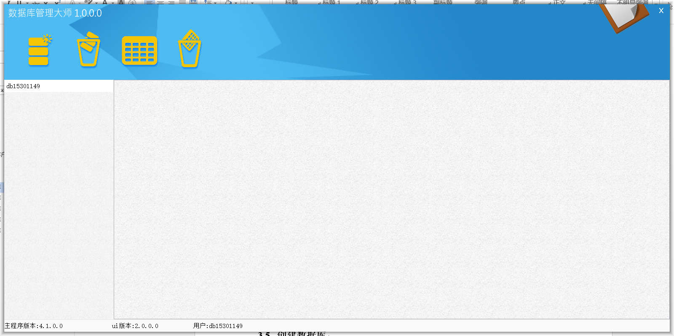

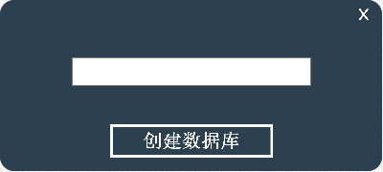

(3) Development idea and core code

bool DBDataOps::Create(const QString strFilepath, DBEntity db, bool bAppend)
{
char* c_CtTime;
try
{
QFile file(strFilepath);
if(bAppend == true)
{
if (file.open(QIODevice::Append|QIODevice::WriteOnly) == FALSE)
{
return false;
}
}
else
{
if (file.open(QIODevice::Truncate|QIODevice::WriteOnly) == FALSE)
{
return false;
}
}
QDataStream out(&file);
c_CtTime=new char[256];
DatabaseBlock DBlock=db.GetBlock();

strcpy(c_CtTime,DBlock.crtimAe.toString("yyyy-MM-dd hh:mm:ss").toLatin1().data());
out<<DBlock.name<<DBlock.type<<DBlock.filepath<<c_CtTime;

delete c_CtTime; //释放动态内存
file.close();
return true;
}
catch(AppException e)// Catch exceptions
{
delete c_CtTime; //释放动态内存
// Delete the exception information

// Throw a custom exception
//throw new AppException(_T("Failed to create the database file!"));
}
return false;
}
2. Requirement Function 2
(1) Functional description

创建表格，在程序界面中显示，并将数据存入本地

(2) Running screenshot


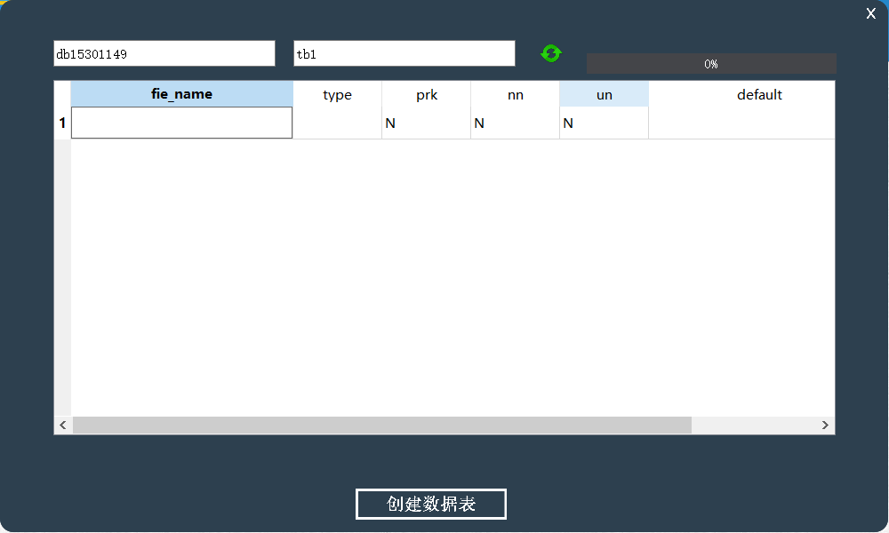
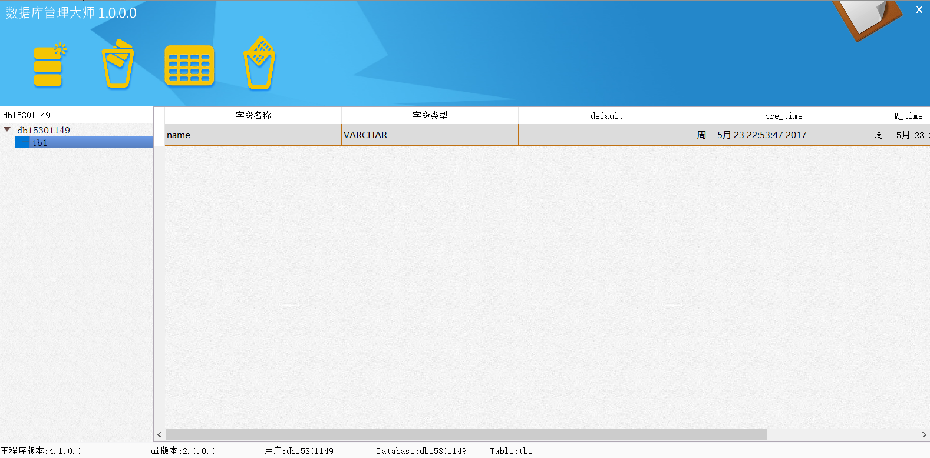

(3) Development idea and core code

bool TableDataOps::Create(const QString strFilePath, TableEntity *te)
{
try
{
char* c_Crtime;
char* c_Mtime;
QFile file(strFilePath);

// Open file
if (file.open(QIODevice ::WriteOnly|QIODevice::Append) == FALSE)
{
return false;
}
QDataStream out(&file);
// Write in the database table information to the file

TableBlock tb = te->GetBlock();
c_Crtime = new char[256];
c_Mtime = new char[256];
strcpy(c_Crtime,tb.crtime.toString("yyyy-MM-dd hh:mm:ss").toLatin1().data());;
strcpy(c_Mtime,tb.mtime.toString("yyyy-MM-dd hh:mm:ss").toLatin1().data());

out << tb.name;
out<<tb.record_num;
out<<tb.field_num;
out<<tb.tdf;
out<<tb.trd;
out<<tb.tic;
out<<c_Crtime;
out<<c_Mtime;

// Close file
delete c_Crtime;
delete c_Mtime;
file.close();
return true;
}
catch (QException e)
{
throw new AppException(QString::fromLocal8Bit("Failed to add table information!"));
}
return false;
}
3. Requirement Function 3
(1) Functional description

删除数据库，并删除本地数据文件

(2) Running screenshot



(3) Development idea and core code

bool DBDataOps::DeleteDB(const QString DBDirepath,const QString dbFilepath, DBARR &arrDB)
{
//删除数据库文件夹
FileLogic fl;
fl.DeleteDirectory(DBDirepath);

//修改.db文件
QFile file(dbFilepath);
file.open(QIODevice::Truncate|QIODevice::WriteOnly);
QDataStream out(&file);

char *c_CtTime=new char[256];
for(int i=0;i<arrDB.size();i++)
{
DBEntity* db=arrDB.value(i);
if(db!=NULL)
{
DatabaseBlock DBlock=db->GetBlock();
strcpy(c_CtTime,DBlock.crtimAe.toString("yyyy-MM-dd hh:mm:ss").toLatin1().data());
out<<DBlock.name<<DBlock.type<<DBlock.filepath<<c_CtTime;
}
}
file.close();
return true;

4. Requirement Function 4
(1) Functional description

删除表格，并删除本地数据文件

(2) Running screenshot



(3) Development idea and core code
bool TableDataOps::delTable(TABLEARR &arrtab,const QString tbFilePath,const QString DirPath)
{
/*
* 清空文件夹
*/
FileLogic fl;
fl.DeleteDirectory(fl.GetAbsolutePath(DirPath));

/*
* .tb文件夹中删除表信息
*/
QFile file(tbFilePath);
QDataStream out(&file);
file.open(QIODevice::Truncate|QIODevice::WriteOnly);

char *c_Crtime=new char[256];
char *c_Mtime=new char[256];
//遍历TABLEARR
for(int i=0;i<arrtab.size();i++)
{
TableEntity* te=arrtab.value(i);
if(te!=NULL)
{
TableBlock tb = te->GetBlock();
strcpy(c_Crtime,tb.crtime.toString("yyyy-MM-dd hh:mm:ss").toLatin1().data());
strcpy(c_Mtime,tb.mtime.toString("yyyy-MM-dd hh:mm:ss").toLatin1().data());
out << tb.name<<tb.record_num<<tb.field_num<<tb.tdf<<tb.trd<<tb.tic<<c_Crtime<<c_Mtime;
}
}
delete c_Crtime; //释放内存
delete c_Mtime;
file.close();
return true;

}

2.5 Deliverables
Processes(Stages) | Deliverables | Deliver or not（√） | Remarks
Project start | Project Start Report | √
Project planning | Project Planning Report | √
Requirement analysis | Requirement Specifications（SRS） | √
System design | System Design Specifications（SD） | √
Coding implementation and test | Project Source Code | √
Coding implementation and test | Project user’s manual | √
Acceptance and close | Project Closure Summary Report | √

3. Project Work Summary

3.1 Code statistics

File | Lines of coding | Lines of comments | Comment rate
dbdataops.cpp | 181 | 20 | 0.1
recorddataops.cpp | 229 | 25 | 0.1
tabledataops.cpp | 556 | 35 | 0.06
dbentity.cpp | 90 | 23 | 0.2
fieldentity.cpp | 164 | 43 | 0.21
recordentity.cpp | 79 | 21 | 0.21
tableentity.cpp | 193 | 38 | 0.16
dblogic.cpp | 114 | 46 | 0.29
filelogic.cpp | 181 | 35 | 0.16
recordlogic.cpp | 67 | 21 | 0.24
service.cpp | 401 | 26 | 0.06
tablelogic.cpp | 177 | 35 | 0.17
centerwindow.cpp | 440 | 58 | 0.12
createdb.cpp | 95 | 21 | 0.18
createtable.cpp | 214 | 28 | 0.12
loginWindow.cpp | 121 | 13 | 0.097
main.cpp | 21 | 6 | 0.2
recordwidget.cpp | 159 | 24 | 0.13
total | 3482 | 518 | 0.16

3.2 Document work summary
Name | Process | Document | Pages
 | Initialization | Project Start Report | 7
 | Plan | Project Planning(optional) | 6
 | RA | Requirement Specification(optional) | 22
 | System Design | System Design(optional) | 10
 | Implement | User Manual | 12
 | Accepting | Project Acceptance report
 | Accepting | Project Closure Summary Report | 13
Total |  |  | 70

4. Lessons learned and Suggestions for Improvement
1、在项目初期没有进行风险的管理探讨，项目远景定义和功能集合的详细定义。
经验总结：
由于客户一般对计算机不是很了解，和他们交流是用软件行业的专业俗术语，他们根本就不懂，如果用文档也很难把需求写得那么明白。
如果让客户一看就可以看出这个就是他们想要的，我认为最好的方式就是做系统原形（界面的功能模拟）。
2、不注重用户参与。
没有一开始就让用户参与详细需求的制定的做法，大部分都是靠需求采集人员的猜想，猜想往往和实际有差距，造成系统功能不切合实际，与项目实际需求差距大，运行效果差。
经验总结：
项目的开始和结束用户是需要一直参与进来的，我们每做个可以运行的功能等就需要和用户交流，这样可以避免很多风险也可以尽早发现需求的误解的等等。

