

DBMS

Mini Project
Assignment

Semester -4th sem
Subject code -css453
Submission date -8th April, 2025

Group-16

Group Members
-23CS8077 P.Surya Teja
-23CS8078 B.Nikhileswar Reddy
-23CS8079 K.Jaswika
-23CS8080 M.Vindhya

Project

Name:

Database for Online Ticket Booking System

Statement:
The database should manage users, ticket bookings and payment details

Objective:
The objective of an online ticket booking database is to create well structured tables and perform operations on the Relations to get required data

Goal of the Project
It is to design and implement a relational database for Online Ticket Booking System that supports users to perform some operations on the data to extract a structured information

System Design
The online Ticket Booking System is designed using the principles of relational database management.
The key Relations of the system are Users, Tickets and Payments. These entities are modeled as individual tables and operations are done such that they ensure data consistency

Tables
-Users
For unique identification of the user
-UserID
Other additional details about the user
-Name
-Email
-Phone Number
-Tickets
For unique identification of Ticket
-TicketID
Use of foreign key to identify user
-UserID
Specifications of the ticket
-EventName
-SeatNumber
-Price
-Payments
For unique identification of Payment
-PaymentID
Use of foreign key to identify user and ticket
-UserID
-TicketID
Details
-Amount
-PaymentDate

Operations
• Retrieve all ticket bookings by a specific user
• List all upcoming events
• Update ticket price for a specific event
• Find the total revenue from ticket sales
• Delete a user’s booking and payment details
• Retrieve all payments made within a specific date range
• Find the most frequently booked event
• Identify users who booked more than three tickets
• Generate a report of total revenue by event
• Retrieve the top five highest-paying customers

ER Diagram
Let’s understand the problem with an ER(Entity-Relation) Diagram
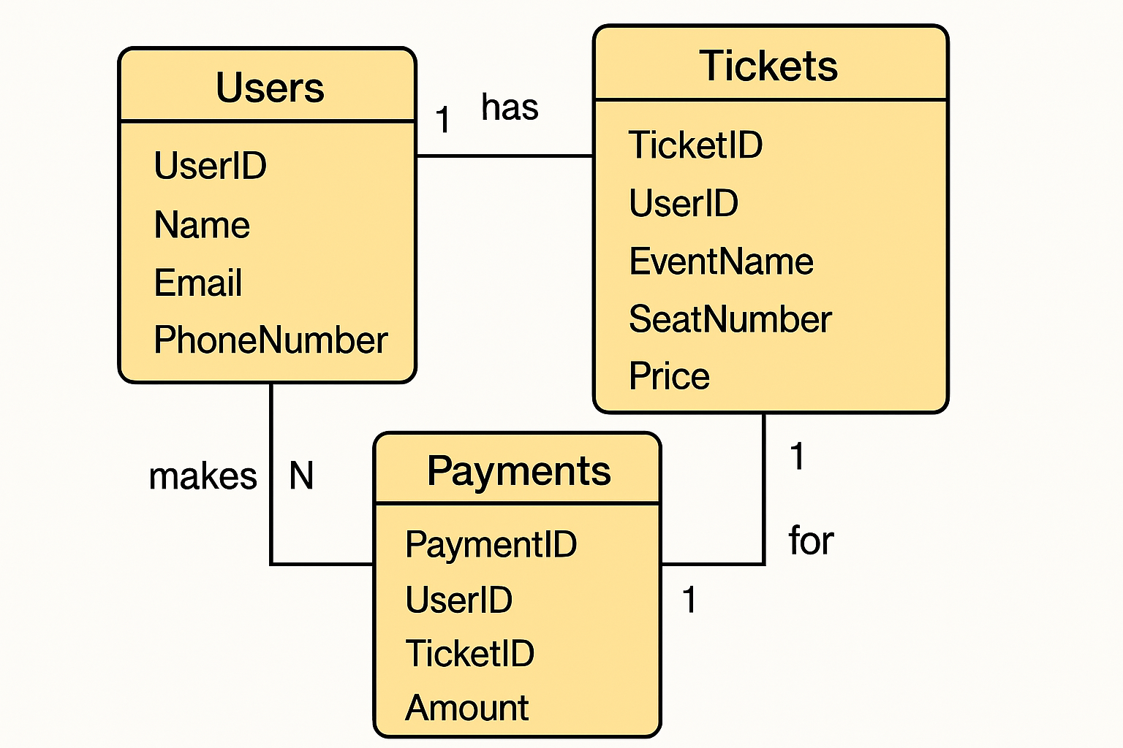

We use MySQL for table creation and query execution

Table Creation Scripts

Users Table
create table Users
(
UserID int primary key,
Name varchar(30),
Email varchar(30),
PhoneNumber char(10) check(length(PhoneNumber)=10)
);

Tickets Table
create table Tickets
(
TicketID int primary key,
UserID int,
EventName varchar(30),
SeatNumber int,
Price int,
Foreign key (UserID) references Users(UserID)
on delete cascade
on update cascade
);

Payments Table
create table Payments
(
PaymentID int primary key,
UserID int,
TicketID int,
Amount int,
PaymentDate date check(PaymentDate <=current_date),
Foreign key (UserID) references Users(UserID)
on delete cascade
on update cascade,
Foreign key (TicketID) references Tickets(TicketID)
on delete cascade
on update cascade
);

Working on sample data

Inserting values into Users table
insert into Users values
(1,'surya','surya@gmail.com','9398294616'),
(2,'nikhileswar','nikhileswar@gmail.com','7893615681'),
(3,'jaswika','jaswika@gmail.com','6301780659'),
(4,'vindhya','vindhya@gmail.com','9888933372');

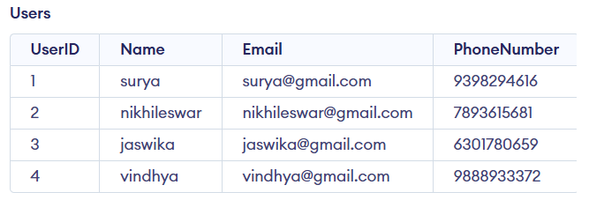

Inserting values into Tickets table
insert into Tickets values
(1234,1,"Dgp_Hwh",131,345),
(2345,2,"Dgp_Hwh",156,165),
(2680,3,"Dgp_Hwh",119,210),
(2681,4,"Dgp_Hwh",120,210),
(3456,3,"Hwh_Krv",80,1740),
(4567,4,"Hwh_Krv",44,1740),
(7890,1,"Hwh_Che",51,1460),
(7892,2,"Hwh_Che",78,1450),
(5796,3,"Krv_Hyb",79,1100),
(9753,2,"Che_Bza",78,900),
(9953,2,"Bza_bha",10,100);

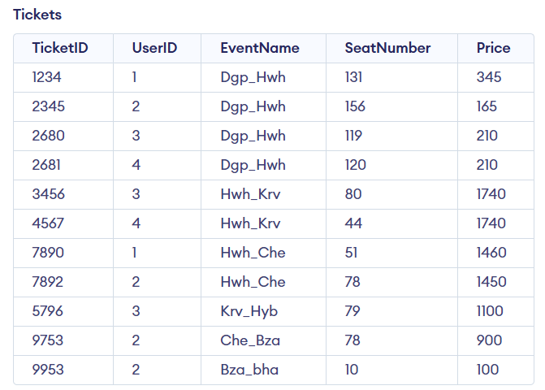

Inserting values into Payments table
insert into Payments values
(654789,1,1234,385,"2025-03-02"),
(123456,2,2345,205,"2025-03-02"),
(891230,3,2680,250,"2025-03-01"),
(891302,4,2681,250,"2025-03-01"),
(234567,3,3456,1800,"2025-03-01"),
(345678,4,4567,1800,"2025-03-01"),
(456732,1,7890,1520,"2025-03-02"),
(998601,2,7892,1520,"2025-03-02"),
(569123,3,5796,1145,"2025-03-03"),
(789361,2,9753,948,"2025-03-04"),
(943258,2,9953,130,"2025-03-04");
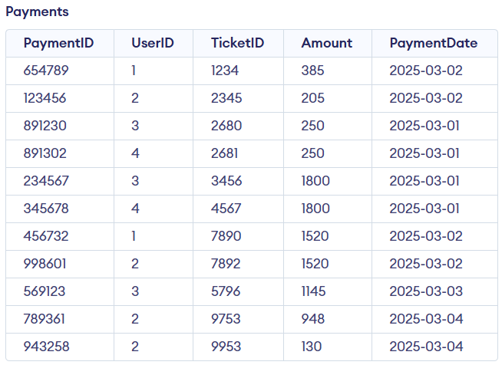

Queries

• Retrieve all ticket bookings by a specific user
select * from Tickets
where UserID=<User_ID>;

for User_ID=1
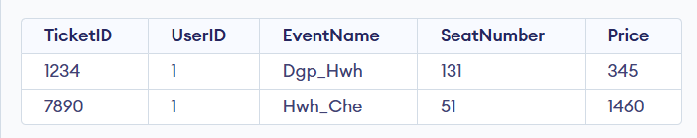

• List all upcoming events
select distinct EventName as Events from Tickets;
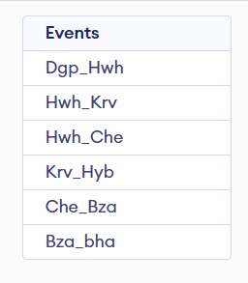

• Update ticket price for a specific event
update Tickets set price=<new_price> where EventName=<Name_of_Event>;

for new_price=1780 and Name_of_Event=”Hwh_Krv”
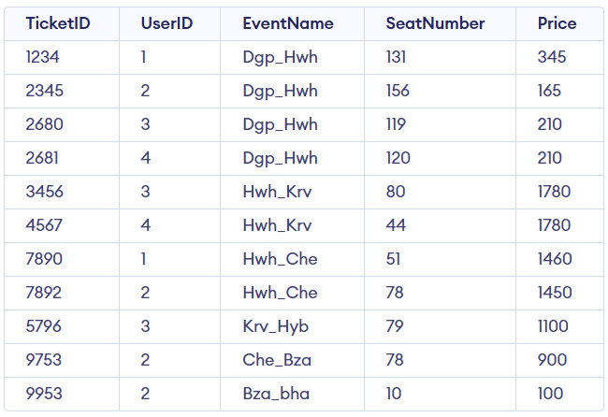

• Find the total revenue from ticket sales
select sum(price) as ToatalRevenue from Tickets;
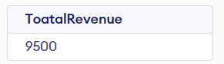

• Delete a user’s booking and payment details
delete from Payments where UserID=<User_ID>;
delete from Tickets where UserID=<USER_ID>;

for User_ID=1

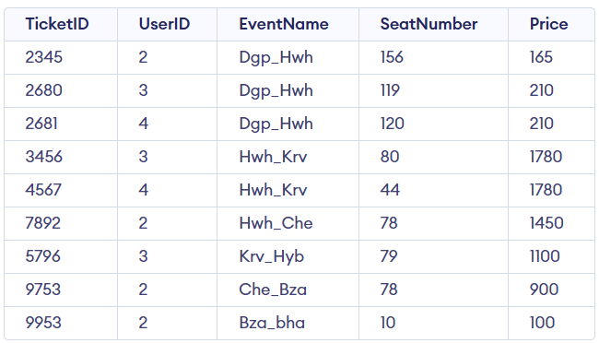
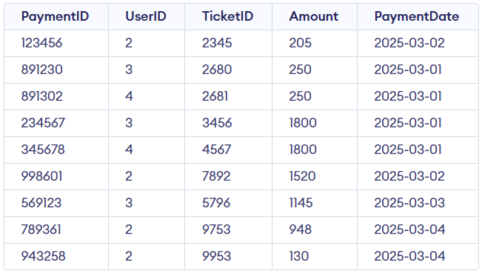

• Retrieve all payments made within a specific date range
select * from Payments
where PaymentDate between <start_date> and <end_date>;

for strat_date=’2025-03-02’ and end_date=’2025-03-03’
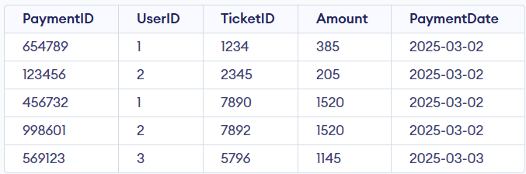

• Find the most frequently booked event
select EventName as Event,count(EventName) as Bookings
from Tickets
group by EventName
order by Bookings desc
limit 1;
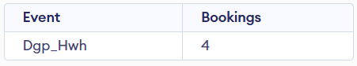

• Identify users who booked more than three tickets
select U.UserID,U.Name,count(T.EventName) as TicketCount
from Tickets as T join Users as U on U.UserID=T.UserID
group by U.UserID
having TicketCount>3;
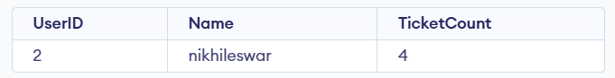

• Generate a report of total revenue by event
select EventName as Event,sum(price) as TotalRevenue
from Tickets
group by EventName;
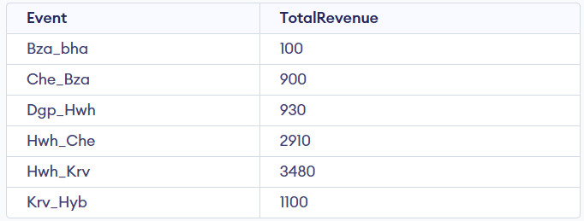

• Retrieve the top five highest-paying customers
select U.UserID,U.Name,sum(P.Amount) as TotalAmount
from Payments as P join Users as U on P.UserID=U.UserID
group by U.UserID
order by TotalAmount desc
limit 5;
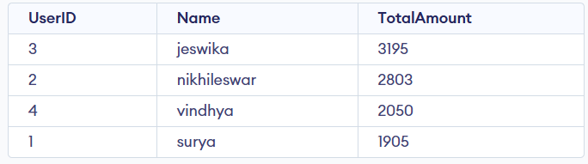

Implementation and Github
The above tables creation, adding values to the tables and implementation of operations on the tables are saved in

Github Repository:

https://github.com/nit-dgp-cse-gp-16/Database-for-Online-Ticket-Booking-System

Group Members:
Suryatejapotnuru
b-nikhileswar-reddy (B.Nikhileswar Reddy)
JaswikaKilaru (jaswika kilaru)
VindhyaMuvva

