
Mini project report on
SOFTWARE DEPENDENCY VULNERABILITY AND
IMPACT TRACKING SYSTEM (SDVIT)
Submitted in partial fulfilment of the requirements for the award of degree of
Bachelor of Technology
in
Computer Science & Engineering
UE24CS351A – DBMS Project
Submitted by:
Samaresh – PES2UG24CS657
Vaibhav R – PES2UG24CS664
under the guidance of
Dr. Shilpa S
Assistant Professor
FACULTY OF ENGINEERING
PES UNIVERSITY
(Established under Karnataka Act No. 16 of 2013)
Electronic City, Hosur Road, Bengaluru – 560 100, Karnataka, India

CERTIFICATE
PES UNIVERSITY
(Established under Karnataka Act No. 16 of 2013)
Electronic City, Hosur Road, Bengaluru – 560 100, Karnataka, India
This is to certify that the mini project entitled
SOFTWARE DEPENDENCY VULNERABILITY AND IMPACT TRACKING SYSTEM (SDVIT)
is a bonafide work carried out by
Samaresh – PES2UG24CS657
Vaibhav R – PES2UG24CS664
In partial fulfilment for the completion of fifth semester DBMS Project (UE24CS351A) in the Program of Study – Bachelor of Technology in Computer Science and Engineering under the rules and regulations of PES University, Bengaluru.

Signature
Dr. Shilpa S
Assistant Professor

DECLARATION
We hereby declare that the DBMS Project entitled “Software Dependency Vulnerability and Impact Tracking System (SDVIT)” has been carried out by us under the guidance of Dr. Shilpa S, Assistant Professor, Department of Computer Science and Engineering, PES University. This work is submitted in partial fulfilment of the course requirements for UE24CS351A – DBMS Project. The work presented in this report is based on our project implementation and has not been submitted elsewhere for any other academic award.
Samaresh – PES2UG24CS657
Vaibhav R – PES2UG24CS664

ACKNOWLEDGEMENT
We express our sincere gratitude to Dr. Shilpa S, Assistant Professor, Department of Computer Science and Engineering, PES University, for her guidance, valuable suggestions, and support throughout the development of this DBMS mini project.
We also thank the faculty members and the Department of Computer Science and Engineering, PES University, for providing the academic environment and resources required to complete this project.
Finally, we thank our families and friends for their encouragement and support during the completion of the project.

ABSTRACT
Software applications rely on third-party libraries and packages to provide functionality and reduce development effort. However, these dependencies may contain security vulnerabilities that can expose applications to risks. Identifying vulnerable dependency versions and understanding which projects are affected are important tasks in software security management.
The Software Dependency Vulnerability and Impact Tracking System (SDVIT) is designed to organize software projects, packages, package versions, dependencies, vulnerabilities, affected versions, alerts, and project risk information. The system uses CVE identifiers to identify publicly known vulnerabilities and CVSS scores to represent their severity.
The database is implemented using MySQL and contains nine relational tables connected through primary keys, foreign keys, unique constraints, and indexes. Views, stored procedures, functions, and triggers support vulnerability reporting, alert generation, alert management, and risk assessment. The frontend and backend are developed using React with Vite and Node.js with Express, respectively. A graph-based layer using Neo4j is included in the proposed architecture for transitive dependency analysis; it is treated as a separate/proposed layer in this report.
SDVIT aims to provide a centralized approach to dependency and vulnerability tracking, helping developers identify affected projects, monitor security alerts, and assess project exposure.

TABLE OF CONTENTS
1. Introduction
2. Problem Definition
3. ER Model
4. ER-to-Relational Mapping
5. DDL Statements
6. DML Statements
7. SQL Queries
8. Stored Procedures, Functions and Triggers
9. Front-End Development
References
Appendix A: Definitions, Acronyms and Abbreviations
Note: Update page numbers after final formatting in Microsoft Word.

1. INTRODUCTION
Modern software applications are rarely developed entirely from scratch. Developers frequently depend on external libraries, frameworks, and packages to implement functionality efficiently. These third-party components reduce development time and improve productivity. However, dependencies can introduce security risks because a vulnerability in a package may affect every project that uses an affected version.
A software dependency is an external component required by a project. A package may have multiple released versions, and a vulnerability may affect only a subset of those versions. Therefore, storing package names separately from package versions is important for accurate vulnerability tracking.
The Software Dependency Vulnerability and Impact Tracking System (SDVIT) provides a centralized database-backed approach to recording projects, dependencies, vulnerabilities, affected package versions, and security alerts. Vulnerabilities are identified using CVE identifiers and assessed using CVSS scores. The database supports automatic alert generation for high-severity vulnerabilities and maintains project risk snapshots.

1.1 OBJECTIVES
- Maintain information about users and software projects.
- Store package names and their individual released versions.
- Record project-to-package-version dependency relationships.
- Maintain vulnerability records using CVE identifiers and CVSS scores.
- Map vulnerabilities to the package versions they affect.
- Generate alerts when a project is exposed to a high-severity vulnerability.
- Support alert acknowledgement and resolution.
- Calculate and retain project risk snapshots.
- Enforce data integrity using primary keys, foreign keys, unique constraints, and indexes.

1.2 SCOPE
The project focuses on the relational representation and tracking of direct project dependencies, vulnerability records, affected package versions, alerts, and risk information. The supported package ecosystems in the schema are npm, PyPI, Maven, Cargo, and other. The database provides procedures, functions, triggers, and views for operational support. The architecture also identifies Neo4j as a graph layer for transitive dependency traversal; this report does not claim that the graph integration is operational unless separately demonstrated.

2. PROBLEM DEFINITION

2.1 PROBLEM STATEMENT
Software projects use multiple third-party packages, and vulnerabilities may exist in particular versions of those packages. Developers need to determine which package versions are affected and which projects depend on them. When dependency and vulnerability information is maintained separately, identifying affected projects and tracking remediation can become difficult. SDVIT addresses this problem by maintaining the relevant information in a centralized database and supporting alert generation and project risk assessment.

2.2 EXISTING SYSTEM
In a basic or manual approach, developers may inspect package manifests, vulnerability advisories, and project records separately. This can require repeated effort to match package versions with affected-version information and to determine which projects are exposed. It may also be difficult to maintain a consistent alert status and historical project risk information across multiple projects.

2.3 PROPOSED SYSTEM
SDVIT organizes project, package, version, dependency, vulnerability, affected-version, alert, and risk information in a MySQL relational database. Foreign keys and uniqueness constraints maintain valid relationships. Database triggers create alerts for high-severity vulnerabilities in two situations: when a project adds a package version already known to be vulnerable, and when a vulnerability is mapped to a package version already used by projects. Stored procedures support reporting, alert status changes, and risk snapshot generation. The frontend provides an interface for interacting with the system.

3. ER MODEL
The ER model represents the main entities in SDVIT and the relationships among them. Users own projects. Projects use package versions through project dependency records. Packages may have multiple package versions. Vulnerabilities are associated with affected package versions, while alerts connect projects to vulnerabilities. Risk snapshots retain calculated risk values for projects.
Entity | Purpose
USERS | Stores user details and role information.
PROJECTS | Stores projects and their owners.
PACKAGES | Stores package names and ecosystems.
PACKAGE_VERSIONS | Stores individual versions belonging to packages.
PROJECT_DEPENDENCIES | Associates projects with package versions.
VULNERABILITIES | Stores CVE identifiers, descriptions, CVSS scores, and dates.
VULN_AFFECTED_VERSIONS | Maps vulnerabilities to affected package versions.
ALERTS | Stores project-level vulnerability alerts and their status.
RISK_SNAPSHOTS | Stores historical project risk scores.

The final ER diagram should reflect the implemented relational schema. In particular, vulnerability impact is traced through package versions and project dependencies; the schema does not define a direct foreign key from projects to affected versions.

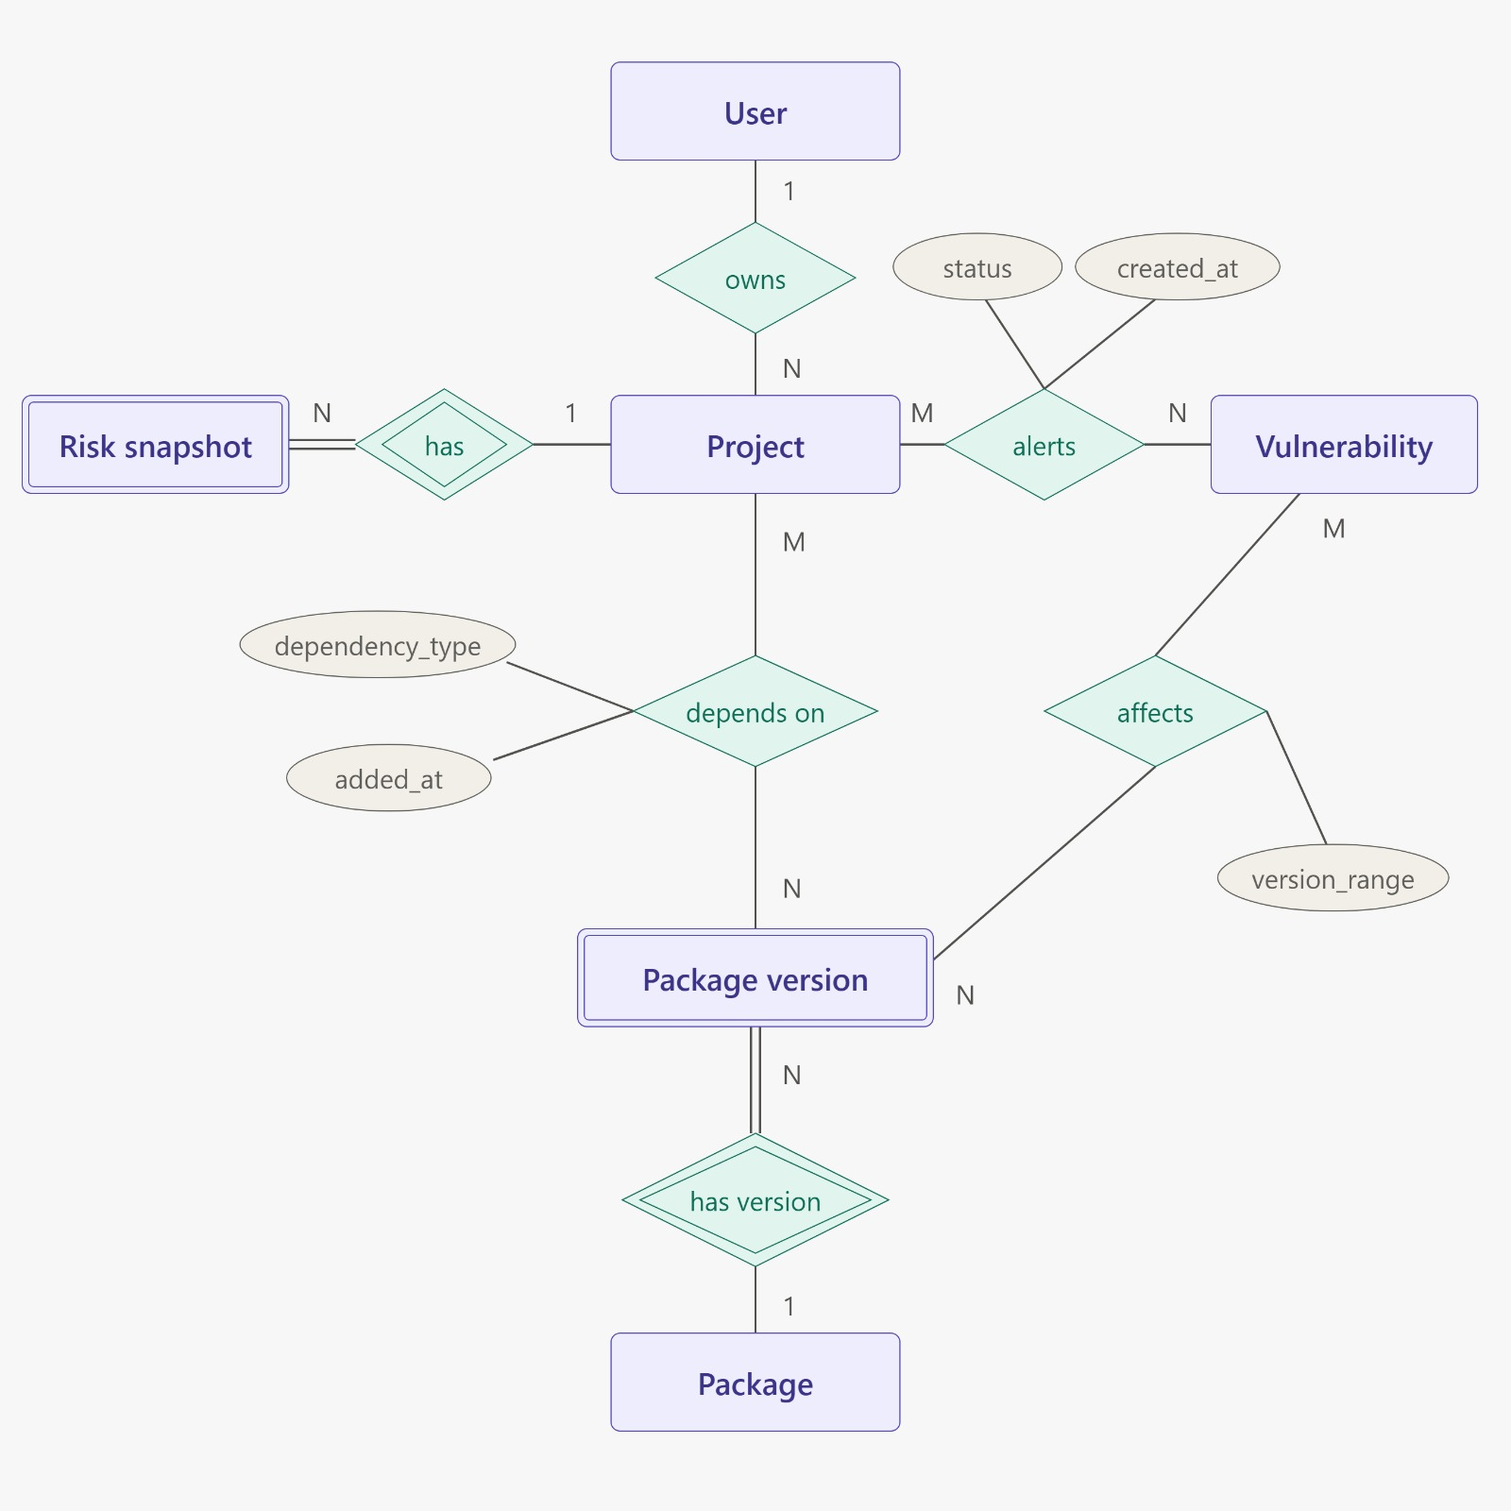

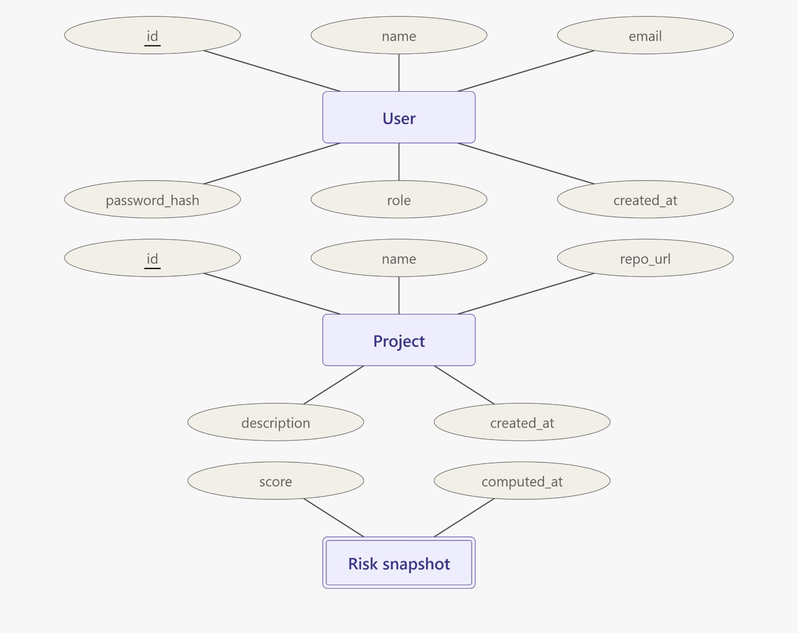

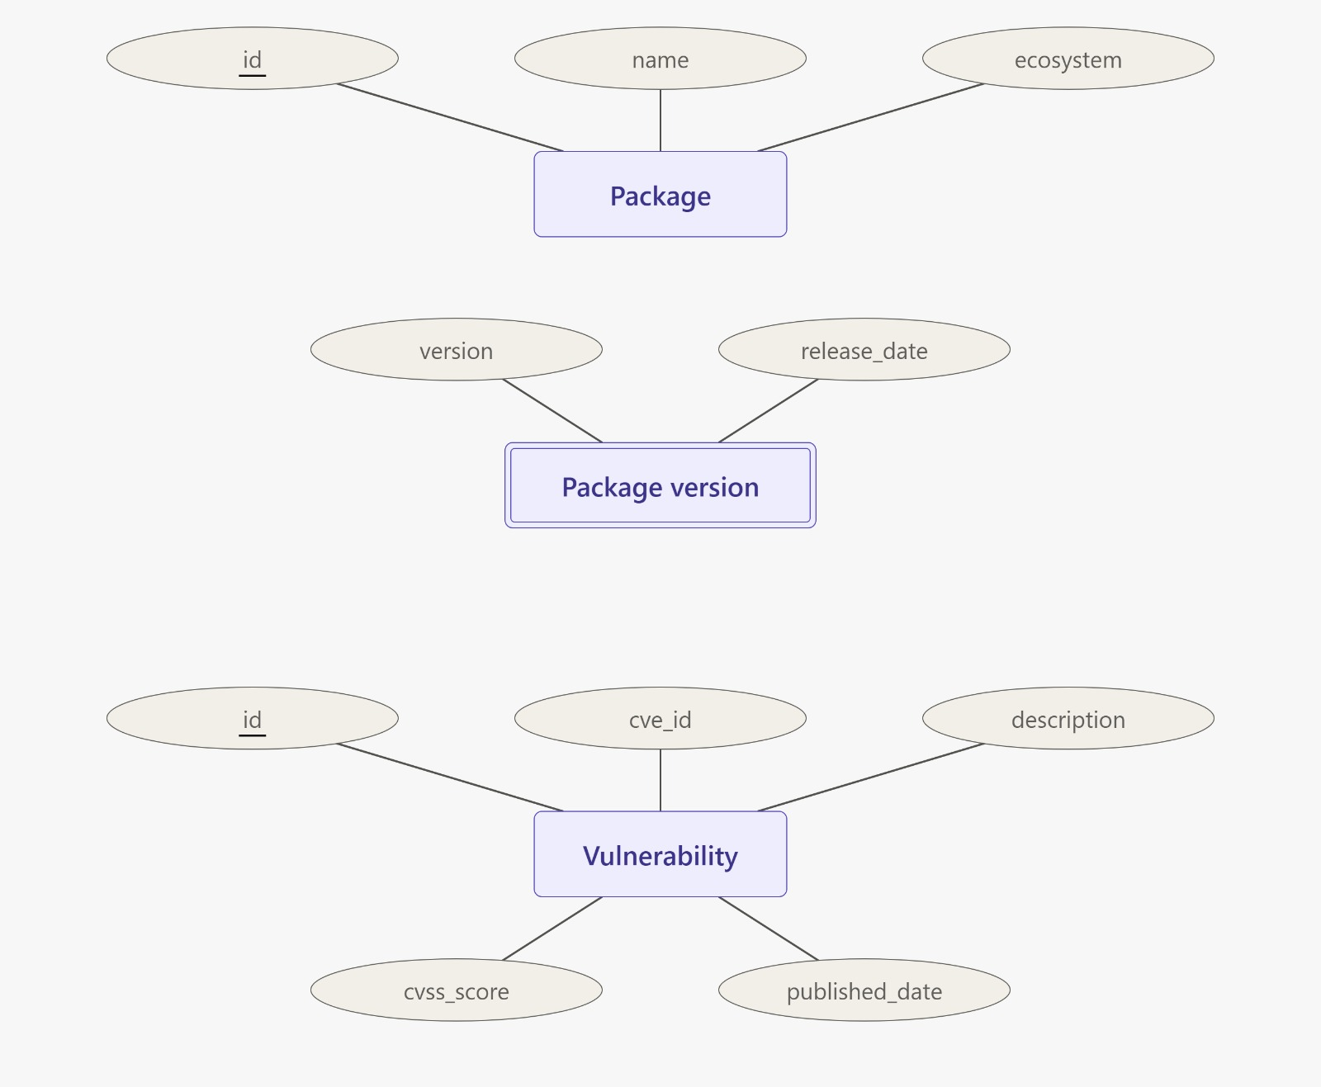

4. ER TO RELATIONAL MAPPING
The ER model is converted into relational tables. Each entity becomes a table with a primary key. One-to-many relationships are represented using foreign keys on the many side. Many-to-many associations between projects and package versions are represented by the PROJECT_DEPENDENCIES relation. The mapping between vulnerabilities and affected package versions is represented by VULN_AFFECTED_VERSIONS.

4.1 MAPPING OF ENTITIES AND RELATIONSHIPS
Relational Table | Primary Key | Important Foreign Keys
USERS | id | —
PROJECTS | id | owner_id → USERS.id
PACKAGES | id | —
PACKAGE_VERSIONS | id | package_id → PACKAGES.id
PROJECT_DEPENDENCIES | id | project_id → PROJECTS.id; package_version_id → PACKAGE_VERSIONS.id
VULNERABILITIES | id | —
VULN_AFFECTED_VERSIONS | id | vulnerability_id → VULNERABILITIES.id; package_version_id → PACKAGE_VERSIONS.id
ALERTS | id | project_id → PROJECTS.id; vulnerability_id → VULNERABILITIES.id
RISK_SNAPSHOTS | id | project_id → PROJECTS.id

4.2 RELATIONAL SCHEMA DIAGRAM
The relational schema diagram should show the nine tables, their primary keys, foreign keys, and relationship cardinalities. Insert the final schema diagram corresponding to the implemented MySQL DDL.
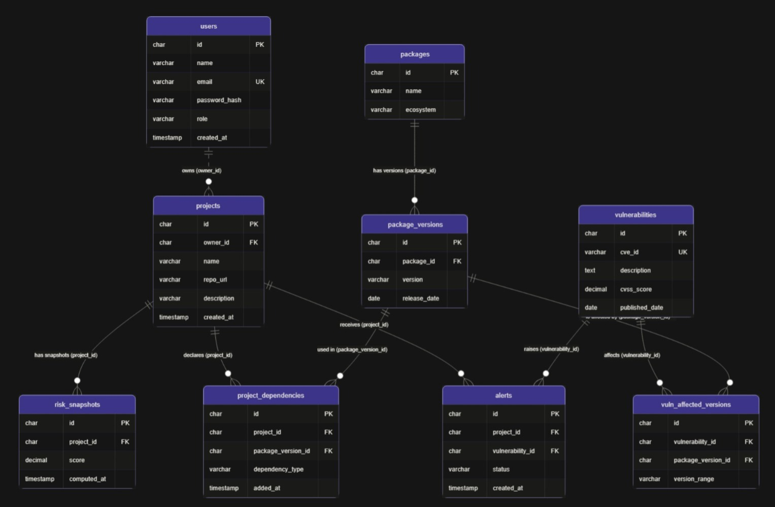

5. DDL STATEMENTS
Data Definition Language (DDL) statements define and modify the database structure. The SDVIT schema is created in MySQL using CREATE TABLE statements. Primary keys uniquely identify records, foreign keys enforce referential integrity, unique constraints prevent duplicate logical records, and indexes support frequently used lookups.
Table | Description
users | User accounts and roles.
projects | Projects owned by users; includes project description.
packages | Package names and ecosystem values.
package_versions | Released versions of packages.
project_dependencies | Project-to-package-version associations.
vulnerabilities | CVE and CVSS vulnerability information.
vuln_affected_versions | Vulnerability-to-affected-version mapping.
alerts | Project vulnerability alert and status records.
risk_snapshots | Historical risk score records.

The DDL also creates indexes on dependency references, affected-version references, alert project/status fields, risk snapshot project references, and vulnerability CVSS scores. The PROJECTS table is extended with a description column using ALTER TABLE. The project_risk_overview view summarizes open vulnerability counts and CVSS information for each project.
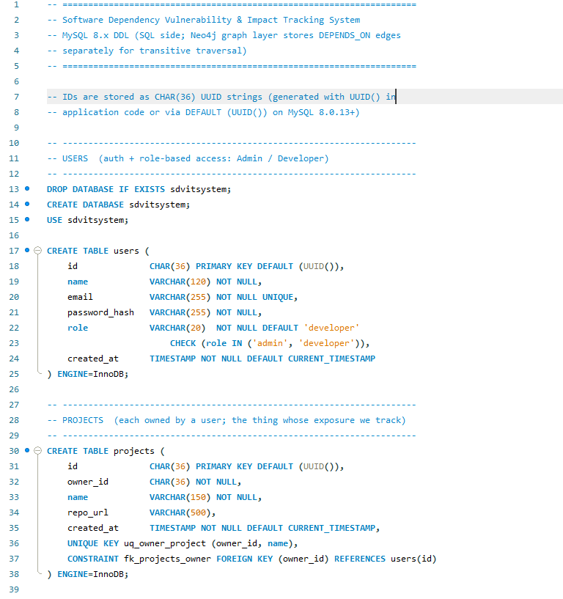
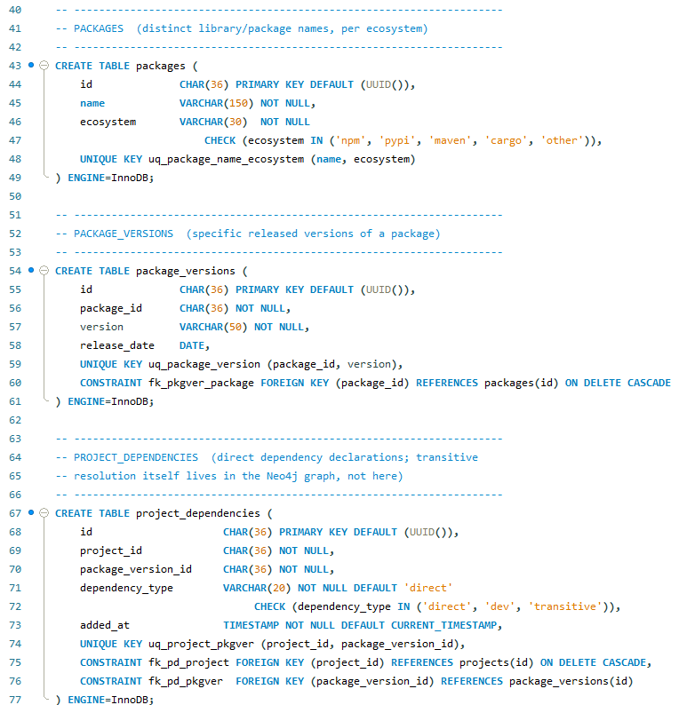

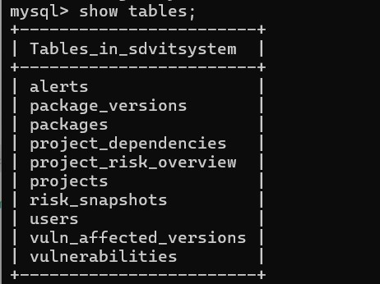
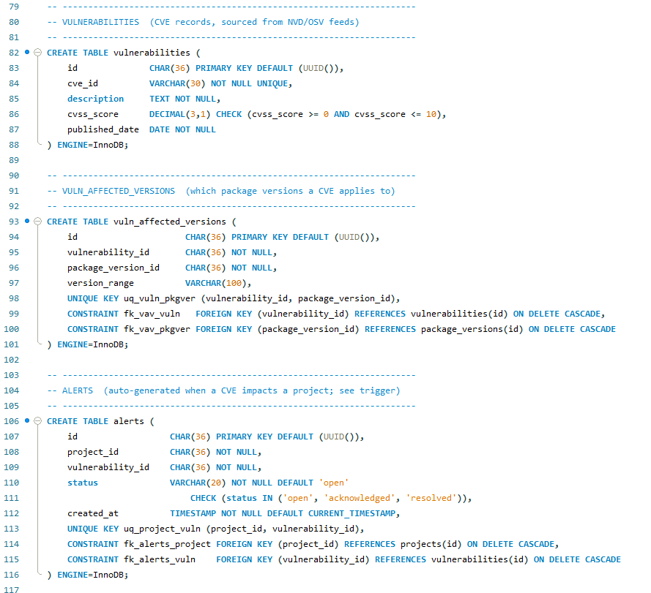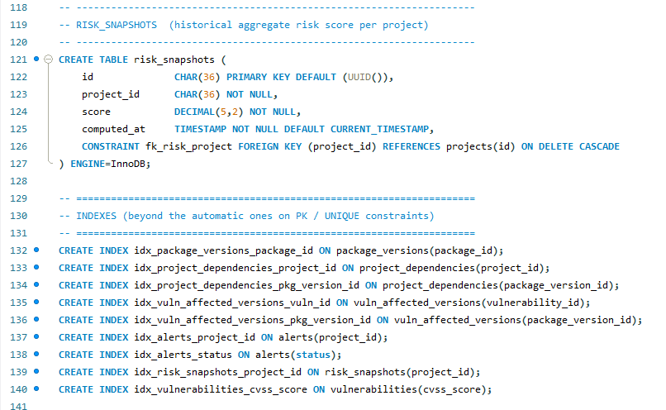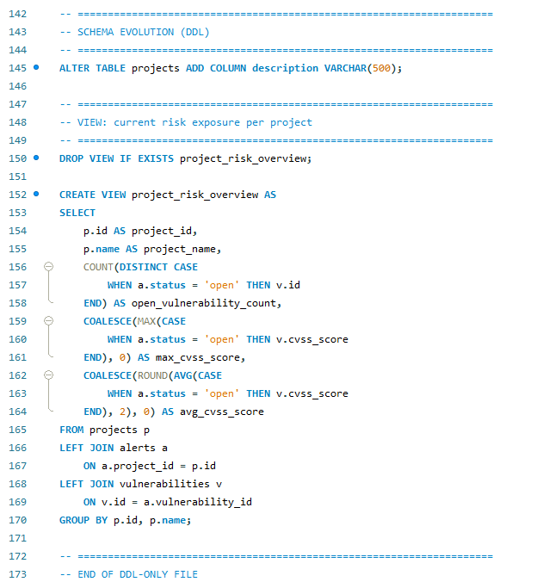

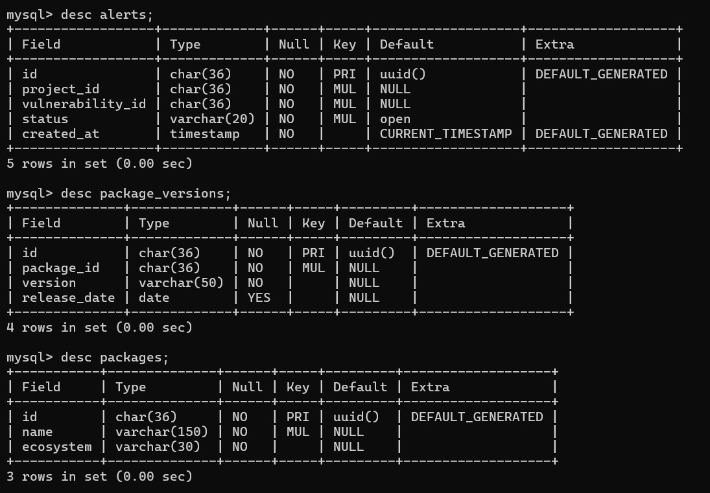

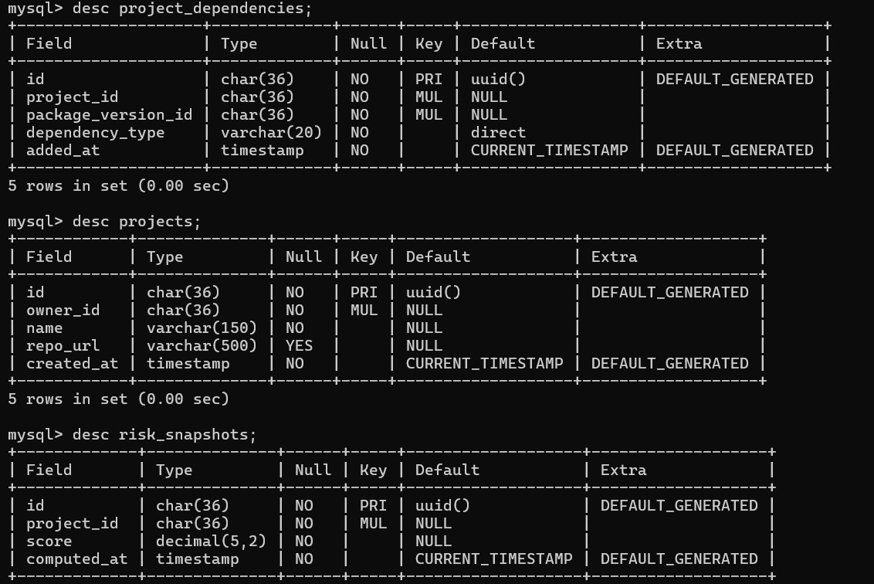

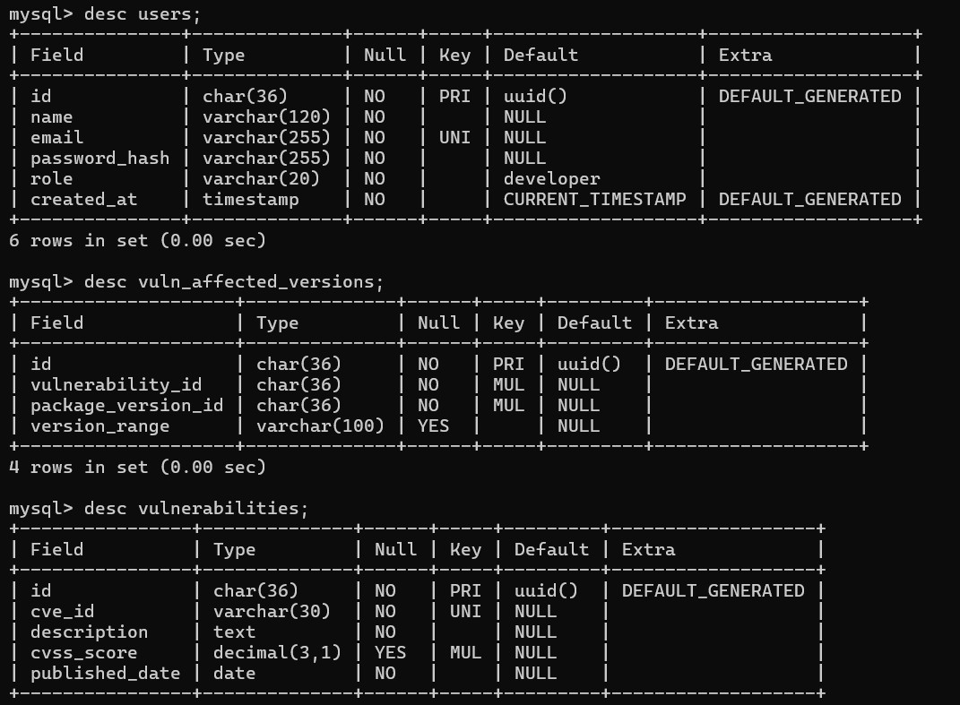

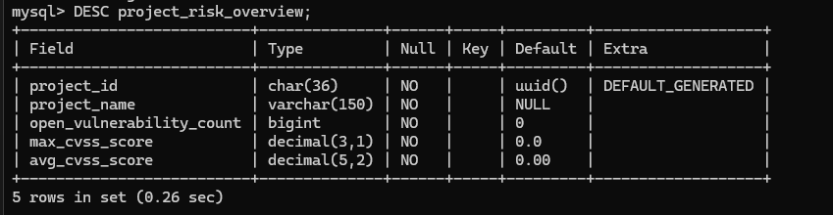

6. DML STATEMENTS
Data Manipulation Language (DML) statements insert, modify, and delete records stored in database tables. Sample data is inserted into the SDVIT tables to demonstrate users, projects, packages, package versions, dependencies, vulnerabilities, affected versions, alerts, and risk snapshots
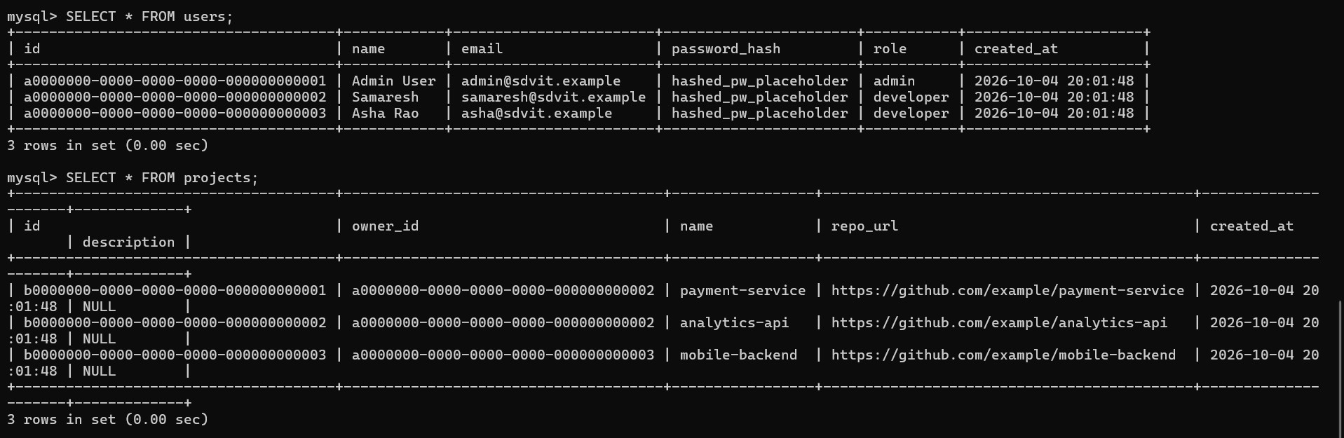
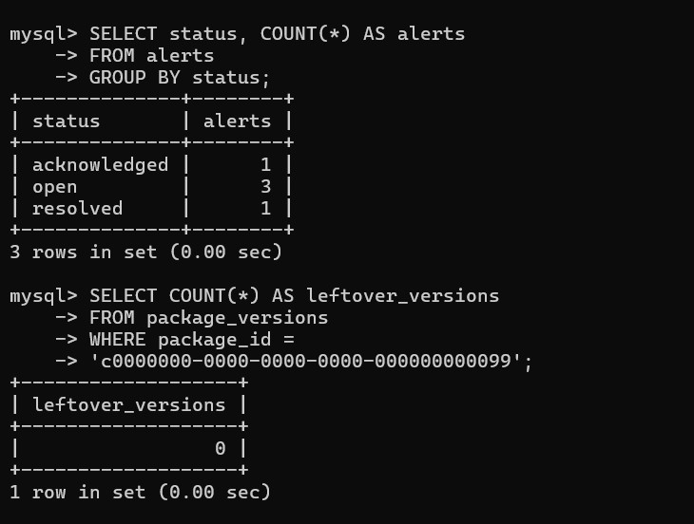

7. QUERIES
SQL queries are used to retrieve and analyze information stored in SDVIT. The examples below demonstrate aggregate queries, update and delete operations, correlated subqueries, and nested subqueries.

7.1 SIMPLE QUERY WITH GROUP BY, AGGREGATE
Aggregate queries summarize information across related records. GROUP BY groups rows by a selected attribute, while functions such as COUNT, AVG, MAX, and SUM calculate summary values. In SDVIT, such queries can summarize open alerts or dependency counts for each project.
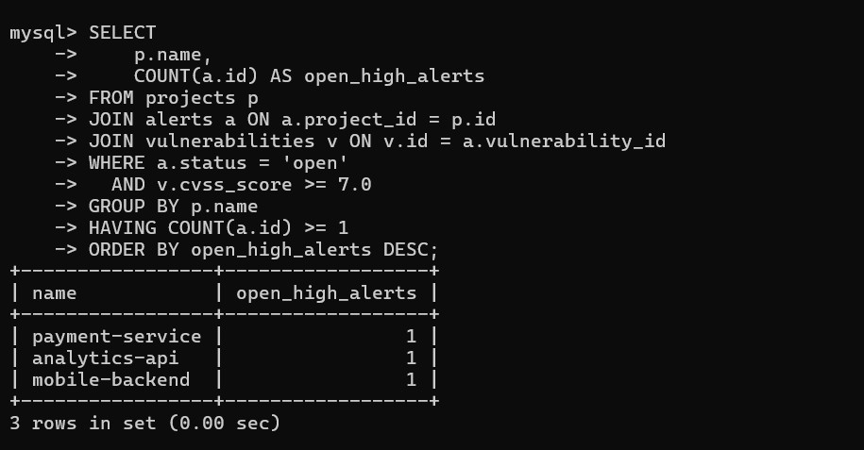

7.2 UPDATE OPERATION
An UPDATE query changes existing values without deleting the record. The following example changes a selected alert status.
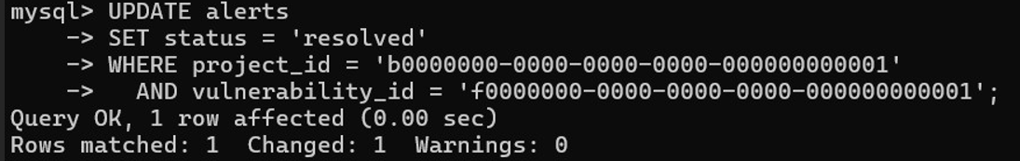

7.3 DELETE OPERATION
A DELETE query removes selected records. The following example demonstrates deletion of a temporary package; the associated package versions are removed through the configured cascade relationship.
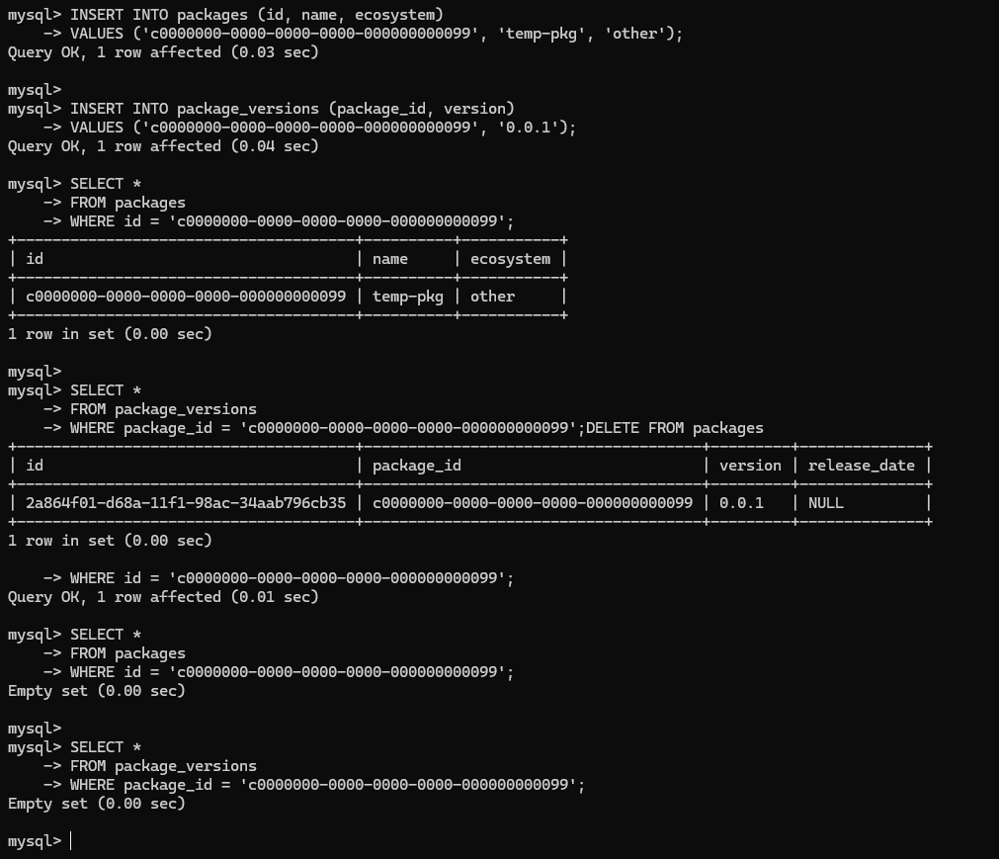

7.4 CORRELATED QUERY
A correlated subquery refers to a column from the outer query. The following query lists package versions that do not have a corresponding affected-version record.
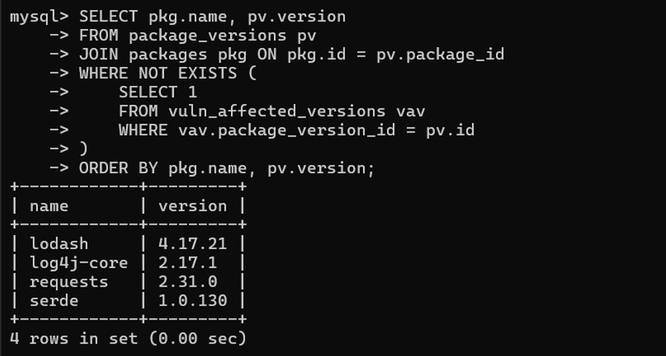

7.5 NESTED QUERY
A nested query contains a subquery inside the main query. In this example, the subquery calculates the average CVSS score, and the outer query returns vulnerabilities whose scores are above that average. 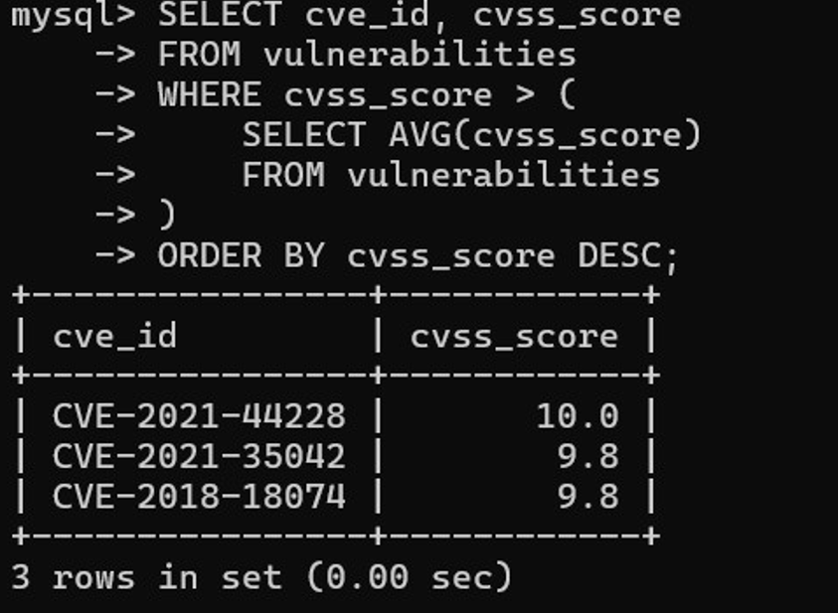

8. STORED PROCEDURES, FUNCTIONS AND TRIGGERS
Stored procedures, functions, and triggers are programmable database objects used to encapsulate operations and automate database actions. Procedures are explicitly called to perform a task, functions return a value, and triggers execute automatically when a specified table event occurs.

8.1 STORED PROCEDURES OR FUNCTIONS

Stored Procedures
Procedure | Purpose
recompute_project_risk | Calculates the sum of distinct CVSS scores for a project's open alerts and inserts a risk snapshot.
get_project_vulnerability_report | Returns vulnerability and alert details for a project, including severity.
recompute_all_project_risk | Iterates through projects, calculates risk for each, inserts snapshots, and reports the number processed.
resolve_alert | Uses a transaction to resolve an open or acknowledged alert; an error handler rolls back if the operation fails.
acknowledge_alert | Uses a transaction to change an open alert to acknowledged; signals an error if no matching open alert exists.
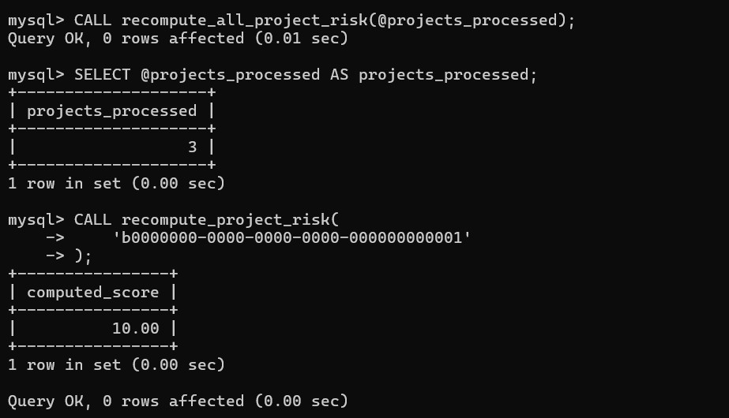Procedure execution: risk snapshots recomputed for all 3 projects, and for payment-service on its own.
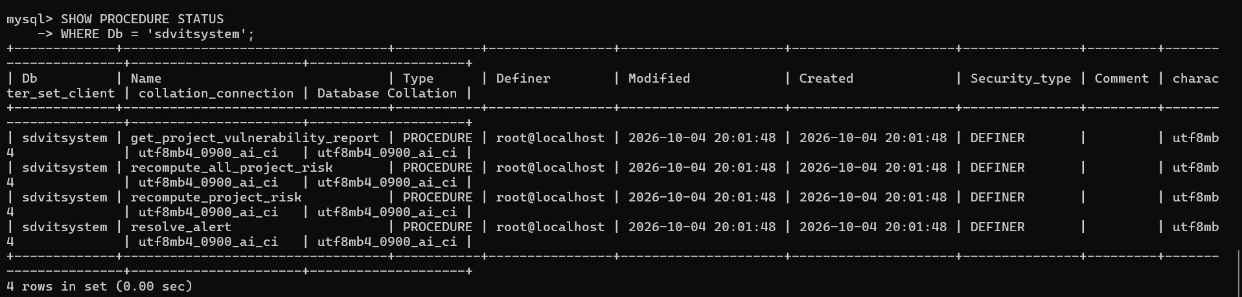

Functions
Function | Purpose
get_vulnerability_severity | Converts a CVSS score into Critical, High, Medium, or Low severity.
get_open_alert_count | Returns the number of open alerts for a specified project.

The severity function uses the following thresholds: Critical for scores greater than or equal to 9.0; High for scores greater than or equal to 7.0 and below 9.0; Medium for scores greater than or equal to 4.0 and below 7.0; and Low for scores below 4.0.
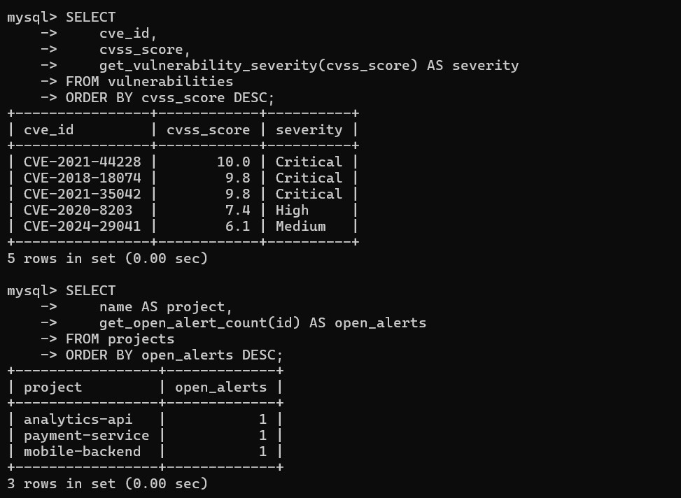Function execution: severity classification of each CVE and open-alert count per project
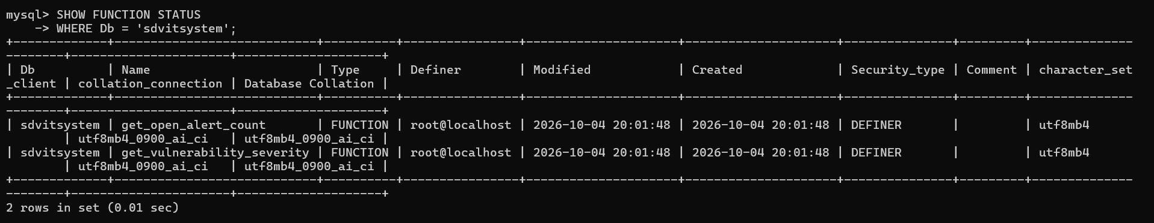

8.2 TRIGGERS
A trigger is a database object that executes automatically when a specified event occurs on a table. SDVIT contains three triggers.
Trigger | Event and Purpose
trg_alert_on_new_dependency | AFTER INSERT on PROJECT_DEPENDENCIES. Creates an open alert when a project adds a package version already mapped to a vulnerability with CVSS ≥ 7.0.
trg_alert_on_new_vuln_affected_version | AFTER INSERT on VULN_AFFECTED_VERSIONS. Creates open alerts for projects already depending on the newly mapped package version when CVSS ≥ 7.0.
trg_risk_snapshot_on_alert_resolved | AFTER UPDATE on ALERTS. When an alert changes to resolved, recalculates the project's remaining open-vulnerability risk score and inserts a risk snapshot.

The first two triggers cover two different insertion orders. One handles a project adding a package version that is already known to be vulnerable. The other handles a vulnerability being mapped to a package version that projects already use. The third trigger records updated risk information when an alert is resolved.
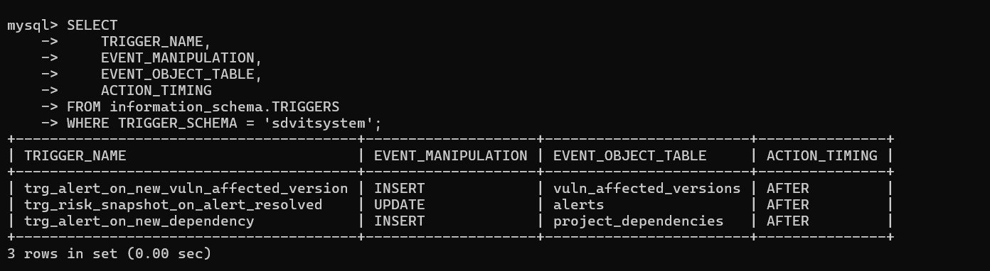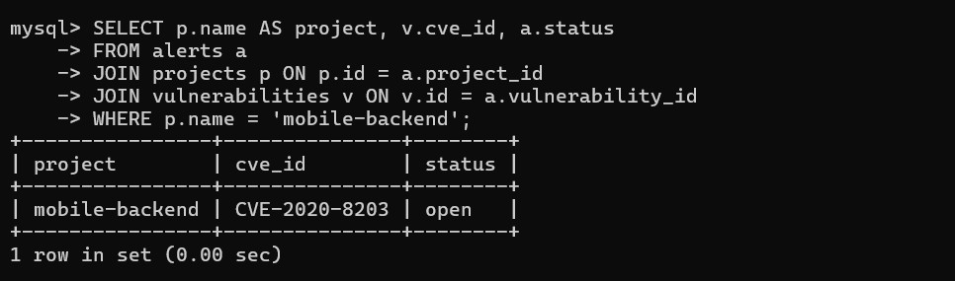Trigger result: mobile-backend has an open alert for CVE-2020-8203, created automatically when it added a vulnerable dependency

9. FRONT END DEVELOPMENT
The SDVIT frontend is developed using React with Vite. It provides the user interface for interacting with the dependency and vulnerability tracking system. The backend is developed using Node.js and Express, while MySQL stores the structured project, dependency, vulnerability, alert, and risk information.
The frontend section of the final submission should contain screenshots of the actual implemented application pages. Each screenshot should be accompanied by a short description of the operation or information displayed. Only implemented screens and verified functionality should be documented.
[ INSERT SCREENSHOT: SDVIT HOME / DASHBOARD ]
Insert screenshot / diagram here

[ INSERT SCREENSHOT: PROJECT MANAGEMENT PAGE ]
Insert screenshot / diagram here

[ INSERT SCREENSHOT: PACKAGES / DEPENDENCIES PAGE ]
Insert screenshot / diagram here

[ INSERT SCREENSHOT: VULNERABILITIES / ALERTS PAGE ]
Insert screenshot / diagram here

[ INSERT SCREENSHOT: ADDITIONAL IMPLEMENTED FRONTEND PAGE ]
Insert screenshot / diagram here

CONCLUSION
The Software Dependency Vulnerability and Impact Tracking System (SDVIT) provides a structured approach to maintaining software project dependencies and tracking vulnerabilities that affect package versions. The MySQL database organizes users, projects, packages, package versions, dependencies, vulnerabilities, affected versions, alerts, and risk snapshots through relational constraints.
The use of views, stored procedures, functions, and triggers supports vulnerability reporting, severity classification, automatic alert generation, alert status management, and project risk snapshot generation. The React frontend and Node.js backend provide the application layer for interacting with the system. Overall, SDVIT demonstrates how database concepts can be applied to organize dependency and vulnerability information and support project-level security monitoring.

REFERENCES
[1] CVE Program, “Common Vulnerabilities and Exposures,” https://www.cve.org/.
[2] FIRST, “Common Vulnerability Scoring System (CVSS),” https://www.first.org/cvss/.
[3] MySQL, “MySQL 8.0 Reference Manual,” https://dev.mysql.com/doc/refman/8.0/en/.
[4] React, “React Documentation,” https://react.dev/.
[5] Node.js, “Node.js Documentation,” https://nodejs.org/docs/.
[6] Express, “Express Documentation,” https://expressjs.com/.

APPENDIX A – DEFINITIONS, ACRONYMS AND ABBREVIATIONS
Term | Definition
SDVIT | Software Dependency Vulnerability and Impact Tracking System.
DBMS | Database Management System.
SQL | Structured Query Language.
DDL | Data Definition Language; defines database structures.
DML | Data Manipulation Language; inserts, updates, and deletes records.
CVE | Common Vulnerabilities and Exposures; identifier for a publicly known vulnerability.
CVSS | Common Vulnerability Scoring System; framework for expressing vulnerability severity.
Package | A reusable software component or library used by a project.
Package Version | A specific release/version of a package.
Dependency | A package version required by a software project.
Trigger | A database object that executes automatically in response to a table event.
Stored Procedure | A named set of SQL statements invoked explicitly to perform an operation.
Function | A stored database program that returns a value.
Risk Snapshot | A stored record of a project's calculated risk score at a point in time.
ER Model | Entity Relationship model representing entities and their relationships.
FK | Foreign Key.
PK | Primary Key.

