Instruction: Rasberry Pi setup + Display Installation

Our Hardware:
- Raspberry Pi 4 Computer Model B 2GB (short: RPi)
- Personal Computer/Laptop
- Micro sd card
- 3.5inch RPi Display: 480x320 Pixel, XPT2046 Touch Controller (Manufacturing Model: VMP400)
- External Monitor (+ HDMI <->micro HDMI cable)
- Keyboard
- Mouse
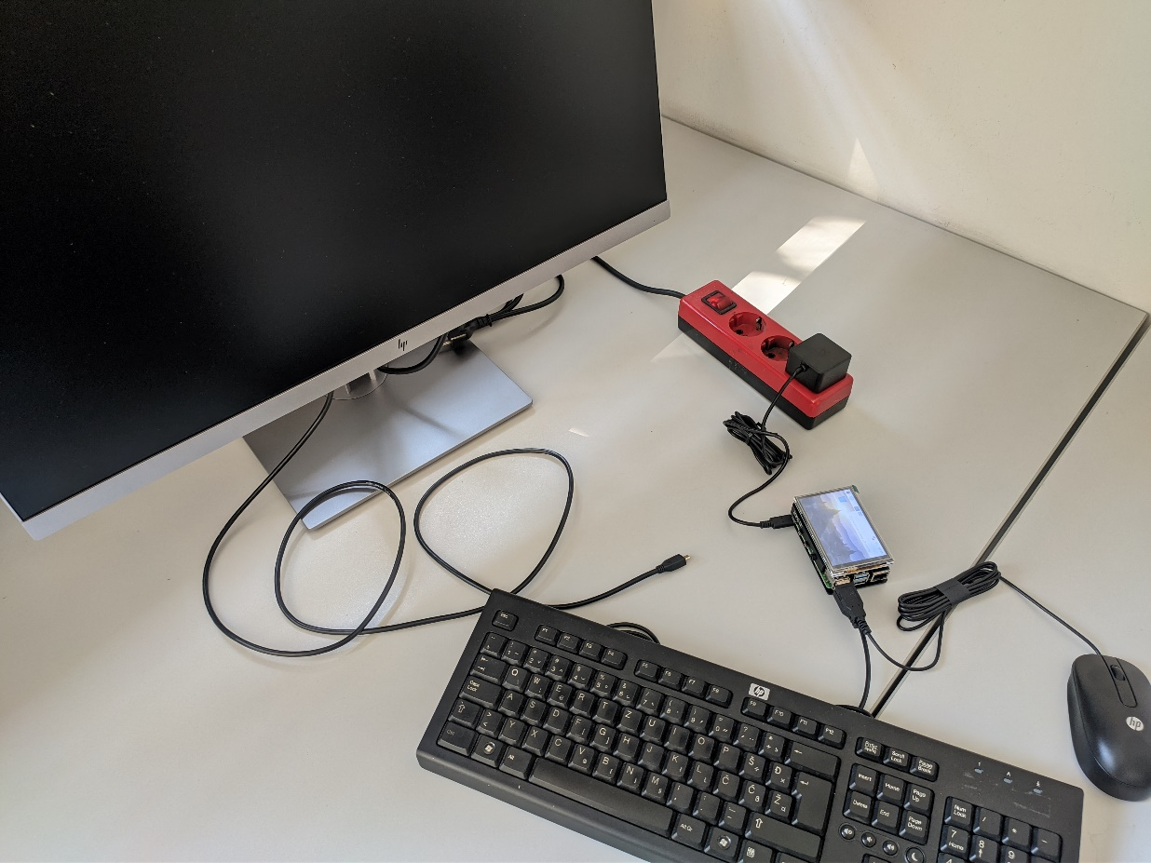
- Raspberry Pi (RPi) USB-C Power Supply

Installation of Raspberry Pi OS and 3.5inch Display (through GPIO connection)
http://www.lcdwiki.com/3.5inch_RPi_Display
- How to install Raspberry Pi Operating System (OS) on the micro sd card:
  - Insert micro sd on your Personal Computer (not the RPi)
  - Download and install the ‘Raspberry Pi Imager’ Software, to write the OS to sd-card (https://www.raspberrypi.org/software)
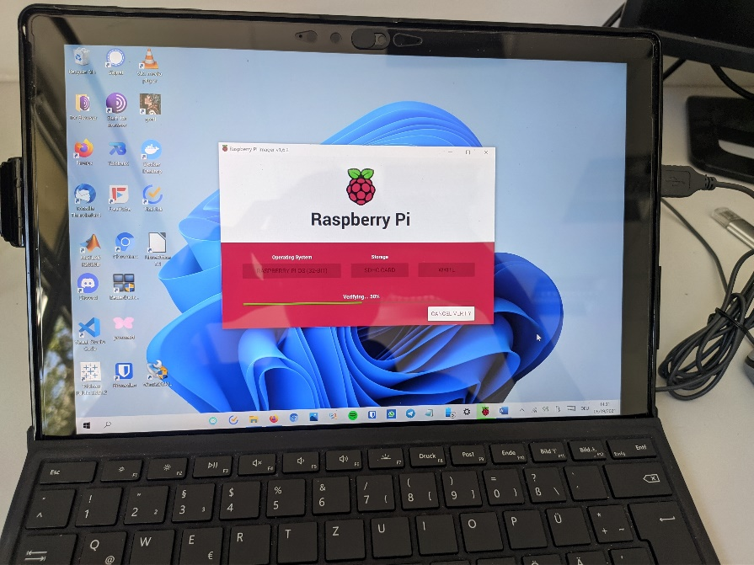
  - Open ‘Raspberry Pi Imager’ and select Raspberry Pi OS and the micro sd, and then click on ‘write’
- Attach the Raspberry Pi to the other hardware:
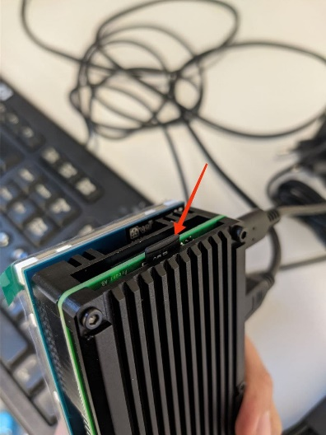
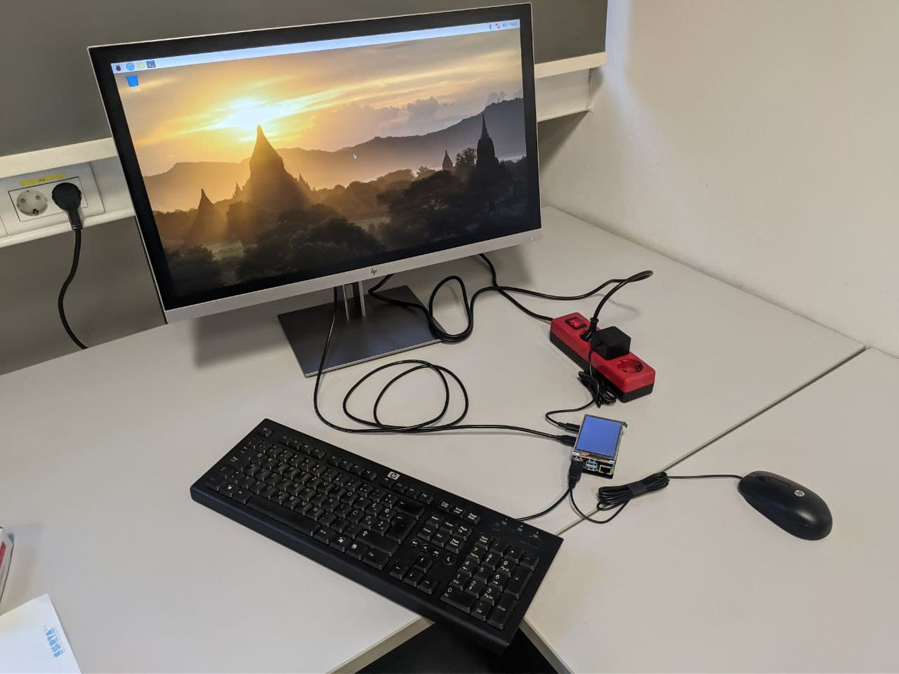
  - Take out the micro sd from your computer and insert it to the RPi. Connect the external monitor, mouse, 3.5inch RPi Display, keyboard and the power supply to the RPi

  - Plug the external Monitor and the RPi power supply in the plug socket. Now the RPi should boot.

  - Set up the OS regarding keyboard (menu>preference>keyboard and mouse>keyboard>keyboard layout) and wifi (click on wifi symbol).
Be aware if you don’t set a password, the RPi password will be “raspberry” and the username: “pi”

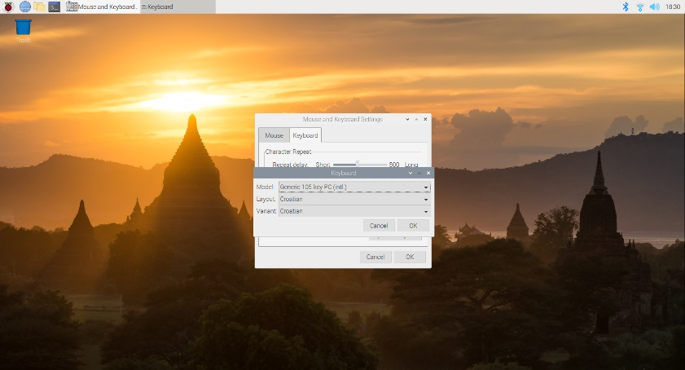

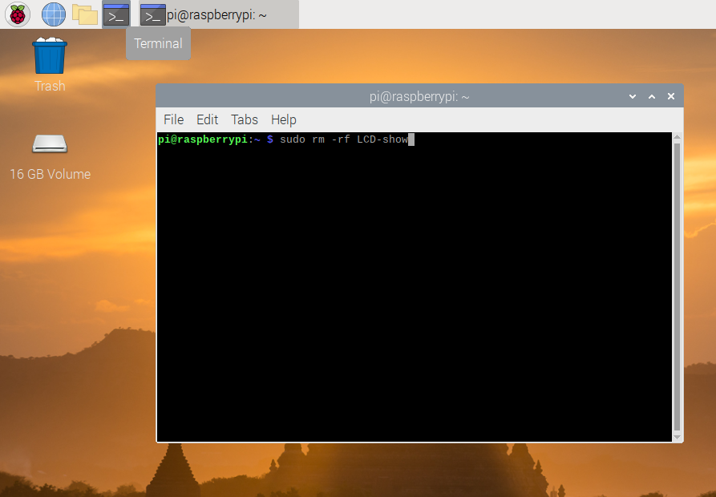
- How to install the driver for the 3.5inch RPi Display (http://www.lcdwiki.com/3.5inch_RPi_Display):

  - Open Terminal on your RPi and execute the following commands step by step:
    - sudo rm -rf LCD-show
    - git clone https://github.com/goodtft/LCD-show.git
    - chmod -R 755 LCD-show
    - cd LCD-show/
    - sudo ./LCD35-show
Explanation:
3.1.1 & 3.1.2 First delete the ‚LCD-show‘ folder, if this already exists. Then downloading the desired ‚LCD-show‘ folder, which contains the driver for display, from the link. Inside this folder is the desired driver named ‘LCD35-show’.
3.1.4 Open the ‚LCD-show‘ folder to access its content with the following commands
3.1.5 Install the ‘LCD35-show’-driver inside the folder and reboot

  - Now the RPi will reboot. If the 3.5inch Display still doesn’t show anything: turn off the RPi, unplug the hdmi cable from RPi and reboot it (unplug and plug the power supply)
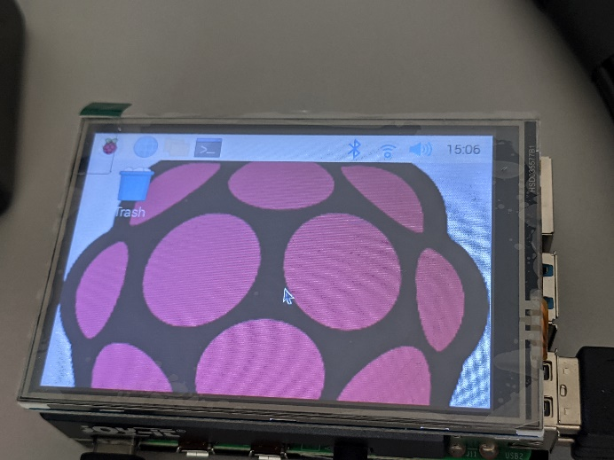
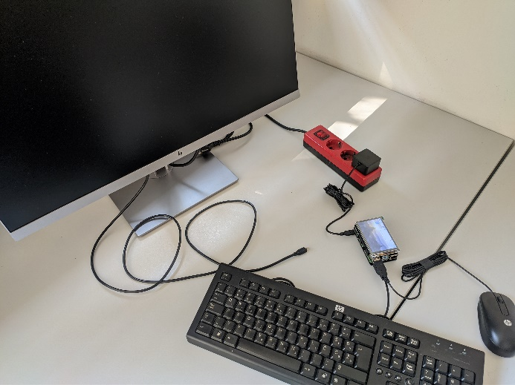
How to switch between ext. monitor and 3.5inch RPi Display:
(WARNING: Frequent switching between both display may corrupt the OS)
- RPi Display -> monitor: a)Connect monitor cable to RPi and restart OR b)Open Terminal and execute:
  - chmod -R 755 LCD-show
  - cd LCD-show
  - ./LCD-hdmi
- monitor-> RPi Display: Open Terminal and execute:
  - chmod -R 755 LCD-show
  - cd LCD-show
  - ./LCD35-show

If the driver Installation of step 3. causes trouble:
- Insert micro sd card to your PC
- On your PC: Download Software to write OS to micro sd. For Windows: Win32DiskImager, For Linux: Etcher
- Download the modified OS: https://mega.nz/folder/ixQiTa7R#EM2uFGwMC8QSU6D4untoGA (user:pi password:raspberry)
- Open the installed Software from 2. and select the modified OS from 3. Then select the micro sd and start writing the selected OS to the micro sd card.
- Insert micro sd to RPi and reboot

