SE LAB 1
Problem Statement 06
Alumni Mentorship & Mock Interview Platform
Name: Daruru Bhuvan Sai
SRN: PES1UG24AM356
Section: F

Requirements Table
Problem Statement 06: Alumni Mentorship & Mock Interview Platform
Req ID | Type | Description | Priority | Acceptance Criteria | Rationale
FR-001 | Functional | The system shall recommend alumni mentors to students based on their selected domain and allow booking of an available mentorship session from the recommendation list. | High | Pass: A matching active mentor is listed and selecting an open slot creates exactly one confirmed booking with calendar entries and a meeting link. Fail: An unrelated mentor is listed, an occupied slot is booked, or the booking is incomplete. | Provides relevant mentor discovery and quick booking.
FR-002 | Functional | The system shall allow alumni mentors to create, update, and remove their available session slots. | High | Pass: A new slot appears immediately, an edited or removed slot is reflected within 5 seconds, and an overlapping slot is rejected. Fail: Conflicting availability is saved. | Keeps mentor availability accurate and prevents conflicts.
FR-003 | Functional | The system shall allow a student or alumni mentor to reschedule or cancel a confirmed session using the mentor's currently available slots. | High | Pass: A valid reschedule updates the booking and both calendars within 30 seconds; cancellation releases the slot and notifies both users. Fail: Old calendar entries remain active or the slot is not released. | Supports unavoidable schedule changes without manual coordination.
FR-004 | Functional | The system shall allow the assigned alumni mentor to submit a structured mock-interview scorecard containing 1-5 ratings for technical knowledge, problem solving, and communication, with optional comments. | High | Pass: The assigned mentor can submit all required ratings only after the session, and one scorecard is stored against that session. Fail: Missing ratings, duplicate submissions, or an unauthorized mentor are accepted. | Creates consistent and useful post-interview feedback.
FR-005 | Functional | The system shall allow a student mentee to view completed scorecards and the status of past and upcoming mentorship sessions. | Medium | Pass: The student can view ratings and comments for their completed session and cannot access another student's scorecard. Fail: Own feedback is unavailable or another student's feedback is visible. | Helps students track feedback and progress securely.
NFR-001 | Nonfunctional  (Security & Privacy) | The system shall protect user profiles and feedback scorecards and shall soft-delete the requested user's data within 24 hours of a valid deletion request. | High | Pass: Authorization tests block cross-user access, and the audit log shows the profile and related scorecards hidden from normal access within 24 hours. Fail: Unauthorized access succeeds or requested data remains active after 24 hours. | Protects sensitive academic and professional feedback.
NFR-002 | Nonfunctional  (Performance) | The system shall return mentor recommendations and availability within 2 seconds for at least 95% of requests under a simulated load of 500 concurrent users. | Medium | Pass: A load test of at least 1,000 requests with 500 concurrent users records a 95th-percentile response time of 2 seconds or less. Fail: The measured value exceeds 2 seconds. | Maintains responsive search and booking during peak usage.

UML Use-Case Diagram
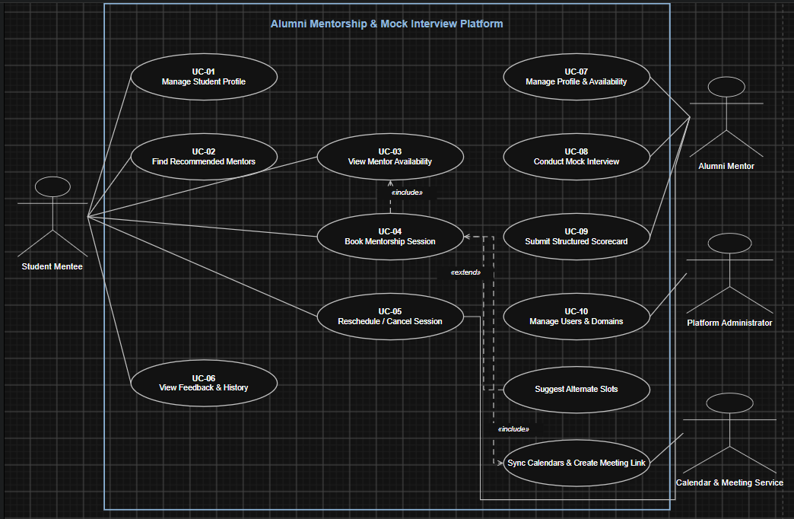

Use-Case Flow Specification
Use Case | UC-04 - Book Mentorship Session
Primary Actor | Student Mentee
Supporting Actors | Alumni Mentor; Calendar & Meeting Service
Trigger | The student chooses an available mentor slot and selects Book Session.
Preconditions
- The student is authenticated and has selected at least one mentorship domain.
- The alumni mentor has an active profile and at least one available slot.
Postconditions
- A confirmed session is stored, the selected slot is reserved, and both calendars contain the meeting link.
- If booking is not completed, no partial session or calendar entry remains.
Main Success Scenario
- The student opens Find Recommended Mentors.
- The system uses the student's selected domain to display matching active alumni mentors.
- The student opens a mentor profile and chooses View Availability.
- The system displays the mentor's currently available slots.
- The student selects a suitable slot and chooses Book Session.
- The system revalidates that the slot is still available.
- The system creates the session and reserves the selected slot.
- The system creates a meeting link and adds the session to both calendars.
- The system displays the confirmation and notifies the student and alumni mentor.
Alternate Flow - 6a: Selected Slot Is No Longer Available
- The system does not create the booking and informs the student that the slot was taken.
- The system displays up to three next available slots for the same mentor.
- If the student selects an alternate slot, the flow resumes at Step 6; otherwise, the use case ends with no changes.

