**Question 3**

Step 1: Create a feature branch. 

Step 2: Switch to the new branch.

Step 3: open the file and make some changes to it. 

Step 4: Add and commit the changes to the new branch.

Step 5: Push the changes to the new feature branch. 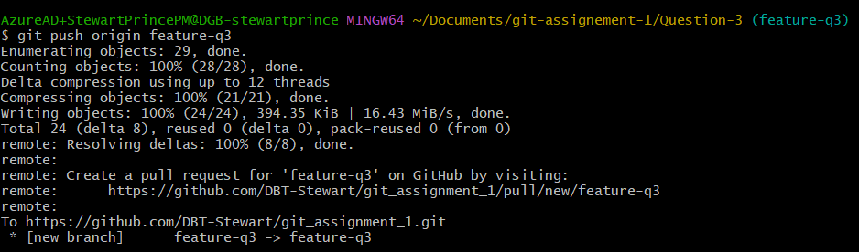

Step 6: Create a pull request.

Step 6: As another user in the master branch make some changes to the same file. 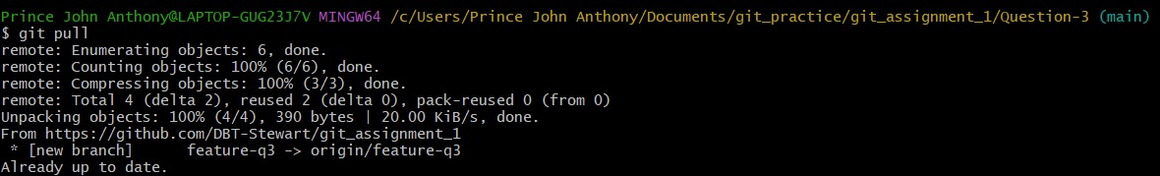

Step 7: Add and commit the changes to the master branch.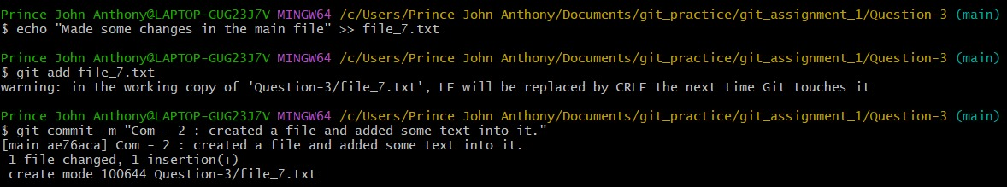

Step 8: Push the changes to the master branch.

Note: There will be a conflict in the pull request, how do we resolve it??

Hint: git rebase