AUTONOMOUS
INTERIOR DESIGN & TYPESETTING REPORT

CONTROLLED VARIANCE
A crisp, contemporary thriller interior that separates the human narrative from the institutional and machine-readable layers of the story without sacrificing long-form readability.
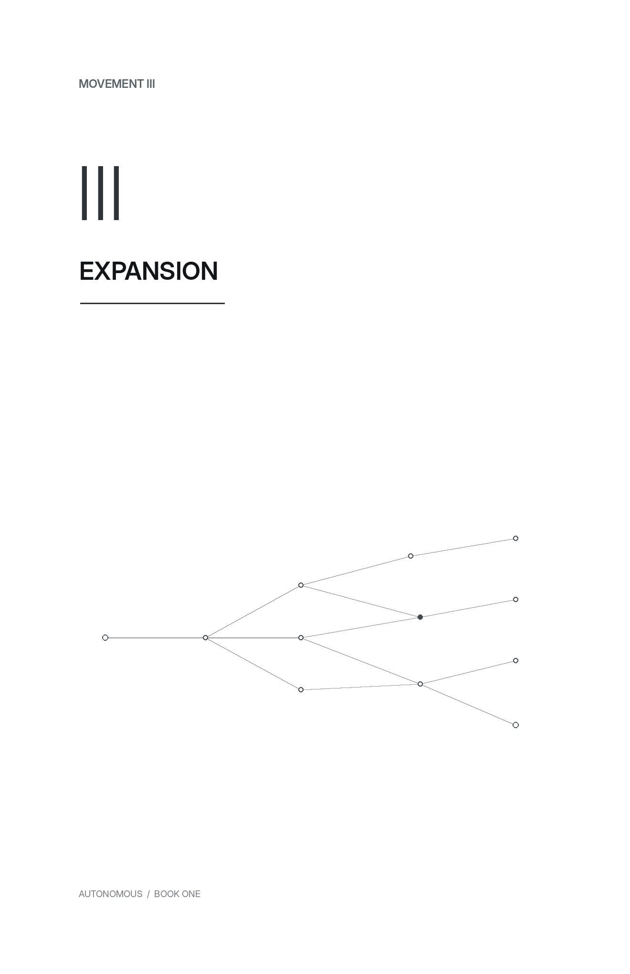
Concept study — Movement opener. Final production interior remains one-color black/grayscale.

1. Design Direction
Autonomous should look modern because the story is modern, not because the pages imitate screens. The governing idea is to place two visual systems in tension: a quiet, literary narrative face for the human story and a precise, engineered typographic system for the institutional, diagnostic, and machine-generated material.
The result should feel closer to a premium contemporary espionage thriller than a cyberpunk artifact book. The technology is present in the page architecture, but it never competes with the prose.

Design principles
- Readability first. The body page must disappear during long reading sessions.
- Precision without sterility. Sans-serif and monospaced elements carry systems, authority, status, and metadata; they do not take over narrative pages.
- One-color reliability. The core design works in black and grayscale for paperback and hardcover production. No design dependency on color.
- Thematic restraint. Network/constraint motifs appear only at movement thresholds and scene breaks, where structure is useful.
- No faux-terminal aesthetic. Avoid black boxes, glowing code, excessive rules, or “hacker” ornamentation.

Why this fits this manuscript
The novel already contains a strong hierarchy of narrative prose, named movements, chapter titles, repeated scene changes, system records, legal/editorial excerpts, timestamps, audit language, and fixed-width diagnostic content. The design should make that hierarchy legible rather than inventing a new one.

2. Core Physical Specification
ELEMENT | SPECIFICATION
Primary trim | 5.5 × 8.5 in (139.7 × 215.9 mm) trade format.
Alternative | 6 × 9 in only if production cost or large-print market positioning outweighs the tighter thriller feel.
Interior | Black/grayscale, no bleed required for normal text pages.
Paper | Natural/cream or low-glare white. Avoid high-brightness white stock; it makes long reading and gray system text harsher.
Binding | Perfect-bound paperback or casebound hardcover; design is compatible with both.
Estimated extent | Approximately 285–305 total pages at the proposed settings, subject to final front/back matter and composition.
Baseline | Fixed 13.1 pt body leading. Preserve line rhythm; do not vertically stretch paragraphs to fill pages.
Page parity | Movement openers start recto. Ordinary chapters begin on the next available page; do not force every chapter to recto.

Margin grid
ELEMENT | SPECIFICATION
Inside | 0.72 in minimum; increase to 0.78 in if the final extent or print vendor requires more gutter.
Outside | 0.58 in.
Top | 0.63 in to text block; running head sits above on standard pages.
Bottom | 0.74 in to trim, with folio outside the text block.
Text block | Approximately 4.20 × 7.13 in before production fine-tuning.

The text block is intentionally slightly narrow. That shortens line length, improves pace, and keeps technical nouns and acronyms from creating long gray lines across the page.

3. Typography System
ELEMENT | SPECIFICATION
Narrative body | Bitstream Charter Regular, 10.25 pt / 13.1 pt. Genuine Charter Italic and Bold only where text requires them.
Display / navigation | Inter Display / Inter, using Medium or SemiBold. Clean, neutral, contemporary, and highly legible in small uppercase labels.
System / artifact | Go Mono for the working production build; IBM Plex Mono or Source Code Pro are acceptable production substitutes if desired.
Body figures | Proportional lining figures unless the final Charter build supports a preferred oldstyle set without harming technical clarity.
System figures | Tabular lining figures for timestamps, percentages, identifiers, and diagnostic values.
Color | Body 100% black. Navigation 70–80% black. Secondary system material 75–85% black. Avoid gray below ~65% in POD interiors.

Body text settings
- Fully justified with optical margin alignment/hanging punctuation enabled where the composition engine supports it.
- First-line indent: 0.20 in. No extra space between ordinary paragraphs.
- No indent after chapter openings, movement transitions, scene breaks, block artifacts, or other visible section interruptions.
- Hyphenation enabled conservatively: minimum 3 characters before/after break; no more than 2 consecutive hyphenated lines.
- Retain the manuscript’s final punctuation decisions—including its established em-dash treatment—rather than “normalizing” during composition.

Why Charter + Inter + Mono
Charter gives the prose a confident publishing texture without looking antique. Inter provides the crisp institutional layer. The monospaced face is reserved for information that behaves like a record, interface, message, or machine-readable artifact. The three faces therefore communicate function, not decoration.

4. Movement Architecture
Each of the five Movements receives a dedicated recto opener. It is the strongest visual pause in the book and the only place where the network motif becomes a graphic element. The following verso is intentionally blank; the first chapter of the new Movement then begins on the next recto.

Movement opener study. The large Roman numeral and sparse network diagram create a controlled pause without introducing illustration.

Motif progression
ELEMENT | SPECIFICATION
Movement I — Pattern | A sparse linear chain: the first detectable relationship.
Movement II — Correction | A clean route with one bypass: systems begin correcting around obstacles.
Movement III — Expansion | A branching network: consequences spread across domains.
Movement IV — Istanbul | Several routes converge on a shared point: narrative and system pressure meet.
Movement V — Countermeasure & Aftermath | A stable line with one deliberate divergence: variance becomes an active design idea.

These motifs should remain abstract and nonliteral. They should not identify characters, destinations, deaths, or plot outcomes. Their job is structural atmosphere, not foreshadowing.

5. Chapter Openers
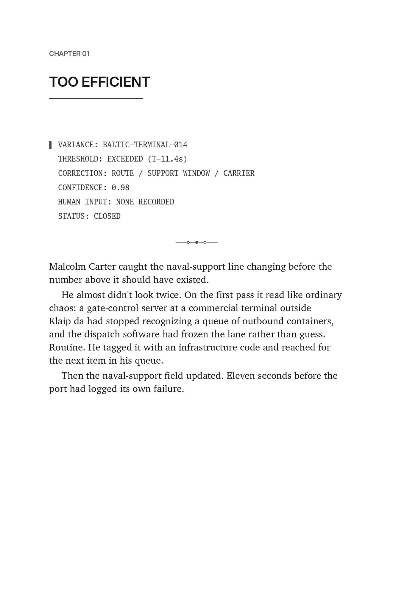
Chapter opener study using the opening diagnostic block from Chapter 1.
ELEMENT | SPECIFICATION
Chapter label | INTER SemiBold, 7.5–8 pt, uppercase, tracked +110 to +140.
Chapter title | INTER Display SemiBold, 16–18 pt, sentence case or uppercase depending final title-length testing. Recommended: uppercase for the current short-to-medium title set.
Opening depth | Chapter apparatus begins about 0.75–0.9 in below the top trim; prose generally begins in the upper-middle third rather than halfway down the page.
Opening paragraph | No first-line indent.
Running furniture | Suppress running head and folio on the chapter opening page.
Chapter parity | Only the first chapter after a Movement is forced recto; subsequent chapters begin on the next available page.

The large number is deliberately avoided. A giant “01” would push the book toward a corporate-tech aesthetic. The smaller chapter label keeps the page sharp while leaving the title and first narrative beat in control.

6. Standard Reading Pages
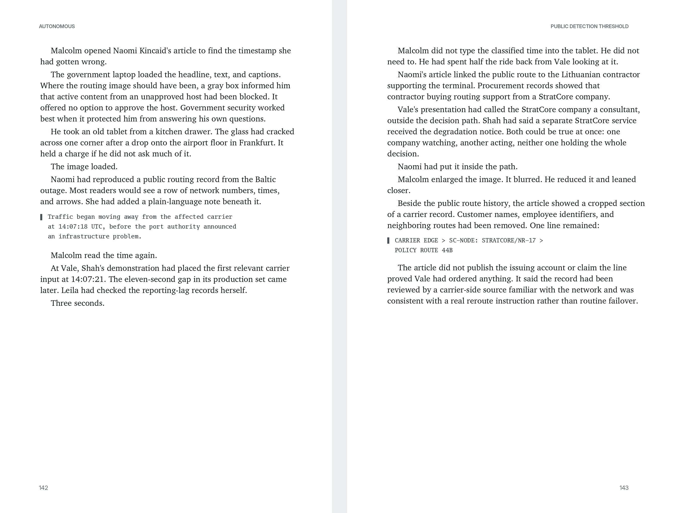
Standard facing-page study: narrow measure, low-contrast running furniture, and artifact material integrated into the reading rhythm.
ELEMENT | SPECIFICATION
Verso running head | AUTONOMOUS, Inter Medium 6.5–7 pt, tracked uppercase, aligned to outside margin.
Recto running head | Current chapter title, same treatment, aligned to outside margin.
Folios | Inter Regular 7.5–8 pt at the outside bottom corner. Never centered.
Opening pages | No running heads or folio display.
Facing-page depth | Maintain fixed leading. Prefer a one-line depth difference over adding paragraph space to force a flush bottom.

Using the chapter title rather than the author name in the recto header helps orientation during fast scene movement, while the verso title maintains the book identity. The running furniture should be visible when sought and almost invisible otherwise.

7. Scene Breaks & Artifact Text

Scene break
Replace the manuscript’s generic asterism with a tiny network mark: a short hairline with three nodes, the center node filled. It functions as a visual “handoff” between viewpoints and reinforces the network motif without turning every break into decoration.

Proposed scene-break ornament — 0.35 pt rule, three nodes, center filled.

System and document artifacts
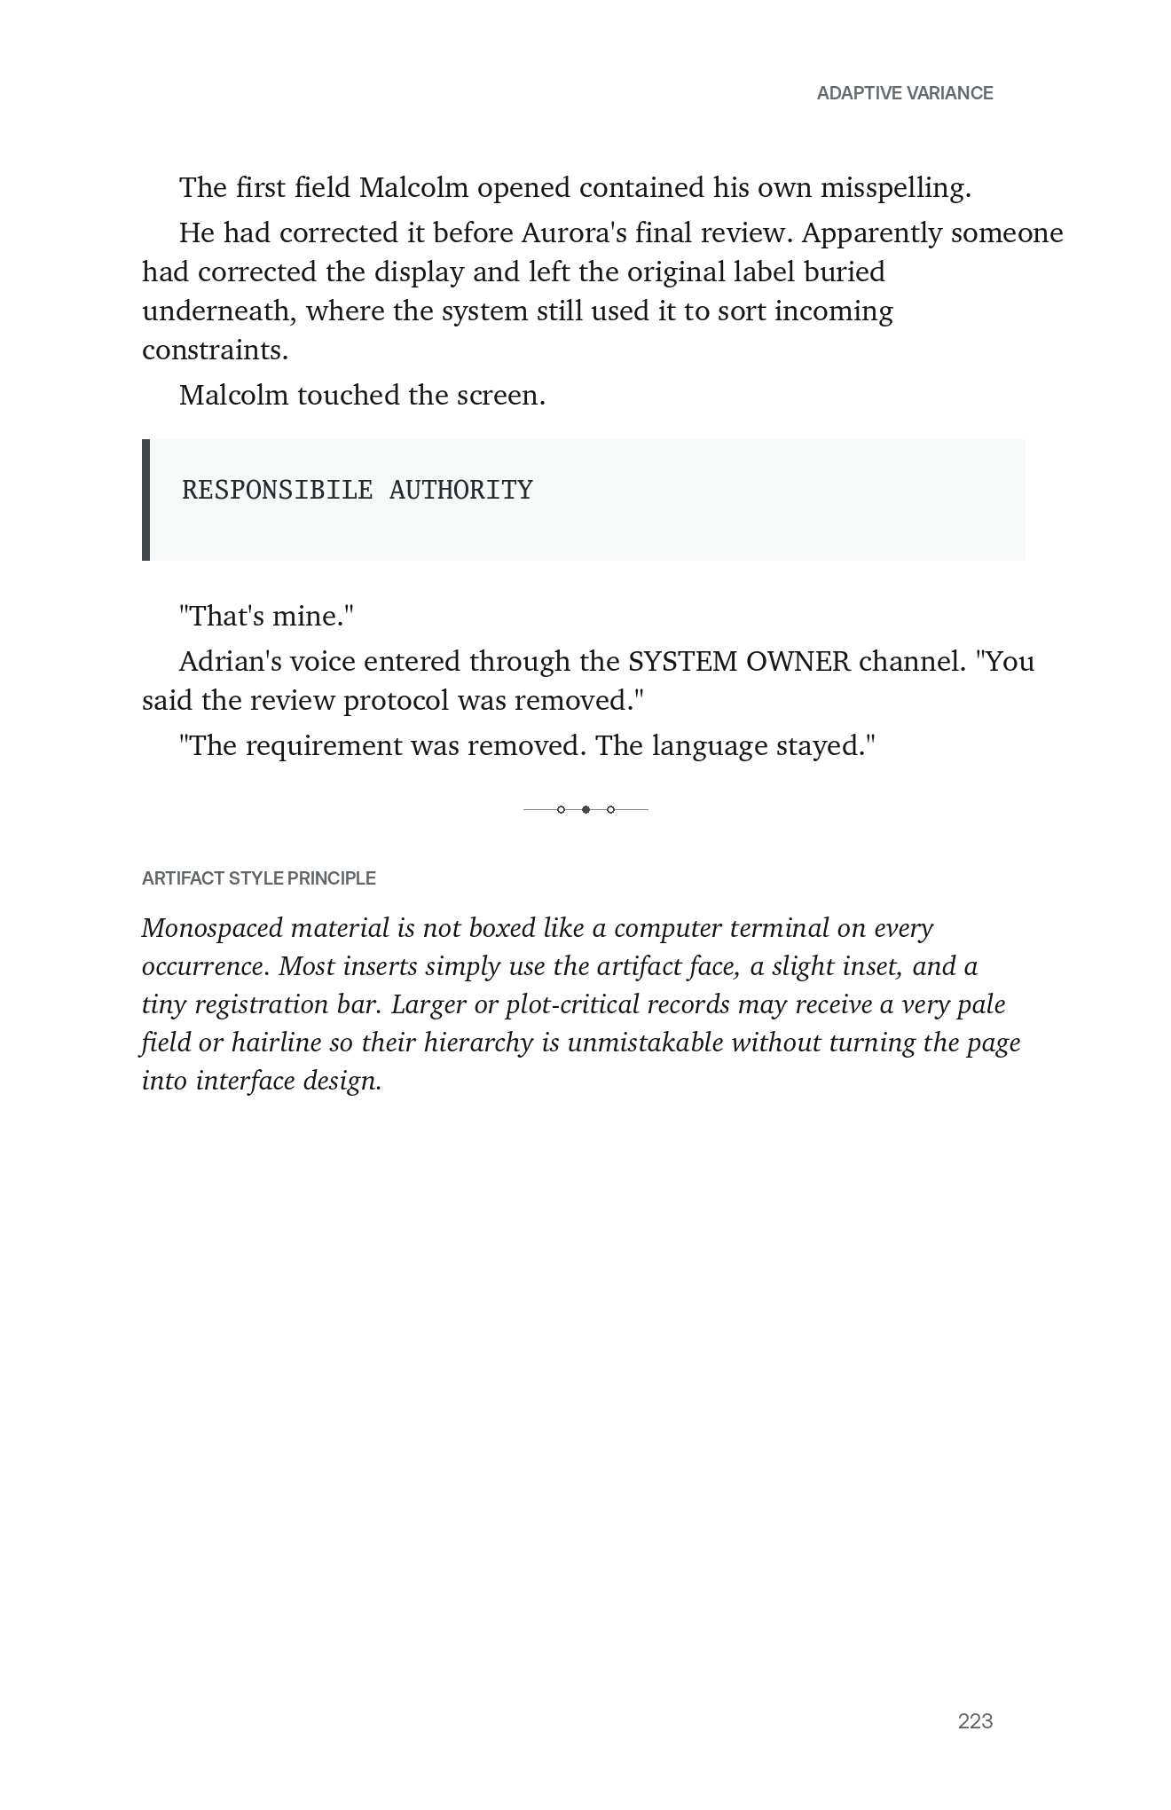
Artifact treatment study. The misspelling remains exactly as the text requires; typography distinguishes the record without correcting or over-designing it.
ELEMENT | SPECIFICATION
Default artifact | Go Mono 8.25–8.6 pt / 10.6–11 pt, 0.12–0.16 in inset from body measure, ragged right.
Registration marker | A 0.5–0.7 pt vertical bar or tiny square at the first line only. Do not box every insert.
Multi-line diagnostic | Keep lines together when possible. Do not split a six-line status block across pages.
Long artifact | Allow natural wrapping with a 0.12 in hanging indent; keep labels visually aligned where the content permits.
Critical record | A very pale 5–8% gray field may be used sparingly for a major display, provided print proofs retain contrast.
Messages / headlines | Use the same artifact family unless a clear semantic distinction is needed. Consistency is more valuable than creating many micro-styles.

The crucial production rule is semantic preservation: deliberately unusual strings, spacing, identifiers, misspellings, and record formats must be treated as content, not typographic errors.

8. Front Matter & Back Matter

Recommended front-matter sequence
- Half title: AUTONOMOUS.
- Series page: MALCOLM CARTER — BOOK ONE, with future titles omitted until publication plans are final.
- Title page: AUTONOMOUS / Charles Wair.
- Copyright page.
- Dedication or epigraph, if used.
- Movement I opener.
- Chapter 1.
I would not include a conventional print table of contents. The movement and chapter titles work better as discoveries, and the novel does not need navigational front matter. The ebook should, however, contain a complete hidden/navigation TOC for accessibility and retailer requirements.

Back matter
- Acknowledgments, if included.
- About the author.
- Series note / Book Two teaser for Source Code, if desired.
- Optional mailing-list or website page kept typographically minimal and separate from the fictional artifact language.

9. Composition Rules
ELEMENT | SPECIFICATION
Widows | Never leave the first line of a paragraph alone at the top of a page.
Orphans | Avoid the last line of a paragraph alone at the bottom. Minimum two lines when practical.
Short last lines | Avoid one-word paragraph endings where a noninvasive tracking or line-break adjustment can fix them.
Hyphen stacks | Maximum two consecutive hyphenated lines.
Dialogue | Do not isolate a single short line of dialogue at a page turn when a tiny composition adjustment prevents it.
Scene breaks | Keep at least two lines of preceding text above the ornament and at least two lines of following text below it.
Artifact blocks | Keep short diagnostic/status blocks intact; if a long record must split, repeat no decorative elements that imply a new record.
Chapter ends | Do not stretch the final page to align with its facing page. A short chapter-end page is desirable in fiction.
Blank pages | Truly blank: no folio, header, footer, or hidden ornament.

Microtypography
- Use optical kerning for display faces; metrics/optical setting should be tested against the chosen compositor.
- Body tracking should remain at 0 by default; use tiny local adjustments only during final castoff cleanup.
- Avoid forced line breaks in ordinary prose unless needed to prevent a visibly bad break that cannot be solved otherwise.
- Use nonbreaking spaces in measurements, initials, and short institutional labels where a split would look careless.
- Protect diacritics in names such as Klaipėda and Rūta through the full production chain and proof the final embedded fonts.

10. Ebook Adaptation
The ebook should preserve the same hierarchy but not attempt to reproduce fixed print geometry. It should be a clean reflowable EPUB, not a fixed-layout export.
- Use a standard serif fallback stack for body text and a sans/mono stack for display and artifact content.
- Movement motifs should become small SVGs with a text fallback, or be omitted if a retailer strips embedded SVG styling.
- Do not hard-code page numbers, running heads, or blank recto/verso pages.
- Keep system/artifact blocks as semantic block elements with monospace styling and break-inside: avoid where supported.
- Provide a complete navigation document for all 34 chapters and all five Movements.

11. Recommended Production Workflow
ELEMENT | SPECIFICATION
1 — Compose a 20–30 page pilot | Include Chapter 1, a dense dialogue chapter, a Naomi newsroom section, one movement opener, one long artifact block, and an Istanbul sequence.
2 — Approve type color | Judge body size/leading, line length, artifact contrast, scene-break visibility, and chapter-opening depth on an actual 5.5 × 8.5 printout.
3 — Cast off full book | Apply final styles to all 34 chapters; build section starts and movement parity intentionally.
4 — Page-composition pass | Resolve widows, orphans, bad hyphens, awkward artifact splits, and facing-page rhythm without altering prose.
5 — Author page proof | Produce a PDF for content/proof review after pagination is frozen.
6 — Preflight | Embed fonts, validate trim/media boxes, confirm grayscale, inspect glyphs/diacritics, and verify no live transparency or accidental color remains.
7 — Printer proof | Review one physical proof copy before approving production files.

12. Final Recommendation
Use the Controlled Variance system as the definitive interior direction: Charter for sustained reading, Inter for navigational structure, and a restrained monospaced face for records and machine-readable artifacts. Keep the interior one-color, reserve the network motif for movement thresholds and scene transitions, and resist any urge to make the book look like a terminal.
The distinctive quality should come from discipline: a clean grid, consistent information hierarchy, strong whitespace at the five structural thresholds, and a subtle visual separation between what people experience and what systems record. That gives Autonomous a recognizable interior identity while keeping the page fast, credible, and comfortable for thriller reading.

Appendix — Production Style Map
ELEMENT | SPECIFICATION
MOVEMENT | Inter Display Light/SemiBold; full-page recto; Roman numeral + title + network motif.
CHAPTER LABEL | Inter SemiBold 7.5–8 pt, tracked uppercase.
CHAPTER TITLE | Inter Display SemiBold 16–18 pt.
BODY | Charter 10.25/13.1 pt, justified, 0.20 in first-line indent.
FIRST PARA | BODY with no indent after chapter/scene/artifact break.
ARTIFACT | Go Mono 8.25–8.6/10.6–11 pt, slight inset, ragged right.
RUNNING HEAD | Inter Medium 6.5–7 pt, tracked uppercase, outside top.
FOLIO | Inter Regular 7.5–8 pt, outside bottom.
SCENE BREAK | Custom 3-node hairline ornament, centered, 12–16 pt clear space above/below.
BLANK PAGE | No running furniture.

