Pre-requisites

Step 1: Specify the TFS team collection URL where you want to add the users and groups

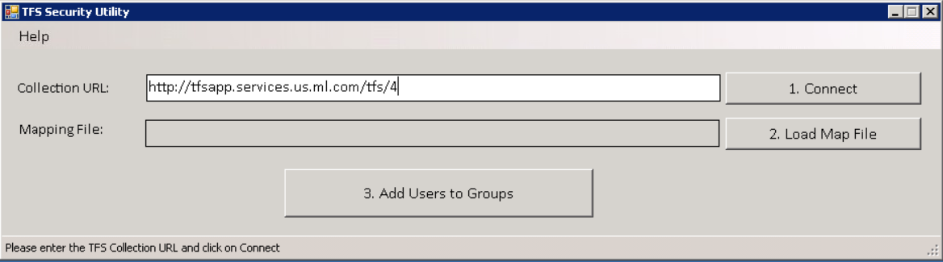

Step 2: Click on the connect button. Once connection is established, the status bar will show a message to confirm.

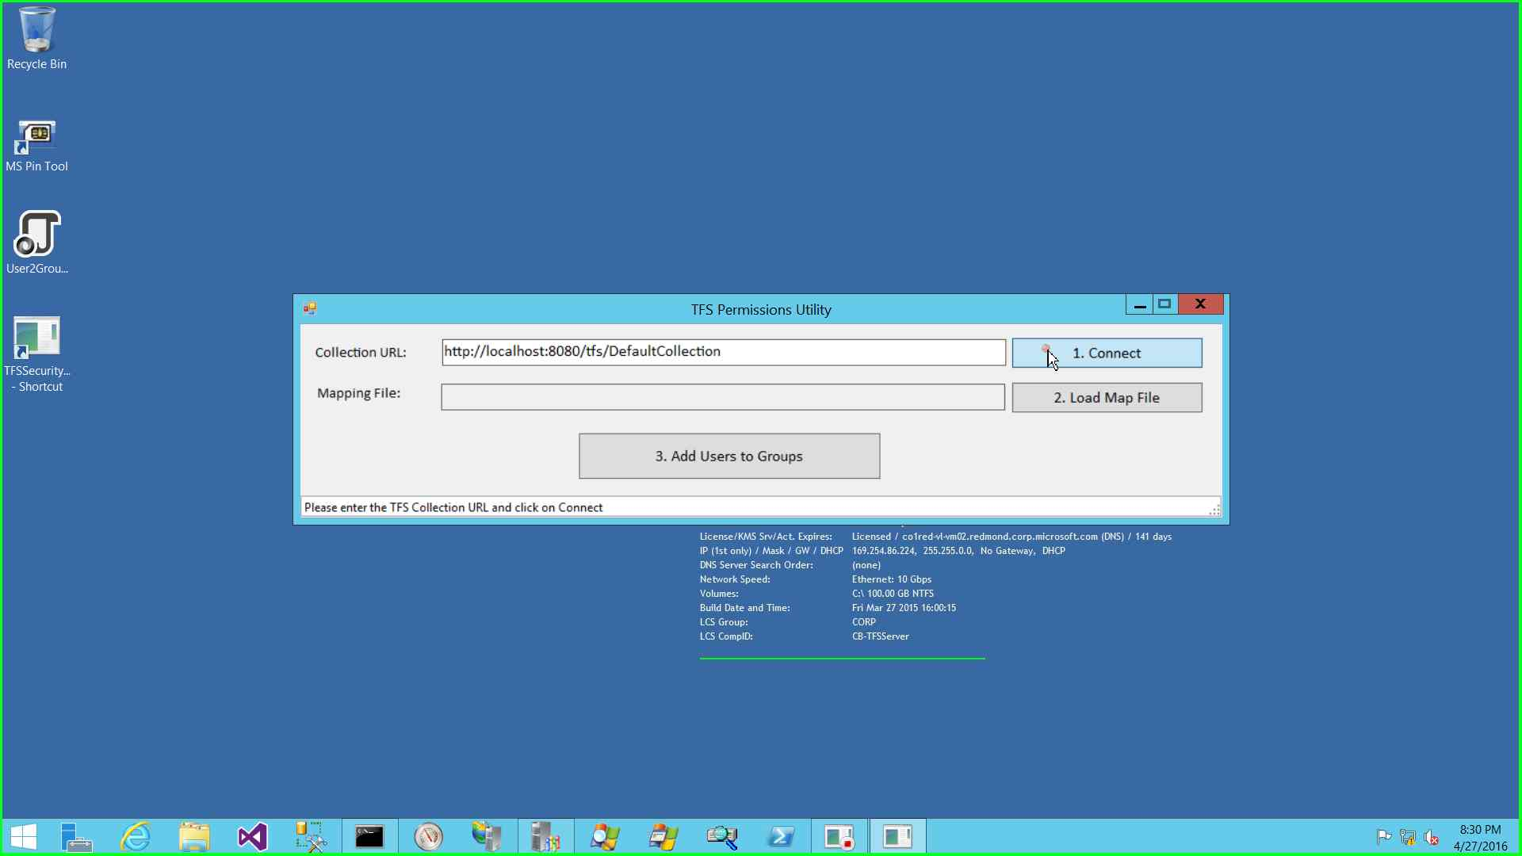

Step 3: Once connection is established, click on the Load map file button and select the json file or csv file containing the mapping of users to groups

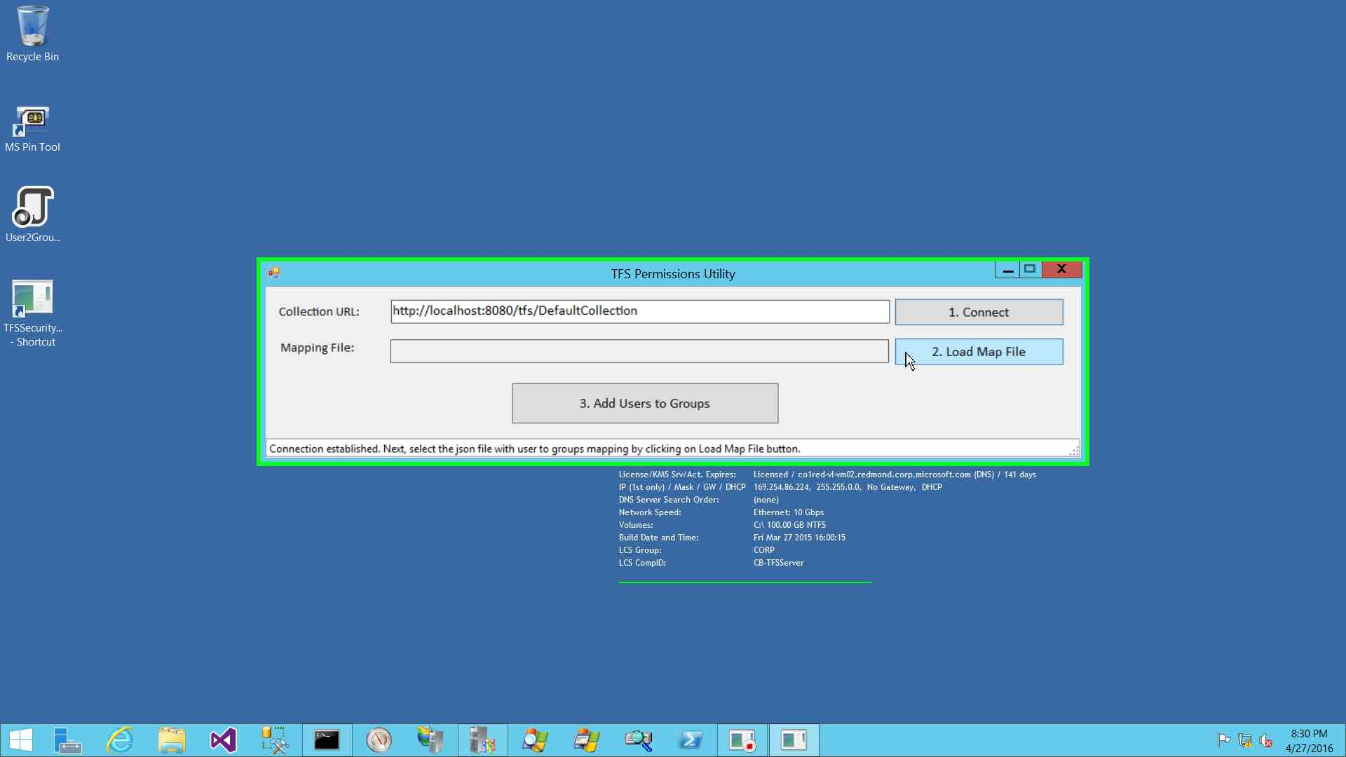

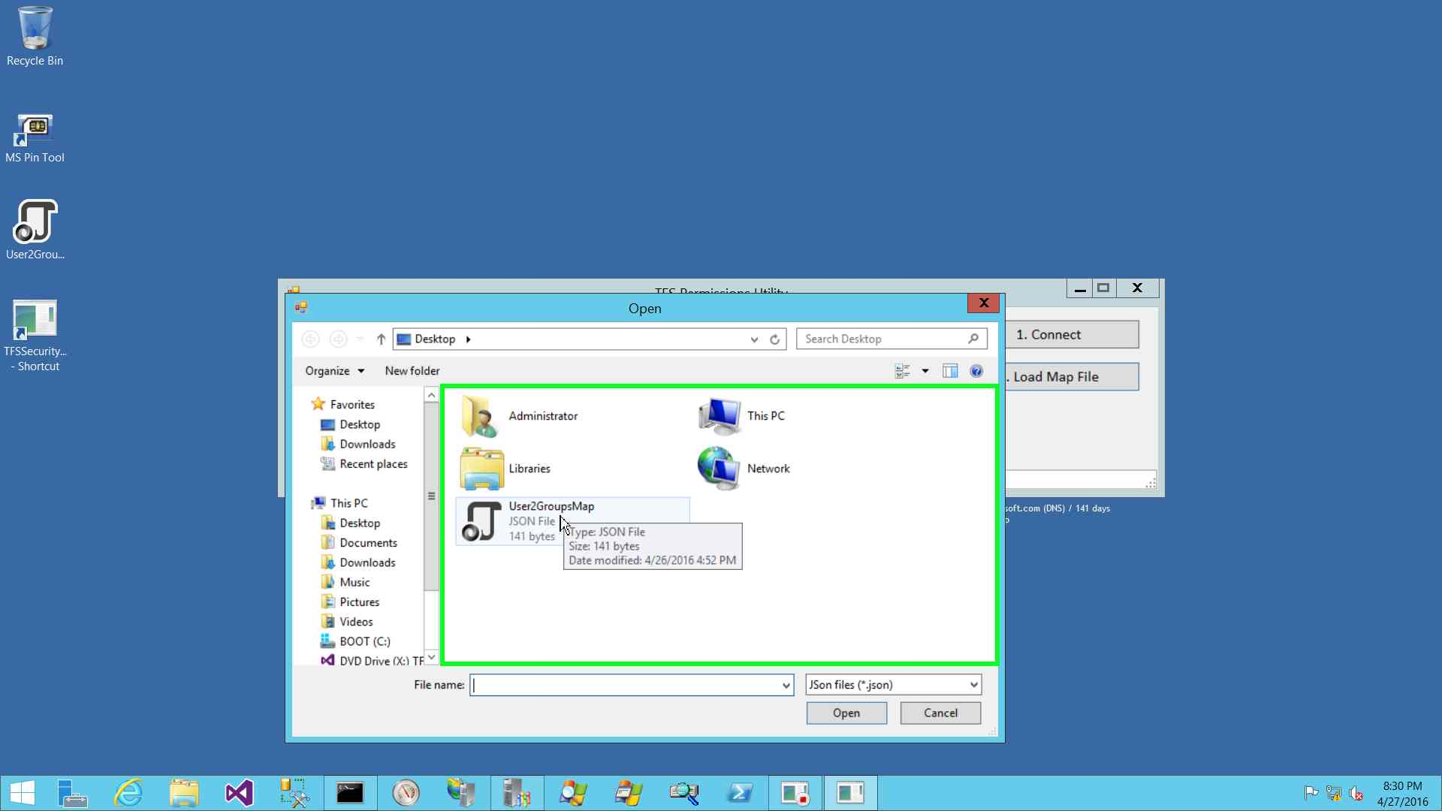

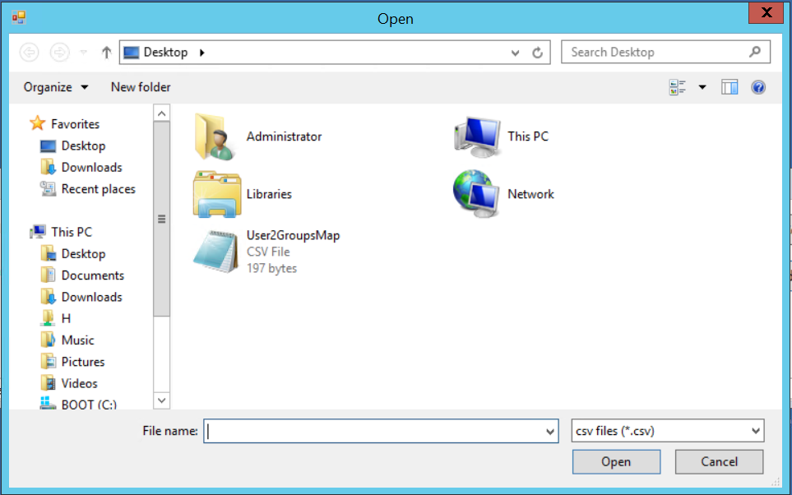

Step 4: Once the map file is loaded, click on the Add users to group button

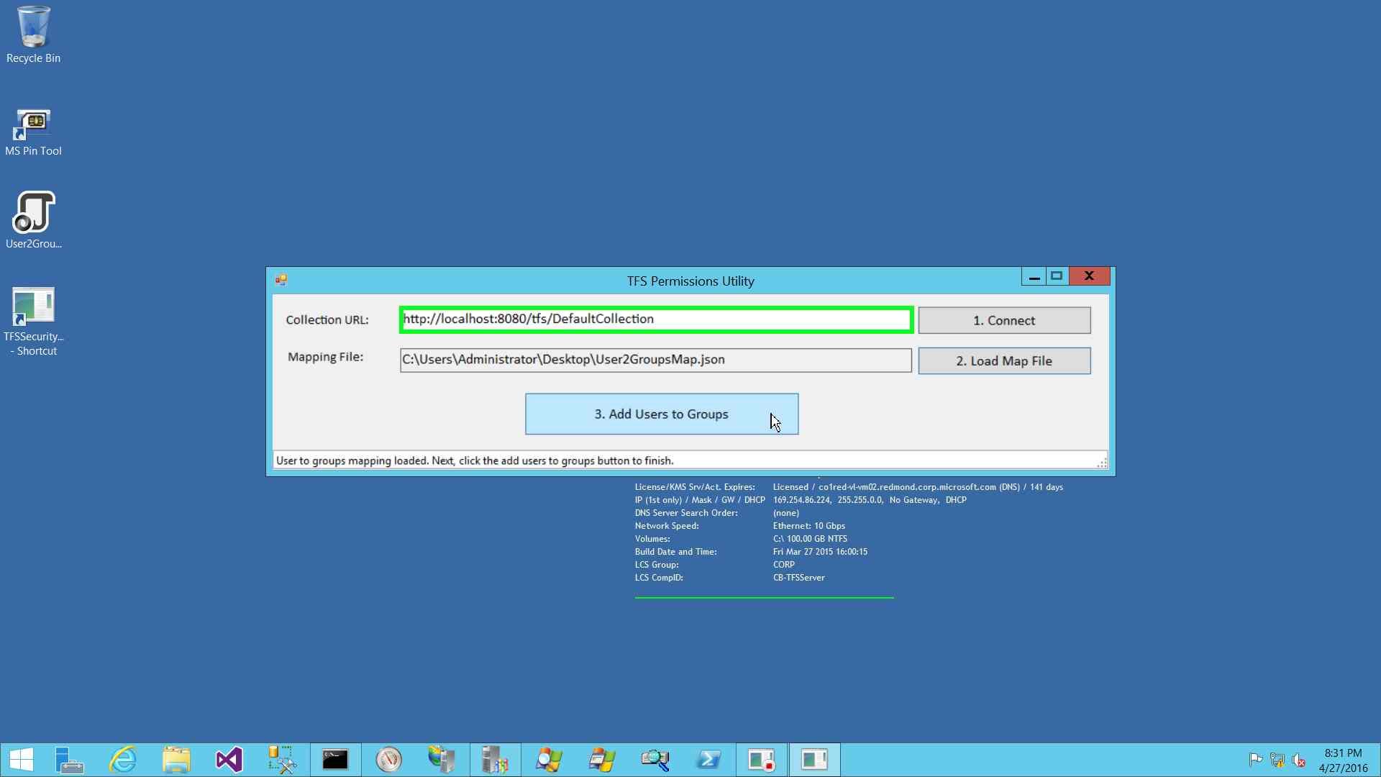

Once complete, the status bar will show the success message.

