Table of Contents

Pre-requisites 1

Steps - Add Users to Groups 1

Steps - Remove Users from Groups 3

View Error Logs 4

## Pre-requisites

1. .NET 4.5.2 runtime
2. TFS Client components (Visual Studio Team Explorer)
   1. The tool is written to work with TFS 2015 and has not been tested with TFS 2017
   2. The Permission Helper library has code comments, for the API changes needed to make the tool work with TFS 2010 as well
3. A user account with TFS Collection Admin privileges

## Steps - Add Users to Groups

Step 1:

*csv format*-

DomainName\TFSPowerUser,Contributors|Readers,DemoWeb|CloudDemo

DomainName\TFSDummyUser,Contributors|Readers,DemoWeb|CloudDemo

*json format-*

[{

"UserName":"DomainName\\TFSPowerUser",

"GroupNames":["Contributors","Readers"],

"TeamProjectNames":["DemoWeb","CloudDemo"]

},

{

"UserName":"DomainName\\TFSDummyUser",

"GroupNames":["Contributors","Readers"],

"TeamProjectNames":["DemoWeb","CloudDemo"]

}]

Create the user to groups mapping list. This can be in csv (comma separated values) or json format. As an example, the below would be the format to add the users TFSPowerUser and TFSDummyUser (in domain “DomainName”) to the groups named Contributors and Readers, in the TFS team projects DemoWeb and CloudDemo

Please note that if the specified group name does not exist, the tool will create it.

Step 2: Specify the TFS team collection URL where you want to add the users and groups

Step 3: Click on the connect button. Once connection is established, the status bar will show a message to confirm.

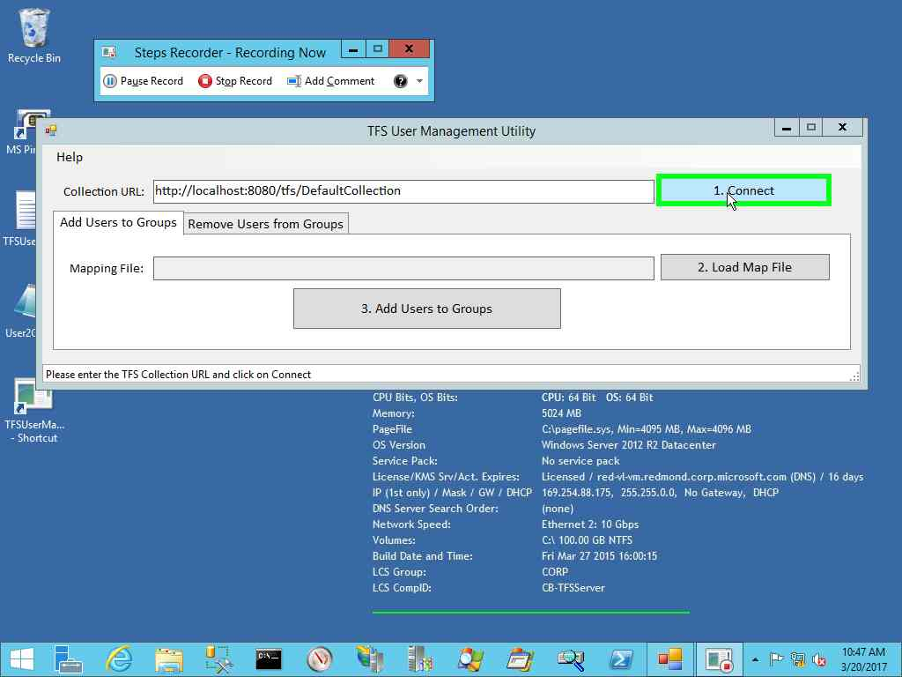

Step 4: Once connection is established, click on the Load map file button and select the json file or csv file containing the mapping of users to groups

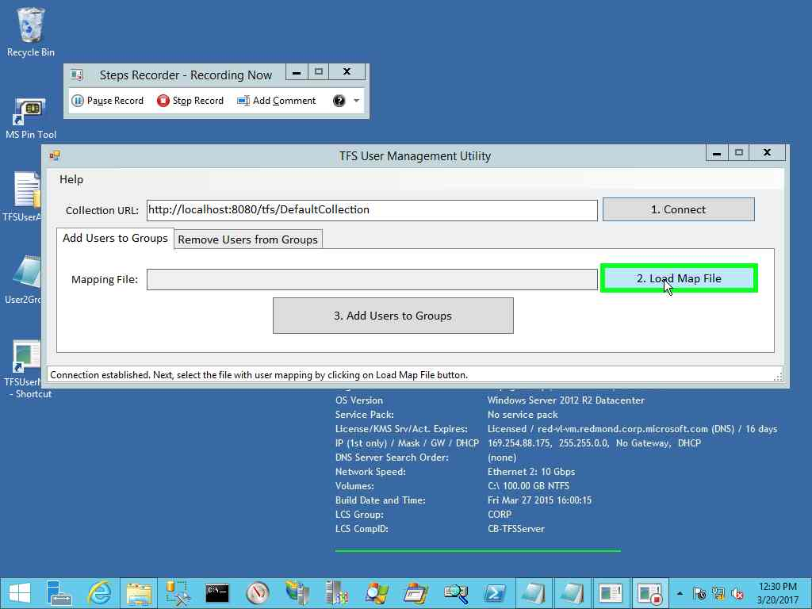

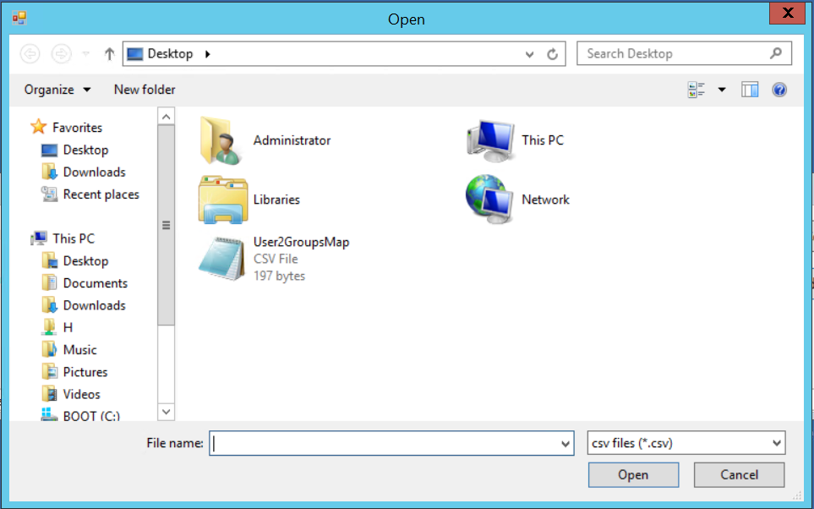

Step 5: Once the map file is loaded, click on the Add users to group button

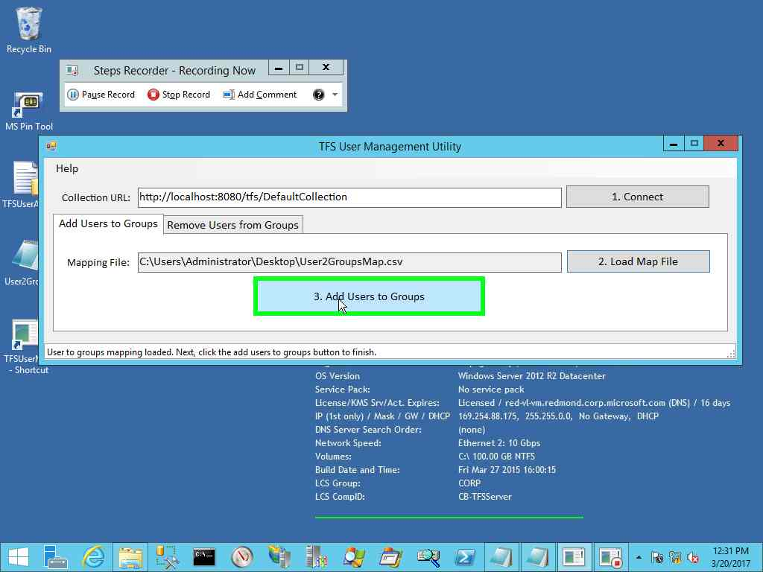

Once complete, the status bar will show the success message.

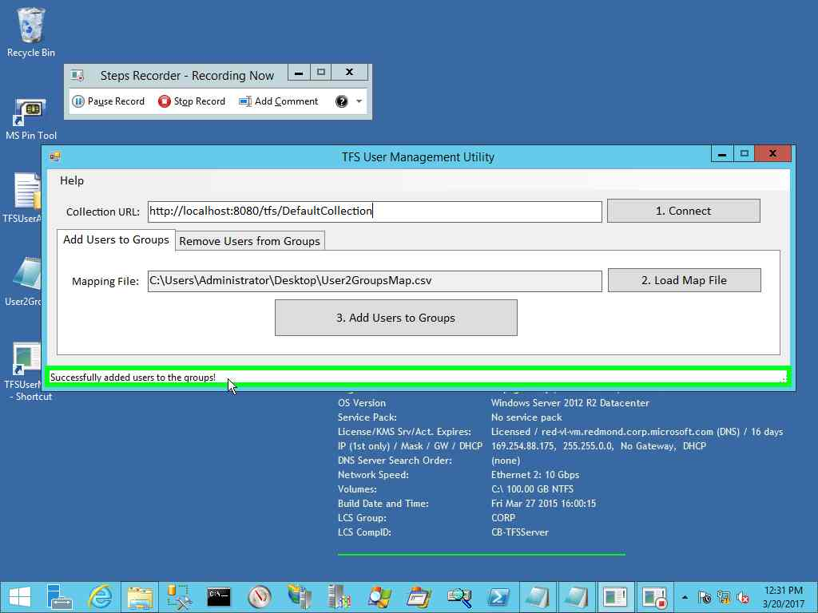

## Steps - Remove Users from Groups

As with the addition of users and groups, you would need to create a file (csv or json) that contains the list of users that need to be removed and their associated Team Projects.

The utility assumes that the users specified in the file needs to be removed from ALL groups in the specified Team Project. This behavior ca be changed in code, if need be.

*csv format*-

# Notation:

# username,GroupName(s) separated by ‘|’,TeamProject name(s) separated by ‘|’

DomainName\TFSPowerUser,DemoWeb|CloudDemo

DomainName\TFSDummyUser,CloudDemo

*json format-*

[{

"UserName":"DomainName\\TFSPowerUser",

"TeamProjectNames":["DemoWeb","CloudDemo"]

},

{

"UserName":"DomainName\\TFSDummyUser",

"TeamProjectNames":["CloudDemo"]

}]

Step 1: Specify the TFS team collection URL where you want to add the users and groups

Step 2: Click on the connect button. Once connection is established, the status bar will show a message to confirm.

Step 3: Once connection is established, click on the Load map file button and select the json file or csv file containing the mapping of users to groups

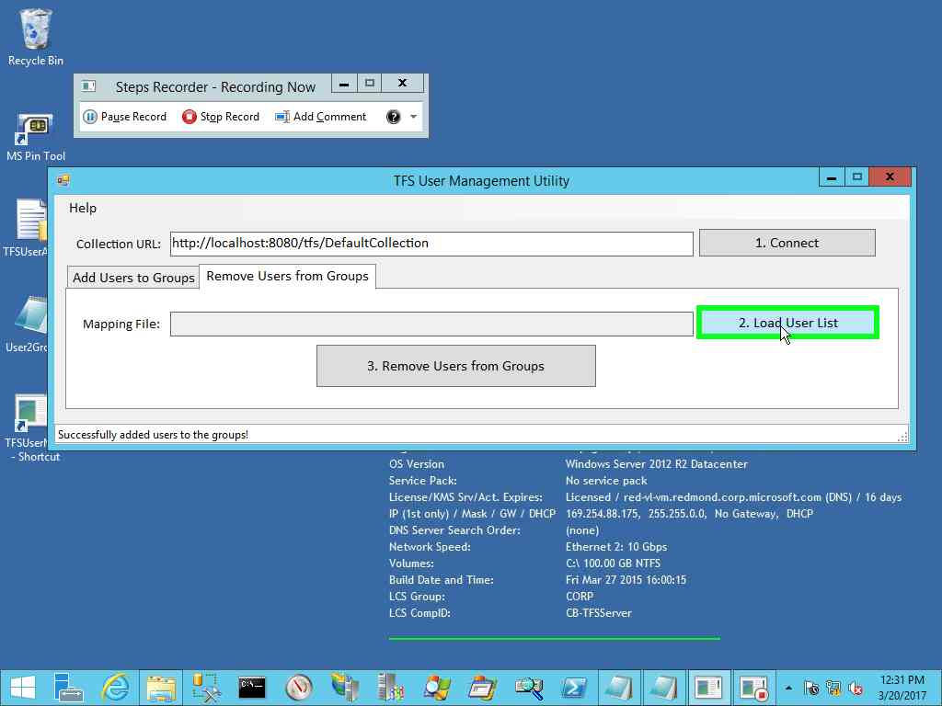

Step 4: Once the map file is loaded, click on the Remove users from Groups button

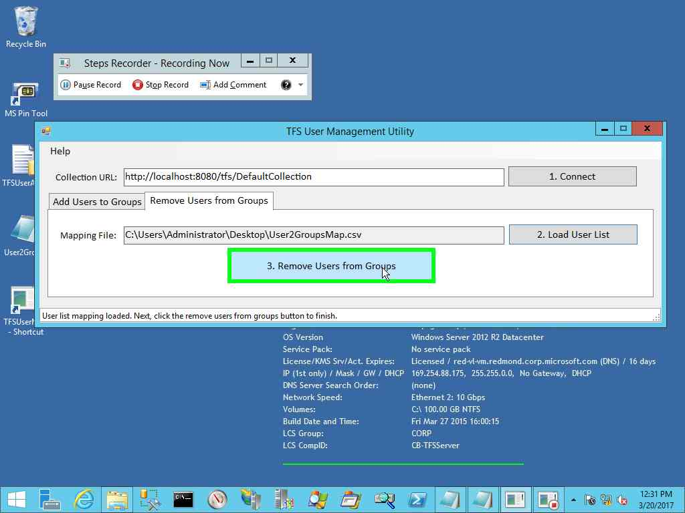

## View Error Logs

