Site-to-Site VPN tunnels SOP - Cisco FTD-3130

Cybersecurity - Network Protection
Objective: Site-to-Site VPN tunnels SOP – Cisco FTD 3130
Device(s): CR-DC-02-FTD3130-VPN-FW1 – Primary(172.26.250.64)
CC-CA-07-FTD3130-VPN-FW2 - Secondary(172.26.250.65)
Author: James Pettit / pettitj@ccf.org / 216.319.5049
Business Case: New Firewall platform

--------------------------------------------------------------------------------------------------------------------------------------------

S2S VPN Topologies:

Cisco FTD-3130 – VPN topologies available:

- Policy Based (Crypto Map)
  - Point to Point
  - Hub and Spoke
  - Full Mesh

- Route Based (VTI-Virtual Tunnel Interface)
  - Point to Point
  - Hub and Spoke
Cybersecurity – Network Protection topology standard - Policy Based (Crypto Map) - Point to Point

--------------------------------------------------------------------------------------------------------------------------------------------

Firewall/VPN Management:

Cisco FTD-3130’s and VPN configurations are managed in Cisco Firewall Management Center

On CCF network, reach the FMC over:

- https://172.26.250.45 – Primary | cr-dc-02-fmc4700-s1.ccf.org
- https://172.26.250.46 – Secondary | cc-ca-07-fmc4700-s1.ccf.org

When building a S2S VPN within the environment, there are several configurations needed for proper VPN traffic flow. Inbound/outbound S2S VPN traffic flows on VLAN 252, the Business side of the network. Our network is asymmetric as we have a Business and General side of the network. Static routes are configured from the DMZ INSIDE switches to the Business Checkpoint FWs, to the Business Cisco FTD-3140s, to the edge Cisco VPN FTD-3130. This is to ensure site to site VPN traffic stays on the Business side of the network. Otherwise, traffic will try to take the General path (general internet traffic i.e. tcp 80/443 traffic, etc.). General traffic traverses VLAN 253. A diagram of the Business side of the network is listed on page 4.

Each S2S VPN requires static route configurations; these routes are created by our team. When configuring the routes, keep in mind they are the remote encryption domain path from vendor to us and vice versa. Routes can also be a path from a CCF managed site back to our Cisco VPN FTD-3130.

A fifth device is included, the “Internet Router”, as it is important and a hop in the network path. However, we do not configure routes on the Internet Router, only a next-hop route to the Internet Router’s public VIP 192.35.79.12 is required.

Network flow and devices from inside the network out to the edge are listed below.

Flow outbound:

- DMZ Inside Nexus Switches
- CC-CA-07-DMZE15-93216-S1 - 172.26.253.246
- CC-CA-07-DMZE15-93216-S2 - 172.26.253.247
- CR-DC-02-DMZBK10-93360-S2 - 172.26.252.60
- CR-DC-02-DMZBK14-93360-S2 - 172.26.252.61

- Business Checkpoint Firewalls
- CR-DC-02-DMZBK32-23800-BUSINESS-FW03 – 172.26.252.205
- CC-LL-01-DMZR24-23800-BUSINESS-FW04 – 172.26.252.206

- Business FTD-3140 Firewalls
  - CR-DC-02-FTD3140-BUS-FW1 – 172.26.250.62
  - CC-CA-07-FTD3140-BUS-FW2 – 172.26.250.63

- Business FTD-3130 Firewall - S2S VPN Concentrator
  - CR-DC-02-FTD3130-VPN-FW1 – 172.26.250.64
  - CC-CA-07-FTD3130-VPN-FW2 – 172.26.250.65
- Internet Router
  - CR-DC-02-DMZBK32-1006-R3 – 172.26.252.30
  - CC-LL-01-DMZR23-1006-R3 – 172.26.253.30

- Managed by Network Services – Dave Hines group
  - Static routes are not needed here unless a net new IP space is added. CCF internal and public IP spaces are already configured:
>10.0.0.0/8
>172.16.0.0/12
>192.168.0.0/16
>192.35.79.0/24
>139.137.0.0/16
>167.90.0.0/16

Flow inbound:

- Internet Router
  - CR-DC-02-DMZBK32-1006-R3 – 172.26.252.30
  - CC-LL-01-DMZR23-1006-R3 – 172.26.252.30

- Business FTD-3130 Firewall - S2S VPN Concentrator
  - CR-DC-02-FTD3130-VPN-FW1 – 172.26.250.64
  - CC-CA-07-FTD3130-VPN-FW2 – 172.26.250.65

- Business FTD-3140 Firewalls
  - CR-DC-02-FTD3140-BUS-FW1 – 172.26.250.62
  - CC-CA-07-FTD3140-BUS-FW2 – 172.26.250.63

- Business Checkpoint Firewalls
- CR-DC-02-DMZBK32-23800-BUSINESS-FW03 – 172.26.252.205
- CC-LL-01-DMZR24-23800-BUSINESS-FW04 – 172.26.252.206

- DMZ Inside Nexus Switches
- CC-CA-07-DMZE15-93216-S1 - 172.26.253.246
- CC-CA-07-DMZE15-93216-S2 - 172.26.253.247
- CR-DC-02-DMZBK10-93360-S2 - 172.26.252.60
- CR-DC-02-DMZBK14-93360-S2 - 172.26.252.61

Business Side Network architecture and inbound/outbound data flow

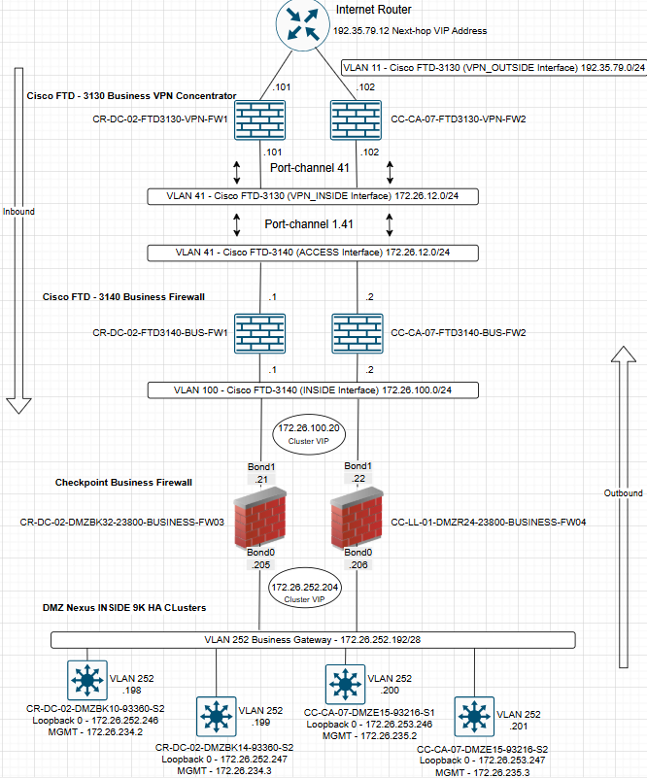

Static Route Configurations

- DMZ routes are created on 4 switches. The Nexus INSIDE – 9K HA clusters.
CC-CA-07-DMZE15-93216-S1 - 172.26.253.246
CC-CA-07-DMZE15-93216-S2 - 172.26.253.247
CR-DC-02-DMZBK10-93360-S2 - 172.26.252.60
CR-DC-02-DMZBK14-93360-S2 - 172.26.252.61

Static routes configured on these switches need to point to the next-hop Checkpoint firewall cluster IP: 172.26.252.204
-------------------------------------------------------------------------------------------------------------------------------

Adding static route and saving configuration example for the remote CCAC-LAB-VPN network:

- Add static route of 172.26.67.0/24 pointing to VLAN 252 and Checkpoint FW next-hop VIP.
CLI commands:

#configure terminal
# ip route 172.26.67.0/24 Vlan252 172.26.252.204 name CCAC-LAB-VPN
# end
# copy running-config startup-config

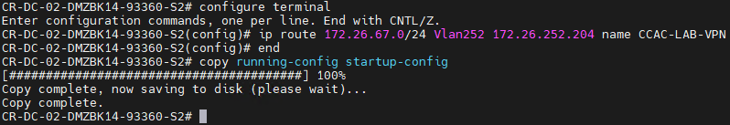

- Parsing the running configuration and routing table to find specific route created.

#show running-config | include CCAC

#show ip route 172.26.67.0

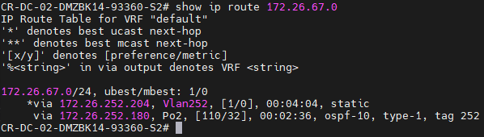

- Checkpoint 23800 Business firewall routes:
CR-DC-02-DMZBK32-23800-BUSINESS-FW03 – 172.26.252.205
CC-LL-01-DMZR24-23800-BUSINESS-FW04 – 172.26.252.206

Only RFC 1918(private IP space) static routes are needed on this cluster. Public internet routes to AWS/Azure/GPC/vendor public addressing, etc. will take the default route configured and flow outbound to the Business FTD-3140 (Inside interface) IP – 172.26.100.1

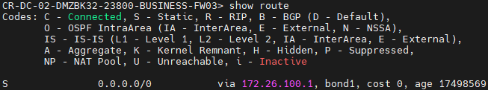

RFC 1918 routes must be manually configured from the CLI on each cluster member. Repeat the same steps on standby firewall FW04

Adding static route and saving configuration example for the remote CCAC-LAB-VPN network:

- Enter Clish mode from Expert mode
#clish

- Set the static route of the remote network and point the route towards the next-hop gateway of 172.26.100.1. The next-hop gateway is the Business FTD-3140 Inside interface IP.

> set static-route 172.26.67.0/24 nexthop gateway address 172.26.100.1 priority 1 on

- Verify and save configured route.
Show route destination 172.26.67.0

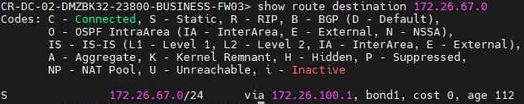
>save config

- Business FTD-3140 Firewalls routes:
CR-DC-02-FTD3140-BUS-FW1 – 172.26.250.62
CC-CA-07-FTD3140-BUS-FW2 – 172.26.250.63

Business FTD-3130 Firewall - S2S VPN Concentrator routes:

CR-DC-02-FTD3130-VPN-FW1 – 172.26.250.64
CC-CA-07-FTD3130-VPN-FW2 – 172.26.250.65

Static routes for the FTD-3140 and VPN FTD-3130 clusters are configured on our FMC 4700 management servers and pushed to the FTD’s.

Listed below are the interfaces on our FTD-3140 and VPN FTD-3130 cluster.

S2S VPNs traffic flows between these devices on the following interfaces:
- FTD-3140 (inside interface) IP – 172.26.100.1
- FTD-3140 (Access interface) IP – 172.26.12.1
- VPN FTD-3130 (vpn_inside interface) IP 172.26.12.101
- VPN FTD-3130 (vpn_outside interface) IP 192.35.79.101

FTD-3140

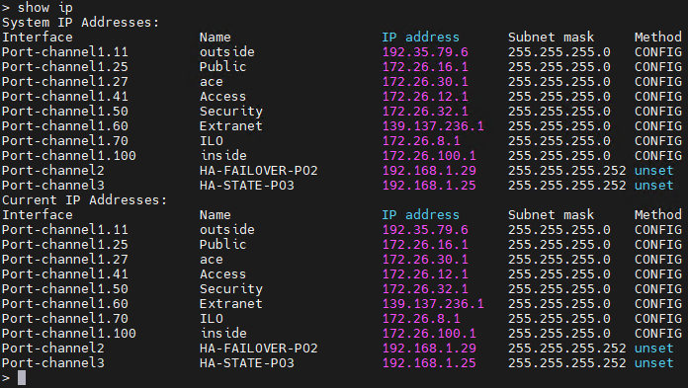

VPN FTD-3130

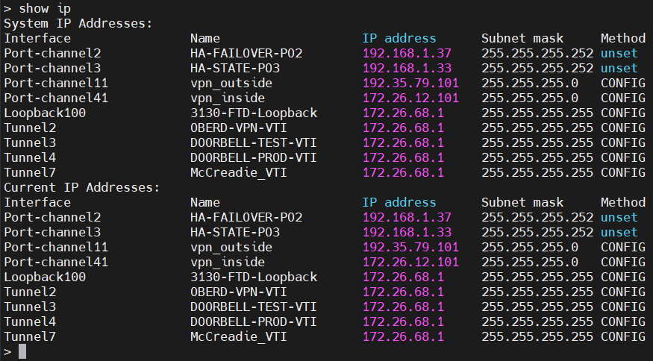

This part of the diagram displays the flow between FTD’s:

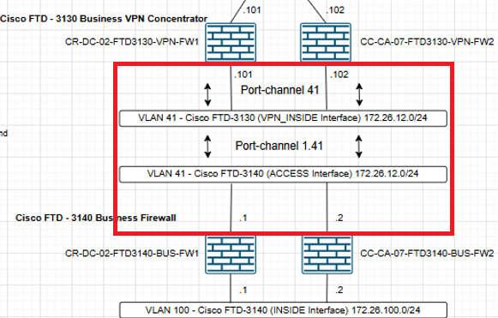

Business FTD-3140 Firewalls routes:

- From the FMC, click on Devices > Device Management

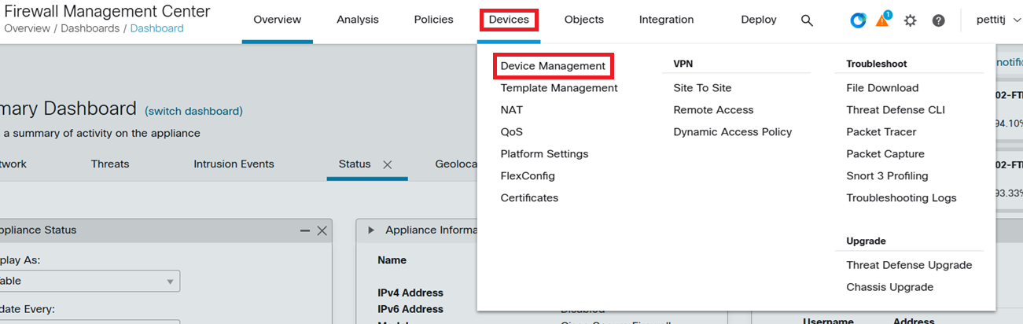

- Click on FTD3140-BUSINESS-HA. Routes will be applied to both nodes in the cluster when editing the routing table under the HA menu.

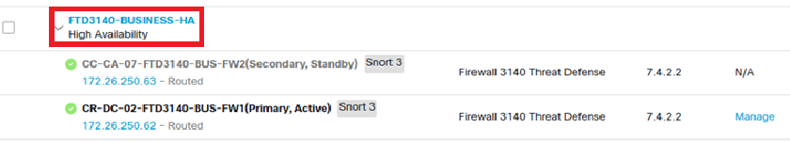

- Select Routing > Static Route

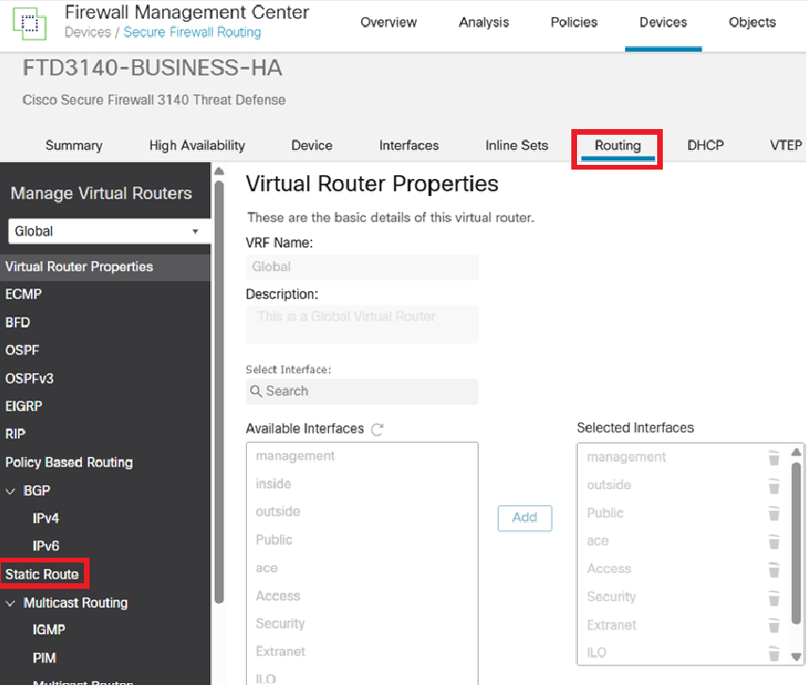

- Click Add Route in the top right corner.

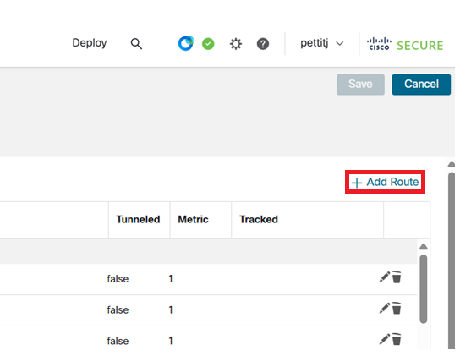

Next page

- FTD-3140 routes flow from the “Inside” interface to the “Access” interface. We include the remote network of the vendor or CCF site, and gateway next-hop interface which is the “vpn_inside” interface on the FTD-3130.

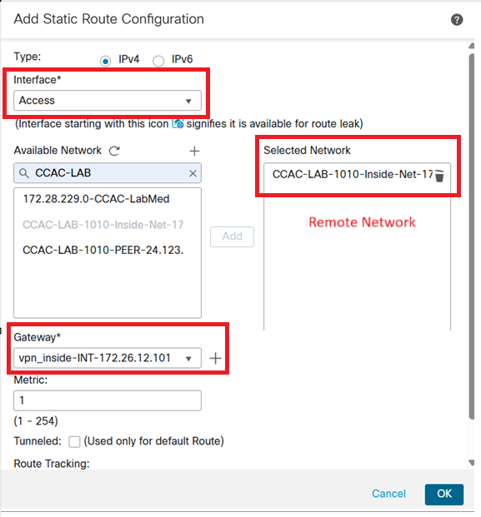

GUI routing table

- The process is repeated on the FTD-3130 VPN concentrator however, two routes per VPN are needed to complete a path and connectivity to the vendor network. In some cases, a vendor may provide several remote networks, this would result in more static routes created. Additionally, as traffic is leaving our edge VPN concentrator and headed towards the Internet Router, the “vpn_outside” interface is selected for the traffic path. The “vpn_outside” interface is used as our peer IP address(192.35.79.101). Our peer IP is on the same subnet as the Internet Router VIP 192.35.79.12. This is the last leg of connectivity that gets us to and from the internet.

Routes:
      - Vendor remote network pointing to vendor peer IP address.
      - Vendor peer IP address pointing at our Internet Router VIP 192.35.79.12.
First route:

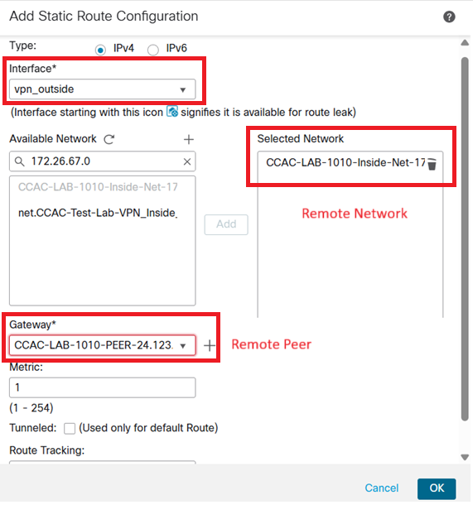
GUI routing table

Second route:

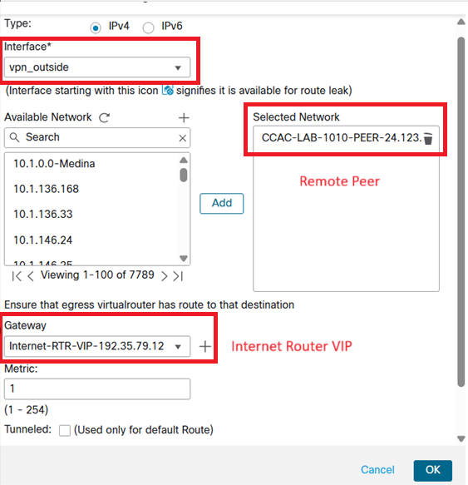

GUI Routing table

End of routing section

Building a Policy Based (Crypto Map) – Point to Point VPN

  - Navigate to the FMC dashboard
  - Select the Devices and VPN - Site To Site tabs

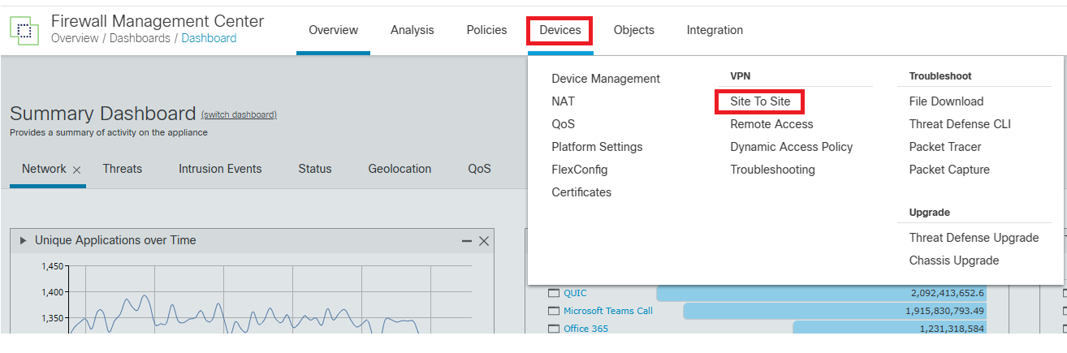

  - On the top right of the screen, create a new S2S VPN topology by clicking Add

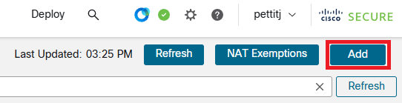

  - Create VPN Topology, select Policy-Based VPN, Peer to Peer
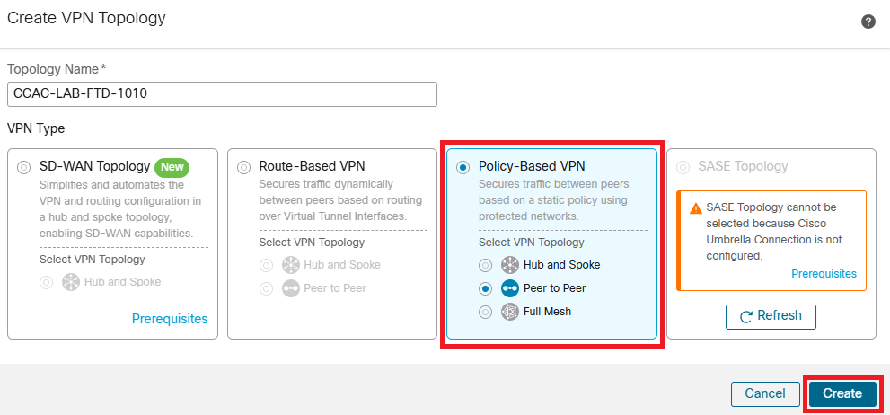

  - IKEv2 is the preferred IKE version and is auto selected.
  - Add “Endpoints” to the topology. These nodes include the peers and protected networks on both sides. FTD-3130 is node A in topology.
    - Select - Device* - FTD3130-VPN-HA
    - Select - Interface* - vpn_outside
    - Select – IP Address* - 192.35.79.101 (CCF peer IP address)
    - Select – Connection Type* Bidirectional. Always select Bidirectional as it provides flexibility. The ACP – Access Control Policy determines what flows are permitted inbound/outbound.
    - Certificate Map* - Leave blank, we do not use certificates for VPNs, we use Pre-Shared Keys.
    - Protected Networks* - Two available options
      - Subnet/IP Address (Network) – Preferred
        - Most of our VPNs will use 139.137.x.x/16 IP space for NATs. This is where we put those NAT IP’s/Networks.
        - If the tunnel is NAT exempt, we put the private IP’s/Networks here.
      - Access List (Extended) – Not preferred as ACLs are completed in the ACP – Access Control Policy configuration.
      - 139.137.255.254 is added to the protected networks for the VPN tunnel. This public IP will NAT to our internal jumpbox(10.88.140.109) as a test host.
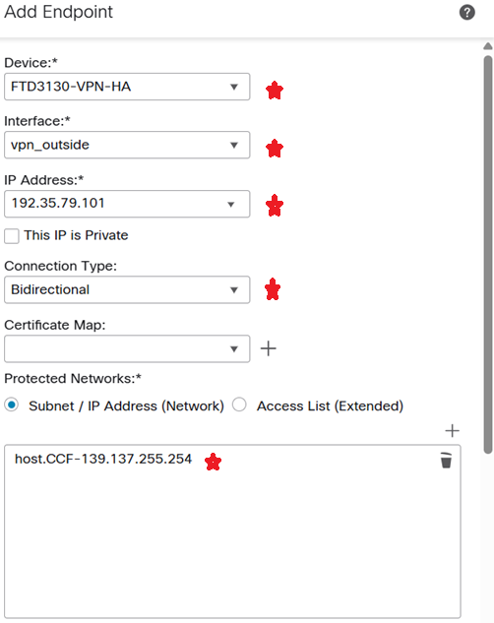

      - Enable NAT Traversal box is selected.
        - NAT breaks down standard IPSec operation. NAT-T circumvents this by encapsulating the IPSec traffic in UDP over port 4500, thus allowing it to pass through NAT devices.
      - Exempt VPN traffic from network address translation
        - Leave unchecked when using NAT in the VPN tunnel.
        - Leave checked when NAT isn’t being used.
      - Advanced Settings:
        - Leave Enable Dynamic Reverse Route Injection unchecked
          - If the checkbox is selected, an automatic static route is created by the FTD-3130. We want to create our own static routes.
        - Leave Send Local Identity to Peers unchecked
          - We only select this checkbox if we use the vpn_inside or loopback interface to be presented to the remote side as our local identity. “IP Address” is selected as the local identity. This is for IKE negotiation to be established. Normally the local identity is a firewall interface IP. However, we would select this when configuring a VTI tunnel.
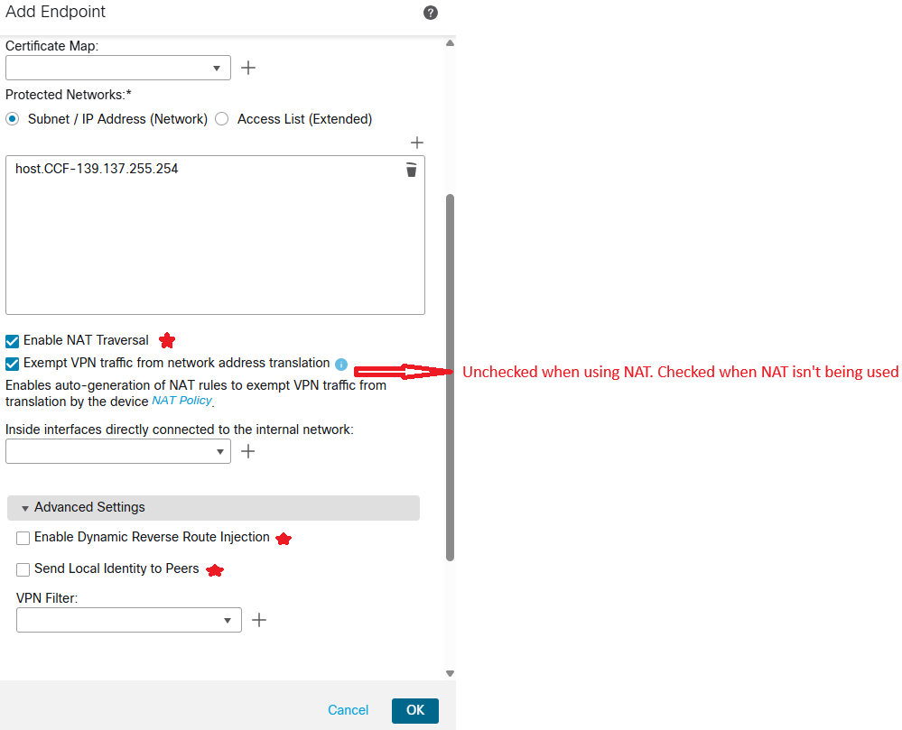

  - The “Extranet” device is Node B in the topology. This is the remote peer device that either the vendor or CCF manages.
    - Select – Device* - Extranet
    - Select – Device Name – MANUALLY DEFINED – This example: CCAC-LAB-1010-PEER-24.123.53.244
    - Select – IP Address* - 24.123.53.244 (Vendor or CCF managed peer IP address)
    - Certificate Map* - Leave blank, we do not use certificates for VPNs, we use Pre-Shared Keys.
    - Protected Networks* - Two available options
      - Subnet/IP Address (Network) – Preferred
        - Vendor or CCF managed remote network that we’re protecting inbound/outbound over the VPN. In this example it is 172.26.67.0/24.
      - Access List (Extended) – Not preferred as ACLs are completed in the ACP – Access Control Policy configuration.
      - Advanced Settings: These settings are grayed out and not able to be selected.

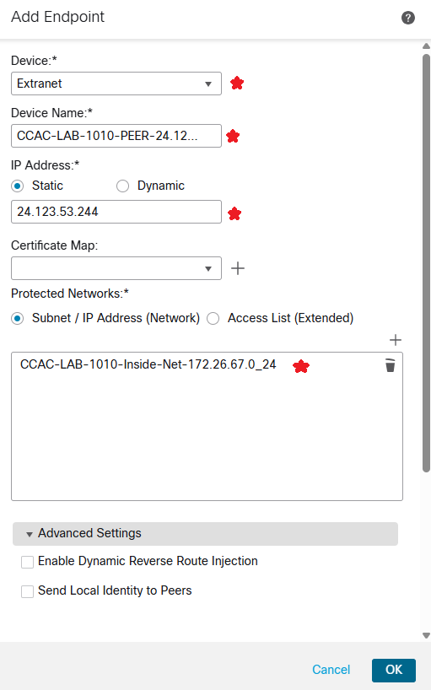

  - IKE- Internet Key Exchange configuration.
    - Select – IKE
    - The topology menu defaults to IKEv2 Settings as it was version selected during the initial topology setup.
    - IKEv2 Settings: CCF encryption, hashing, and timing standards have been prebuilt for phase 1 & phase 2 VPN connectivity. They can be added under Policies*. If our prebuilt policies are not compatible with the remote vendor, we can create a custom policy as a workaround.
      - Phase 1 standards
        - AES-256 – CBC & GCM
        - SHA-512
        - Diffie-Hellman Groups 14, 19, 20, & 21
        - Lifetime timeout, 86400 seconds
        - CBC & GCM standards available. GCM is preferred as it is more secure.
      - Policies example:
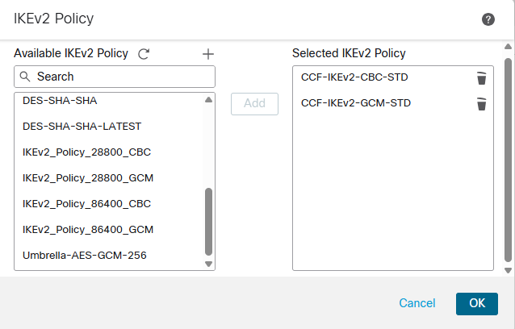
    - Authentication Type: Select* Pre-shared Manual Key
      - Enter manual PSK.
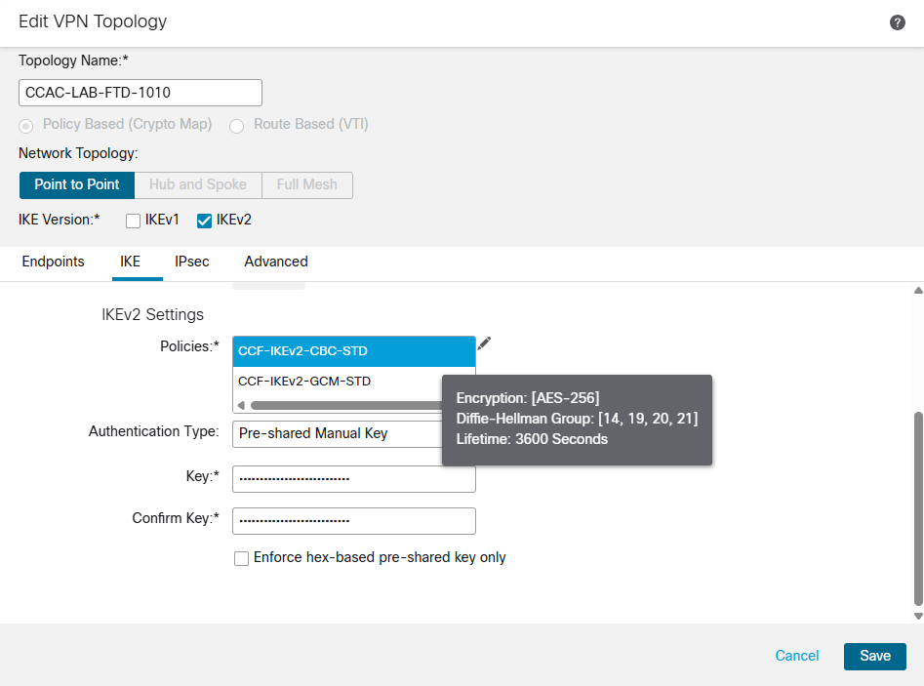

  - IPsec – Internet Protocol Security configuration.
    - Select – IPsec
    - The topology menu defaults to IKEv2 Settings as it was version selected during the initial topology setup.
    - Crypto Map Type: Select – Static
    - IKEv2 Mode: Select – Tunnel
    - Transform sets: CCF encryption, hashing standards have been prebuilt for phase phase 2 VPN connectivity. They are added under IKEv2 IPsec Proposals*. If our prebuilt policies are not compatible with the remote vendor, we can create a custom policy as a workaround.
    - Enable Security Association (SA) Strength Enforcement – Leave Blank
    - Enable Reverse Route Injection – Leave Blank
      - This selection creates an automatic static route if checked. We want to control our static route creation, so we leave the box unchecked.
      - Phase 2 standards
        - AES-256 – CBC & GCM
        - SHA-512
        - Diffie-Hellman Groups 14, 19, 20, & 21
        - PFS – Perfect Forward Secrecy enablement. Define DH group under Modulus Group*
        - Lifetime timeout, 3600 seconds – entered manually on phase 2
        - CBC & GCM standards available. GCM is preferred as it is more secure.
        - Lifetime Size: Per Cisco, keep default setting

      - ESPv3 Settings – Leave Blank

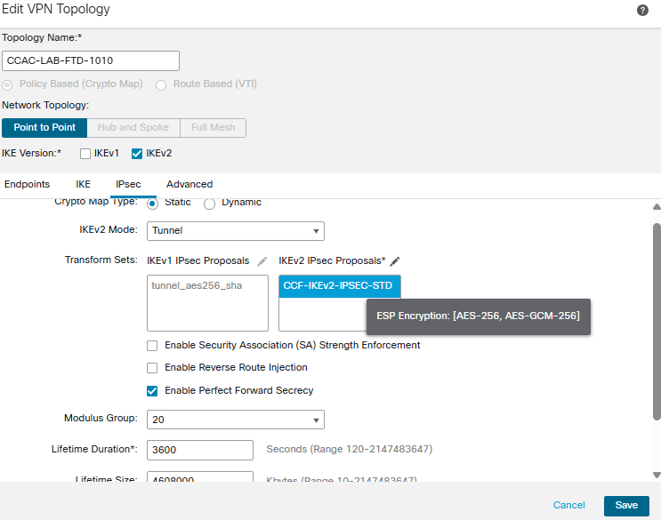
  - Advanced Settings
    - IKE – Default settings
    - IPsec – Default settings
    - Tunnel – Default settings
      - Select - Bypass Access Control policy for decrypted traffic (sysopt permit-vpn)
        - Decrypted traffic is subjected to Access Control Policy by default. This option bypasses the inspection, but VPN Filter ACL and authorization ACL downloaded from AAA server are still applied to VPN traffic.
Our Business FTD-3140 and Business Checkpoint FW’s will be performing the filtering for all VPN traffic. Trust rules are created for S2S VPNs, and no inspection is performed by our VPN FTD-3130.

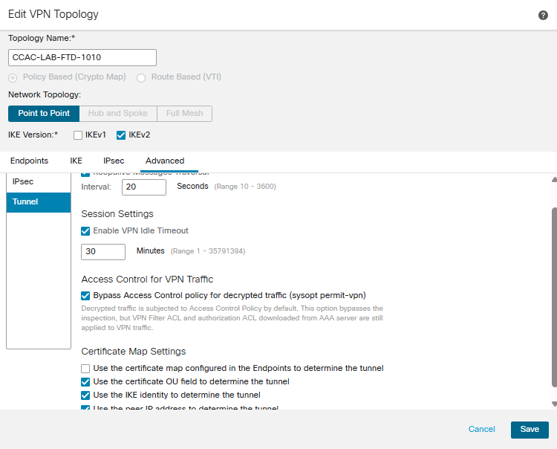

--------------------------------------------------------------------------------------------------------------------------------------------

Go To: Top

