### Avida-ED Lab Manual

**2015 Summer Workshop Version**

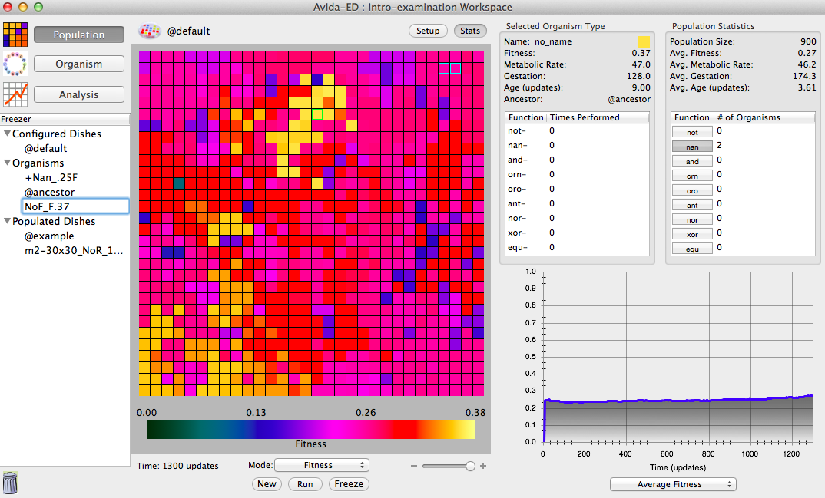

###### **Avidians**

**Avida-ED Project Team**

Wendy Johnson, Amy Lark, Louise Mead,   
Robert T. Pennock and Jim Smith  
<http://avida-ed.msu.edu>

**Preface**

This Avida-ED Lab Book contains a set of Avida-ED exercises that serve as the basis for a series of conference presentations and workshops presented by Michigan State University’s Avida-ED Project Team in the summer of 2015. These include:

* American Society for Microbiology Conference for Undergraduate Educators (ASMCUE), May 28-31, 2015, Austin, TX.
* 1st Avida-ED IUSE Train-the-Trainers Workshop, June 4-6, 2015, BEACON Center and Lyman Briggs College, Michigan State University, East Lansing, MI.
* HHMI/BioQUEST/SCN Conference, June 13-20, 2015, Harvey Mudd College, Claremont, CA.
* Joint annual meeting of the Society for the Study of Evolution (SSE), the Society of Systematic Biologists (SSB), and the American Society of Naturalists (ASN), June 26-30, 2015, Casa Grande Resort, Guarujá, Brazil.
* Western Conference for Science Education (WCSE), July 7-10, 2015, University of Western Ontario, London, ON, Canada.
* Undergraduate Biology Education Research (Gordon Research Conference), July 12-17, 2015, Bates College, Lewiston, ME.

The Lab Book itself is divided into two sections. The first section contains a set of materials used as a part of the Laboratory Curriculum in the Introductory Cell and Molecular Biology course (LB145) taught by Jim Smith at Michigan State University in the fall of 2014.

The second section in the Lab Book consists of materials from three additional Avida-ED exercises developed in conjunction with the Avida-ED Curriculum Development Group, “Exploring the Effects of Mutation Rate on Individuals”, “From Genotype to Phenotype: Understanding the Introduction of Phenotypic Variations”, and “Evolving TCE Biodegraders”. Student handouts are provided for each of these exercises, as are web links to more complete curricular materials.

In addition to the Avida-ED Project Team Members listed on the front cover of this Lab Manual, the group in summer 2015 now includes project PostDoc Michael Wiser and computer programmer Diane Blackwell. The work done by the group would not be possible without their contributions.

**Part I: Avida-ED Exercises from LB145 F14**

The first part of the Avida-ED Lab Book consists of Avida-ED Exercises used in slightly modified form in Jim Smith’s LB145 course in fall semester 2014. These are:

**Introduction - Avida-ED and Digital Evolution**

This introductory exercise is a modification of the Introduction to Digital Evolution Handout & Tutorial by Wendy Johnson et al. contained in the Hands-on Activity: Studying Evolution with Digital Organisms available via the TeachEngineering.Org website at <https://www.teachengineering.org/view_activity.php?url=collection/mis_/activities/mis_avida/mis_avida_lesson01_activity1.xml>

**Exercise 1. Understanding the Introduction of Genetic Variations by Random Mutation**

This exercise is a modification of the exercise of the same name originally produced by Amy Lark and Rob Pennock. Complete materials for this original lesson are available under the CURRICULUM link at <http://avida-ed.msu.edu>.

**Exercise 2. Exploring Fitness, Functions, and Selection**

This exercise is a modification of the exercise titled Exploring Selection and Fitness written by Amy Lark and Rob Pennock. Complete materials for this original lesson are available under the CURRICULUM link at <http://avida-ed.msu.edu>.

**Exercise 3. Exploring Mutations and Selection: Pre-adaptive or Post-adaptive?**

This exercise was newly developed for LB145 F14.

**Independent Research – Experimental Evolution Project with Evolving Digital Organisms**

This exercise is a modification of the exercise by the same name written by Rob Pennock and Amy Lark. Complete materials for this original lesson are available under the CURRICULUM link at <http://avida-ed.msu.edu>.

## Introduction - Avida-ED and Digital Evolution

## Avida-ED is adapted from Avida, a software platform created by a group of computer scientists and software engineers interested in the experimental study of digital organisms in order to better understand how biological evolution works. Both programs provide an instance of evolution in a model environment. The evolution itself is real; the digital organisms are subject to the same processes as biological organisms, like mutation and selection. Scientists can study how digital organisms evolve, and examine questions related to the evolution of complex features, sex, intelligence, cooperation, and foraging behavior. Avida has even been used to predict or verify the outcomes of ongoing biological experiments. This is possible because the process of evolution is “substrate neutral”, meaning that when a system possesses three key characteristics – variation, inheritance, and selection – evolution will inevitably result.

## Using this powerful tool, you will be able to design and perform your own experiments to test hypotheses about evolution in much the same way that researchers use Avida in the labs.

**Driving Questions**

* + What is Avida-ED (how does it work)?
  + What do biologists mean when they say the word “evolution”?
  + Can we observe evolution? How?
  + Can we study evolution by doing experiments? What kinds?
  + How is Avida a useful tool for biologists? What are the strengths and limitations of such an approach?

**Tasks**

1. Begin by reading the article by Carl Zimmer “Testing Darwin” that appeared in *Discover* Magazine in 2005. The article can be found immediately following this Introduction.

2. Download Avida-ED.

a. Go to <http://avida-ed.msu.edu/>.

b. Click on “App Download”.

c. Choose “Avida-ED Version 2.0 for Mac OS X 10.8 or greater”. This is Avida-ED 2.0 Build 41, which will be the version used for all summer workshop activities. (Note: You may choose an alternate version of Avida-ED for your own use, but your results may differ slightly.)

d. Click on “Download Avida-ED now”.

e. Open Avida-ED-2.0b41 and drag the Avida-ED icon to your desktop. Open the application.

3. Watch the Avida-ED video tutorial found in the support section of the Avida-ED website or on YouTube: <https://www.youtube.com/watch?v=Z4fLAzYaKwE> and use it to help you explore the application’s controls.

**Using Avida-ED**

The Avida-ED workspace includes:

1. The “Navigation” area (*view mode buttons*) allows you to switch among three modes:
   1. Population – the organisms evolving in the virtual Petri dish and the experimental set-up;
   2. Organism – displays the “genome” of any single individual; and
   3. Analysis – allows comparisons of population variables (e.g. average fitness) over time.
2. The “Freezer” (*saved materials*)
   1. Configured dishes – settings, no organisms;
   2. Organisms – individual organisms, including the “@ancestor”; can be saved by dragging or saving to the freezer; and
   3. Populated Dishes – settings and organisms saved by freezing populations.
3. Lab bench (*where things happen*)

When in “Population” mode, the Lab Bench contains a “Virtual Petri Dish”, which is the place where your Avidians will grown and multiply (Figure 1). You can access the settings by clicking on the “Set-Up” button (Figure 2). There, you can change the dish size (60x60 is default), mutation rate (2.0% is default), whether or not functions are rewarded (default is all nine rewarded), and other options.

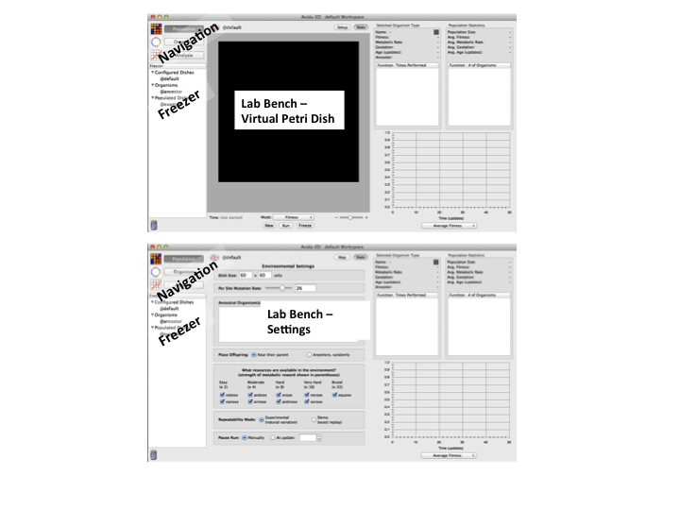

**Figure 1. A screen shot of Avida-ED panels.**

**Figure 1. Screen shot of the Avida-ED Workspace in the “Population” view.** The virtual Petri Dish is where Avidians will grow and divide. The “Navigation” and “Freezer” areas are on the left.



**Figure 2. Screen shot of the Avida-ED Lab Bench Setting in the “Population” view.** Several parameters of the experimental set-up can be manipulated.

To run an Avida-ED experiment, drag an organism from the freezer to the virtual Petri dish (if in Map view) or into the Ancestral Organism box (if in Setup view) and click “Run” in Map view. You can also choose “Run” under the Control pull down menu at the top of the screen. To start a new experiment in the population view, choose “Start New Experiment” under the control pull down menu. NOTE: Loading the organism into the “Ancestral Organism Box” in “Setup” assures that the individual will be placed in the center of the virtual Petri dish.

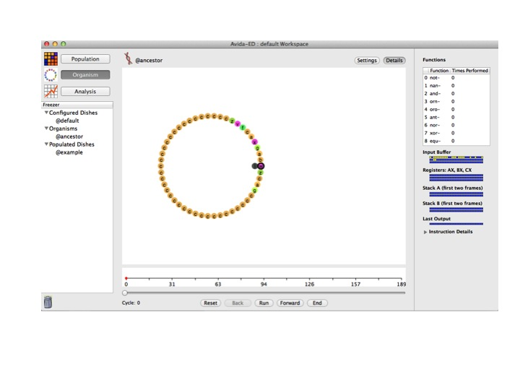

**Figure 3. Screen shot of the Avidian “@ancestor” in the “Organism” view.** The genome is circular and represented by colored letters. Each letter is a specific command. Notice that most of the instructions in “@ancestor” are tan-colored C’s (these are “no operation” commands and here essentially serve as placeholders).

**Part I: Examining an Avidian Individual and Observing Replication**

The digital organisms in Avida are referred to as Avidians, and are defined by a series of commands, including instructions for replication (Figure 3).During an experiment,the Avida-ED application reads the “genome” of an organism and carries out the commands, which are symbolized by letters. The default organism (“@ancestor”) has a circular genome of 50 letters, which includes instructions for replication.

Follow the steps below to observe Avidian replication.

1. Click on “Organism” in the Navigation panel. The lab bench becomes an empty rectangle with a set of buttons at the bottom.
2. Drag the default organism (@ancestor) from the freezer panel to the lab bench area. A set of circles with letters inside them appears (see Figure 3).
3. Click the “Run” button and observe as the organism’s code is read by Avida-ED. At a certain point, you will notice that the organism replicates. Press, “Reset” and repeat this step a number of times. You can observe the code being read and replicated more slowly by clicking on the “Forward” button, which moves the read head forward one instruction at a time.

***Once you have observed a number of “Runs”, please respond to the following questions by entering your responses in the “Avida-ED Introduction Quiz”.***

* At which position of the Avidian “genome” does the program begin reading the instructions?
* At which positions of the “genome” are the instructions for replication?
* What do you think would happen if a mutation occurred in the replication instructions?
* If you wanted to determine the function of each letter (command) of the code, where would you find that information??
* How does the offspring Avidian compare to its parent? In other words, how many differences are there in the set of 50 commands, and where are the differences located in the “genome”?
* How is the instruction set (“genome”) for an Avidian similar to a bacterial genome?

**Part II: Observing the Frequency and Location of Mutations that Occur During Replication**

1. Under Settings (still in Organism view), find the mutation rate that you used above, and record it.
2. Next, if it isn’t already, set the per site mutation rate to 2% by moving the slider or typing “2%” in the box. If you use the slider to change the mutation rate, look carefully at the placement of the decimal to verify you have set it to 2% and not 0.20%. Also, be sure to press, “enter”, and verify that the slider actually moved to 2.0%.
3. Click the arrow again to return to the genome view.
4. Then click play or drag the slider to watch the organism run through its code.

***Please respond to the following questions by entering your responses in the “Avida-ED Introduction Quiz”.***

* There are 50 commands. How many sites do you expect will have a mutation given a 2% per site mutation rate?
* How does your replicated offspring compare to the parent? (Note- mutated instructions have a green outline).
* How did your offspring (replicated with the 2% mutation rate) compare to your neighbor’s offspring (also replicated with a 2% mutation rate)? Did they have the same number and/or type of mutations?

**Storing an Avidian Individual in the Freezer**

1. Click and drag the offspring genome into the Freezer Panel. Avida-ED will ask you to open an existing workspace or create a new one. Choose “create new workspace” and give it a name. Make sure you save the workspace folder someplace where you can find it later.
2. Then you will be prompted to “enter name of organism to freeze.” You may use any name you like, but we suggest something descriptive, perhaps indicating the mutation rate.

**Part III: Evolving a Population**

Avidians replicate in the virtual Petri dish, much the way bacteria replicate when plated on a medium. The virtual dish is divided into a grid in which each box holds one Avidian. When an Avidian replicates, the offspring are placed in a box adjacent to the parent (the default setting) or randomly on the grid. As we have seen above, if there is mutation, offspring will not be exactly like the parent.



**Figure 4. Screen shot of the panels displaying population and individual statistics.** The upper right panel shows basic population statistics, plus how many individuals in the population perform each function. The panel just to its left does the same for a selected individual. The lower panel graphs a number of population parameters as the run progresses.

Carrying out the set of numbered tasks below will result in the growth of an Avidian population, with each individual in that population having descended from a single ancestral Avidian. At the end of the run, you will save the Petri plate containing your Avidians to the Freezer, as well as saving a single Avidian with relatively high fitness.

1. Click on “Population” in the navigation panel. The lab bench changes back to the Petri dish.
2. Click on Setup. Drag the default organism (@ancestor) from the freezer panel into “Ancestral Organism” box. Set the world size to 30 x 30 cells and the per site mutation rate to 2.0%. Place offspring near their parent. Turn off all resources (i.e., notose, nanose, etc.) by clicking in the box so that it is not checked. [Note: resources, when made available, provide additional energy to Avidians that evolve the ability to use these resources.]
3. Click “Map” to return to the Petri dish view. In the drop down menu below the Petri dish, choose “Fitness”. Use the +/- slider below the Petri dish to increase the view size.
4. Push the Run button below the Petri dish and watch as the ancestor and subsequent descendants start multiplying. Each grid square represents an organism.
5. As you watch the Avidians multiply, notice that the information in the Population Statistics box and the graph change. When the dish looks full, click to stop the growth in the Petri dish.
6. Click on an organism (a grid square). The information for the Avidian in this grid square appears in the Selected Organism Type panel (Figure 4). Click on a few other organisms and notice how their information differs. You may click on different individuals during the run to observe their characteristics in the organism information box.
7. Information on the population is displayed in the Population Statistics panel, and in the graph below this panel. Click the play button again and observe the dish and the population statistics boxes as the run proceeds.
8. Pause the run when there have been about 1,000 updates (unit of time for Avida-ED). Before proceeding with the next step, save the entire plate by clicking the Freeze button at the bottom and saving the population to the Freezer. We recommend using a labeling system that keeps track of the mutation rate and world size (i.e., m2-w30x30-number of updates, but you can use any naming system that makes sense to you).
9. Click on individual organisms, one at a time, to find an individual with a high fitness. To do this, use the fitness scale below the Petri dish, as well as looking in the organism info panel for each organism.
10. Drag an organism with a relatively high fitness to the freezer panel. In the box, type a name for this organism followed by the fitness value.

***Please respond to the following questions by entering your responses in the “Avida-ED Introduction Quiz”.***

* What do biologists mean when they use the word “fitness”? How is fitness measured in Avida-ED?
* Calculate fitness for two Avidians in your population.
* Based on what you observed in the Population Statistics and the Organism Type boxes during the run, what do you think accounts for changes in individual fitness and changes in the average fitness in the population?

***Some additional details and questions about Avida-ED and Avidians: please respond to the following questions by entering your responses in the “Avida-ED Introduction Quiz”.***

* Occasionally you will freeze an organism in Avida-ED only later to find out that it cannot replicate itself. Based on what you know about the nature of random mutation, can you explain the fact that some organisms would be incapable of reproduction?
* In Avida-ED, a selected organism is displayed with its parent’s fitness. Knowing this, how certain are you of the fitness value of the particular individual you saved? What could cause an individual to have a fitness value different than its parent?

**Exercise 1 - Understanding the Introduction of Genetic Variations by Random Mutation**



**An Avidian in the process of replication**

**Background**

The basic components of the Darwinian evolutionary mechanism are variation (V), inheritance (I), natural selection (S) and time (T). This exercise focuses on variation and one basic way it can be introduced into populations.

Natural selection acts upon phenotypic variations in a population of organisms. Variations can arise in a population in several different ways. Here we will look only at variations that may be introduced by genetic *mutations*—random changes in an organism’s genome—and not at other processes such as recombination, horizontal transfer, etc. Genetic mutations may be substitutions (changes from one instruction to a different one), insertions (additions of an instruction into the genome), or deletions (deletions of an instruction from a genome). [Note: For simplicity, this version of Avida-ED allows only substitutions, not insertions or deletions.]

As in nature, a population of Avidians—the model organisms in Avida-ED—can vary both phenotypically (in terms of the functions they can carry out) and genotypically (in terms of the instructions of code). Like bacteria, Avidians have a circular genome composed of simple genetic instructions. Different genetic sequences can produce different phenotypic functions. Each instruction (command) in the sequence is represented by a colored circle with a letter inside of it. During Avidian replication, mutations may occur at random in the sequence.

**Making Mutant Avidians**

Your goal in this exercise is to understand *how* mutations produce variation and, specifically, what it means to say that mutations in Avidians occur at “random”. We will then explore how these random mutations play a role in evolutionary processes.

**Use the Organism Viewer to observe how substitution mutations change the genomes of organisms.**

1. In the Organism viewer, go to settings.
2. Set the per site mutation rate to 10%. Keep repeatability mode set to Experimental.
3. Drag the “@ancestor” from the freezer.
4. Click “Run” to observe replication.
5. Record your data.
   1. Use the sequence template below to record the position, type of change, and total # of changes in the offspring’s genome.
      1. Do this in clockwise order starting from the 3 o’clock position on the circular genome (W in the ancestor), which is the origin of replication.

**Run #1:** ______ % Mutation Rate. Mark differences from the ancestral genome.

Wzcagcccccccccccccccccccccccccccccccccccczvfcaxgab

1 10 20 30 40 50

Total # of mutated sites _______

Location(s) of mutated sites _________________

1. Compare your offspring organism (replicated with the 10% mutation rate) to your neighbor’s offspring (also replicated with a 10% mutation rate.

***As an individual, please respond to the following questions by entering your responses in the “Avida-ED Exercise 1 Quiz”.***

* Does your neighbor have the same number and/or type of mutations? How can you account for any differences?
* What do you ***expect*** to see if you repeat this using the same ancestor with the same mutation rate?
  + Do you think the *specific* mutations will be the same? Explain your reasoning.
  + Do you think the *number* of mutations always be the same? Explain your reasoning.

**Testing your prediction.** AFTER you have written down your predictions above, repeat the process of replicating the ancestor twice more. For each run, record your results below.

**Run #2:** ______ % Mutation Rate. Mark differences from the ancestral genome.

Wzcagcccccccccccccccccccccccccccccccccccczvfcaxgab

1 10 20 30 40 50

Total # of mutated sites _______

Location(s) of mutated sites _________________

**Run #3:** ______ % Mutation Rate. Mark differences from the ancestral genome.

Wzcagcccccccccccccccccccccccccccccccccccczvfcaxgab

1 10 20 30 40 50

Total # of mutated sites _______

Location(s) of mutated sites _________________

**Recording your data.** We will be exploring the data generated by the entire group in all of their runs. Instructions for entering your data from each of your three runs will be distributed in your workshop session.

***Discussion Questions and Wrap-up.*** *After you’ve explored the class data, please work with your lab team to respond to the following questions. Enter your responses (one set per lab team) into the* ***“Avida-ED Exercise 1 Quiz”.***

* Did everyone in the class get the same number and type of mutations?
* What does the distribution of everyone’s data look like?
* How do you explain this?
* What are the implications for the role of mutations in creating variation in a population?

**Exercise 2 - Exploring Fitness, Functions, and Selection**

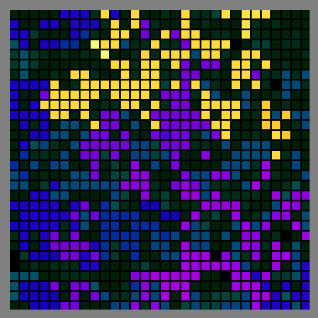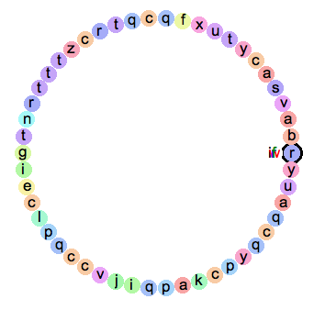

Selection acts on individual variation within a population, resulting in differential fitness.

**Driving Question**

How does selection act on individual variation to produce differential fitness in a particular environment?

**Fitness, Functions, and Selection**

Individual variation is the result of random genetic mutations during genome replication. Variants that are better suited to the environment tend to have greater reproductive success. Advantageous traits are thereby selected by the environment and become more prevalent as individuals possessing those traits tend to leave behind more offspring. These individuals are fitter than organisms lacking the advantageous traits. If selection is strong enough, these advantageous traits will go to fixation, meaning that they will be present in every individual in the population. An individual’s fitness is therefore dependent upon the interaction between its traits and the environment, and is relative to other individuals in the population.

As you have seen, Avidians are capable of carrying out different instructions, which in turn can allow an Avidian to perform a specific function. For our purposes here, it is probably simplest to keep these abstract, knowing simply that these are logic functions. There are nine possible functions that an Avidian can carry out: *not, nan, and, orn, oro, ant, nor, xor, equ*. The ancestor is not capable of carrying out any of these functions, but mutations can change the genome and offspring can evolve these functions. The ability to perform one of these functions can increase the fitness of an individual. As you have seen, there are resources that correspond to each of these functions: *notose, nanose, andose, ornose, orose, antose, norose, xorose, equose*. If an Avidian has evolved the ability to carry out one of these functions, and the corresponding resource is in the environment, the individual gains some processing speed, thereby becoming more fit.

In comparing evolution in Avida to evolution in bacteria, the Function/Resource pairing is analogous to putting a particular food source in bacterial media so that it increases growth and reproduction. Alternatively, if drawing the analogy to antibiotic resistance, bacteria are able to survive in the presence of an antibiotic because they have some form of resistance to the effects of the antibiotic in much the same way that an Avidian is better able to outcompete its neighbors if it has evolved a function (assuming the corresponding resource for that function is present in the environment).

In this exercise you will perform a set of two experiments to explore relationships between variation, selection, and fitness. In the first experiment, you will evolve and freeze individual Avidians that have evolved for 1000 updates in the absence and presence of a reward for the ability to perform the logic function, *not*. These organisms will then be competed with each other, in environments both without and with rewards for *not*. Whom do you think will win in each case? Why?

In the second experiment, we will explore the concept of an allele, genotype, or phenotype becoming more frequent in a population as a function of its environment. Will *not* become more frequent in a population if it is rewarded? Why? What does it mean to say that *not* has gone to fixation in a population?

**Experiment 1. Competing individuals evolved in the presence or absence of a reward for *not*.** The following experiment consists of four Avida-ED runs. At the end of Runs 3 & 4, you will be asked to answer a set of questions, which you should respond to as a part of your Exercise 2 Avida-ED Quiz.

**Run 1 - Evolve a population from the @ancestor, with all resources turned off. Select an individual with high fitness.**

1. In the Population viewer, flip to Setup.
2. Set the following parameters: World size 30x30; 2% Mutation Rate; Drag @ancestor into Ancestral Organism box; Place offspring near parent; Turn off all resources; Repeatability Mode Experimental; Pause Run after 1000 updates.
3. Return to Map view and Run.
4. Once 1000 updates have completed, use the Fitness Scale and the Organism Box to identify an individual with a relatively high fitness.
5. Freeze this individual (refer to Introduction).
6. Freeze the plate (refer to Introduction).
7. Verify that the individual you saved is capable of reproducing by switching to Organism View and dragging the saved individual to the window and running through its code.
8. If for some reason the individual has a mutation in the replication region, go back to the Population and save another individual with relatively high fitness.

**Run 2 - Evolve a population from the @ancestor, with only NOT turned on. Select an individual with high fitness.**

1. Under the Control Menu, “Start a new experiment”.
2. In the Population viewer, flip to Setup.
3. Set the following parameters: World size 30x30; 2% Mutation Rate; Drag @ancestor into Ancestral Organism box; Place offspring near parent; Turn on Notose, leave all other resources off; Repeatability Mode Experimental; Pause Run after 1000 updates.
4. Return to Map view and Run.
5. Once 1000 updates have completed, use the Fitness Scale and the Organism Box to identify an individual with relatively high fitness ***that can perform not***.
6. Freeze this individual (refer to Introduction).
7. Freeze the plate (refer to Introduction).
8. Verify that the individual you saved is capable of reproducing by switching to Organism View and dragging the saved individual to the window and running through its code.
9. If for some reason the individual has a mutation in the replication region, go back to the Population and save a different individual with relatively high fitness ***that can perform not***.

**Run 3 - Competing Evolved Individuals in the Absence of Reward**.

1. Under the Control Menu, “Start a new experiment”.
2. In Population viewer, go to Setup and set up experiment with the following: Dish size 60x60; 2% mutation rate; Place both the Avidians evolved in NoReward and Notose-Only in the Ancestral Organism window; Turn off all rewards; Repeatability Mode is Experimental. Pause run manually.
3. Return to Map.
4. Record the following information.
   1. Starting fitness of Avidian evolved in NoReward environment.
   2. Starting fitness of Avidian evolved in Notose-Only environment.
5. Select Ancestral Organism in the “Mode” Drop down menu.
6. Press Run.
7. Pause after 150, 500, and 1000 updates.
   1. Record the relative frequencies of the NoReward and Notose-Only descendants in each case.

***Please respond to the following questions by entering your responses in the Avida-ED Exercise 2 Quiz.***

* In this run, what was the starting fitness of the Avidian evolved in the NoReward environment? What was the starting fitness of the Avidian evolved in Notose-Only environment?
* Assuming the individual with the higher fitness is better at surviving and reproducing, what would you expect the frequency of descendants from these two individuals to be after running the experiment for 150, 500 and 1000 updates?
* What were the relative frequencies of NoReward descendants at 150, 500, and 1000 updates? Did everyone in the class get the same result?
* What conclusions can you draw from these observations?

**Run 4 - Competing Evolved Individuals in the Presence of Notose**.

*Repeat Run 3 with the same set of initial settings, with the sole exception that in this trial you will* ***turn on*** *the Notose resource.*

***Please respond to the following questions by entering your responses in the Avida-ED Exercise 2 Quiz.***

* In this run, what was the starting fitness of the Avidian evolved in the NoReward environment? What was the starting fitness of the Avidian evolved in Notose-Only environment?
* Assuming the individual with the higher fitness is better at surviving and reproducing, what would you expect the frequency of descendants from these two individuals to be after running the experiment for 150, 500 and 1000 updates?
* What were the relative frequencies of NoReward descendants at 150, 500, and 1000 updates? Did everyone in the class get the same result?
* What conclusions can you draw from these observations?

**Experiment 2. Exploring the concept of alleles or genotypes going to fixation.** The following experiment consists of two Avida-ED runs. At the end of the two runs, you will be asked to answer a set of questions, which you should respond to as a part of your ***Exercise 2 Avida-ED Quiz***.

**Run 1. Frequency of *not* in the absence of reward.**

1. Under the Control Menu, “Start a new experiment”.
2. In “Setup”, choose the following options: Dish size 30x30; 0.2% mutation rate **[NOTE: MUTATION RATE SHOULD NOW BE 0.2% INSTEAD OF 2%]**; Drag your Notose-Only evolved Avidian from the Freezer to the Ancestral Organism window; Turn off all rewards; Experimental setup; Pause Run at 1000 updates.
3. Return to Map.
4. Set Mode to ancestral.
5. Press Run.
6. Watch how the number of individuals in the dish performing *not* changes.
7. Record after 2000 updates the population size, the number of individuals that are performing *not*, and the percentage of the population that is performing *not*.

**Run 2. Frequency of *not* in the presence of reward.**

*Repeat Run 1 with the same set of initial settings, with the sole exception that in this trial you will* ***turn on*** *the Notose resource.*

1. Again, watch how the number of individuals in the dish performing *not* changes.
2. Record after 2000 updates the population size and number of individuals in the population that are performing *not*.

**Record your data.** We will be exploring the data generated by the entire group in each of their two runs. Record your data in the Table below, as well as in the class data collection instrument. Instructions for entering the data from each of your runs into the instrument will be distributed in your workshop session.

**Table. Frequency of not in populations with and without notose rewards**

|  |  |  |
| --- | --- | --- |
|  | w/ notose turned OFF | w/ notose turned ON |
| Population Size |  |  |
|  |  |  |
| # performing *not* |  |  |
|  |  |  |
| % performing *not* |  |  |

**Discussion Questions and Wrap-up.** After you’ve explored the class data, please respond to the following questions by entering your response into the **Avida-ED Exercise 2 Quiz**.

* How does the frequency of individuals performing *not* compare in the absence of reward and in the presence of reward?
* Did your classmates obtain similar results?
* Describe a mechanism that could provide an explanation for the pattern you observed.

**Exercise 3 - Exploring Mutations and Selection: Pre-adaptive or Post-adaptive?**



Only one individual in this Avidian population can   
perform *not*. Did *not* evolve because it was needed?

**Driving Question**

When do mutations arise that can confer a selective advantage relative to the presence of a selective agent?

**Luria, Delbrück and Directed Mutations**

Before scientists understood the role of DNA, scientists hypothesized that bacteria could develop heritable genetic mutations depending on the circumstances or environment in which the bacteria resided – in other words, mutations were thought to be *directed*, or post-adaptive – when exposed to a particular selective pressure, bacteria were thought to be able to generate mutations that would allow them to respond to these environmental pressures and changes.

To test if mutations were random (pre-adaptive) or directed (post-adaptive), two scientists (Salvador Luria and Max Delbrück) devised an elegant experiment that allowed them to differentiate between these two scenarios. We can investigate this same question in Avida-ED.

In this exercise you will perform an experiment with two runs to explore the relationship between the time of appearance of a mutation in a population and the presence or absence of a selective agent (advantage). In the first run, you will monitor your run to determine at what update the first individual to perform *not* appears in the population. Next, you’ll do the same thing in a run where *not* is rewarded. Do you think the individual performing *not* will appear earlier or later in the second run? Why?

**Experiment 1. Does a mutation occur in response to a reward for that mutation?**

**Run 1 – First appearance of not with all resources turned off.**

1. In the Population viewer, flip to Setup.
2. Set the following parameters: World size 30x30; 2% Mutation Rate; Drag @ancestor into Ancestral Organism box; Turn off all resources. Place offspring near parent; Repeatability Mode Experimental; Pause manually.
3. Return to Map view and click on Run.
4. Pause your Run at the first occurrence of an organism that can perform the function, *not*. (Note: you’ll need to watch closely and be very quick on the Pause button!!)
5. Record the Update number at this occurrence.

**Run 2 - First appearance of not with *notose* turned on.**

1. In the Population viewer, flip to Setup.
2. Set the following parameters: World size 30x30; 2% Mutation Rate; Drag @ancestor into Ancestral Organism box; Turn on *notose*; Place offspring near parent; Repeatability Mode Experimental; Pause manually.
3. Return to Map view and click on Run.
4. Pause your Run at the first occurrence of an organism that can perform the function, *not*. (Note: you’ll need to watch closely and be very quick on the Pause button!!)
5. Record the Update number at this occurrence.

**Record your data.** To allow us to explore the class data, record your data in the class data collection instrument. Instructions for entering the data from each of your runs into the instrument will be distributed in your workshop session.

**Discussion Questions and Wrap-up.** After you’ve explored the class data, please respond to the following questions by entering your responses in the ***Avida-ED Exercise 3 Quiz****.*

* What’s the point of this exercise?
* Did the first occurrence of your mutation happen earlier, later, or at the same time in Run 1 compared to Run 2?
* Is this also true of the class as a whole?
* What would you have expected to see happen if mutations occur in response to the presence of a selective environment?
* Given the data you’ve seen, when do you think mutations arise that can confer a selective advantage relative to the presence of a selective agent?

**Independent Research - Experimental Evolution Project with Evolving Digital Organisms**

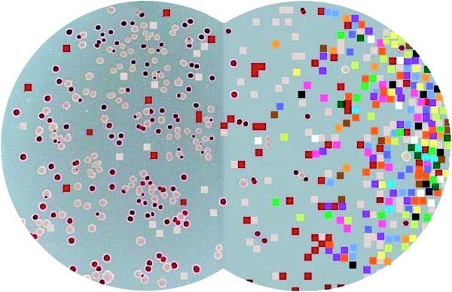

Two model systems: *E. coli* is on the left, while   
Avidians (digital organisms) are on the right.

**Background**

Some evolutionary biologists, such as Richard Lenski at Michigan State University, conduct experiments using microorganisms like *E. coli* to answer fundamental questions about evolutionary processes. Bacteria are useful model organisms because they replicate quickly and their small size means that they don’t take up much space in the laboratory. Lenski’s work with *E. coli* has helped shed light on some important aspects of evolution and, having spanned 25 years and over 60,000 bacterial generations, it is the longest-running investigation of its kind.

As far as biological organisms go, *E. coli* replicates—and evolves—at an incredibly fast rate. Even so, *E. coli* grows too slowly to be of practical use in addressing many questions about evolution. To pursue such questions, scientists can use digital organisms that model biological systems. Avida is such a model system, and is used by researchers to study evolutionary processes and even to find solutions to engineering problems.

In this workshop session, your research team will perform experiments using digital organisms in Avida-ED to answer an evolutionary question. The question is up to you; your team will propose a hypothesis and then design an experiment that you will carry out to answer your question. The final product of your work will be a poster that your team will present to your peers for your final presentation.

***Research Tasks***

**Hypothesize:** Propose a hypothesis to an evolutionary question that can be tested using Avida-ED. Some parameters to explore are mutation rate, world size, and the presence and absence of rewards in the digital environment.

**Design your experiment:** Develop an experimental plan that your team will follow to test your hypothesis. You should consider relevant variables, what data to collect, and how many replicates you will need.

**Predict:** Indicate what experimental outcomes you would expect to find if indeed your hypothesis is true.

**Write up a Proposal Brief:** Write up a “brief” summarizing your team’s proposed research project. This should be 1-2 pages long and emphasize those items listed above. (In addition, tell the reader why the experiment is cool!)

**Present your Proposal:** As a team, prepare a PowerPoint, KeyNote, or Prezi presentation that you present to the group. This should consist of six slides, with each team member presenting one or two of the slides.

**Conduct your experiment:** Carry out your proposed research and record the appropriate data.

**Analyze your data:** Summarize your data and perform appropriate statistical tests (chosen in consultation with the teaching team). Decide how best to represent your data and create appropriate tables and/or graphs.

**Report your findings:** Put together a poster for the final presentation. The poster should include: (i) introductory background information and a statement of your hypothesis; (ii) methods; (iii) results and conclusions; and (iv) future directions.

**Avida-ED Independent Research Project**

**Proposal and Proposal Presentation - Guidelines and Expectations**

**(20 points Total)**

**Proposal (15 points)**

Write up a *brief* summarizing your team’s proposed research project. The following sections must be included:

**Question.** Describe the evolutionary question that your team has. Why is it interesting and cool?

**Hypothesis.** Frame and present a hypothesis that will allow you to test your evolutionary question using Avida-ED.

**Experimental Design.** Develop an experimental plan that your team will follow to test your hypothesis. Describe relevant variables, what data you intend to collect, and how many replicates you will carry out.

**Predict:** Indicate what experimental outcomes you would expect to find if indeed your hypothesis is true.

**Rubric for Grading the Proposal**

***Three points each awarded for:***

1. The question your team is asking and why your team chose it.

2. Your team’s hypothesis, stated formally.

3. The description of the experimental methods to be employed in your study.

4. How you will analyze and interpret your results, depending upon what they are. In other words, what conclusions will be drawn, depending on the outcomes of your experiments?

5. Overall structure and presentation of the written document. Is it logical and clear, etc.

Points will be awarded in each area based on the quality and the completeness of the write-up.

**Avida-ED Proposal Presentation (5 points)**

**Teams should create a set of 6 pptx slides.**

***1. Title slide (Student “A”)***

* Introduces the team and its members; shows project title

***2. Introduction (Student “A”)***

* Describes the team’s original question and their study system
* Tells audience why it’s interesting (why do I care?)
* Provides some of background (from the literature?)

***3. Hypothesis (Student “B”)***

* Shows and explains the team’s Experimental Hypothesis and why it is a high quality hypothesis

***4. Experimental Methods (Student “C”)***

* Describes the experimental methods to be employed in the study

***5. Predictions (Student “B”)***

* Describes what you predict you will see if your hypothesis is correct

***6. Data Analysis (Student “D”)***

* Shows what data resulting from the experiment might look like, and how the team will interpret them in the light of their hypothesis

**Part II: Additional Avida-ED Exercises**

The following pages contain three additional Exercises for possible classroom use with Avida-ED. These are:

**A. Exploring the Effects of Mutation Rate on Individuals**

Student handout from Amy Lark’s exercise based on the Fukushima nuclear reactor disaster in the wake of the 2011 Japanese earthquake and tsunami. This natural disaster provided scientists with a natural experiment to explore the effects of mutation.

More complete lesson materials are available under the CURRICULUM link at <http://avida-ed.msu.edu>.

**B. From Genotype to Phenotype: Understanding the Introduction of Phenotypic Variations**

Student handout from Rob Pennock’s exercise helping students to understand that there are may be multiple independent pathways leading to a particular complex phenotype.

More complete lesson materials are available under the CURRICULUM link at <http://avida-ed.msu.edu>.

**C. Evolving TCE Biodegraders**

Student handout from Wendy Johnson et al.’s activity in which student teams try to evolve a bacterium capable of degrading an environmental contaminant.

More complete lesson materials are available via the TeachEngineering.Org website at

<https://www.teachengineering.org/view_activity.php?url=collection/mis_/activities/mis_avida/mis_avida_lesson01_activity2.xml>.