|  |
| --- |
|  |

Improving Greenhouse Health using a Smart Monitoring System

Submitted by: Daniel Bujold

Discipline: Computer Engineering Technology

Date: January 15, 2020

Status

/1 Hardware present?

/1 Title Page

/1 Declaration of Joint Authorship

/1 Proposal (500 words)

/1 Executive Summary

# Declaration of Joint Authorship

We, Ryan, Aiden, and Daniel, confirm that this work submitted is the joint work of our group and is expressed our own words. Any uses made within it of the works of any other author, in any form (ideas, equations, figures, texts, tables, programs), are properly acknowledged at the point of use. A list of the references used is included. The work breakdown is as follows: Each of us provided functioning, documented hardware for a sensor or effector. Ryan provided the BME 680 for gas and humidity. Aiden provided the DS18B20 for temperature. Daniel provided the EK1940 for capacitive soil moisture. In the integration effort Aiden is the lead for further development of our Mobile Application, Daniel is the lead for the Hardware, and Ryan is the lead for connecting the two via the Database.

# Proposal

This project solves the need for an improved greenhouse monitoring system in the Humber Nurseries. Such a system would be vital in ensuring the optimal health of the plants. This system will enable employees to view and monitor greenhouse conditions in real-time. Data acquisition will help with adjusting the environment and future planning. Theoretically, this system will improve plant health, increase yield, decrease resource use, and minimize human error.

We have created a mobile application, worked with databases, and prototyped a small embedded system with a custom PCB as well as an enclosure (3D printed/laser cut). Our Internet of Things (IoT) capstone project uses a distributed computing model of a smart phone application, a database accessible via the internet, an enterprise wireless (capable of storing certificates) connected embedded system prototype with a custom PCB as well as an enclosure (3D printed/laser cut), and are documented via this technical report targeting OACETT certification guidelines.

Intended project key component descriptions and part numbers:  
Development platform: Broadcom (Raspberry Pi 4)  
Sensor/Effector 1: BME 680 gas sensor  
Sensor/Effector 2: DS18B20 temperature sensor  
Sensor/Effector 3: EK1940 capacitive soil moisture sensor

The solution consists of a Broadcom development platform (Raspberry Pi 4) connected to the sensors/effectors listed above. This system will generate readings from these sensors and store them in a database. The database will store . The device will be connected to WiFi in order to send and receive data. These readings will then be viewable from within the mobile app. The mobile device functionality will include The system will also be configured to automatically maintain the greenhouse environment. It will control the various effectors based on sensor readings in order to keep the conditions within given parameters.

Our project description/specifications will be reviewed by, Valeria from the Humber Nurseries, ideally an employer in a position to potentially hire once we graduate. They will also ideally attend the ICT Capstone Expo to see the outcome and be eligible to apply for NSERC funded extension projects. This typically means that they are from a Canadian company that has been revenue generating for a minimum of two years and have a minimum of two full time employees.

The small physical prototypes that we build are to be small and safe enough to be brought to class every week as well as be worked on at home. In alignment with the space below the tray in the Humber North Campus Electronics Parts kit the overall project maximum dimensions are 12 13/16" x 6" x 2 7/8" = 32.5cm x 15.25cm x 7.25cm.

Keeping safety and Z462 in mind, the highest AC voltage that will be used is 16Vrms from a wall adapter from which +/- 15V or as high as 45 VDC can be obtained. Maximum power consumption will not exceed 20 Watts.

# Executive Summary

This report presents a system for “smart” monitoring greenhouse conditions. The system consists of a mobile application, embedded system, and a database. The user will be able to view greenhouse conditions from within the app and make adjustments to the various control systems. When users are not actively monitoring, the system will have parameters in place to automatically maintain conditions.

This system is very beneficial to organizations with a large volume of greenhouse space. It will help improve plant health, increase yield, decrease resource use, and minimize human error. As a result, this will lead to greater productivity and reduced costs. It will also provide the same benefits to small scale users or hobbyists.

Greenhouses are used across the world for many industries including: food/vegetable, floriculture, retail garden centers, and science/teaching. Given such a wide spread of uses, it is apparent that there is much potential in this space for innovation and profit.

Our system is at the forefront of this innovation and will help modernize the industry.

Contents

Declaration of Joint Authorship 2

Proposal 2

Executive Summary 2

List of Figures 2

1.0 Introduction 2

1.1 Scope and Requirements 2

2.0 Background 2

3.0 Methodology 2

3.1 Required Resources 2

3.1.1 Parts, Components, Materials 2

3.1.2 Manufacturing 2

3.1.3 Tools and Facilities 2

3.1.4 Shipping, duty, taxes 2

3.1.5 Time expenditure 2

3.2 Development Platform 2

3.2.1 Mobile Application 2

3.2.2 Image/firmware 2

3.2.3 Breadboard/Independent PCBs 2

3.2.4 Printed Circuit Board 2

3.2.5 Enclosure 2

3.3 Integration 2

3.3.1 Wireless Connectivity 2

3.3.2 Database Configuration 2

3.3.3 Security and Testing 2

4.0 Results and Discussions 2

5.0 Conclusions 2

6.0 References 2

7.0 Appendix 2

7.1 Firmware code 2

7.2 Application code 2

# List of Figures

Figure 7. By Android Studio - https://developer.android.com/studio/, CC BY-SA 4.0, https://commons.wikimedia.org/w/index.php?curid=74094999 2

Figure 1. Initial schematic. This work is a derivative of "http://fritzing.org/parts/" by Fritzing, used under CC:BY-SA 3.0. 2

Figure 2. This work is a derivative of "http://fritzing.org/parts/" by Fritzing, used under CC:BY-SA 3.0. 2

Figure 3. Breadboard prototype. 2

Figure 4. PCB design This work is a derivative of "http://fritzing.org/parts/" by Fritzing, used under CC:BY-SA 3.0. 2

Figure 5. Humber Sense Hat Prototype PCB. 2

Figure 6. Example enclosure. 2

# 1.0 Introduction

Idea. Self-driving cars using Machine Learning. Scope and Requirements specification. Project Schedule.

## 1.1 Scope and Requirements

Describe what will be done. It is an Internet of Things (IoT) capstone project that uses a distributed computing model of a smart phone application, a database accessible via the internet, an enterprise wireless (capable of storing certificates) connected embedded system prototype with a custom PCB as well as an enclosure (3D printed/lasercut), and is documented via an OACETT certification acceptable technical report. Also describe the limits of the project and what will not be done (CSA testing) in this project. Include the development platform specifications and any other hardware specifications possibly organized in point form, the Android device requirements, and database specifications/protocols.

Report

/1 Hardware present?

/1 Introduction (500 words)

/1 Scope and Requirements

/1 Background (500 words)

/1 References

# 2.0 Background

We would like to thank mentor Diego Magalhães from AWS for supporting this project. This section is to include at least three references, here is an example of an APA citation of a website (OACETT, 2017) followed by a sentence citing an Article in a Periodical, a Book, and a Journal Article. Humber is planning to host an internal DeepRacer event using an existing example of machine learning (Robuck, 2018), artificial intelligence (Media, O., 2019), and internet connected servers (Kinsella, 2019).

# 3.0 Methodology

## 3.1 Required Resources

Report

/1 Parts/components/materials (500 words)

/1 PCB, case (500 words)

/1 Tools, facilities (500 words)

/1 Shipping, duty, taxes (250 words)

/1 Working time versus lead time (250 words)

### 3.1.1 Parts, Components, Materials

### 3.1.2 Manufacturing

### 3.1.3 Tools and Facilities

### 3.1.4 Shipping, duty, taxes

### 3.1.5 Time expenditure

Working time versus lead time.

## 3.2 Development Platform

### 3.2.1 Mobile Application

Status

/1 Hardware present?

/1 Memo by student A + How did you make your Mobile Application? (500 words)

/1 Login activity

/1 Data visualization activity

/1 Action control activity

Include screenshots such as Figure 1. Testing. Progress.

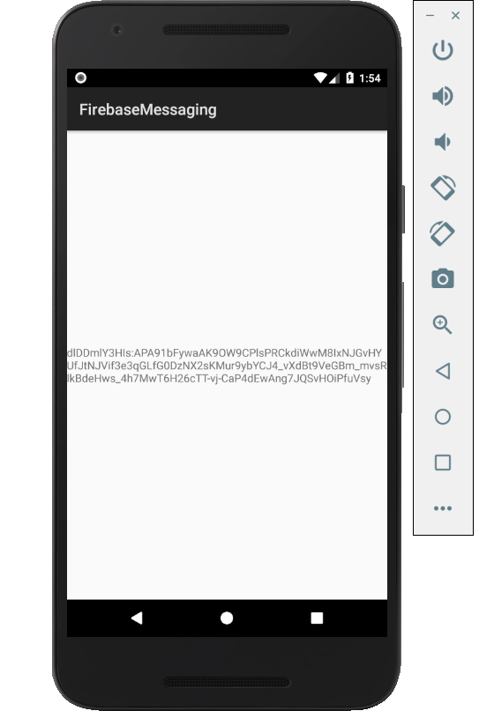

Figure 1. By Android Studio - https://developer.android.com/studio/, CC BY-SA 4.0, https://commons.wikimedia.org/w/index.php?curid=74094999

### 3.2.2 Image/firmware

Status

/1 Hardware present?

/1 Memo by student B + How did you make your Image/firmware? (500 words)

/1 Code can be run via serial or remote desktop

/1 Wireless connectivity

/1 Sensor/effector code on repository

### 3.2.3 Breadboard/Independent PCBs

Status

/1 Hardware present?

/1 Memo by student C + How did you make your hardware? (500 words)

/1 Sensor/effector 1 functional

/1 Sensor/effector 2 functional

/1 Sensor/effector 3 functional

The initial schematic design, Figure 2, based on datasheets (Bosch Sensortec, 2019) led to a breadboard layout Figure 3 that was realized Figure 4.

How did you build your Prototype: Breadboard?

Then a PCB was designed, Figure 5, and populated (Figure 6). Bill of Materials, Case, Time commitment. Testing. Progress.

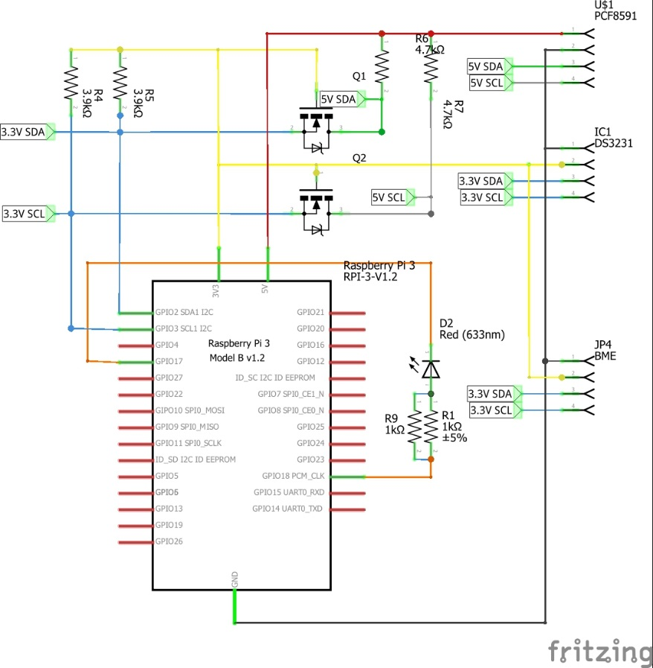

Figure 2. Initial schematic. This work is a derivative of "http://fritzing.org/parts/" by Fritzing, used under CC:BY-SA 3.0.

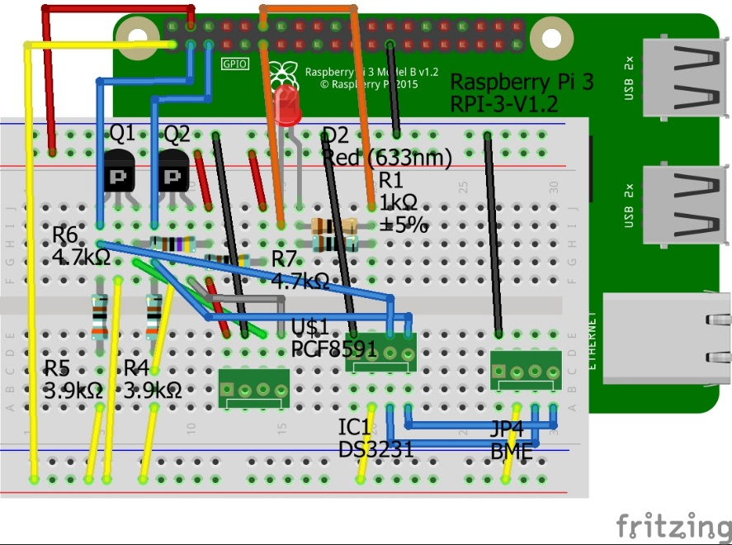

Figure 3. This work is a derivative of "http://fritzing.org/parts/" by Fritzing, used under CC:BY-SA 3.0.

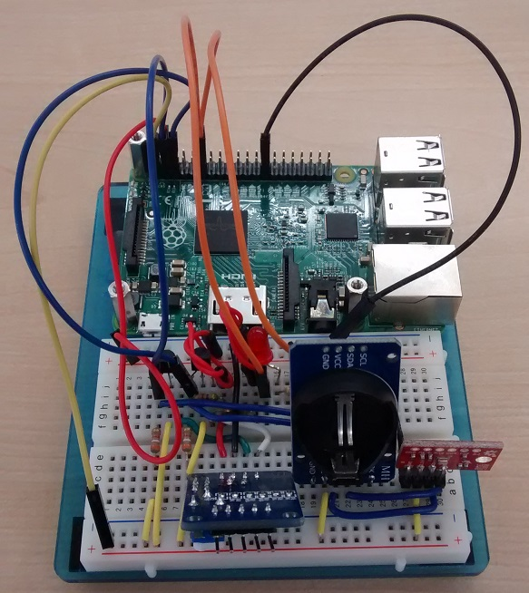

Figure 4. Breadboard prototype.

### 3.2.4 Printed Circuit Board

Demo

/1 Hardware present?

/1 PCB Complete and correct

/1 PCB Soldered wire visible but trim, no holes or vacancies

/1 PCB Tested with multimeter

/1 PCB Powered up

How did you build your Prototype: PCB?

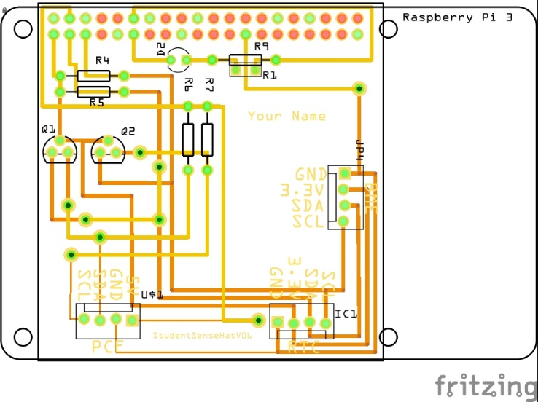

Figure 5. PCB design This work is a derivative of "http://fritzing.org/parts/" by Fritzing, used under CC:BY-SA 3.0.

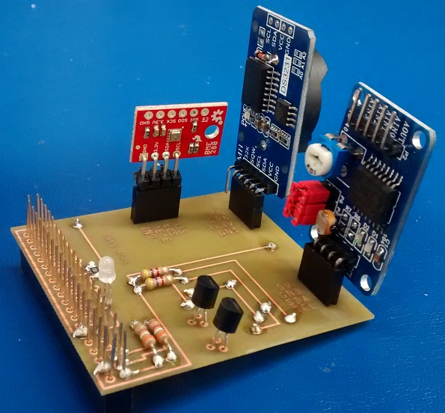

Figure 6. Humber Sense Hat Prototype PCB.

### 3.2.5 Enclosure

Demo

/1 Hardware present?

/1 Case encloses development platform and custom PCB.

/1 Appropriate parts securely attached.

/1 Appropriate parts accessible.

/1 Design file in repository, photo in report.

How did you build your Prototype: Case?

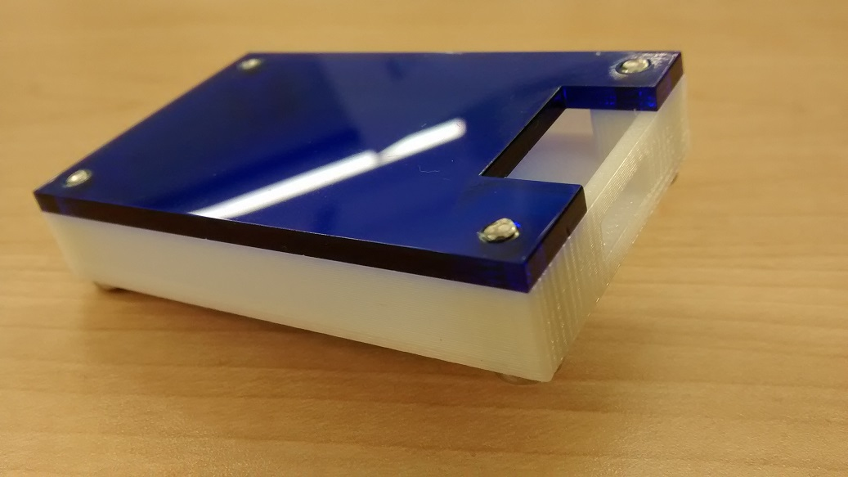

Figure 7. Example enclosure.

## 3.3 Integration

Demo

/1 Hardware present?

/1 Data sent by hardware

/1 Data retrieved by mobile application

/1 Action initiated by mobile application

/1 Action recieved by hardware

Report

/1 Enterprise wireless connectivity (250)

/1 Database configuration (250 words)

/1 Security considerations (500 words)

/1 Unit testing (900 words)

/1 Production testing (100 words)

### 3.3.1 Enterprise Wireless Connectivity

How did you make a Database accessible by both your Prototype and Mobile Application?

### 3.3.2 Database Configuration

### 3.3.3 Security

### 3.3.4 Testing

Unit testing and Production testing.

# 4.0 Results and Discussions

Is your prototype perfect? What did you learn?

# 5.0 Conclusions

If you were making 1000 of these.

Report

/1 Hardware present?

/1 Checklist truthful

/1 Valid Comments

/1 Results and Discussion (500 words)

/1 Conclusion

# 6.0 References

Bosch Sensortec. (2019, July). *BME680 - Datasheet.* Retrieved from Robert Bosch GmbH: https://ae-bst.resource.bosch.com/media/_tech/media/datasheets/BST-BME680-DS001.pdf

Kinsella, J. (2019). Five trends predicted for the cloud industry in 2019. *Software World*, 50(1), 11.

Media, O. (2019). *O'Reilly artificial intelligence conference 2019 - San Jose, California.* California: O'Reilly Media, Inc.

OACETT. (2017, March). *I need to Complete a Technology Report*. Retrieved from The Ontario Association of Certified Engineering Technicians and Technologists: https://www.oacett.org/Membership/Technology-Report-and-Seminar

Robuck, M. (2018, 11). AWS goes deep and wide with machine learning services and capabilities. *Fierceinstaller*.

# 7.0 Appendix

## 7.1 Firmware code

Demo

/1 Hardware present?

/3 Code runs concurrently for all sensors/effectors

/1 Project repository contains integrated code

Status

/1 Memo including updates

/1 Financial update

/1 Progress update

/1 Modified Code Files in Appendix

/1 Link to Complete Code in Repository

## 7.2 Application code

Demo

/1 Hardware present?

/1 Memo by student A

/1 Login activity

/1 Data visualization activity

/1 Action control activity

Report

/1 Login activity

/1 Data visualization activity

/1 Action control activity

/1 Modified Code Files in Appendix

/1 Link to Complete Code in Repository